**MINISTRY OF EDUCATION AND TRAINING**

**FPT UNIVERSITY**

Capstone Project Document

Football Pitches Booking

|  |  |
| --- | --- |
| **Group 10** | |
| **Group Members** | Nguyễn Duy Phương – SE60761 – [phuongndse60761@fpt.edu.vn](mailto:phuongndse60761@fpt.edu.vn)  Nguyễn Hữu Hoàng Giang – SE60606 – [giangnhhse60606@fpt.edu.vn](mailto:giangnhhse60606@fpt.edu.vn)  Nguyễn Đức Thịnh – 60398 – [thinhnd60398@fpt.edu.vn](mailto:thinhnd60398@fpt.edu.vn)  Nguyễn Quốc Khánh – 60556 – [khanhnq60556@fpt.edu.vn](mailto:khanhnq60556@fpt.edu.vn) |
| **Supervisor** | Lại Đức Hùng |
| **Ext Supervisor** |  |
| **Capstone Project code** | FPB |

- Ho Chi Minh, 01/2014 –

Table of Contents

Definitions, Acronyms, and Abbreviations 3

Report No.1: Introduction 4

1.1. Initial idea of group: 4

1.2. Overview of existing system: 4

1.3. Benefit of expected system: 4

Report No.2: Project Management Plan (PMP) 5

2.1. Problem Definition 5

2.1.1. Name of this CapStone Project. 5

2.1.2. Problem Abstract 5

2.1.3. Project Overview 5

2.2. Project organization 6

2.2.1. System Process Model 6

2.2.2. Roles and Responsibilities 7

2.2.3. Tools and Techniques 8

2.3. Project management plan 8

2.3.1. Tasks: 8

2.3.2. Task Sheet: Assignments and Timetable 10

2.4. Convention Rules 10

2.5. Other material 10

Report No.3: System Requirements Specifications (SRS) 11

3.1. User requirement specification 11

3.1.1. Guest requirement 11

3.1.2. Unauthorized member 11

3.1.3. Authorized member 11

3.1.4. Stadium Owner 11

3.1.5. Stadium Staff 12

3.1.6. Website Master 12

3.1.7. Website Staff 12

3.2. System requirement specification (Specific Requirements) 12

3.2.1. External Interface Requirements 12

3.2.2. Functional Requirements 13

3.2.3. Non-Functional Requirements 20

3.3. Entity Relationship Diagram 21

## Definitions, Acronyms, and Abbreviations

|  |  |  |
| --- | --- | --- |
| No. | Keyword | Definition |
| 1 | B2B2C | Stand for Business to business to customer.  In this system, first business is the organization that provides stadium owner to register their stadiums. The second business is stadium owner, who provides hire stadium service, and customer is the user, who want to hire field by this system. |
| 2 |  |  |
| 3 |  |  |
| 4 |  |  |
| 5 |  |  |

## Introduction

### Initial idea of group:

Football Pitches Booking is a B2B2C (Business to Business to Customer) website that allows customers to book field online. Beside that it helps the stadium owners with advertising football stadiums and managing reservation. In addition, the website enables its admin to manage information of those customers and stadium owners.

In this situation, the organization is first business provide services

### Overview of existing system:

For customers: Existing system just provides customers with address and contact information of stadium owners, then customers have to contact with the stadium owner to book space. They have to call each stadium owner individually to check whether the field is available or not. Moreover, the current system does not have either functions to make statistics of customers' habits or some smart functions like offering options/suggestion to customers, which is time-consuming and inconvenient to customers.

For the stadium owners, sometimes they make mistakes in management such as duplicate reservation, which leads to bad result: they could lose their customers as well as profit. Beside the management is executed manually, they do not have tools to optimize the timing to utilize the fields, this has bad impact on profit. Sometimes customers cancel their reservation, the stadium owners will suffer the loss. Apart from cancellation, the website does not have functions to create events to appeal customers to take part in.

For the Web masters, the shortage of functions of the website is the obstacle to persuade stadium owners to pay for the services.

### Benefit of expected system:

Football Pitches Booking makes the reservation easier and save time for customers. Once they have booked, they don’t have to worry there will be a duplicate reservation caused by stadium owners' mistake. The website's smart functions help users to find the appropriate field by searching stadium around customers' position, comparing price among stadiums. The benefits to customers are saving time, getting more information and enjoying discount or voucher from the stadium owners.

This system helps stadium owner to manage their field easily, reduce the implement process of business operations, save time and costs. The automatic system helps to prevent the risk of duplicate booking and to minimize the loss caused by reservation cancellation. The self-arrangement and self-timing offered to customers makes the utilization of field possible, reduce the dead time and increase profit for the stadium owners. Furthermore, stadium owners can use the website as a channel to advertise their services as well as communicate with their customers; hence, they can win more customers and gain more prestige through rating-feedback functions. Analyzing and evaluating the feedback to make the business plan more reasonable.

For the webmaster, with many smart and outstanding functions of the new system, they have more chances to increase the profit by attracting stadium owners to use this service.

## Project Management Plan (PMP)

### Problem Definition

#### Name of this CapStone Project.

This Capstone Project Name is “Football Pitches Booking” or “FPB” in short.

#### Problem Abstract

Ho Chi Minh City (HCMC for short) has over seven million of population, is Vietnam’s centre of commerce and the country’s biggest city by far, though not its administrative capital. HCMC is a youthful city, almost residents are student and clerical worker. Even live in a busy environment, they still take free time to play sport for their health and their relaxation. One of the most popular sport is football. Nowadays more and more spontaneous football games are opened. So the number of artificial grass field increase faster. Based on the latest count, there are more than 100 hundred stadium around district 1 and 3 in 2012, it include five, seven and eleven-man field. And the amount of stadium around HCMC increases constantly.

With the high demand of hiring field, almost stadium owners still manage their ground manually. Player used to contact with stadium owner to book field by phone, and some problem was occurred. They have to call stadium owner to ask for an available booking time, sometimes the manager’s mistake makes the duplicated reservation. This process is wasting time and making more inconvenience.   
There are some websites allow player to search stadium and book it, but it still has limitation. Player have to wait for confirmation of stadium owner after they check this booking time. Manager still arrange reservation manually and mistake still happens.

To meet that demand, we develop a website that allow user to book field online. They can find an appropriate field base on booking time, location or field type. Some automatic function help them with saving time by customer habits statistic. System arranges the booking time and allows manager to change it manually if necessary, it minimize doubling reservation. Some promotion functions help stadium owner to attract their customer. Obviously player get more priority when they register this system.  
In summary, Football Pitches Booking is develop for attending to customer, stadium owner and so website administrator. It makes the reservation becomes easily, helps service provider manage precisely and encourages business efficiently.

#### Project Overview

##### The Current System

According to our research, there has never been a Football pitches booking online system like the one we are developing. There are some websites that provides stadium’s information. We divide it into two types: single stadium service (Website for one stadium owner) and multiple stadium service (Website for more than one stadium owner).

Single stadium service:

There are some services applied for one stadium. For example: <http://tuyensonsport.vn>; <http://sanbongdamini.seonhatnghe.com>

* User just books field belonging to this stadium. The way to book is call stadium owner.
* It is easy to makes mistake in management when executing manually such as duplicate reservation.

Multiple stadium service:

* Some websites collect stadium and provide information to user and they must contact stadium owner then. They have to call each stadium owner individually to check whether the field is available or not.
* Some websites have the booking online system, for example: http://datsan.com.vn  
  Datsan.com.vn is a website that allows users to pick a field and book it online. This website provides searching function to make it more convenient for users. Firstly, users have to choose field, then they fill in the booking form; one point of this form that must be noticed is the booking time. After that, they wait for the stadium owner's call to confirm this reservation.    
  Maybe the booking time that user booked has been occupied. So when the stadium owner calls back, user must change the booking time. It is a waste of time and it causes inconvenience to both customers and service providers.

##### The Proposed System

The system that needs to be established should have these abilities:

* The website must have more categories that are built on the basis of districts,  types of field etc. to make it more convenient for users.
* The website has "search stadium" function. Information can be searched based on location, booking time, type of field (5, 7 or 11 men field). In addition, it should have some auto functions such as suggesting appropriate stadium based on customer habits.
* This website must implement account level to make good offer to users.
* Management function for stadium owners to manage their fields, arrange booking time manually if necessary and manage their users.
* Promotion function to attract customers.
* The website enables players to create matches to challenge other teams.

##### Boundaries of the System :

* Website focus about booking field for player, managing stadium for stadium owner
* Website don’t intervene about finance problem of stadium owner.

##### Development Environment:

**Hardware requirements:**

* + A computerwith hardware that capable of running Windows 7 operating system, 2GB of RAM for addition software

**Sotfware requirements:**

* + Operating System : Windows 7 Professional (32 or 64 bit).

### Project organization

#### System Process Model

The software will be developed by using waterfall model. The waterfall model developing process includes five main phases:



Figure 1: Waterfall model

* + - Requirement analysis and software definition: The first phase is also the most important phase of the process which may cause great effect to other phases. This phase includes gathering requirements from customer, or from other source like the Internet, and producing the most detail and accurate software definition.
    - System design: This phase is fundamental for implementation phase. Based on customer’s requirements to create logical modules, and definite their inter relations. Using algorithm and diagram to describe implementation of those modules.
    - System implementation and Unit testing: Developing software modules follow detail designs, and doing unit testing for each module.
    - Integration and System testing: Testing output, performance in modules integrating process, and retests all functions of whole system.
    - System deployment and maintenance: After testing completely, the software is handle over client, developing team will respond for maintenance of the system.

#### Roles and Responsibilities

|  |  |  |
| --- | --- | --- |
| Full Name | Role | Responsibilities |
| Lại Đức Hùng | Supervisor, Project Manager | * Tracking and managing process * Advising ideas and solutions * Specify requirement |
| Nguyễn Duy Phương | Team Leader, Business Analyst, Developer, Tester | * Tracking and managing process * Analyzing requirement * Writing documents and reports * Designing database * Creating and managing project’s structure * Creating and managing project configuration * Creating project’s plan * Designing GUI * Coding and testing |
| Nguyễn Hữu Hoàng Giang | Team Member, Business Analyst, Developer, Tester | * Analyzing requirement * Writing documents and reports * Designing database * Designing GUI * Coding and testing |
| Nguyễn Đức Thịnh | Team Member, Business Analyst, Developer, Tester | * Analyzing requirement * Writing documents and reports * Designing database * Designing GUI * Coding and testing |
| Nguyễn Quốc Khánh | Team Member, Business Analyst, Developer, Tester | * Analyzing requirement * Writing documents and reports * Designing database * Designing GUI * Coding and testing |

#### Tools and Techniques

##### Tools

* Visual Studio 2012
* Microsoft SQL Server 2008 R2
* Star UML 5.0
* Microsoft Office 2013
* Tortoise SVN
* Google Code
* Log4net

##### Techniques

* .NET Framework 4.0
* ASP.NET MVC 4
* UML Modeling 2.0
* HTML5, CSS3, jQuery
* LINQ

### Project management plan

#### Tasks:

##### Study requirement and review technology

|  |  |
| --- | --- |
| Description | Discussing with project manager to understand requirement, business process.  Self-review the technology will be used in project. |
| Deliverables | N/A |
| Resources Needed | 12 man-days |
| Dependencies and Constraints | N/A |
| Risks | Requirement too strange to develop.  The project is not feasible.  The chosen technology is not feasible. |

##### Project Introduction

|  |  |
| --- | --- |
| Description | From requirements and result of researching old system create project introduction document. |
| Deliverables | Project Introduction document. |
| Resources Needed | 4 man-days |
| Dependencies and Constraints | Depend on result of studying requirement. |
| Risks | Lack of experience in researching old system  Do not understand requirements clearly. |

##### Project Management Plan

|  |  |
| --- | --- |
| Description | Prepare project plan and task list. |
| Deliverables | Project Management Plan (PMP) document. |
| Resources Needed | 4 man-days |
| Dependencies and Constraints | Depend on result of studying requirement. |
| Risks | Lack of experience in scheduling may lead to fail in keeping deadline. |

##### System Requirement Specification

|  |  |
| --- | --- |
| Description | Specify system requirements |
| Deliverables | System Requirement Specification (SRS) document |
| Resources Needed | 28 man-days |
| Dependencies and Constraints | Depend on result of studying requirement.  Follow the SRS Template.  Keeping the deadline in plan. |
| Risks | Do not understand requirements clearly. |

##### System Design Description

|  |  |
| --- | --- |
| Description | Design system architecture, describe system component, user interface design, database in details level for developer. |
| Deliverables | System Design Description (SDD) document |
| Resources Needed | 38 man-days |
| Dependencies and Constraints | Clear requirements of system.  Follow design documents template. |
| Risks | Lack of experience in system designing.  Do not understand requirements clearly.  Requirement change quickly. |

##### System Implementation and Testing

|  |  |
| --- | --- |
| Description | Implement System follow System Design Description document.  Execute unit testing.  Integrate all parts into complete system.  Integration test and system test. |
| Deliverables | Source code.  Unit test document. |
| Resources Needed | 111 man-days |
| Dependencies and Constraints | Follow SDD.  Keeping schedule. |
| Risks | Developers may not misunderstand the design.  Testers are not experience in testing.  Lack of experience in integration.  Resources cannot keeping schedule. |

##### System User’s Manual

|  |  |
| --- | --- |
| Description | Prepare guide document for users. |
| Deliverables | System User’s Manual document. |
| Resources Needed | 6 man-days |
| Dependencies and Constraints | Depend on SDD document.  The guide must easy to understand. |
| Risks | User may not understand the guide |

#### Task Sheet: Assignments and Timetable

Reference to “Football Pitches Booking.mpp” in same folder.

### Convention Rules

Reference to Microsoft C# Programming Guide – C# Coding Conventions.

<http://msdn.microsoft.com/en-us/library/vstudio/ff926074.aspx>

### Other material

N/A.

## System Requirements Specifications (SRS)

### User requirement specification

Football Pitches Booking is a website that allows customers to book field online. Beside that it helps the stadium owners with advertising football stadiums and managing reservation. In addition, the website enables its admin to manage information of those customers and stadium owners.

More detail, the system should have list of features below:

#### Guest requirement

* View list of stadium
* Find and view the stadium’s information
* Find available stadium at specific date, time and duration
* Register to become member of website

#### Unauthorized member

* View list of stadium
* Find and view the stadium’s information
* Find available stadium at specific date, time and duration
* Login
* Recovery password

#### Authorized member

* Update account profiles
* Booking stadium
* Cancel stadium booking
* View booking history
* Rating stadium
* Review stadium
* Create a game
* Find game and join
* Feedback website
* Receive appropriate stadium suggestion
* Request for stadium join into system

#### Stadium Owner

* Update stadium profiles
* Manage fields of stadium:
  + Add field to stadium
  + Update number of field
  + Update field type of field
  + Update price table of field
  + Remove field from stadium
* Manage reservation of stadium:
  + Create new reservation
  + Update status of reservation
  + View reservation detail
  + View list reservations of stadium
* Manage promotion of stadium
  + Create new promotion
  + Update promotion details
  + Delete promotion from stadium
  + View promotion detail
  + View list promotion of stadium

#### Stadium Staff

* Manage reservation of stadium
* Manage promotion of stadium

#### Website Master

* Manage stadium:
  + View list of joining request
  + Update joining request status
  + Add new stadium
  + Update stadium status
* Manage member ranking
  + Create new rank
  + Update rank
  + Remove rank
  + View rank detail
  + View list rank
* Manage advertisement
  + Create new advertisement
  + Update advertisement detail
  + Remove advertisement
  + View advertisement detail
  + View list advertisement
* Manage user
  + Update account status
  + Update role
* Manage Website Block
  + Update block content

#### Website Staff

* Manage advertisement
  + Update advertisement detail
  + View advertisement detail
  + View list advertisement
* Manage user
  + Update account status
* Manage Website Block
  + Update block content

### System requirement specification (Specific Requirements)

#### External Interface Requirements

##### User Interfaces

* The interface of website is simple and friendly
* Main function with multistep should be careful note, easy to understand

##### Hardware Interfaces

N/A

##### System Interfaces

N/A

##### Communications Protocol

Website using HTTP protocol for communication with the web browser and the web server

#### Functional Requirements

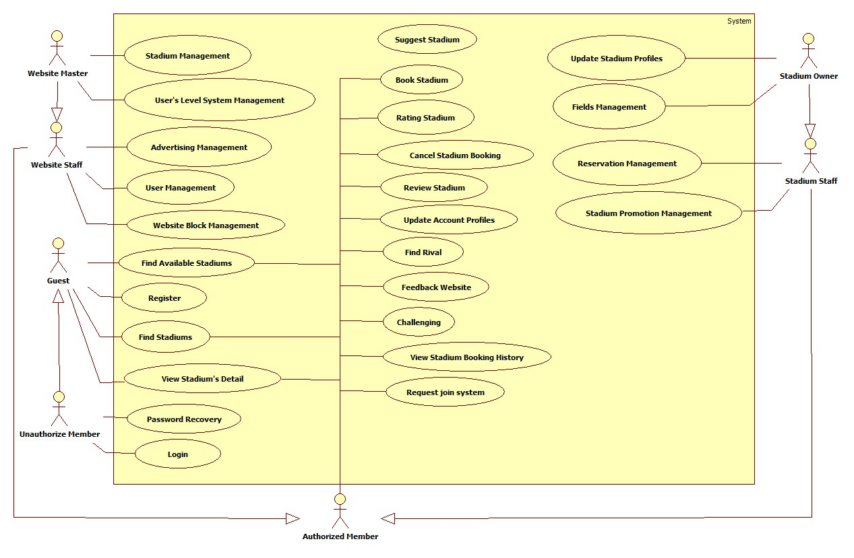

##### Find Stadiums

###### Use Case 1

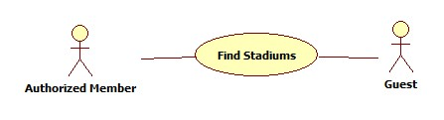

###### Use Case 1 Specification

|  |  |  |  |  |
| --- | --- | --- | --- | --- |
| **USE CASE-n SPECIFICATION** | | | | |
| **Use-case No.** | <UC001> | **Use-case Version** | | <1.0> |
| **Use-case Name** | Find Stadiums | | | |
| **Author** | PhuongND | | | |
| **Date** | 22/01/2014 | **Priority** | High | |
| **Actor:**  *Authorize Member, Guest*  **Summary:**  *This use case describe finding stadium*  **Goal:**  *Find out expect stadiums*  **Triggers:**  *Actor go to Stadium page*  **Preconditions:**  *N/A*  **Post-conditions:**  *Display found stadiums those satisfy actor*  **Main Success Scenario:**   |  |  |  | | --- | --- | --- | | Step | Actor Action | System Response | | 1 | User input keywords into:   * Name text box   User select options of group:   * Province/City radio button * District checkbox * Field type checkbox |  | | 2 | User click Search button |  | | 3 |  | Display results that correspond with user’s expect |   **Alternative Scenario:**  *N/A*  **Exceptions:**  *N/A*  **Relationships:**  *N/A*  **Business Rules:**  *N/A* | | | | |

##### Find Available Stadiums

###### Use Case 2

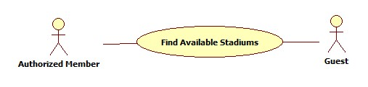

###### Use Case 2 Specification

|  |  |  |  |  |
| --- | --- | --- | --- | --- |
| **USE CASE-n SPECIFICATION** | | | | |
| **Use-case No.** | <UC001> | **Use-case Version** | | <1.0> |
| **Use-case Name** | Find Available Stadiums | | | |
| **Author** | PhuongND | | | |
| **Date** | 22/01/2014 | **Priority** | High | |
| **Actor:**  *Authorize Member, Guest*  **Summary:**  *This use case describe finding available stadium at specific date and time with duration*  **Goal:**  *Find out expect stadiums*  **Triggers:**  *Actor use Find Available Stadium forms on any page which contain the form.*  **Preconditions:**  *N/A*  **Post-conditions:**  *Display found stadiums those satisfy actor*  **Main Success Scenario:**   |  |  |  | | --- | --- | --- | | Step | Actor Action | System Response | | 1 | User select options of group:   * Province/City radio button * District checkbox * Field type checkbox   User specify date on Date picker  User specify time on Time dropdown list  User specify duration on Duration dropdown list |  | | 2 | User click Find Available Stadium button |  | | 3 |  | Display results that correspond with user’s expect |   **Alternative Scenario:**  *N/A*  **Exceptions:**  *N/A*  **Relationships:**  *N/A*  **Business Rules:**  *N/A* | | | | |

##### Book Stadium

###### Use case 3

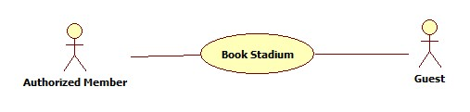

###### Use case 3 specification

|  |  |  |  |  |
| --- | --- | --- | --- | --- |
| **USE CASE-n SPECIFICATION** | | | | |
| **Use-case No.** | <UC001> | **Use-case Version** | | <1.0> |
| **Use-case Name** | Book Stadium | | | |
| **Author** | PhuongND | | | |
| **Date** | 22/01/2014 | **Priority** | High | |
| **Actor:**  *Guest, Authorize Member*  **Summary:**  *This use case describe booking stadium*  **Goal:**  *Reverse a stadium with specific field type at specific date, time and duration*  **Triggers:**  *Actor clicks on “Book Now” button correspond to expected stadium*  **Preconditions:**  *N/A*  **Post-conditions:**  *Success: a reservation is created*  *Fail: cancel booking and display error message*  **Main Success Scenario:**   |  |  |  | | --- | --- | --- | | Step | Actor Action | System Response | | 1 |  | Display Booking page with attached information for logged in user  [Alternative-Not Login] | | 2 | User update information to booking form:   * Field type dropdown list * Date picker * Time dropdown list * Duration dropdown list |  | | 3 | User click on “Book” button |  | | 4 |  | Display Confirm Reservation page  [Alternative-Field Not Available] | | 5 | User update information to confirm form:   * Full Name * Email * Phone |  | | 6 | User click on “Confirm” button |  | |  |  | Display Booking success page  [Alternative-Field Not Available] |   **Alternative Scenario:**  *[Alternative-Not Login]*   |  |  |  | | --- | --- | --- | | Step | Actor Action | System Response | | 1 |  | Display Booking page include:   * Register link * Login link | | 2 | User click Register link  [Alternative-Have No Account] |  | | 3 |  | Redirect to Register page |   *[Alternative-Field Not Available]*   |  |  |  | | --- | --- | --- | | Step | Actor Action | System Response | | 1 |  | Display field not available message |   *[Alternative-Have No Account]*   |  |  |  | | --- | --- | --- | | Step | Actor Action | System Response | | 1 | User click Login link |  | | 2 |  | Redirect to Login page |   **Exceptions:**  *N/A*  **Relationships:**  *N/A*  **Business Rules:**  *N/A* | | | | |

#### Non-Functional Requirements

##### Reliability

* Mean Time Between Failures (MTBF): The acceptable failure is once a year
* Mean Time To Repair (MTTR): The acceptable mean time for a particular failure must be least than 12 hours
* Maximum Bugs or Defect Rate: 05 bugs / KLOC

##### Availability

* The system always responds to every user who got permission. The server shall be working 24/7.

##### Security

* Customer information must be secured
* The system always check authenticate and permission for every function

##### Maintainability

N/A

##### Portability

N/A

##### Performance

N/A

### Entity Relationship Diagram

