Jeremias Platero

CSE 341

**Project Proposal:**

**Tic Tac Toe**

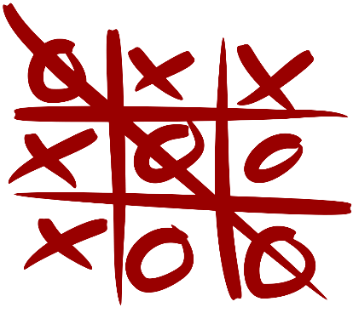

**Purpose**:

The purpose is to create a tic tac toe game in which a player will be able to be against a “bot”. The bot will use machine learning algorithms to determine the best possible move.

**Requirements checklist:**

1. Professional look and feel
   1. The site will utilize the same color scheme throughout the website
   2. Any “meme” references or images will be excluded *(barring any that were excluded due to programmer’s lack of knowledge)*
   3. It will utilize a minimalist design
2. Accomplishes a meaningful a meaningful task/ Does something interesting
   1. The interesting task will be incorporating machine learning into the bot opponent
      1. The programmer must understand the fundamentals of machine learning
      2. The programmer must implement the machine learning utilizing the programming language of JavaScript
         1. *Note: typically, machine learning is done in python or R*
      3. The bot must be able to calculate which move will yield to higher probability of winning
3. Demonstrate proficiency in Node.js and express principles
   1. Shall be created utilizing Node.js
   2. Shall utilize express module
4. Demonstrates mastery of Client-side and Server-side communication
   1. Shall utilize sessions to keep users logged in
      1. This will persist even if subsequent games are played
5. Incorporates a data layer
   1. Will utilize MongoDB to handle save states
   2. MongoDB shall be utilized to store accounts of users
   3. MongoDB shall store the following information
      1. Wins
      2. Loses
      3. Account information
6. Incorporates a log and authentication system
   1. Users will be able to create an account
   2. If logged in user will be able to see information about their win/loss ratio
      1. The above will be inaccessible if not logged in
   3. Users will have the ability to logout
7. Demonstrates web security principles
   1. Will utilize csrf tokens
   2. Shall utilize hashing to encrypt passwords
8. Exhibits modern and organized web architecture
   1. Shall utilize MVC pattern
      1. Model will contain the machine learning part of the algorithm

**Stretch Goals:**

This section is for functionality that can be added once the project is completed. If the instructor deems that the main proposal is insufficient then the instructor can mandate stretch goals that will satisfy the projects needs. (the goals are not included in any particular order)

* Ability for 2 human players
* Ability for 2 bots to play against each other
* A system to suggests the most optimal move to the player
* Leaderboard that will show which user has won the most games