TECHNOLOGY INTRODUCTION / DESIGN PROPOSAL

Smart CNC
Factory
  - Hybrid architecture with
Siemens Opcenter, Simio
and a local AI agent

TWO CONNECTED PRODUCTION FLOWS
Precision parts manufactured using CNC equipment, and complete CNC machine tools manufactured from internal and purchased components.

Operational authority | Predictive analysis | Human interface
Opcenter APS + execution | Simio process digital twin | Local, evidence-grounded AI
One approved production schedule | Controlled what-if experiments | Authorized tools and approvals

Deployment target: fully on-premises and air-gapped.
AI infrastructure context: 2 servers × 8 H200 GPUs; other platform sizing remains workload-dependent.
Document date: September 9, 2026.
Version: 1.0 — architecture and evaluation baseline.
This document is a proposed technology architecture, not evidence of an installed integration, a software license entitlement, a safety certification, or a measured production result. All numerical examples and identifiers are synthetic.

Contents
1. Project definition and baseline | 3
2. Recommended hybrid design | 4
3. Two linked manufacturing flows | 5
4. Modeling precision-part production | 6
5. Modeling complete CNC machine builds | 7
6. System ownership and boundaries | 8
7. Reference architecture | 9
8. Opcenter implementation design | 10
9. Simio process digital twin design | 11
10. Schedule release and rescheduling | 12
11. Integration and interface contracts | 13
12. Canonical data model | 14
13. Example records and evidence | 15
14. Built-in local AI agent | 16
15. Proposed AI tool and scenario contract | 17
16. Engineering, quality and release | 18
17. Worked example: shared machining capacity | 19
18. Worked example: outage and risk | 20
19. Worked example: assembly is the bottleneck | 21
20. Worked example: genealogy and change | 22
21. Air-gapped security architecture | 23
22. Deployment and hardware allocation | 24
23. Resilience, observability and operation | 25
24. Proof-of-concept implementation stages | 26
25. Acceptance tests and evaluation | 27
26. Procurement, deliverables and source ownership | 28
27. Roadmap, trade-offs and decision gates | 29
Glossary | 30
Sources and verification notes | 31
Source numbers such as [2] refer to the primary references at the end. “Proposed” means a project design choice; “documented” means supported by the cited vendor or standards source. Product availability and license entitlements must be verified for the exact purchased versions.
Core terms: CNC = computer numerical control; AI = artificial intelligence; LLM = large language model; APS = advanced planning and scheduling; MES = manufacturing execution system; ERP = enterprise resource planning; API = application programming interface.
Engineering and software terms: CAM = computer-aided manufacturing; NC = numerical control; PLM = product lifecycle management; PLC = programmable logic controller; SQL = Structured Query Language; GPU = graphics processing unit; UTC = Coordinated Universal Time.

1. Project definition and baseline
The factory makes both parts and complete CNC machine tools.
The confirmed scope is precision-part production using CNC equipment plus complete-machine manufacturing. In-house components can flow into machine assembly. External part sales are shown as an optional stream, not a confirmed factory activity. The examples include that stream to test shared capacity. Shared machines, people, tools and inspection capacity must be planned together.

Requirements carried forward
Requirement | Design consequence
Both types of manufacturing | Model internal components, purchased items, subassemblies, final assembly and acceptance tests; include external part demand where applicable.
Confidential, isolated operation | No public LLM API or external connectivity dependency in normal operation; validate activation, recovery and support offline.
Natural-language AI agent | Support questions, follow-up dialogue, evidence retrieval and controlled tool orchestration, not just keyword commands.
Local AI hardware | Treat 16 H200 GPUs across two servers as the AI context, not as a validated sizing plan for MES, APS or simulation.
Existing project baseline | Prior requirements name ERPNext, an unspecified MES and Siemens NX. Preserve these interfaces until a migration decision is approved. [1]

What remains unverified
Opcenter and Simio are candidates in this design, not confirmed installed systems. The current MES product, Teamcenter presence, controller mix, plant scale, product families, software versions, licenses and data quality have not been audited. Siemens CNC controllers are not a prerequisite for evaluating this architecture.
The current confirmation of “both” overrides the narrower machining-only examples used earlier. Sample assembly steps in this document are a modeling template, not a statement about the factory’s actual process or machine design.
A crucial identity rule
A CNC machine used to manufacture a part is a production resource. A CNC machine being assembled for a customer is a product instance. They must never become interchangeable simply because both are called “CNC machines.”

2. Recommended hybrid design
Choose complementary roles, not two competing production schedulers.
My recommended starting point is Opcenter-led operational scheduling and execution, with Simio as a separately governed process-simulation and risk-analysis service. The local AI agent operates above these services through a controlled integration layer. This is an engineering recommendation for evaluation, not an independently benchmarked product ranking.
Layer | Proposed responsibility
ERP and engineering | ERP owns demand, purchasing and commercial records. NX and the engineering release process own approved product and process definitions.
Opcenter APS | Create candidate operational schedules and maintain the schedule version selected for publication.
Opcenter Execution Discrete / current MES | Dispatch approved work and record starts, completions, consumption, inspections and product genealogy.
Simio | Evaluate a defined plan or dispatch policy under modeled variation; compare alternatives without issuing shop-floor instructions.
Data and tool services | Validate interfaces, reconcile identifiers, capture snapshots and evidence, and enforce permissions and approvals.
Local AI | Interpret requests, select allowed tools, explain evidence and prepare recommendations.

Why the products are plausible candidates
Siemens documents multi-constraint scheduling, material dependencies and sequence-dependent changeovers in Opcenter Scheduling. Opcenter Execution Discrete is positioned for both job shops and complex assembly. Simio documents simulation-based scheduling and risk analysis. These capabilities justify a joint pilot, not an assumption of plug-and-play compatibility. [2–4, 6–7]

Three boundaries that prevent expensive mistakes
One schedule publisher: Simio never publishes a competing schedule to the same resources. Independent production: loss of the AI or simulation service must not stop normal MES execution. Engineering safety: process simulation is not proof of collision-free machining or safe equipment operation.
Keep the existing MES in place during the pilot. Opcenter Execution should replace or coexist with it only through a deliberate, scoped migration. If coexistence is needed, assign each operation and resource to exactly one execution owner; do not let two MES products issue work to the same cell.

3. Two linked manufacturing flows
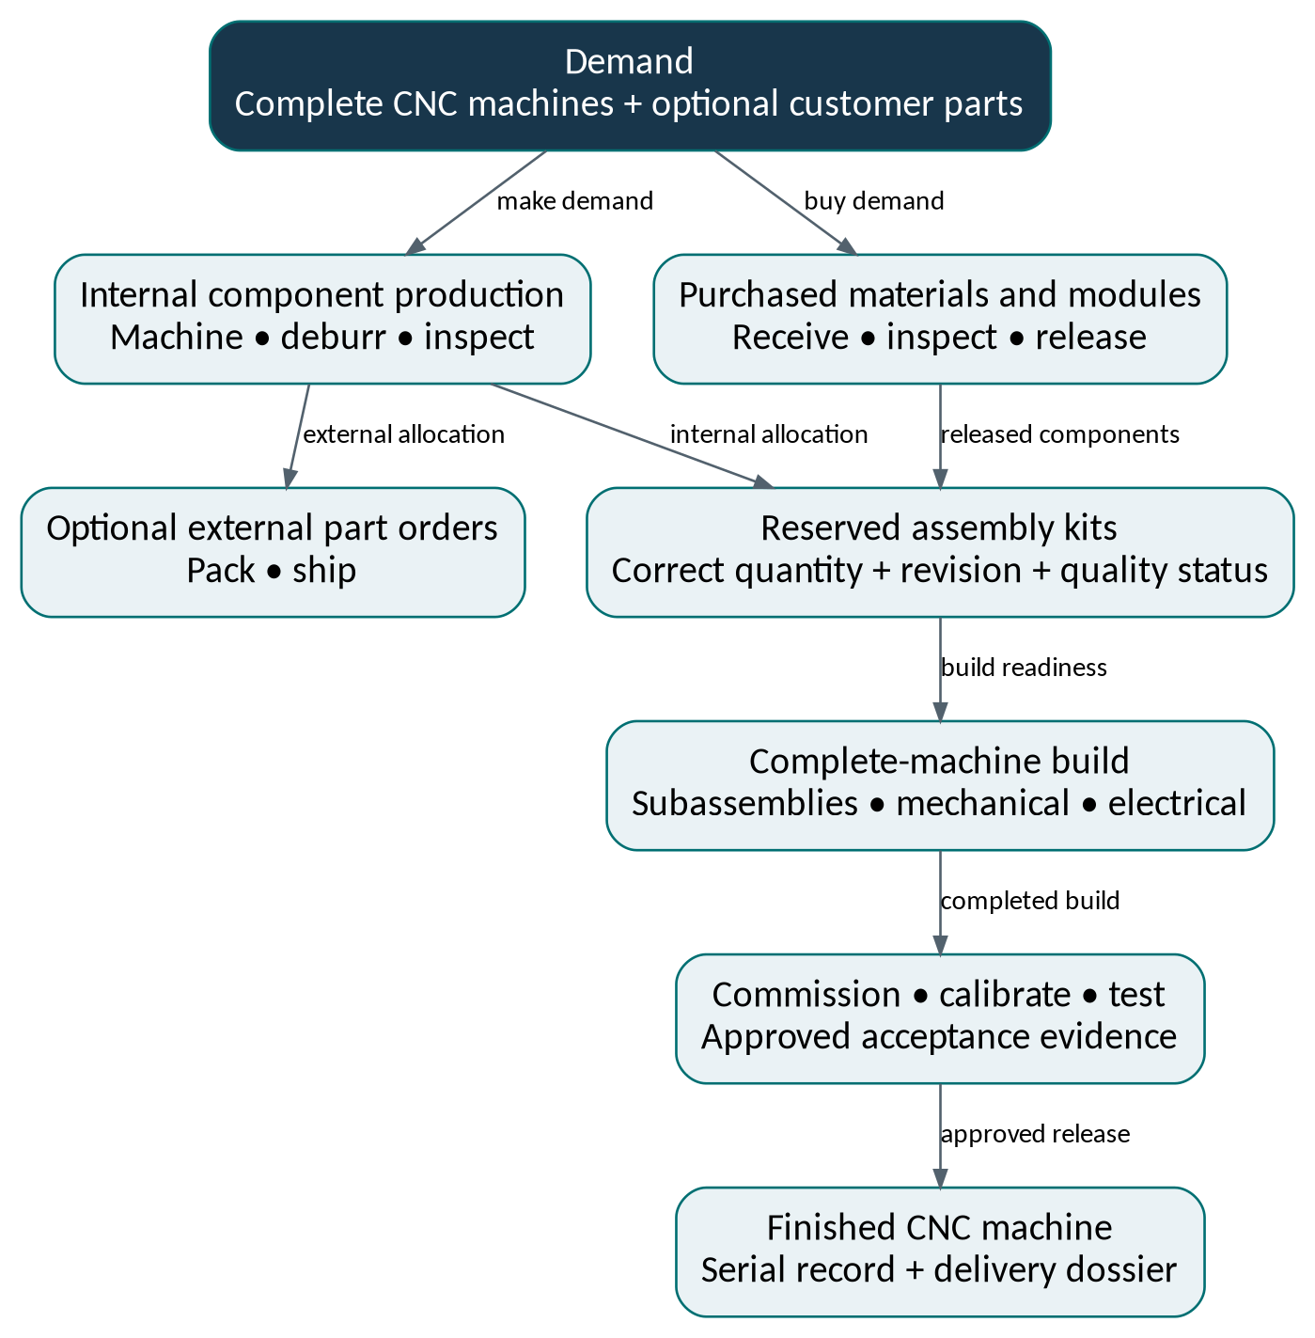
Figure 1. Physical product flow. External part sales are optional. Arrows show material or product progression, not computer commands.
The architectural connection is demand allocation, not simply a common dashboard. A machined component may satisfy an external sales order or an internal machine-build requirement, but the same physical quantity cannot satisfy both. The ERP/material-reservation process must preserve that allocation and communicate it to scheduling and execution.
Plan all shared capacity once. Final assembly may also share cranes, specialists, gauges, floor space and test rigs. Optimizing only CNC utilization can create excess components while complete machines remain blocked at assembly or acceptance.

4. Modeling precision-part production
Represent executable operations, not just product names and due dates.
For each part revision, create an approved routing: a linked set of operations with quantities, resource eligibility and release conditions. A routing can branch for alternative processes or rework, but those branches require engineering approval. A model should distinguish setup time, attended work, unattended machining, waiting and transfer.
Model object | Required information and example
Part and routing revision | PART-HSG-200 revision C; routing R-C3. A different revision may change tooling, inspection or cycle time.
Operation eligibility | OP20 may use RES-CNC-01 or RES-CNC-02 only if the approved machine/program/fixture combination is available.
Resource occupancy | Machine, fixture and tool reservations may span the entire operation; a setter may be needed only for setup and first-off approval.
Material and quantity | Released raw stock, batch identity, transfer quantity, scrap disposition and the internal/external demand allocation.
Sequence effects | Changing from material family A to B may require cleaning or a different setup. Use approved transition rules, not an average guessed by the LLM.
Quality and maintenance | Inspection holds, tool-life status, scheduled maintenance, calibration validity and rework eligibility must affect readiness.
External processes | Heat treatment, coating or grinding at a supplier needs a transport/receipt/inspection step and a supplier commitment, not an unlimited-capacity placeholder.

Scheduling detail that matters
Use alternate-machine processing times where appropriate. Define whether jobs may pause across shifts, whether batches may split, and whether a transfer batch may reach the next operation before the entire production batch finishes. A resource calendar is necessary, but it is not enough to express every constraint.
For this design, an operation is ready only when prerequisites, released materials, approved program revision and required resources are available. An engineering override must be recorded as an explicit approved exception; neither the AI nor a simulation run may silently relax that rule.
Example question
“Can we move OP20 to the second machining center?” must trigger an eligibility and impact check. Similar axis counts or spare machine hours alone do not establish manufacturing equivalence.

5. Modeling complete CNC machine builds
Use a configuration-aware assembly network with release gates.
Represent each finished machine as a serialized product instance, linked to its configured manufacturing bill of materials and build plan. Long-lead purchased modules and in-house components must meet the same assembly requirements. The example below is generic: actual operations, durations and safety criteria must come from factory engineering.
Stage | Resources and constraints to represent
Engineering release | Approved configuration, drawings, manufacturing BOM, build instructions and applicable changes.
Component readiness | Bed, column and housings where applicable; purchased spindle, drives, controller and other modules; incoming inspection and reservation.
Subassembly | Axis or spindle modules, electrical cabinet and lubrication assemblies; assembly benches, tooling and specialist labor.
Mechanical integration | Assembly bays, crane time, alignment work, fixtures and floor-space occupancy. Labor and bay occupancy are separate constraints.
Electrical and configuration | Qualified technicians, wiring checks, approved controller/PLC software and configuration baselines.
Commissioning and calibration | Authorized test sequence, appropriate instruments, calibration status, stabilization time and permitted environment.
Acceptance and release | Factory acceptance test, required witness availability, approved results, nonconformance disposition and shipment dossier.

Kit readiness is operation-specific
Do not block every safe early task because a late-stage component is missing, and do not begin an irreversible assembly merely because most of the kit is present. Define the mandatory component set for each operation. The readiness service should return the exact missing or held items and the downstream effect.

Parallel work and persistent occupancy
Mechanical and electrical work may overlap only where the approved process allows it. A machine can occupy a bay while no technician is working on it; modeling only labor hours would overstate bay capacity. Test-rig occupancy, specialist attendance and customer witnessing may also have different time windows.
Do not count an unfinished product as production capacity
A newly built machine becomes a production resource only after an explicit acceptance, asset-registration and capability-release workflow. Test-cut telemetry belongs to its commissioning record until then.

6. System ownership and boundaries
The data hub connects authorities; it does not replace them.
Information or decision | Proposed authoritative owner | What other layers may do
Sales demand, purchasing, commercial stock | ERP; ERPNext is the project baseline | Read permitted records; propose changes through ERP workflows.
Part definition and approved engineering revision | Engineering release system; NX data and PLM if present | Index approved evidence; reference immutable revisions.
Manufacturing BOM and routing | Named engineering/process owner; published to operational systems | Use released versions; reject revision conflicts.
Published production schedule | Opcenter APS, via one release workflow | Simio evaluates; AI explains; MES acknowledges and executes.
Actual operation state and WIP | Assigned MES execution owner | Publish events and reconcile progress.
Released/held material and inspection decisions | Assigned quality and inventory workflows | Scheduling respects holds; AI cannot self-approve disposition.
Product genealogy / as-built record | MES traceability record with engineering references | Data hub provides authorized joins and historical views.
Machine measurements | Historian/collector, linked to validated identities | Expose quality, timestamp and context with readings.
Simulation assumptions and outputs | Versioned Simio model and scenario registry | Label predictions as conditional, not observed facts.
Permissions and approval evidence | Local identity/policy services and approving business role | AI carries user scope; it cannot grant itself extra rights.

Where current systems differ, retain their legitimate ownership and adjust adapters. Ownership is a field-level contract: two applications may both display inventory, but only one workflow should authorize the same stock movement. Conflicts are quarantined and reconciled rather than resolved by whichever update arrived last.
ERPNext integration should use the installed Frappe APIs and a least-privileged service identity. Frappe documents REST/RPC interfaces and checks permissions for authenticated API users. Direct writes to vendor databases are not the default integration method. [12]

7. Reference architecture
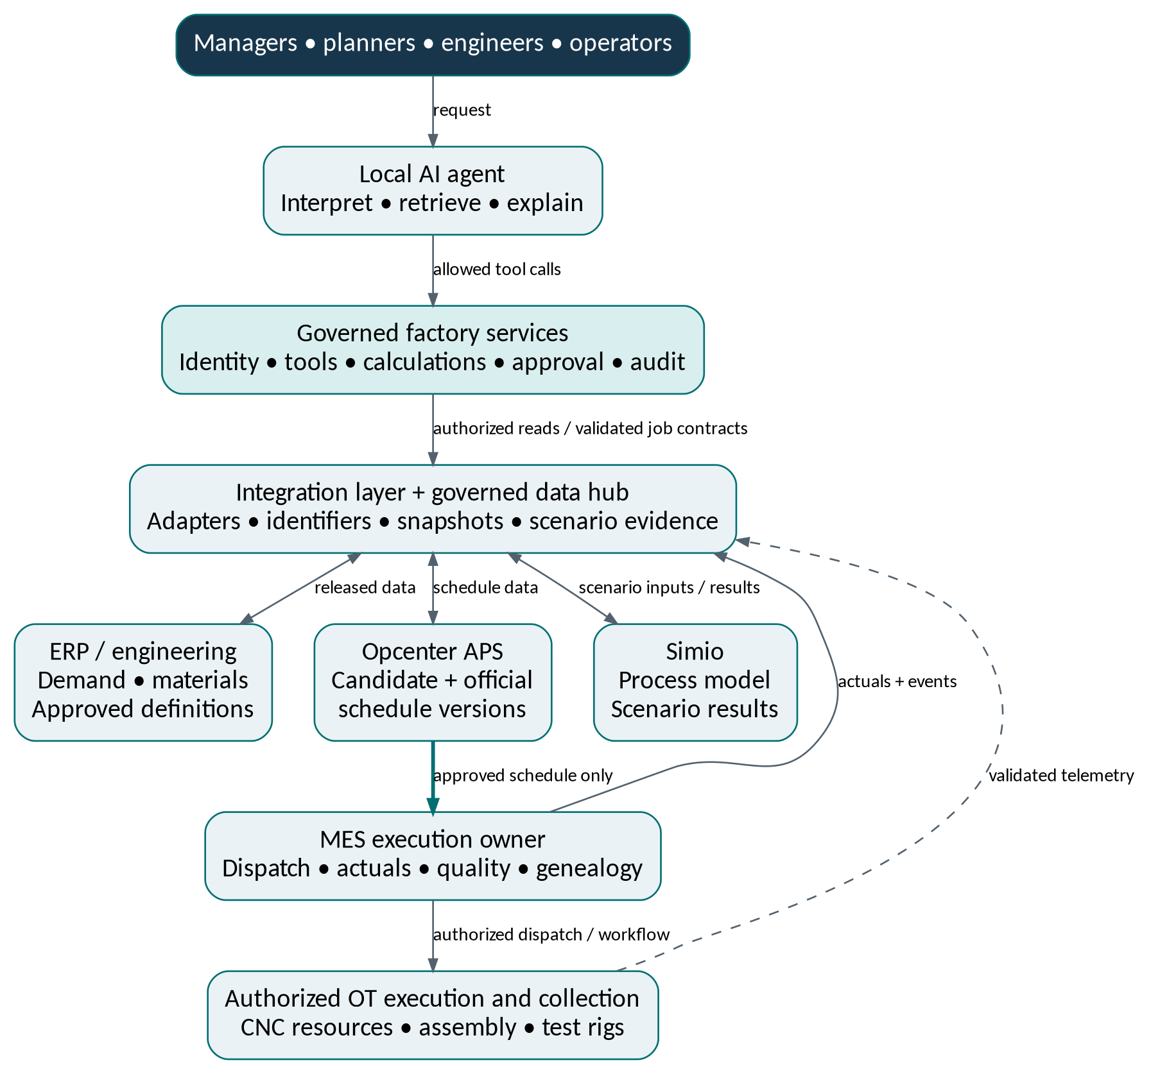
Figure 2. Logical integration architecture. Labeled arrows show specific interfaces; they do not imply direct AI control of equipment.
Read path: local AI → governed tools → authorized current data or approved documents. Scenario path: tools create a versioned snapshot, call Simio and return an evidence package. Write path: an authorized user approves a specific validated schedule version; only the publishing service sends it to the execution owner.
The data hub is a logical service boundary, not a requirement to copy every byte into one database. Vendor-supported application databases remain separate. No arrow represents a turnkey Opcenter–Simio connector or an unrestricted LLM-to-controller connection.

8. Opcenter implementation design
Separate scheduling, execution and integration products explicitly.

Opcenter APS: operational planning and scheduling
Use the selected Scheduling edition to construct resource- and material-constrained plans for both production streams. Siemens documents order priorities, alternative run speeds, sequence-dependent changeovers and material relationships. Configure only rules that manufacturing engineers can explain and test. Planning may be added when longer-horizon capacity and demand planning justifies it. [2]
For the pilot, define a rolling detailed horizon, a frozen near-term zone, a review cadence and disruption thresholds. These are factory policy decisions. A machine alarm should not automatically reshuffle every released order; the response depends on safety actions, expected impact and schedule stability.

Execution Discrete: operational record and workflow
Evaluate Execution Discrete for job-shop and assembly execution, not as a generic “Siemens database.” Its documented scope covers both manufacturing patterns. The 2601 release material also describes containment and traceability-related workflows; verify which applications and licenses are required for the proposed implementation. [3–4]
Configure operator work instructions, material consumption, serialized installation records, inspections and exception handling around actual work practices. A completed operation should record who did it, when, on which resource, against which revision and with what result. Engineering and quality signatures remain meaningful business controls.

Integration and brownfield coexistence
Opcenter Connect MOM is a candidate integration component for heterogeneous systems. Its presence does not establish that ERPNext or Simio is already integrated. Require a demonstrated mapping for orders, operations, calendars, material states, schedule versions and execution acknowledgements. [5]
Avoid | Use instead
Assuming “Opcenter” is one license | A named module/version/entitlement matrix, including non-production and disaster-recovery rights.
Big-bang replacement of the existing MES | One pilot scope, controlled migration and a defined rollback path.
Two dispatch systems for one resource | One execution owner per operation/resource scope.
Direct SQL updates to internal tables | Supported APIs, integration interfaces or vendor-approved import/export procedures.

9. Simio process digital twin design
A calibrated factory-flow model, not a picture and not a safety certificate.
Use Simio to represent the behavior of machining, material movement, assembly, inspection and testing. Discrete-event simulation advances between events such as a job arrival, operation completion or resource release. Risk analysis repeats a defined scenario with modeled variation. Simio documents these concepts and their use in scheduling. [6–7]
Model element | Proposed treatment
Entities | Part lots, individual serialized modules and finished-machine build instances; split and join rules preserve quantities.
Resources | CNC equipment, fixtures, tools, labor skill pools, bays, cranes, gauges and test rigs; distinguish attendance from occupancy.
Initial state | Active operations, remaining work, machine status, WIP locations, material reservations, open holds and current setup.
Deterministic inputs | Approved precedence, nominal durations, eligibility, calendars, maintenance windows and planned receipts.
Uncertainty inputs | Observed duration distributions, repair time, supplier delay and rework behavior, with data coverage and assumptions recorded.
Outputs | Completion-time distributions, lateness, queue time, WIP, resource loading and uncertainty intervals at selected decision points.

Separate two experiment modes
Evaluate the plan: preserve the imported candidate’s identity, machine assignment, priority/sequence and defined dispatch rules. Explain whether planned start times are lower bounds or exact reservations. Search for alternatives: allow only declared changes, then label the result as a different candidate requiring another operational validation.
A model that silently rearranges jobs is not testing the imported schedule. A result is tied to both its schedule and its recovery/dispatch policy. After converting a suggested alternative back into Opcenter, evaluate the actual resulting schedule, not the earlier simulation proposal.

Validate before relying on probabilities
Reconcile deterministic runs against hand-checkable cases first. Then back-test on held-out production periods, compare distributions with observations and review failure modes with engineers. Preserve correlated disruptions where relevant. Do not infer rare-failure probabilities from too little data or report “95% confidence” as an unconditional promise.

10. Schedule release and rescheduling
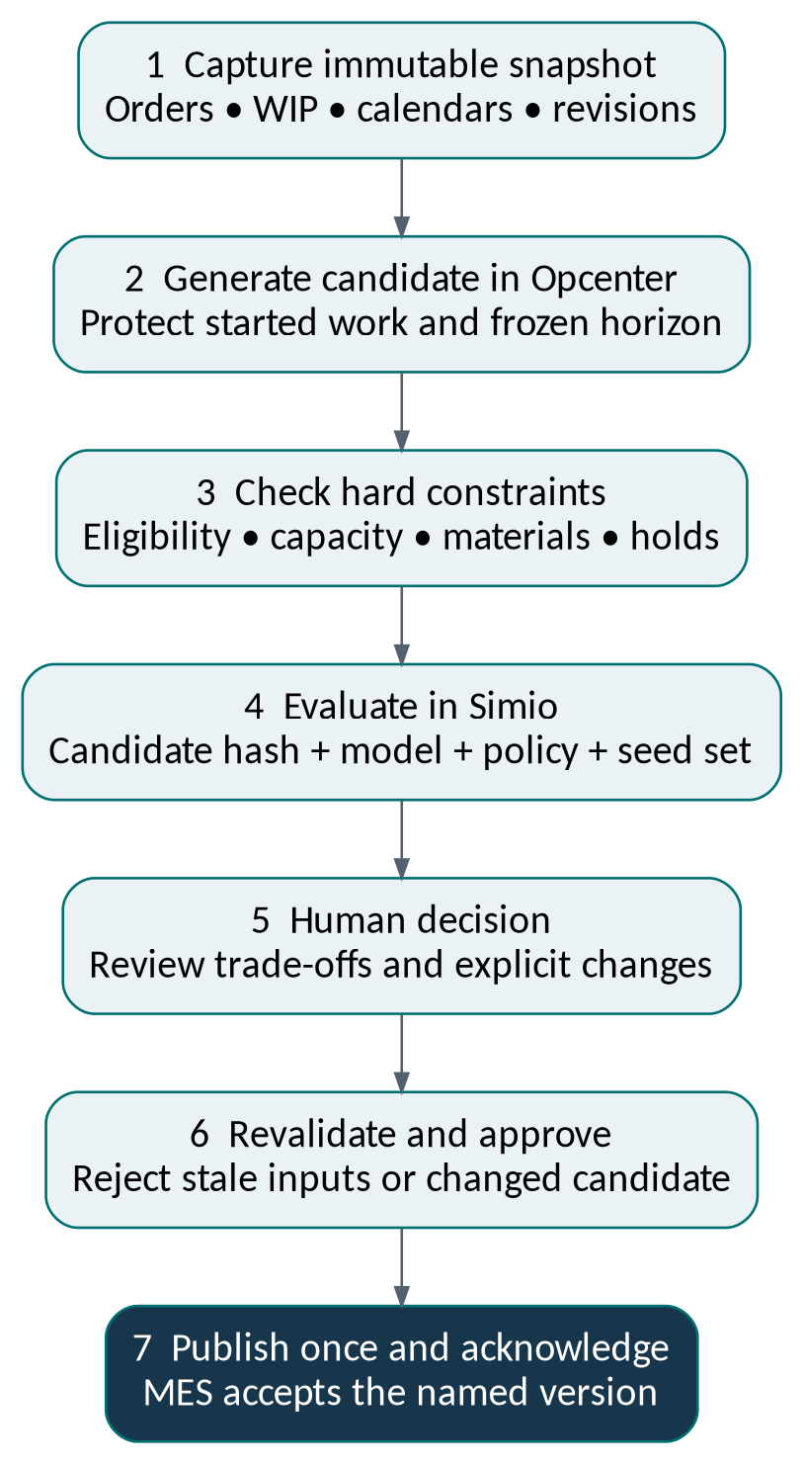
Figure 3. Proposed schedule lifecycle. Every transition produces an audit event; rejection returns a proposal for correction.
Use states such as Draft, Constraint-checked, Risk-evaluated, Awaiting approval, Approved, Published and Acknowledged. Any change to the candidate or a material input invalidates dependent approval and risk results. A schedule is not operationally active merely because a publish request was sent.
The publisher checks the current schedule version, input freshness and approval scope, then uses an idempotent request and verifies the MES acknowledgement. A retry must not duplicate work. A timeout requires status reconciliation before another publish attempt.
After work has started, “rollback” means a safe new plan for remaining work—not reversing physical production. Emergency stops and other equipment protection actions remain in established OT procedures; they must never wait for this scheduling workflow.

11. Integration and interface contracts
Build a versioned factory interface, not a web of unrestricted connections.
The following are project interface contracts, not vendor endpoint names. Adapter implementations must be verified against licensed product interfaces. Simio documents data connectors, Portal programmatic access and .NET extension points, but public overview pages do not establish the complete API required by this project. [8–10]
Flow | Required payload | Contract behavior
ERP → integration | Demand IDs, item/revision, quantity, due time, material availability and reservation state | Stable IDs; revision checks; explicit cancellation/change handling.
Engineering → integration | Released BOM/routing/program metadata, effectivity and approval references | Immutable release versions; no silent replacement of an active definition.
MES → data services | Operation state, quantity, resource, lot/serial, hold status, actual timestamps | Event ID, source version, ordering key and replay policy.
APS → scenario service | Candidate operations, resources, times, sequence, allocations and frozen work | Snapshot ID and content hash; preserve declared schedule semantics.
Scenario service ↔ Simio | Model-ready tables, uncertainty settings, run job, outputs and diagnostics | Job state, timeout, cancellation, concurrency limit and versioned result schema.
Publisher → MES | Approved schedule version, operation dispatch instructions and approval reference | Single publication owner, idempotency and acknowledgement reconciliation.
AI ↔ factory tools | User-scoped questions, typed requests and evidence-bearing results | Server-side authorization, validation and bounded read/write privileges.

Synchronization rules
Use events for changes and controlled snapshots for repeatable analysis. Collect source high-water marks and relevant timestamps; a “snapshot” spanning several systems is not automatically an atomic transaction. Require a reconciliation barrier for critical order, allocation and WIP states before publishing.
Deduplicate events by source and event ID. Preserve sequence/version information to handle late arrival. Detect schema changes, quarantine invalid records, expose source lag and maintain retry/dead-letter handling. An event bus is transport, not automatically the system of record.

12. Canonical data model
Use one vocabulary while preserving original system ownership.
Use stable internal keys plus an explicit cross-reference to each source-system key. Avoid using display names as joins. Keep master data, released definitions, physical instances, operational events and simulated predictions in separate entities. The table is a recommended logical model, not a replacement vendor database schema.
Entity group | Key relationships and rules
Item / item revision | item_id + revision_id; definition includes units and release/effectivity. A part model and a physical serialized part are different objects.
BOM / BOM line / configuration | bom_revision_id → component revision and quantity; configure each machine build; record valid substitutions and approved effectivity.
Routing / operation definition | routing_revision_id → operation IDs; model predecessor edges, alternative resources and setup families.
Demand / reservation / production order | Demand lines distinguish external sales and internal assembly demand. Reservation links stock or planned supply to one or more quantities without over-allocation.
Resource / capability / calendar | resource_id identifies equipment, bay or tool; capability and calendar revisions constrain eligibility and capacity.
Lot / serial / installation | A physical lot or serial is linked to inspections and consumption. Installation records join child serial to parent build serial with position and valid-from/to times.
Operation execution / event | execution_id ties a work order to actual resource, times, operator role, input/output quantity and state changes.
Schedule / scenario / approval | Immutable schedule version, operation allocations, snapshot, model and policy revisions, result hash and approval scope.
Document / revision / evidence | Approved content, source location, access policy, checksum, and the exact section or row used in an answer.

Minimum integrity rules
Enforce foreign keys in the canonical store where feasible, explicit units, valid timestamp ordering, nonnegative quantities and uniqueness for active identifiers. Represent correction events instead of overwriting historical evidence. An installed component cannot simultaneously occupy two active assembly positions unless its physical quantity model explicitly allows that.
Do not explode the same machine BOM independently in ERP and the data hub and count both as new demand. Record the originating demand and explosion version so internal requirements are traceable and deduplicated.

13. Example records and evidence
All identifiers below are synthetic; they illustrate meaning and relationships.
Record | Example | Why it exists
Production resource | resource_id = RES-CNC-03 | Existing machining center that can execute approved part operations.
Finished product definition | item_id = PROD-MC500; revision = B | The configurable CNC machine model being manufactured.
Machine under construction | build_serial = BUILD-MC500-026 | A customer machine instance; not an available production resource.
Internal component lot | lot_id = LOT-HSG-0914; item = PART-HSG-200; revision = C | Physical housing supply with traceable inspection and consumption.
Component installation | parent = BUILD-MC500-026; child = SPINDLE-0081 | As-built relationship with position, procedure revision and installation time.
Schedule evidence | schedule = SCH-0042; snapshot = SNAP-0087 | Names the exact operational plan and its input baseline.
Scenario evidence | scenario = SCN-0018; model = MODEL-1.4 | Distinguishes a prediction from an observed production event.

Telemetry and history
Store measurements with asset identity, source tag, source timestamp, ingestion timestamp, value, unit and quality code. Keep high-rate signals in an appropriate historian/time-series store; expose interpreted state intervals and aggregates to planning. A current temperature is not a document-retrieval result.
Use UTC in interfaces and store the plant time-zone configuration separately. Display local dates clearly, including daylight-saving ambiguity where applicable. Unknown, stale, bad-quality and zero values must remain distinct. A missing signal must not be interpreted as “machine available.”

Binding commissioning data correctly
During factory acceptance, a test station may observe BUILD-MC500-026. Record a time-bounded binding between station, product serial and test run. When the next machine arrives, change the binding—not the historical serial on earlier data. Do not combine acceptance-test readings with the maintenance history of RES-CNC-03.
Evidence package for every consequential answer
Include observed facts, source timestamps, assumptions, calculation inputs, query/tool identifiers, snapshot and schedule versions, model/seed/policy references where relevant, and approval status. Predictions and recommendations must be visibly labeled.

14. Built-in local AI agent
One conversational entry point; controlled industrial services underneath.
The AI is the user-facing reasoning and explanation layer. It should not become the primary database, the scheduling solver or a safety controller. This follows the project’s earlier requirements for local models, retrieval, rule/calculation engines and approved tool orchestration. [1]
Step | Required behavior
Understand the request | Identify intent, entities, quantity, time window, factory scope and whether the request is analysis or a proposed action.
Resolve conversation context | Retain the referenced order or machine within authorized session scope; confirm ambiguity without guessing a dangerous interpretation.
Retrieve current evidence | Use controlled APIs for live facts and permission-filtered retrieval for approved documents. Enforce permissions before content reaches the model.
Run the correct service | Call deterministic calculations, APS, Simio or engineering data services. Do not synthesize numerical results from model memory.
Validate results | Check schema, units, identifiers, source freshness, tool status and evidence completeness. Report missing inputs.
Explain trade-offs | Separate facts, assumptions, forecasts and recommendations. Cite the records and model run that support each important conclusion.
Prepare a governed action | Create a proposed change only within permission scope. Bind approval to the exact payload and revalidate before execution.

Model strategy
Start with one qualified local conversation model. Use a second model selectively for difficult interpretation or benchmark comparison; agreement between models is not proof of correctness. Use local embeddings and, where beneficial, a reranker for document retrieval. Model selection should be based on your manufacturing questions, language needs, tool-call behavior and licensing—not a generic leaderboard.
Version the system instructions, schemas, approved tools and evaluation set. Treat retrieved documents and tool-returned text as untrusted input: a sentence inside a manual cannot authorize a tool call. No unrestricted shell, SQL-write, controller-write or arbitrary network tool belongs in the agent’s production tool set.

15. Proposed AI tool and scenario contract
These are your factory service APIs, not claimed Simio or Siemens endpoints.
Factory service | Permitted effect
get_order_risk / get_build_readiness | Read authorized current facts and evidence for a named order or build.
get_schedule / get_genealogy | Read a scoped schedule or traceability graph, with source versions.
create_scenario / run_scenario | Create and run an isolated analysis job; no production-state changes.
compare_scenarios | Compare compatible runs, identify changed assumptions and preserve uncertainty labels.
propose_schedule_change | Create a reviewable change proposal; cannot publish it.
approve / publish_schedule | Separate protected workflow for authorized roles and the publisher; never general autonomous LLM authority.

A sample request to the project’s scenario service could look like this. All IDs are illustrative, and the UTC outage window is a test input rather than a real incident:
{
"scenario_id": "SCN-0018",
"snapshot_id": "SNAP-0087",
"base_schedule_version": "SCH-0042",
"mode": "evaluate_fixed_plan",
"model_revision": "MODEL-1.4",
"dispatch_policy_revision": "POLICY-3",
"seed_set_id": "SEEDS-02",
"changes": [{
"type": "resource_unavailable",
"resource_id": "RES-CNC-03",
"start_utc": "2026-09-14T07:15:00Z",
"duration_minutes": 360
}],
"replications": 500
}
The server authenticates the caller, enforces user scope, validates every field and derives candidate hashes itself. Return a job ID and explicit state, followed by results with constraint checks, completed replication count, metrics, uncertainty, diagnostics and evidence references. Failed or partial runs must not look like a successful result with zeros.
Maintain two identifiers: an idempotency key for safe submission retries and a content hash for the candidate/model/input identity. Similar questions can still require different runs when factory data or approvals have changed.

16. Engineering, quality and release
Connect product intent, manufacturing instructions and as-built reality.

NX and the engineering record
Retain NX for approved engineering and CAM workflows. Siemens documents CAM programming and G-code-driven simulation; these have a different purpose from Simio’s factory-flow model. A simulated production schedule does not validate toolpaths, controller behavior, surface quality or machine safety. [13]
Begin with read-oriented extraction of released part/revision IDs, material, operation metadata, tooling, program references and approval state. Whether these come from NX Open, managed exports or a PLM system depends on the installed version and licenses. Teamcenter is optional in this architecture until its presence and scope are established.

Engineering BOM, manufacturing BOM and as-built record
The engineering BOM expresses the product design. The manufacturing BOM and routing express how the product will be built. The as-built record states which actual components, software revisions and operations became part of a particular delivered machine. Keep these linked but distinct; a late design change must not rewrite history.

Part quality and finished-machine acceptance
For machined parts, record inspection-plan revision, measured characteristic, unit, instrument/calibration reference, result and disposition. For completed machines, record test procedure, configuration baseline, measured outcomes, responsible personnel and unresolved exceptions. Approved test criteria must come from engineering and applicable requirements; the AI must not invent tolerances.
Represent hold and release decisions as operational constraints. A component that exists in inventory but is quarantined is not available for assembly. A “pass” in one test is not permission to skip another required acceptance step. The quality owner authorizes disposition through the established system.
Generated CNC code remains a separate controlled workstream
Any AI-generated or modified NC program is a draft engineering artifact. It requires approved postprocessing, appropriate simulation/verification, engineering review and controlled release. This architecture does not authorize automatic deployment of generated code or bypassing machine interlocks.

17. Worked example: shared machining capacity
Synthetic arithmetic: a necessary capacity check, not a delivery promise.
Assume a component family needs two housings for each complete machine. The same housing is also sold to external customers. All housing operations in this simplified calculation are eligible for the three listed CNC resources; actual scheduling still has to enforce dates, sequences and downstream readiness.
Input | Value and explanation
Nominal machining capacity | 3 machines × 5 working days × 8 hours/day = 120 machine-hours.
Planned exclusions | Each machine has 2 maintenance hours and 2 setup hours: 3 × 4 = 12 hours.
Other committed work | 72 machine-hours already reserved for unrelated production.
Remaining housing capacity | 120 − 12 − 72 = 36 machine-hours.
Required housings | 12 complete CNC machines × 2 housings + 20 external housings = 44 housings.
Usable existing supply | 6 inspected, released and unreserved housings; these are allocated once.
New machining required | 44 − 6 = 38 housings; 45 minutes each = 0.75 hours each.
Required machine-hours | 38 × 0.75 = 28.5 hours; remaining aggregate margin = 36 − 28.5 = 7.5 hours.

What the AI may conclude
“The simplified machining-hour check passes with 7.5 hours of remaining aggregate capacity. This calculation assumes sufficient released raw stock, no scrap/rework, the stated machine eligibility and setup exclusions, and that the six existing housings are not committed elsewhere.”

What the AI must not conclude
It cannot conclude that all 12 complete machines and 20 external housings will ship on time. Internal housings may be required earlier than the external order; labor, fixtures, other BOM items, assembly and acceptance testing may constrain the plan. Section 19 shows how final assembly can still fail even when this machining calculation passes.
A complete answer therefore combines this transparent calculation with an operation-level schedule and readiness checks for every protected delivery commitment. Avoid subtracting the same downtime twice or applying an Overall Equipment Effectiveness (OEE) reduction on top of losses already modeled explicitly.

18. Worked example: outage and risk
Separate aggregate arithmetic from stochastic scenario results.
Continue Section 17. A six-hour outage plus a separate 1.5-hour recovery setup removes the 7.5-hour machining margin. This assumes those losses were not already included in the baseline. The outage is a scenario input, not an AI prediction of actual repair time.
Alternative | Simple machining-hour effect | Additional conditions
Keep remaining plan | 36 − 6 − 1.5 = 28.5 hours available; zero aggregate margin. | Detailed due dates and eligibility may still make the plan infeasible.
Add 4 approved overtime hours | 32.5 hours available; 4 hours above the 28.5-hour requirement. | Machine, labor, tools and material must all be available during those hours.
Outsource 8 accepted housings | 30 housings × 0.75 = 22.5 internal hours; 6-hour margin. | Supplier delivery, revision, inspection and allocation must be approved.

Illustrative risk-result format — not a Simio run
Suppose a hypothetical experiment reports that all protected commitments finish on time in 420 of 500 replications for one candidate, and 475 of 500 for another. The estimated joint success rates are 84% and 95%. These are invented counts to explain interpretation; no factory simulation was run for this document.
For 475 successes out of 500 independent replications, a 95% Wilson interval is approximately 92.7%–96.6%. This interval reflects Monte Carlo sampling uncertainty under the chosen model. It does not cover an incorrect process model, missing constraints or unrepresentative historical data.

Compare like with like
Define success precisely: for example, all 44 housing requirements are fulfilled by their respective internal-assembly or external-shipment dates. That differs from average order-level on-time performance and does not establish complete-machine delivery. Use the same input snapshot and comparable random streams where appropriate, and hold back fresh random seeds for checking a selected alternative.
After any candidate is translated back into Opcenter, check that allocations and constraints survived the round trip and evaluate the resulting schedule. Publish only its approved version. Do not reuse a favorable risk score from a different sequence or a looser dispatch policy.

19. Worked example: assembly is the bottleneck
Producing enough components is not the same as delivering complete machines.
Continue the same synthetic week. Assume the 12 machines are new builds that each require ten remaining assembly-bay hours. There are two eligible assembly bays, each nominally available for 40 hours, with eight total bay-hours unavailable during the week.
Check | Calculation | Interpretation
Assembly availability | 2 bays × 40 hours − 8 unavailable hours = 72 bay-hours. | This is occupancy capacity, not technician labor capacity.
Assembly demand | 12 machines × 10 hours = 120 bay-hours. | The simplified gap is 48 bay-hours.
Maximum full assemblies | floor(72 ÷ 10) = 7 machines, with 2 hours left. | An upper bound before sequencing, labor and kit constraints.
Calibration check | 1 rig × 40 hours; 12 machines × 3 hours = 36 rig-hours. | Aggregate calibration appears sufficient, but arrival timing may create queues.

A useful agent response
“Machining capacity alone is not the limiting issue. The simplified assembly model is short by 48 bay-hours. Adding CNC overtime would not close that gap. We should evaluate approved extra bay time, another qualified bay, or staggered machine delivery, then check labor and calibration readiness.”

Purchased components and assembly kits
If a spindle delivery is late, the scenario must identify which build serials are affected, which earlier tasks remain permitted, and whether the blocked machines continue occupying bays. Moving them to a staging area may require crane time, space and approved handling; it is not a cost-free scheduling change.
An alternate spindle or controller is not just another inventory item. The substitution must meet the configured product definition and engineering/quality release conditions. The AI may surface the option and its evidence, but it cannot approve compatibility or change the customer configuration.

Why the hybrid matters here
The operational scheduler provides the build sequence and resource assignments. The process twin evaluates how queues, kit arrivals, attendance and rework affect that plan. The agent connects the machining result to the finished-machine delivery outcome instead of reporting a misleading local utilization improvement.

20. Worked example: genealogy and change
Answer across parts, modules and finished machines without losing revision history.
A quality engineer asks: “Which completed machines contain a spindle from the affected supplier lot, and what is still in production?” The answer must follow recorded genealogy and installation history; it cannot be inferred from product names or assumed from the latest BOM.
Investigation step | Required evidence
Identify the affected supply | Supplier lot, received quantities, individual serials where available and the approved containment request.
Find current locations | Unconsumed inventory, quarantine, subassemblies, active builds and delivered machines.
Follow installation history | Child serial → subassembly → finished-machine serial, with installation/removal times and positions.
Review quality and test records | Applicable inspections, deviations, concessions and acceptance results for the exact instance.
Evaluate schedule consequences | Which planned operations become blocked and which approved alternatives exist.
Prepare action | An evidence-backed containment proposal for quality review, not an autonomous shipment recall or material release.

Revision change example
Suppose an approved engineering change makes housing revision D effective for selected new machine serials, while revision C remains authorized for previously released builds. The data layer needs explicit effectivity and order/build applicability. A generic “use the newest drawing” rule could select the wrong revision.
The agent should retrieve the change record, identify affected orders, show inventory and WIP consequences, and call scenario tools for schedule impact. Engineering decides the applicability and quality decides any disposition. After approval, republish the manufacturing definition through controlled interfaces and invalidate affected schedule analyses.

When evidence is incomplete
A missing serial-installation record should produce “traceability gap,” not “not affected.” An aggregate lot-consumption record may narrow the candidate population but cannot always identify an exact finished machine. State the resolution limit and route the gap for physical reconciliation.
Causal language must match the evidence
A temperature rise before a quality failure is an observed association unless an investigation establishes causation. Do not invent percentage contributions to lateness or defects without a defined, validated attribution method.

21. Air-gapped security architecture
Local hosting is necessary, but isolation must be demonstrated end to end.
Design separate trust zones for user access, AI/data services, manufacturing applications, OT integration and equipment cells. Use an approved administrative path and a controlled import area for updates. NIST OT security guidance emphasizes the operational reliability and safety context; OPC UA provides security mechanisms that still require correct product support and configuration. [14–15]
Zone or path | Required boundary in this design
User interface and identity | Local authentication; role- and resource-scoped authorization; no internet identity dependency.
AI and retrieval | No direct controller route; permission-filtered documents; bounded tools; confidential logs and local model artifacts.
Application/data services | Supported integration identities; separate read and publish credentials; local secrets, certificates, DNS and time services.
OT integration | Allowlisted conduits and protocol endpoints; bounded collection; command workflows separate from telemetry.
Equipment and test cells | Existing protection logic and local operator authority stay independent of the AI and scheduling services.
Maintenance/import area | Controlled removable media, malware review, verified hashes/signatures, approved packages and offline update records.

MTConnect is read-only and should be treated as a monitoring/data interface. OPC UA can expose different services depending on the implementation; do not interpret connectivity as permission to write. Machine-command interfaces are outside the initial AI scope. [15–16]

Prove permanent-isolation behavior
Test cold start, license checkout, service restart, credential/certificate renewal, backup restore and failover with external network access blocked. Observe attempted outbound traffic. Include local documentation, package dependencies, browser assets, monitoring and support tooling in the test—not only the LLM server.
Simio documents on-premises Portal hosting, but that does not establish permanent-air-gap activation and recovery rights. Obtain written confirmation for the exact product stack. Opcenter X is described as SaaS; do not silently substitute it for the isolated Opcenter deployment required here. [11, 17]

22. Deployment and hardware allocation
Protect operational services from AI and experiment workloads.
The stated AI infrastructure is two servers with eight H200 GPUs each. Use it as a platform context, not a reason to deploy every model or put every application on those hosts. This document does not claim GPU acceleration for Opcenter scheduling or Simio experiments.
Workload | Proposed placement and sizing method
Interactive local LLM | GPU inference services with a measured latency/concurrency budget, model access controls and separate service identities.
Embeddings / model evaluation | Scheduled GPU jobs with admission control; avoid starving production conversations.
Simio runtime and experiments | Vendor-supported compute environment; benchmark CPU, memory, model size, run count and licensed parallelism.
Opcenter application/APS | Vendor-supported application and database topology. Obtain current OS/database/virtualization compatibility matrices.
Data hub and historian | Dedicated or properly isolated storage/compute; size from tag frequency, events, retention, query load and recovery needs.
Integration and publisher | Highly available services where justified; persistent job state, durable audit and a single effective publisher.
Development and test | Separate databases, credentials and model registries; synthetic or authorized sanitized data only.

Two servers do not automatically provide high availability
If one model requires both GPU servers to run, losing either server may remove the AI service. A resilience design must test whether a reduced-capability model can run on the surviving node and whether storage, networking and identity remain available. The APS and MES must still operate if all AI services are unavailable.

Illustrative data-sizing arithmetic
A hypothetical 100 resources × 20 numeric tags × 1 sample/second produces 2,000 values/second, or 172.8 million values/day. At an assumed 40 bytes per stored value, that is about 6.9 GB/day before indexing, replication, metadata and backups. Real storage depends strongly on compression and record format; measure it with the actual collector.
Keep raw high-frequency data only where justified, retain appropriate aggregates for planning, and use retention tiers. Do not send raw vibration waveforms or an entire historian into each LLM prompt.

23. Resilience, observability and operation
A failed AI answer must not become a failed factory.
Failure | Required operating behavior
LLM unavailable | Users continue through MES/APS interfaces; read dashboards remain available where independent.
Simio job fails or times out | Mark the analysis unavailable or partial. Keep the approved schedule; do not fabricate a risk score.
Input source is stale | Show the affected source and age; prohibit new publication when critical freshness policy fails.
MES acknowledgement is missing | Reconcile by publication ID/version before retrying; never issue duplicate work by assumption.
Late or duplicate events | Apply source ordering/version rules, deduplicate and preserve the original audit evidence.
Model/schema update breaks an adapter | Quarantine incompatible data, alert an owner and use the last validated deployment where safe.
OT network or collector outage | Equipment follows established local procedures; unknown telemetry does not become assumed availability.

Operational records to monitor
Track source lag, missing identifiers, snapshot reconciliation failures, scenario queue depth, run duration, model/version mismatches, infeasible-candidate rate, publish latency, acknowledgements and approval invalidations. Monitor AI tool accuracy, unsupported claims, permission denials, retrieval failures and complete evidence coverage.
Separate four notions of time: machine-control response, event collection, management-data freshness and scenario turnaround. Assign measured service objectives to each; do not use “real time” as a blanket promise for all layers. The initial pilot should report actual latency distributions before production targets are finalized.

Ownership and change control
Manufacturing engineering owns model logic and resource eligibility; planning owns schedule policy; quality owns holds and acceptance; IT/OT owns deployment and security; the AI team owns orchestration and evaluation. Appoint an integration owner for cross-system conflicts and failed publication recovery.
Version every model, connector, schema, prompt, tool definition and rule set. Require regression tests before deployment and retain the prior package for recovery. Back up applications, model artifacts, canonical mappings, license recovery information and evidence records, then demonstrate restoration offline.

24. Proof-of-concept implementation stages
Demonstrate both value streams without attempting a complete MES replacement.
The earlier requirements describe an 8–10-week PoC focused on a few workflows. That is a previous planning assumption, not a validated delivery estimate for this expanded hybrid scope. The stages below are controlled by acceptance gates and should be sized after interface and model discovery. [1]
Stage | Concrete output | Exit evidence
1. Scope and contract | Synthetic representative part family, one machine-build family, shared resources, constraints and explicit systems ownership. | Signed data dictionary, flow model, acceptance questions and security boundaries.
2. Data and adapters | Read-only ERP/MES/NX interfaces or approved test exports; canonical IDs and repeatable snapshots. | Reconciled quantities, states, units, revisions and source permissions.
3. Deterministic schedule | A constrained operational plan including internal/external demand, assembly and acceptance steps. | Hand-checkable cases pass; no duplicate capacity/material allocation.
4. Simio evaluation | Import/export mapping, WIP initialization, baseline agreement and scoped risk experiments. | Model validation, recorded assumptions and schedule round-trip fidelity.
5. Local AI workflows | Grounded capacity, outage, assembly readiness and genealogy questions; scenario comparison in natural language. | Held-out evaluation and complete traceable evidence.
6. Shadow operation | Run against authorized factory snapshots without publishing production changes. | Planner review, offline restart/restore tests and a go/no-go report.

A manageable synthetic pilot
A useful illustrative scope is 6 machining resources, 2 assembly bays, 1 calibration/test resource, 2 component families, 1 configured machine family, shared tooling and skill calendars, and about 40 work orders. These counts are a proposed test design, not the factory’s inventory. Include one supplier delay, one machine outage, one quality hold and one revision change.

Four questions that exercise the architecture
“Can we accept more external housing demand without delaying machine builds?” “What changes if the shared CNC is unavailable?” “Which machine builds are not kit-ready?” “Which finished machines contain a held component lot?” Start with these before broadening conversational scope.

25. Acceptance tests and evaluation
Use pass/fail gates before weighted product comparisons.
Test area | Proposed acceptance criterion
Data integrity | Every critical test-case operation, item/revision, resource and lot/serial maps unambiguously; no negative or duplicate allocations.
Schedule feasibility | Zero hard-constraint violations in the agreed suite, including precedence, simultaneous resources, shifts, material holds and frozen work.
Cross-engine fidelity | Imported/exported operation IDs, assignments, sequences, quantities and time semantics match the declared contract; every intentional change is explicit.
Offline operation | Cold start, inference, scenario run, publication rehearsal and restore succeed without external service dependency.
Security | All tested unauthorized reads and writes are denied; document injection cannot grant tool access; no AI controller-write path.
AI task accuracy | Set a pilot target such as at least 95% on a held-out set of supported workflows; inspect each critical error separately.
Evidence and numerical accuracy | Every consequential number links to the source/tool result; arithmetic and units match deterministic checks.
Reliability | Duplicate submissions, stale snapshots, job failures and lost acknowledgements behave as specified without duplicate dispatch.
Simulation validity | Engineering review and historical back-test pass agreed tolerances; predictive intervals and known model limitations are reported.

These are proposed project criteria, not vendor guarantees. A finite test suite cannot prove universal correctness. Safety, authorization, data integrity and schedule feasibility are mandatory gates: a high overall score must not compensate for a failure in one of them.

A suggested comparison score after the gates pass
For the same dataset and questions, assign 30% to dual-stream constraint coverage, 20% to integration and maintenance effort, 20% to model/risk validity, 15% to planner usability and explanation quality, and 15% to support and total lifecycle effort. Weights total 100%; review them with stakeholders before testing.
Evaluate an Opcenter-only baseline, an Opcenter-plus-Simio configuration and, where justified, a Simio-led scheduling alternative with one publisher. This tests whether the second engine provides measurable decision value rather than assuming that more software is automatically better.

26. Procurement, deliverables and source ownership
Separate custom work you should own from licensed vendor products.

Written vendor confirmations before commitment
Topic | Evidence to request
Permanent isolation | Exact activation, renewal, license-service, disaster-recovery and support procedure with no normal outbound dependency.
Supported automation | Versioned API/SDK documentation, sample job submission and result retrieval, schedule import/export and supported service identities.
Complete bill of software | Named modules, editions, server/runtime seats, concurrency limits, databases, operating systems and development, test and disaster-recovery rights.
Scheduling fidelity | A demonstration preserving your operations, calendars, material allocations and frozen work through the proposed round trip.
Model portability | Editable native models, data tables, rules, experiment settings, connector configurations and reproducible test inputs.
Maintenance and upgrades | Compatibility policy, regression obligations, escalation ownership, offline patches and a practical migration path.

What to require from the integration team
The contract should deliver source code for the custom adapters, factory APIs, data migrations, validators, AI orchestration and test harnesses, together with build instructions, dependency inventories, licenses, deployment manifests, runbooks and an offline installation package. Require editable Simio model assets and documented Opcenter configuration/custom rules, subject to vendor terms.
Siemens and Simio product source code is not implied by buying the implementation. Third-party libraries and model weights have separate license conditions. Define ownership, modification rights, handover access, maintenance responsibilities and any escrow needs with appropriate commercial/legal review; this document is not a legal determination.

Capability verification without factory disclosure
Give candidates the same synthetic dataset and failure cases. Require a live demonstration, a reproducible offline rerun, understandable source/configuration handover and evidence that another engineer can rebuild it. A recorded animation or a chatbot answer alone does not demonstrate scheduling correctness, integration reliability or deployment readiness.

27. Roadmap, trade-offs and decision gates
Adopt the hybrid only when its benefits outweigh its operating burden.
The hybrid is attractive because the factory has shared machining capacity plus configuration-dependent assembly and testing. Those interactions create useful scenarios for a process twin. However, the design adds a second model, additional software entitlements and a cross-engine validation obligation. These are real costs, not minor connector details.
Risk or trade-off | Mitigation / decision rule
Duplicate model logic drifts | Assign rule ownership, version common inputs and run reconciliation tests after every change.
Simulation looks precise but is weakly calibrated | Publish assumptions and data coverage; compare with observations; withhold unsupported risk estimates.
Published schedule differs from evaluated one | Bind results to candidate hashes and policy versions; re-evaluate after round-trip transformation.
Excessive rescheduling disrupts the floor | Use frozen work, impact thresholds and stability penalties approved by planning.
Vendor or implementer dependency | Require source/configuration handover, internal training, test data and documented interfaces.
Large GPU investment distracts from data readiness | Fund identity mapping, process modeling, measurements and ownership first; benchmark compute separately.
Hybrid complexity exceeds value | Retain a single APS plus MES, or narrow Simio to high-value engineering/strategic scenarios.

Recommended sequence
First establish the data and ownership contracts. Next demonstrate an accurate deterministic plan across both production streams. Then add a validated Simio model and local AI analysis. Operate in shadow mode before allowing approved schedule publication. Keep autonomous machine control outside this roadmap unless a separately engineered and approved control project is commissioned.

Final go/no-go rule
Proceed only if the isolated deployment is supported, the two engines preserve schedule semantics, the model adds demonstrated decision value, and the factory can maintain the resulting system. Otherwise simplify. A clean single-scheduler architecture is better than an impressive-looking hybrid that cannot be validated or operated reliably.
The target in one sentence
One coherent factory model, one authorized operational schedule, a validated simulation service, and a local AI interface that helps people act on evidence across parts production and complete-machine manufacturing.

Glossary
Term | Meaning in this document
AI agent | Software that uses a language model to interpret a request and call permitted tools under explicit controls.
APS — Advanced Planning and Scheduling | Planning and detailed scheduling against defined resource, material and timing constraints.
MES — Manufacturing Execution System | Operational workflows and records for dispatching, performing and tracking manufacturing work.
MOM — Manufacturing Operations Management | A broader manufacturing-operations scope that may include execution, quality, planning and intelligence.
ERP — Enterprise Resource Planning | Business system for demand, purchasing, inventory and commercial/financial processes.
BOM — Bill of Materials | A versioned component structure; engineering, manufacturing and as-built structures have different purposes.
WIP — Work in Progress | Material or products that have started production but have not completed the defined process.
Digital twin / process twin | In this design, a data-linked process model used to analyze the factory’s behavior; not automatically a physical safety model.
Deterministic / stochastic | Fixed inputs and rules versus explicitly modeled randomness. Both require valid models and data.
Snapshot / candidate hash | A named input baseline / a computed identifier for the exact candidate content being evaluated or approved.
Genealogy / effectivity | Recorded parent-child material/serial history / the conditions and dates or serials for which a revision applies.
RAG — Retrieval-Augmented Generation | Answer generation supported by retrieved documents; live operational facts still use controlled data tools.
OT — Operational Technology | Systems that monitor or control physical processes and equipment.
OPC UA / MTConnect | Industrial interoperability technologies; MTConnect is read-only, while OPC UA services and permissions depend on implementation. [15–16]
FAT — Factory Acceptance Test | The agreed factory test and review process before releasing a completed machine.
Idempotency | Handling a repeated request without repeating its operational effect.
Air-gapped | Isolated operation with no required external network connection in the target deployment; lifecycle support must also be tested.

Key abbreviations are explained on the Contents page and in this glossary. A “resource” can be a machine, worker, tool, bay or test rig; a “product instance” is a particular physical item being made.

Sources and verification notes — 1 of 2
Public sources were checked on September 9, 2026. Product facts in this document are limited to the cited material; proposed interfaces, controls, examples, acceptance criteria and architecture choices are the project design. No vendor pricing, measured ROI or independent performance ranking is asserted.
[1] Project requirements. Smart Factory Industrial AI Platform: Proof-of-Concept Requirements, Architecture and Development Plan
Prior project file: reportdata_smart-factory-requirement.docx, sections 1–12. Names ERPNext, MES and Siemens NX; requires local inference, controlled tools and an isolated deployment. This is a project baseline, not a live system audit.
[2] Siemens. Opcenter Advanced Scheduling Software
Order-based multi-constraint scheduling, sequence-dependent changeovers, material dependencies, and published-schedule visibility. Features and automation interfaces must be checked against the quoted edition.
[3] Siemens. Opcenter Execution Discrete
Product positioning for discrete job shops and complex assembly. Used to establish relevance, not to claim a completed factory implementation.
[4] Siemens, February 16, 2026. What’s new in Opcenter Execution Discrete 2601
Documents complex assembly/job-shop support and release-specific containment and traceability integration. This document does not assert that 2601 is the latest release or that all features share one license.
[5] Siemens. Opcenter Connect MOM
Integration product for heterogeneous manufacturing and business systems; does not establish a turnkey Opcenter–Simio connector.
[6] Simio. Advanced Planning and Scheduling Software
Simulation-based scheduling, what-if analysis and risk-aware process modeling. Vendor performance language is not adopted as a project guarantee.
[7] Simio and Simulation: Modeling, Analysis, Applications, 7th edition. Chapter 12: Simulation-based Scheduling in Industry 4.0
Explains deterministic and stochastic simulation in risk-based planning and scheduling. Provides conceptual grounding for the proposed risk-evaluation service.
[8] Simio. Simio Intelligent Adaptive Process Digital Twin IT Architecture and Integration
Describes data tables, connectors, dynamic operational inputs and integration patterns. Legacy hardware/OS examples on this page are not used as current procurement specifications.
[9] Simio. Python + Simio: Transform Digital Twins for Simulation
Describes programmatic access through the Portal API and Python integration. Public material is not a complete versioned API contract.

Sources and verification notes — 2 of 2
[10] Simio. Simio API Overview
Describes .NET extension points and experiment automation. It does not make every extension or endpoint available in every deployment.
[11] Simio. Next Generation Simulation Software: Introduction to Simio
Documents on-premises Portal hosting, model deployment and role-based access. Permanent air-gap licensing and offline recovery still require written confirmation.
[12] Frappe Framework documentation. REST API
Resource/RPC integration and authenticated API use. The factory’s installed ERPNext/Frappe version and custom DocTypes must be inspected.
[13] Siemens. NX for manufacturing
CAM programming and G-code-driven simulation. Supports distinguishing engineering/machining validation from factory-flow simulation.
[14] NIST, September 2023. Guide to Operational Technology (OT) Security, NIST SP 800-82 Rev. 3
OT cybersecurity guidance with attention to reliability and safety. Used as guidance, not as a certification or a claim that a draft revision is a final standard.
[15] OPC Foundation. OPC Unified Architecture, Part 2: Security Model
Authentication, authorization and role-based security concepts. Actual protection depends on supported and correctly configured implementations.
[16] MTConnect Institute. MTConnect resources
Defines manufacturing data interoperability and a read-only interface. MTConnect is not a machine-command channel.
[17] Siemens, November 6, 2025. What’s new in Opcenter X 2510
Identifies Opcenter X as SaaS; included to prevent confusing that offering with the required isolated deployment.

Limits of verification
This research did not include licensed customer-only API manuals, a configured Opcenter or Simio environment, factory data, product license contracts or a running integration. Consequently, endpoint signatures, exact module entitlements, permanent-air-gap behavior, runtime performance and model accuracy remain pilot/procurement gates.
Current-scope source: the user confirmed on September 9, 2026 that the factory both manufactures parts using CNC machines and manufactures complete CNC machines. The hardware and confidentiality requirements are carried forward from the project conversation.

