VARNA UNIVERSITY OF MANAGEMENT

2022-2023

Software Metrics

ASSIGNMENT 1

Yordanka Budinova, eng

STUDENT NUMBER: 2117024

Tool used for this assignment:
Radon - (is a Python tool that computes various metrics from the source code.)
Pylint - (a static code analyser for Python 2 or 3.)
LocMetrics - (a software tool used to measure a variety of LoC metrics.)
First Report – Python code

Here are the screenshots of the code before improvement 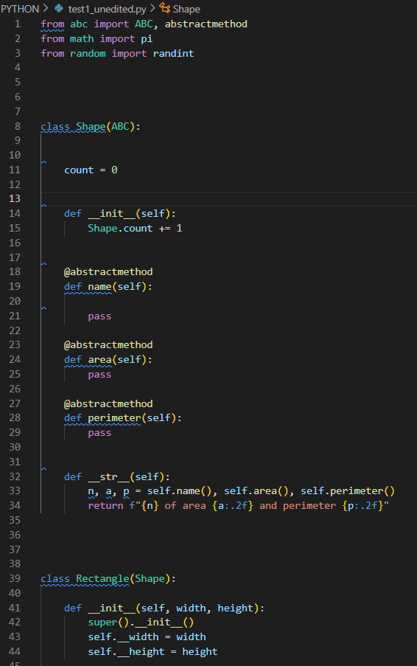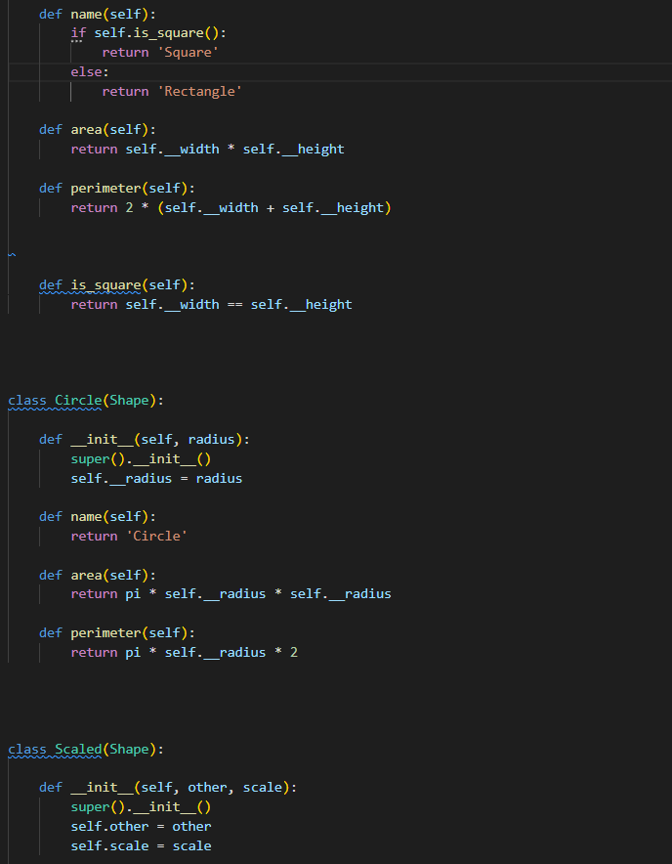
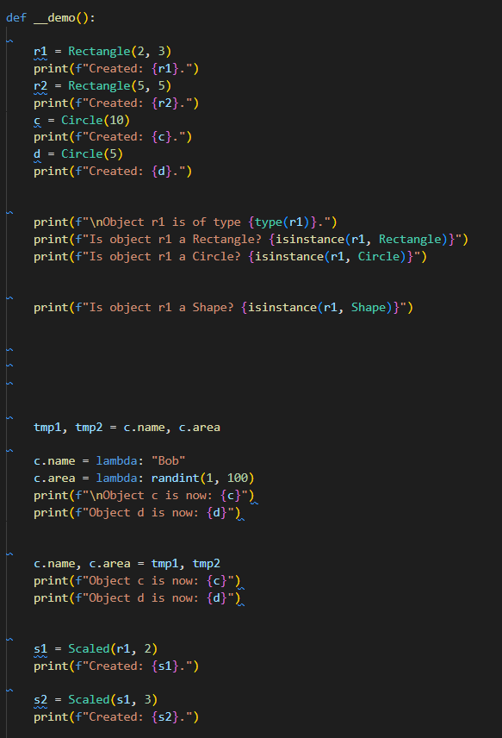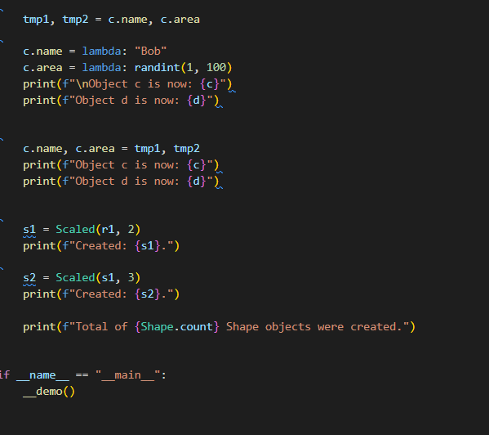

Here are the results calculated with Radon and Pylint:

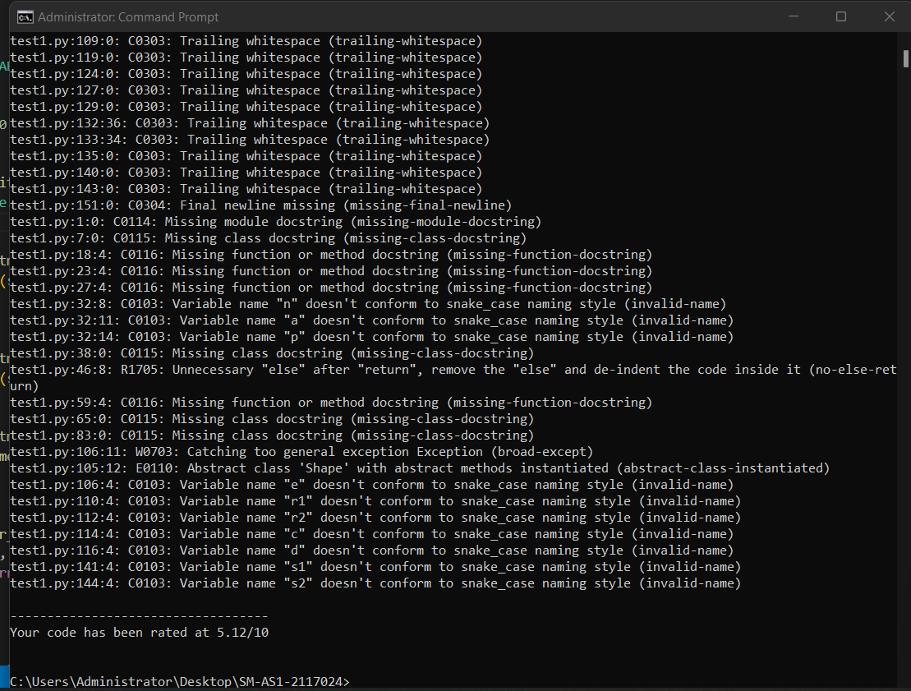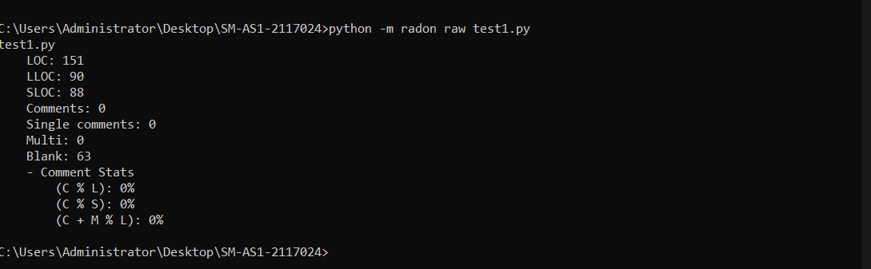

Here are the screenshots from the stages of code improvement. 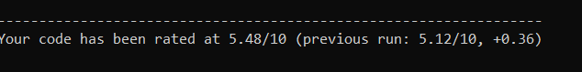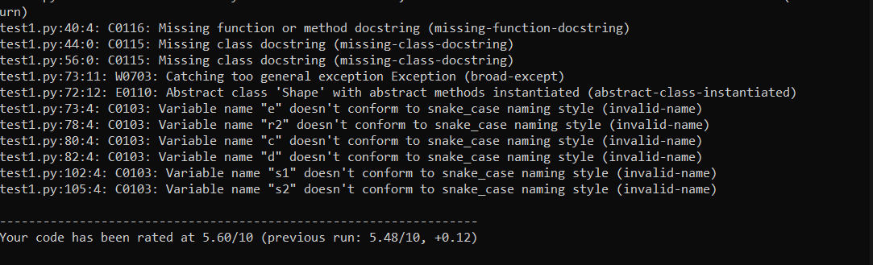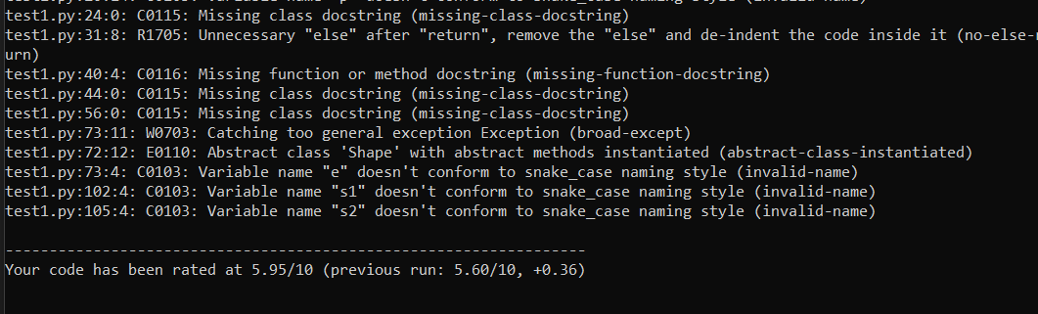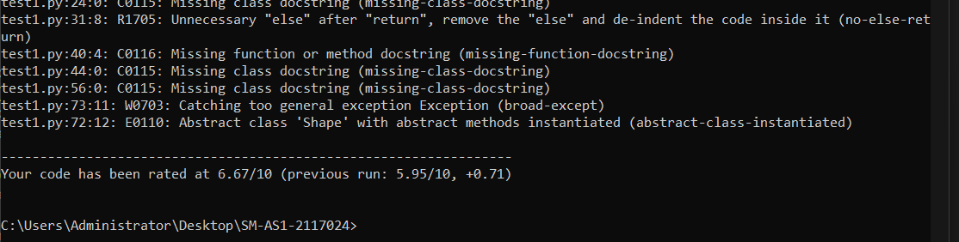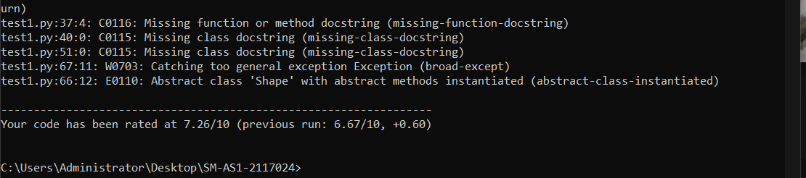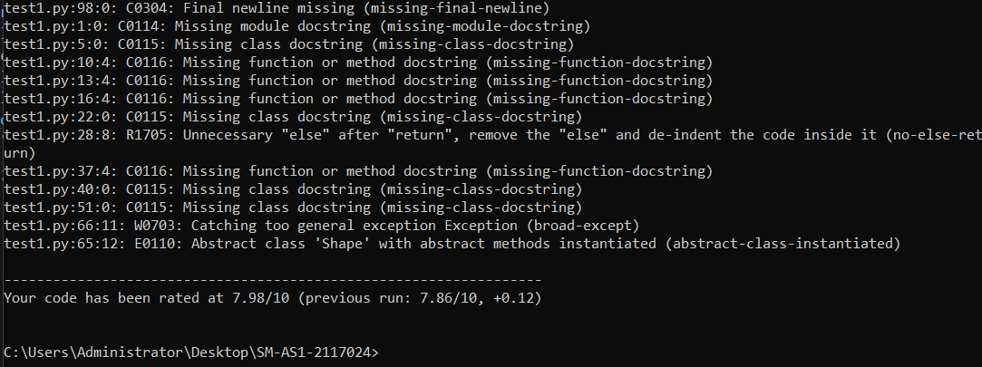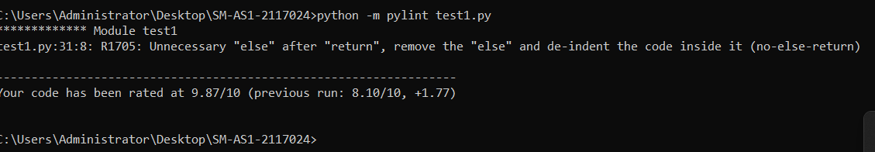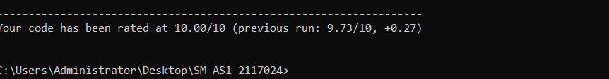

Here are the Radon results after code improvement.
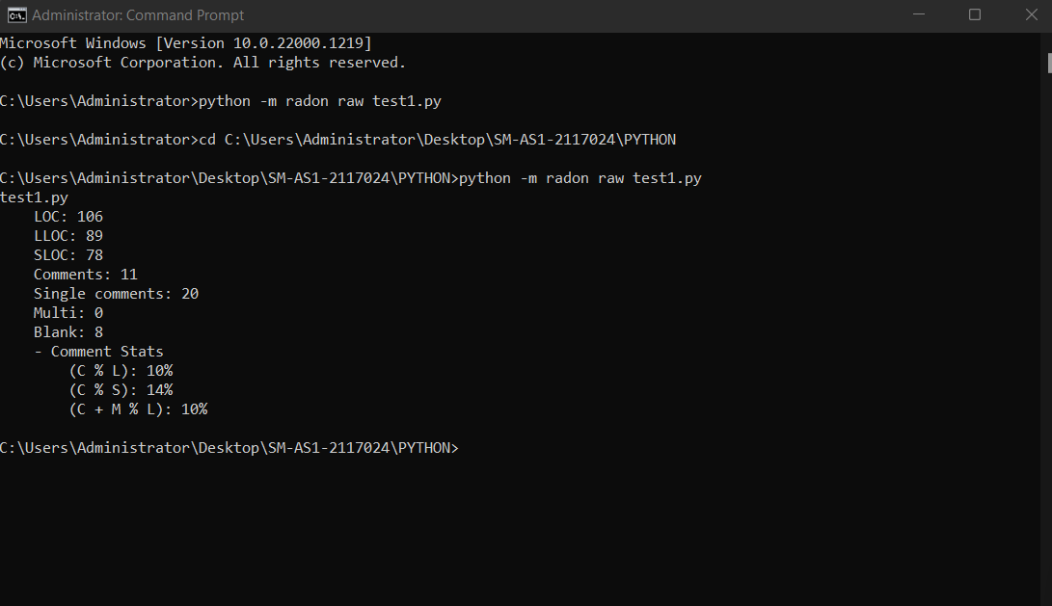

Here are screenshots of the code after improvement:
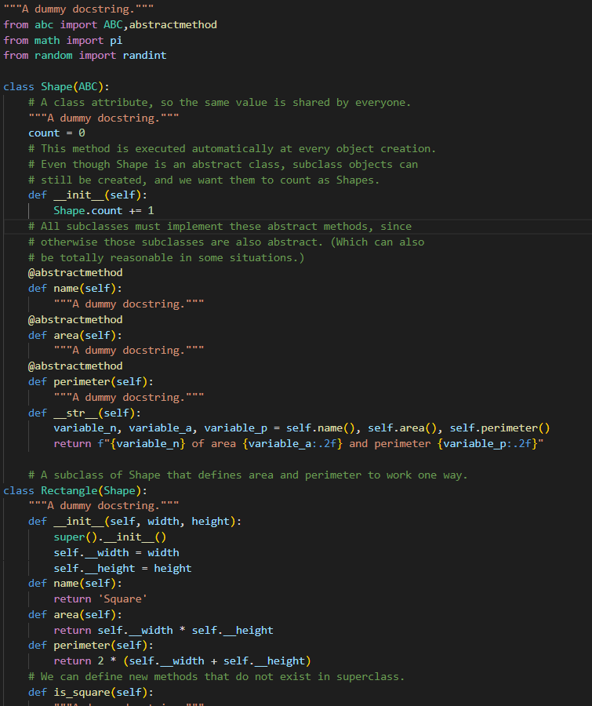
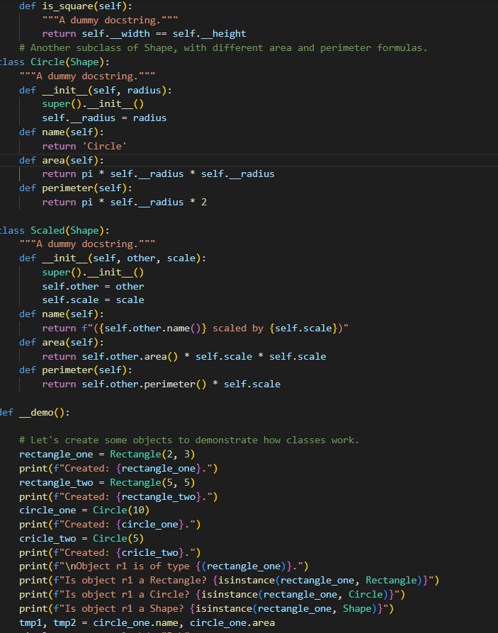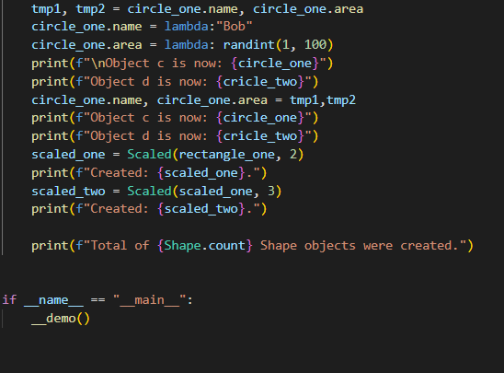

Second report – Java “Hello world” code:

Tools: LocMetrics
Browse Java file destination code then browse output directory floder and click Count Loc.
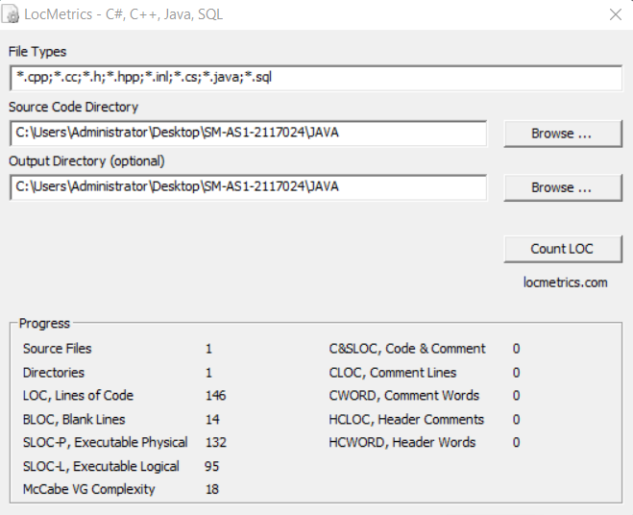
Output on the folder created:
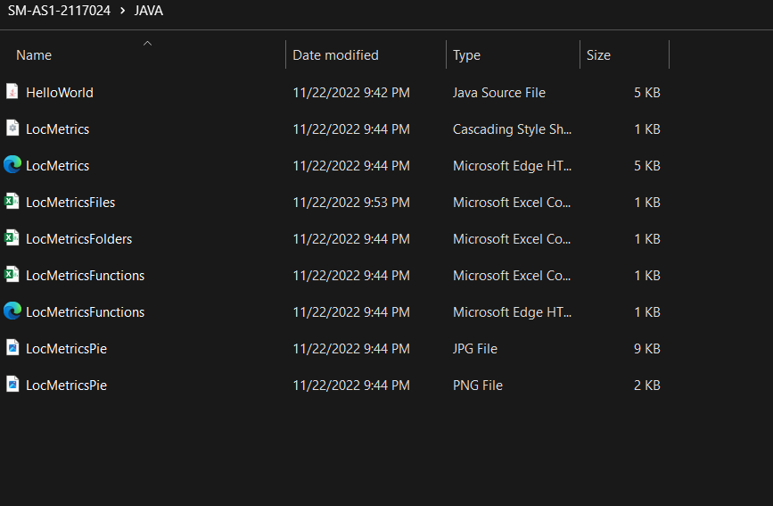

Report of the results in excel file:
