Week 2 Performance Assessment: Transaction and Data Dictionary
The following questions come from the Check your understanding examples of each section of Chapter 5 in your textbook.
After you are finished, please submit a Microsoft Word file that contains screenshots of the SQL queries, resulting output, and contains a comment in the queries showing your name. Your document should be named W2_PA_TransactionDataDictionary_Lastname.docx.

(5-2) Question 1:
Write a script that does the following:
- Turn off Autocommit
- Insert a new row into sec0502_departments
- Save this change by issuing a commit command
- Insert another new row into sec0502_departments
- Undo this change by issuing a rollback command
- Display all the rows in sec0502_departments
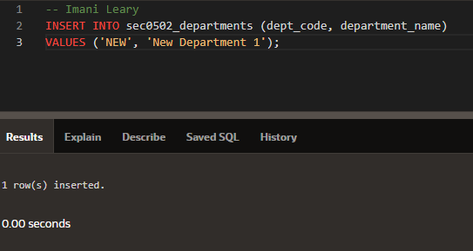
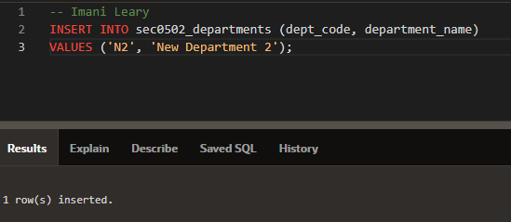
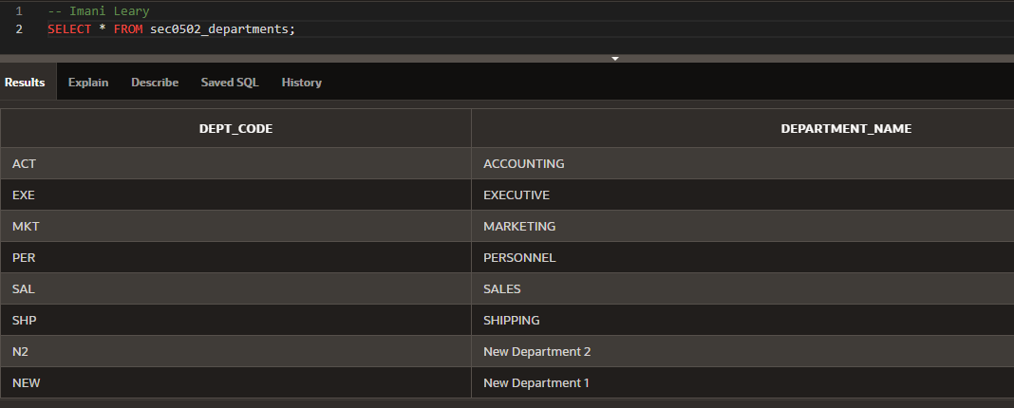
(5-3) Question 2:
Write a script that does the following:
- Turn off Autocommit
- Insert a new row into sec0503_savings_accounts with all of data from the sec0503_checking_accounts table for customer ‘BOB WILKINS’
- Delete customer ‘BOB WILKINS’ data from the sec0503_checking_accounts table
- Commit these changes
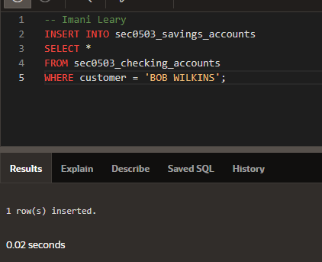
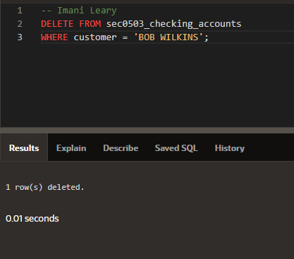
(5-3) Question 3:
Write a script that does the following:
- Turn off Autocommit
- Update sec0503_savings_accounts to decrease the balance of customer ‘FRED BOYD’ by $20,000
- Update sec0503_checking_accounts to increase the balance of customer ‘FRED BOYD’ by $20,000
- Display all rows in sec0503_savings_accounts
- Display all rows in sec0503_checking_accounts
- Rollback these changes
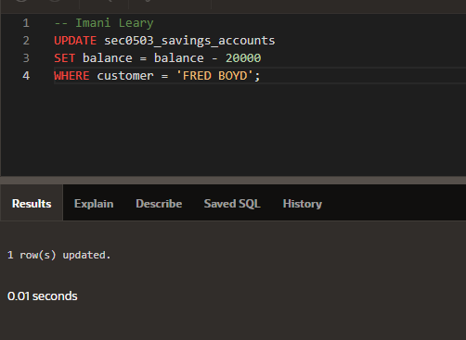
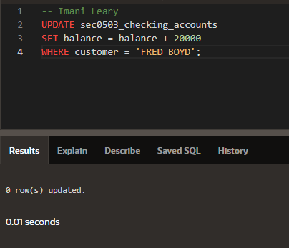
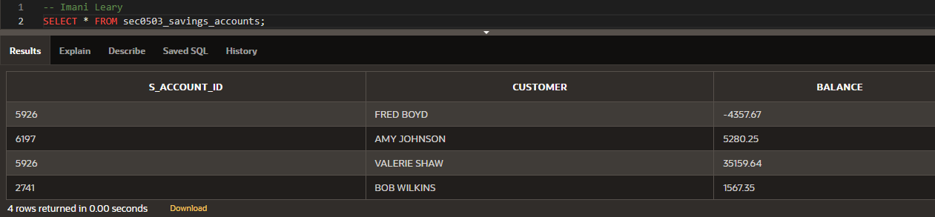
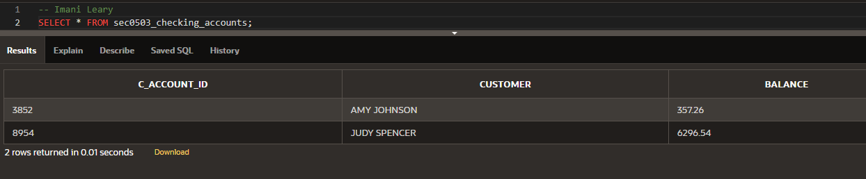
(5-5) Question 4:
Write a script that does the following:
- Display all the data in sec0505_foods
- Create a view of the foods table, including all the columns and rows
- Insert a new row into the view
- Update the view, setting menu_item to 20 and description to ‘CARROTS’ where the description is currently ‘BROCCOLI’
- Delete a row from the view
- Display all the data in the view
- Display all the data in sec0505_foods
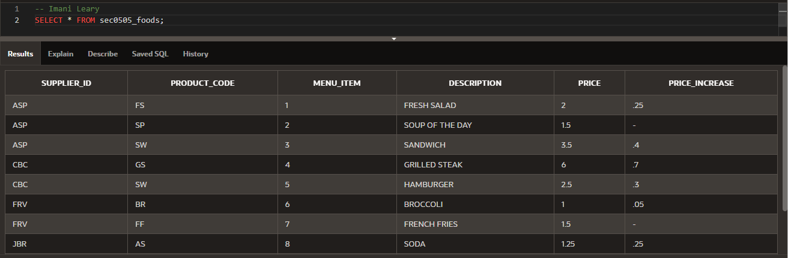
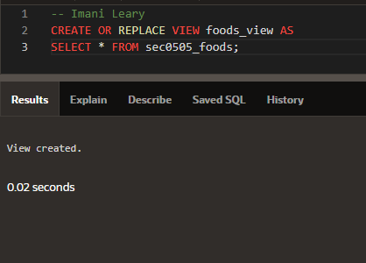
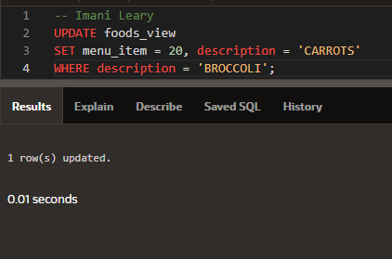
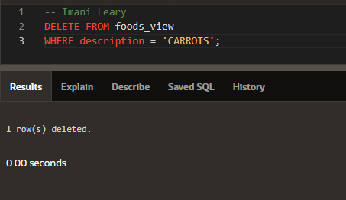
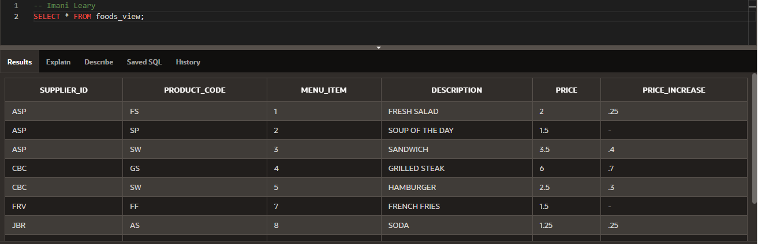
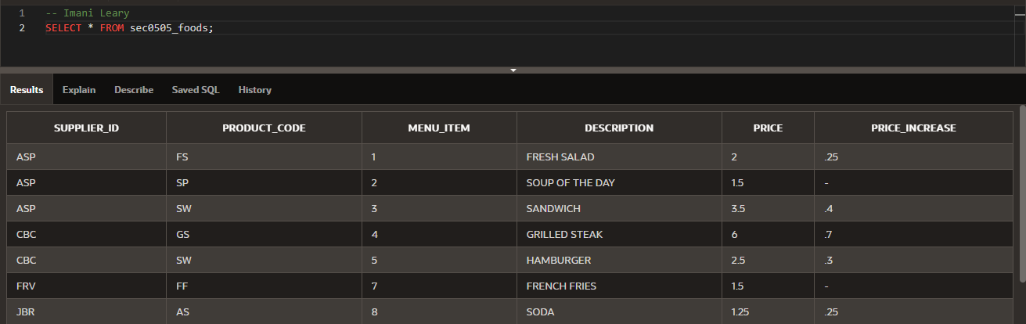
(5-11) Question 5:
List the names of all the tables you own.
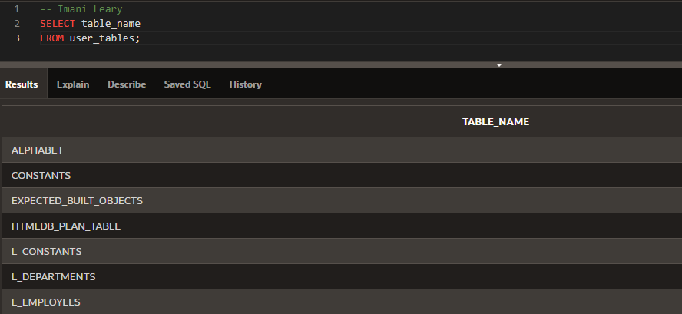
(5-12) Question 6:
List the names of all the views you own.
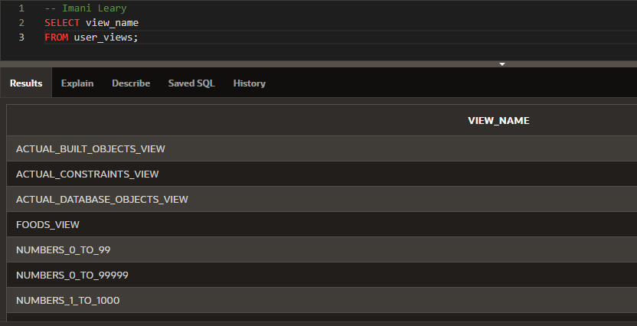
(5-14) Question 7:
Use the Data Dictionary to find the names of all the columns of the L_EMPLOYEES table.
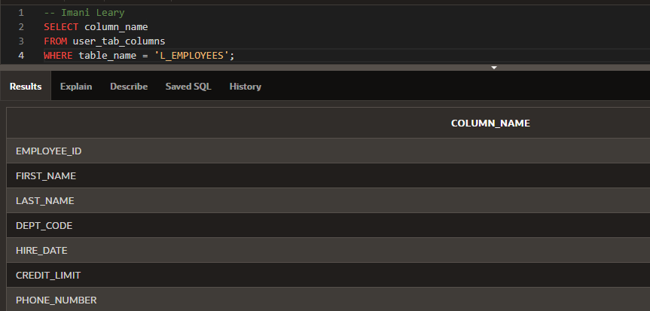
(5-15) Question 8:
Use the Data Dictionary to find the primary key of the L_EMPLOYEES table.
