Week 2 Performance Assessment: Creating Tables
The following questions come from the “Check your understanding” examples of each section of Chapter 6 in your textbook.
After you are finished, please submit a Microsoft Word file that contains screenshots of the SQL queries and the output. Remember to put a comment in your queries that contains your name. Your document should be named W2_PA_CreatingTables_Lastname.docx.

(6-7) Question 1:
Write a script to do the following: Use a create table statement to create a new copy of the L_EMPLOYEES table, with a new name. Then use an insert statement with a select clause to copy all the data from the L_EMPLOYEES table to your new copy of the table.
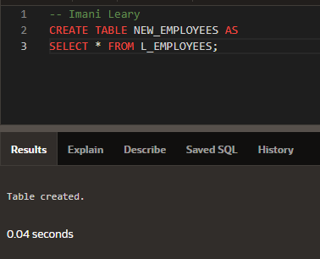
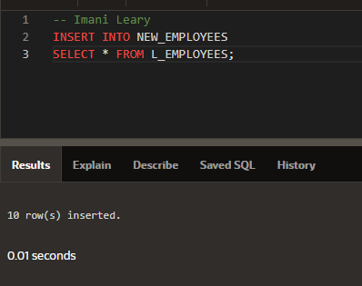
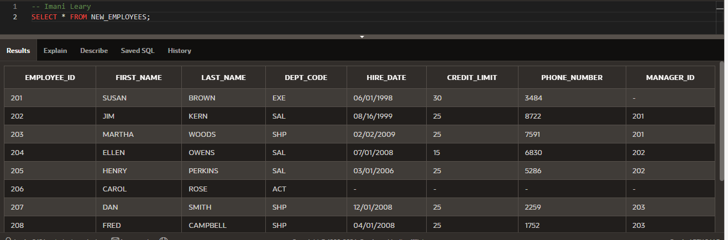
(6-9) Question 2:
Add a primary key to the sec0609_employees table.
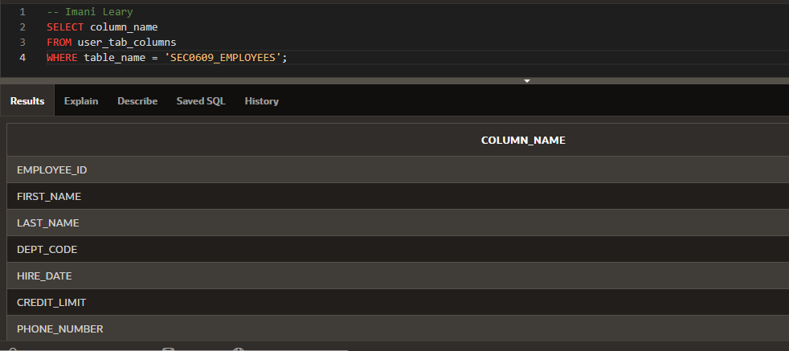
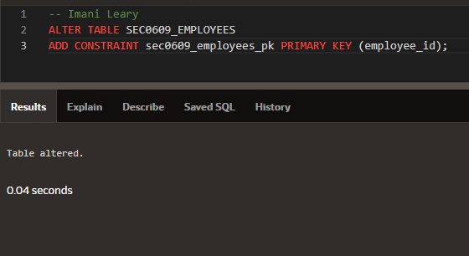
(6-11) Question 3:
Write a script to do the following: Add two new columns to the sec0611_departments table. One new column, a text column, will be for the name of the manager of the department. The other new column, a numeric column, is for the annual budget of the department.
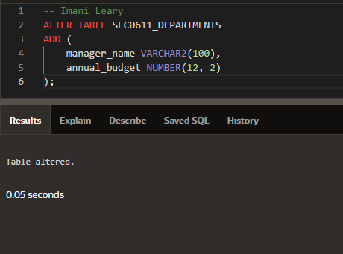
(6-12) Question 4:
Expand the length of the last_name column to the sec0612_employees table. Expand it to a length of 50 letters so people with hyphenated last names can be hired by the company.
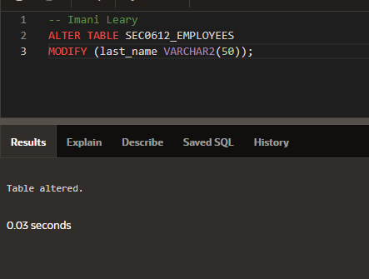
(6-13) Question 5:
Delete the phone_number column from a the sec0613_employees table.
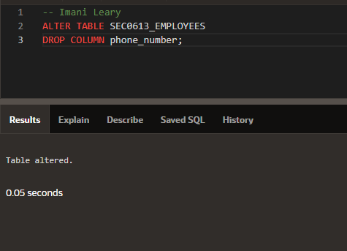
(6-16) Question 6:
Eliminate the duplicate rows from the sec0616_duplicate_rows table.
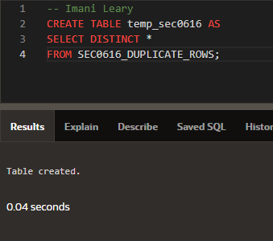
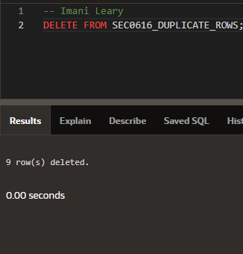
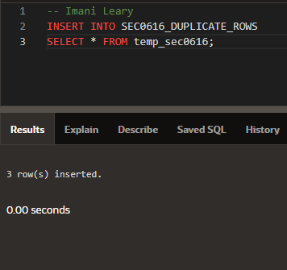
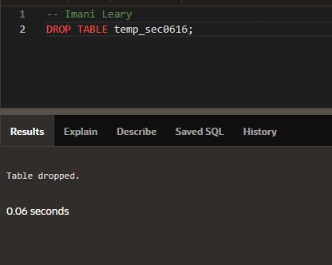
(6-17) Question 7:
Assign a number to each row of the sec0617_duplicate_rows table.
