Week 4 Performance Assessment: Inner Joins Part 1
The following questions come from the “Check your understanding” examples of Chapter 13 in your textbook.
After you are finished, please submit a Microsoft Word file that contains your answers. In this case, since the assignments are “by hand,” you don’t have to run these in Oracle. Your document should be named W4_PA_InnerJoins1_Lastname.docx.

(13-3) Question 1:
Insert a table on this document showing the result set of: Join a row of Table 1 with a row of Table 2 if the first letters are the same. Show all the rows of both tables, even if they do not have a matching row in the other table. Create the result table and state if this is a one-to-one relationship in the mathematical sense or in the database design sense.
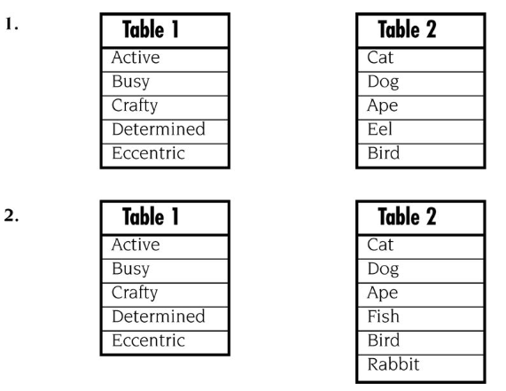
Results table #1:
- Word | - Animal
Active | Ape
Busy | Bird
Crafty | Cat
Determined | Dog
Eccentric | Eel

This is not a one-to-one relationship in either the mathematical or the database sense. Multiple rows from one table can correspond to multiple rows in the other table.
Results table #2:
Word | Animal
Active | Ape
Busy | Bird
Crafty | Cat
Determined | Dog
Eccentric | Fish

This also happens to not be a one-to-one relationship. Multiple rows can match across both tables.

(13-4) Question 2:
Insert a table on this document showing the result set of: Join a row of Table 1 with a row of Table 2 if the first letters are the same. Create the result table and state if this is a many-to-one relationship.
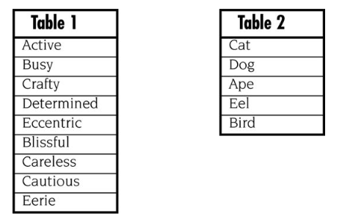
Result table:
Active | Ape
Busy | Bird
Crafty | Cat
Determined | Dog
Eccentric | Eel
Blissful | (no match)
Careless | (no match)
Cautious | (no match)
Eerie | (no match)

This is not a many-to-one relationship because each word that matches an animal has a one-to-one correspondence.
(13-5) Question 3:
Insert a table on this document showing the result set of: Join a row of Table 1 with a row of Table 2 if the first letters are the same. Create the result table and state if this is a one-to-many relationship.
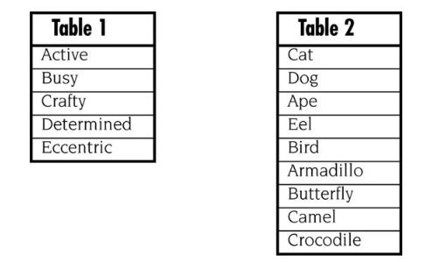
Active | Ape
Busy | Bird
Crafty | Cat
Determined | No match
Eccentric | Eel
No match | Armadillo
No match | Butterfly
No match | Camel
No match | Crocodile

This is not a one-to-many relationship.
(13-6) Question 4:
Insert a table on this document showing the result set of: Join a row of Table 1 with a row of Table 2 if the first letters are the same. Create the result table and state if this is a many-to-many relationship.
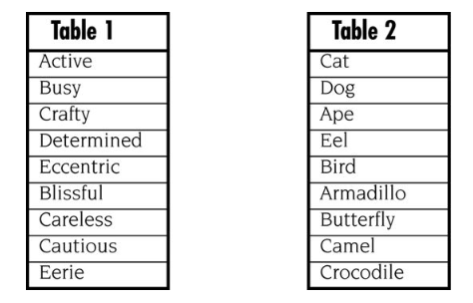
Active | Ape
Busy | Bird
Crafty | Cat
Eccentric | Eel
No match | Armadillo
No match | Butterfly
No match | Camel
No match | Crocodile
Determined | No match
Blissful | No match
Careless | No match
Cautious | No match
Eerie | No match

This is not a many-to-many relationship.
(13-8) Question 5:
Which rows from each table are unmatched and would be dropped from the inner join? Assume a row of Table 1 would be joined with a row of Table 2 if the first letters are the same.
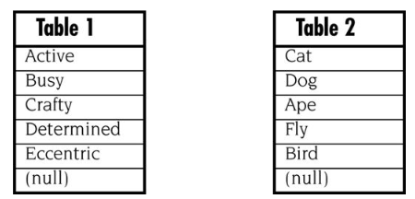
Unmatched rows: determined, eccentric, (null), dog, fly, (null). These rows would be dropped from the inner join since they have no matching first letters with the other table.
(13-9) Question 6:
Insert a table on this document showing the result set of: Write a select statement to create the inner join of these tables. Join a row of Table 1 with a row of Table 2 if the first letters are the same. Write the SQL using variation 1.
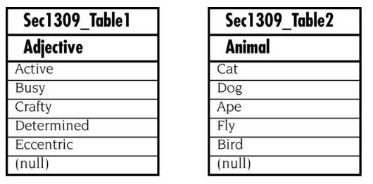
SELECT t1.Word, t2.Animal
FROM Sec1309_Table1 AS t1
INNER JOIN Sec1309_Table2 AS t2
ON LEFT(t1.Word, 1) = LEFT(t2.Animal, 1
WHERE t1.Word IS NOT NULL AND t2.Animal IS NOT NULL;
Result table:
Active | Ape
Busy | Bird
Crafty | Cat

