Week 2 Performance Assessment: Saving Your Results
The following questions come from the “Check your understanding” examples of each section of chapter 4 in your textbook.
After you are finished, please submit a Microsoft Word file that contains screenshots of the SQL queries and the output, and include your name in a comment line in the SQL queries. Your document should be named W2_PA_SavingYourResults_Lastname.docx.

(4-1) Question 1:
Create a copy of the L_EMPLOYEES table. Name it sec0401_employees.

Here is the reason you might want to do this. Later in this chapter you will learn how to change the data in a table. However, you should not make any changes to the data in the L_EMPLOYEES table because many of the examples in this book are based on it. If you make a change to the data in this table, the examples in the book might not work correctly.

Instead, you can make a new copy of the table and then you can change the data in the new copy. This allows you to practice changing the data and still keep the L_EMPLOYEES table unchanged so it works in all the examples from the book.
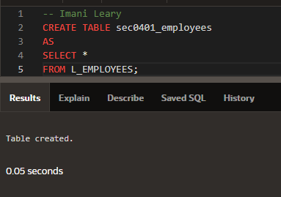
(4-2) Question 2:
Create a view of the L_EMPLOYEES table. Name it sec0402_employees_view
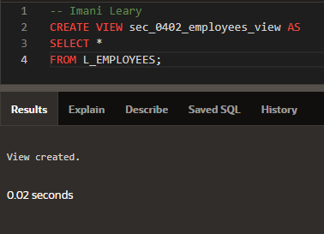

(4-5) Question 3:
Delete the table sec0405_table_to_delete.
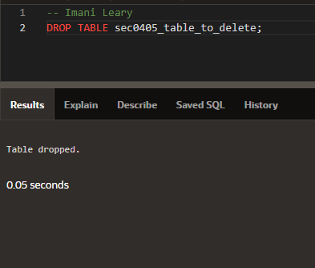
(4-6) Question 4:
Delete the view sec0406_view_to_delete.
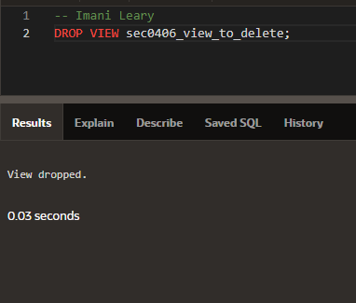

(4-9) Question 5:
Add a new row to the sec0409_employees table. Use the data:
employee_id = 301
first_name = Ellen
last_name = Perkins
dept_code = IT
hire_date = March 9, 2009
credit_limit = $20.00
phone_number = null
manager_id = 201
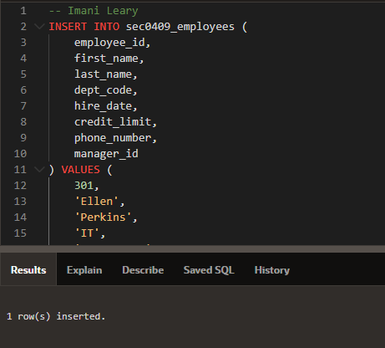
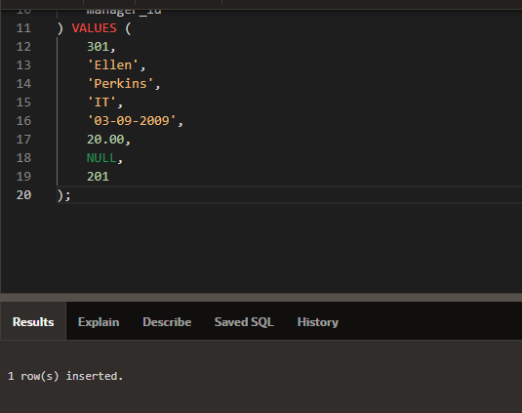
(4-10) Question 6:
Tables sec0410_data2 and sec0410_data1 have the same record structure. Each row has three columns: a number column, a text column, and a date column. Write an insert statement that puts all the rows of table sec0410_data2 into table sec0410_data1.
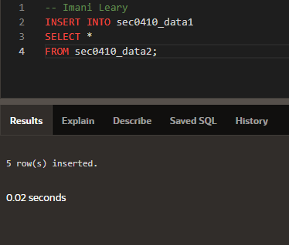
(4-11) Question 7:
In the sec0411_employees table, change the credit limit to $27.00 for all the employees who currently have a credit limit of $15.00 and also for any employee who has a null in the credit limit field.
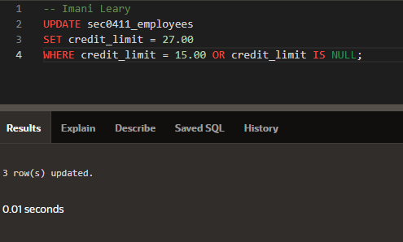
(4-12) Question 8:
In the sec0412_employees table, delete the rows with employee_id between 202 and 205.
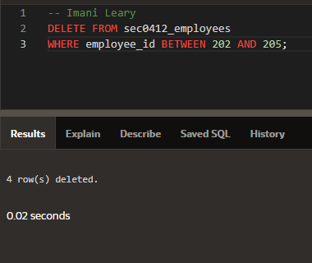
(4-15) Question 9:
Write SQL to delete the Sales Department (SAL) from the sec0415_departments table. This should work. Then apply the same SQL statement to the L_DEPARTMENTS table. This time you will get an error message.
