Week 3 Performance Assessment: Summarizing Data
The following questions come from the “Check your understanding” examples of each section of Chapter 11 & 12 in your textbook.
After you are finished, please submit a Microsoft Word file that contains screenshots of the SQL Queries, the output, and put a comment line in the query with your name. Your document should be named W3_PA_SummarizingData_Lastname.docx.

(11-3) Question 1:
Table sec1103 contains two columns, row_ID and num_1. (It also contains a column named num_2, but we are not going to use that column now.) Find the minimum and maximum values of the num_1 column. Name these values “minimum” and “maximum.”

(11-4) Question 2:
Repeat the exercise in the previous section, except this time add a where clause that limits the row_ID column to values less than 8. Is there any change in the minimum and maximum values?
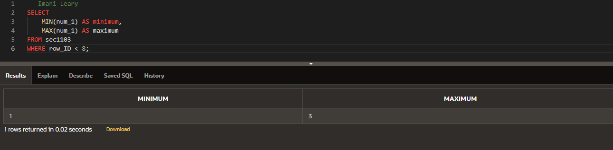
(11-6) Question 3:
In table sec1106, find the following information:
■ The number of rows in the table
■ The number of rows that have a non-null value in the Num_1 column
■ The number of rows that have a null value in the Num_1 column
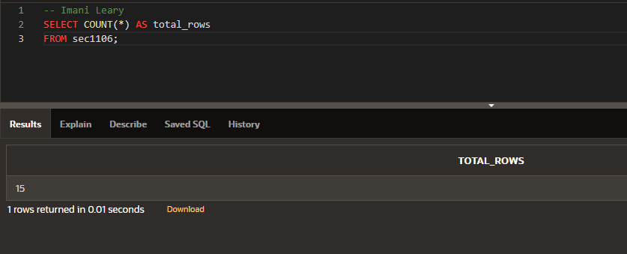
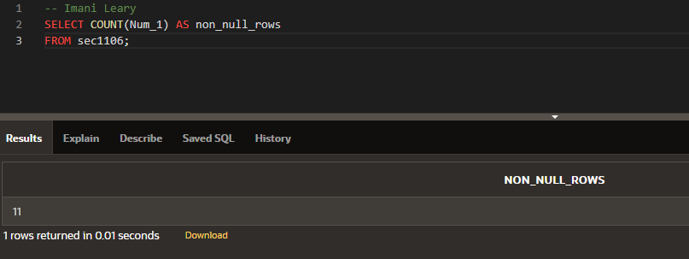
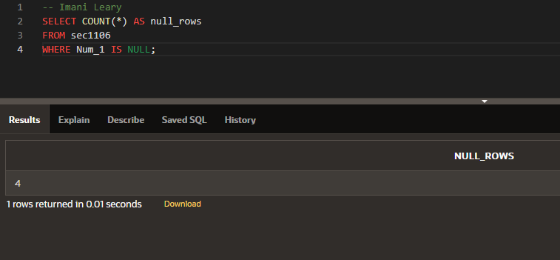
(11-9) Question 4:
In table sec1103, find the number of distinct values in the num_1 and num_2 columns, taken together.
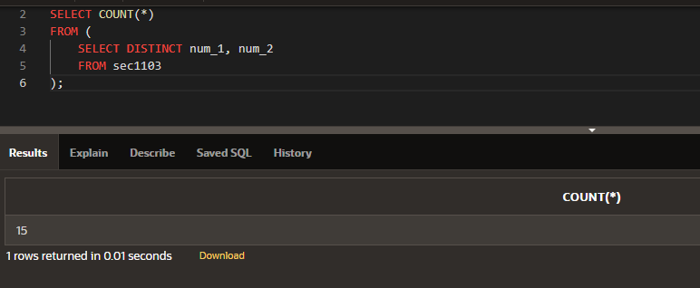
(11-11) Question 5:
In table sec1103, show the problem with nulls in addition and how to solve it.
1. Add columns num_1 and num_2, adding each row first.
2. Add columns num_1 and num_2, adding each column first.
3. Add columns num_1 and num_2, changing all the nulls to zeros first.
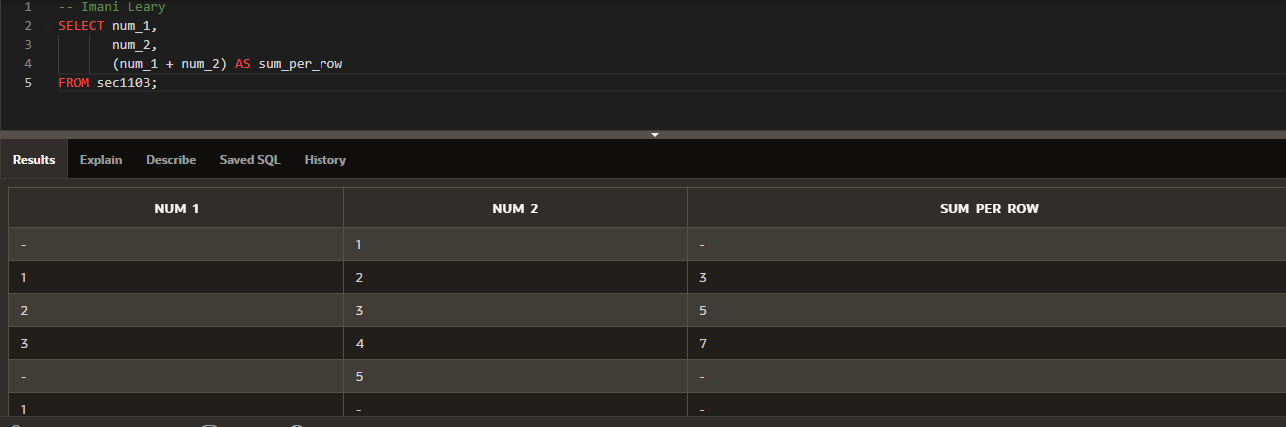
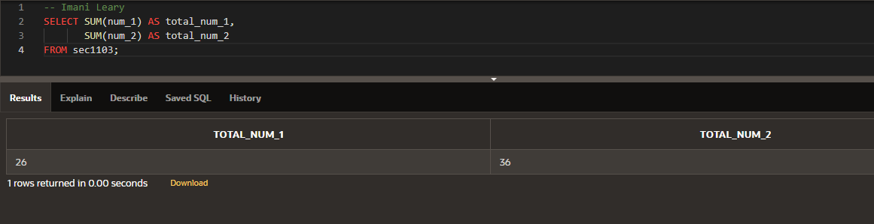
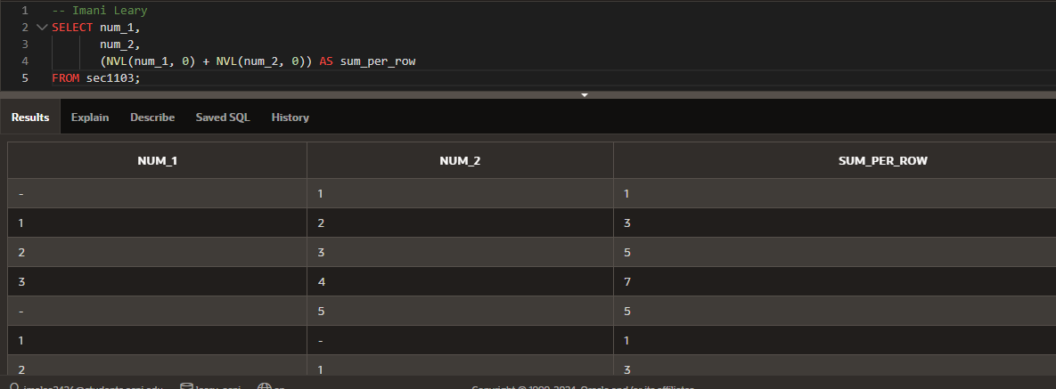
(12-2) Question 6:
Table sec1202 has four columns: row_id, col_1, col_2, and col_3. Write a select statement that groups the rows by the value in col_1 and for each group determines the sum of the values in col_3.
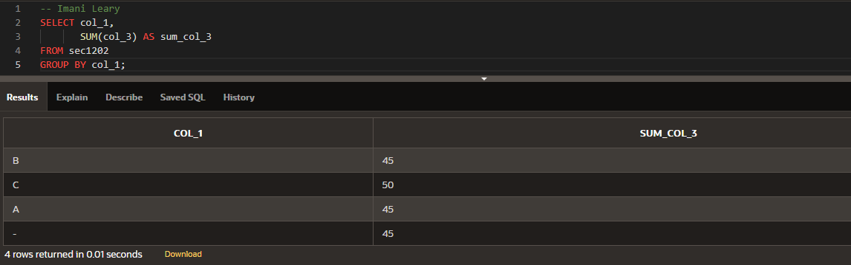
(12-4) Question 7:
Use table sec1202. Write a select statement that groups the rows by the value in col_1 and col_2. For each group determine the sum of the values in col_3.
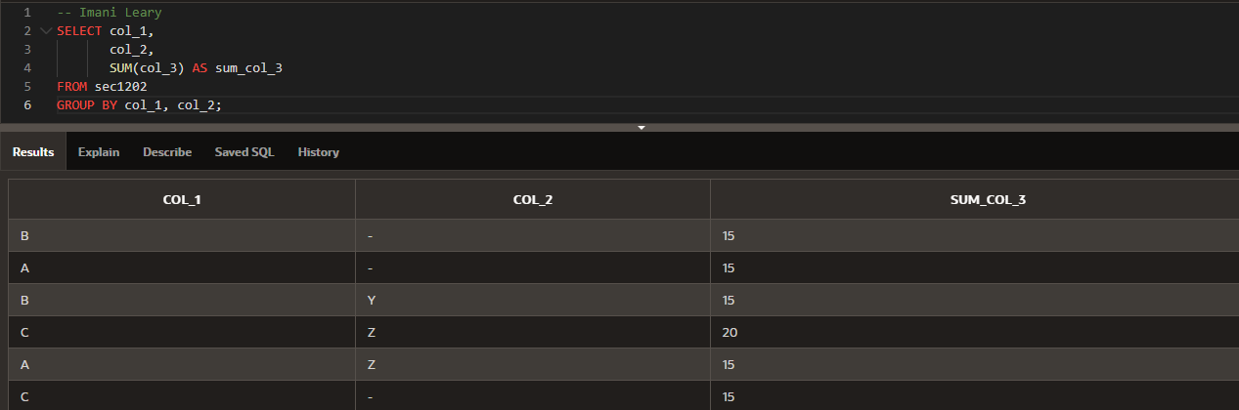
(12-7) Question 8:
Suppose you wanted to show all the data in table sec1202 and you also wanted to show the total for col_3. Could you do this with SQL?
The answer is no. The best you can do is to run two queries. One would show the data with:
select *
from sec1202;
The other would show the total with:
select sum(col_3) as grand_total
from sec1202;
Then, if you were desperate, you could paste the two pieces of paper together. Or you could do the same thing in SQL using a union.
Fortunately, most SQL products give you a better way. There is usually some sort of report level to the software that will do totals and subtotals for you.
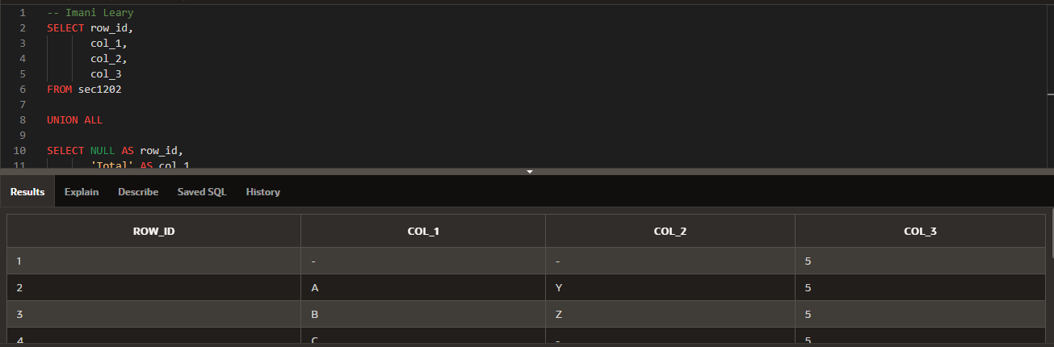
(11-11) Question 9:
Table sec1211 has three columns: row_id, col_1, and col_2. Group on col_1 and get the sum of col_2. Add a having clause to show only the rows of the result table where the sum is greater than 20.



