Week 1 Performance Assessment: Select Statement
The following questions come from the “Check your understanding” examples of each section of Chapter 2 in your textbook.
After you are finished, please submit the Microsoft Word file that contains screenshots of the SQL script and the resulting tables. Your document should be named W1_PA_SelectStatement_Lastname.docx.

(2-4) Question 1:
List the description and price of all the foods. Change the name of the description column to food_item and the name of the price column to cost.
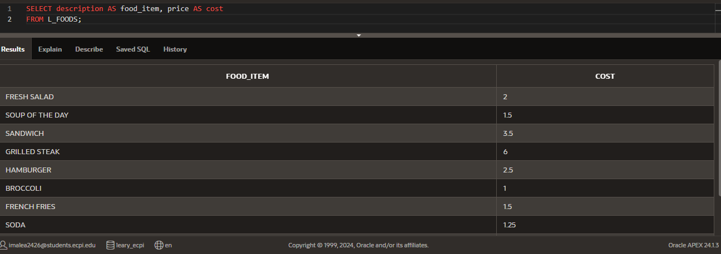
(2-5) Question 2:
List all the columns and all the rows of the L_FOODS table. How many columns are in this table? How many rows? What are the names of the columns?
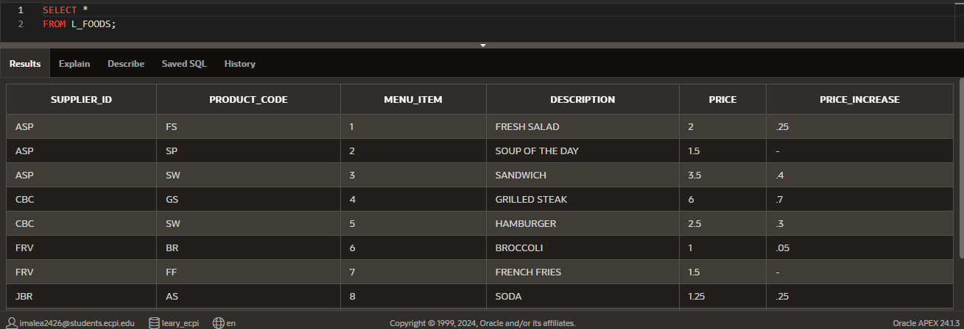
There are 6 rows.
(2-6) Question 3:
List all the different supplier_id values from the L_FOODS table.
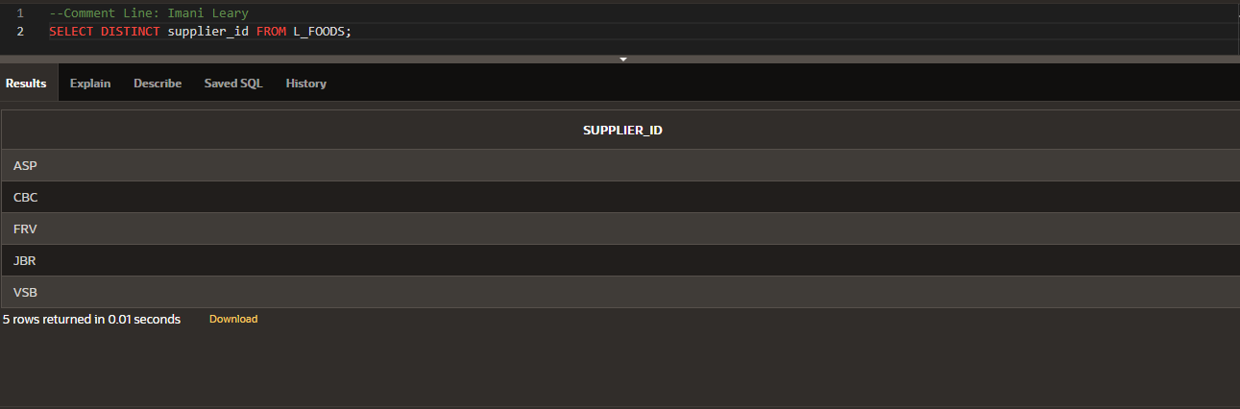
(2-7) Question 4:
List all the different values in columns A and B of the sec0207 table
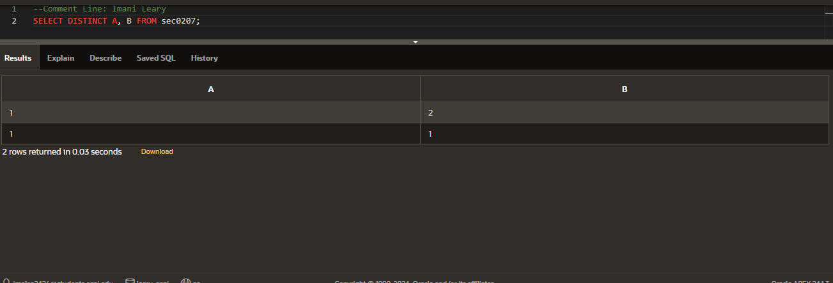
(2-9) Question 5:
List the first name and last name of the employees with the first name of Nancy.
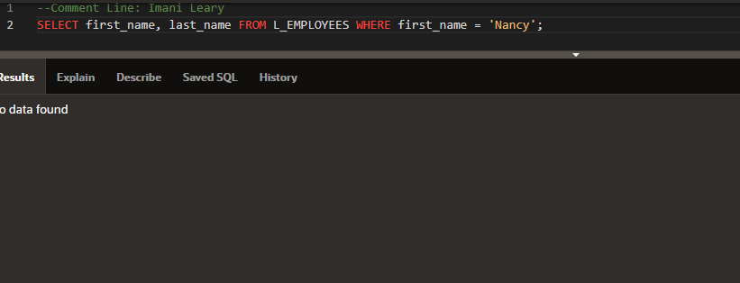
(2-10) Question 6:
List the first name and last name of the employees with employee_id greater than or equal to 205.
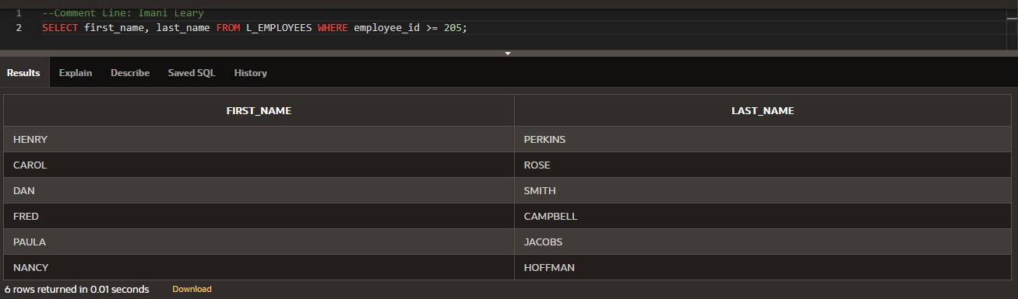
(2-11) Question 7
List the first name and last name of the employees with employee_id not equal to 205. Write this in three different ways that all work in the version of SQL you are currently using.
