August 10, 2022

Editorial Board

*Quantitative Science Studies*

Dear Editors:

Thank you for considering this manuscript, Misapplied Metrics: Variation in the *h*-index within and between disciplines, for publication in *Quantitative Science Studies* that I co-authored with Jill Ann Harrison. This manuscript addresses ongoing debates about the use of bibliometrics in scientific evaluation and we, therefore, hope that you agree that it is a good fit for your journal.

In this manuscript, we address a sources of inequality in the use of the *h­­*-index for evaluative purposes. While critiques against the use of bibliometrics for evaluative purposes are well-known, there use by university and grant administrators continues. We extend prior research on this topic evaluating within- and between-discipline differences in the *h*-index. Drawing on data on high-performing scholars in dozens of disciplines, we build multilevel models of the *h*-index. Results indicate that significant within-discipline and between-discipline inequalities contribute differences in *h*-index scores. The universal application of the *h*-index likely contributes to persistent inequalities in the academy.

Sincerely,

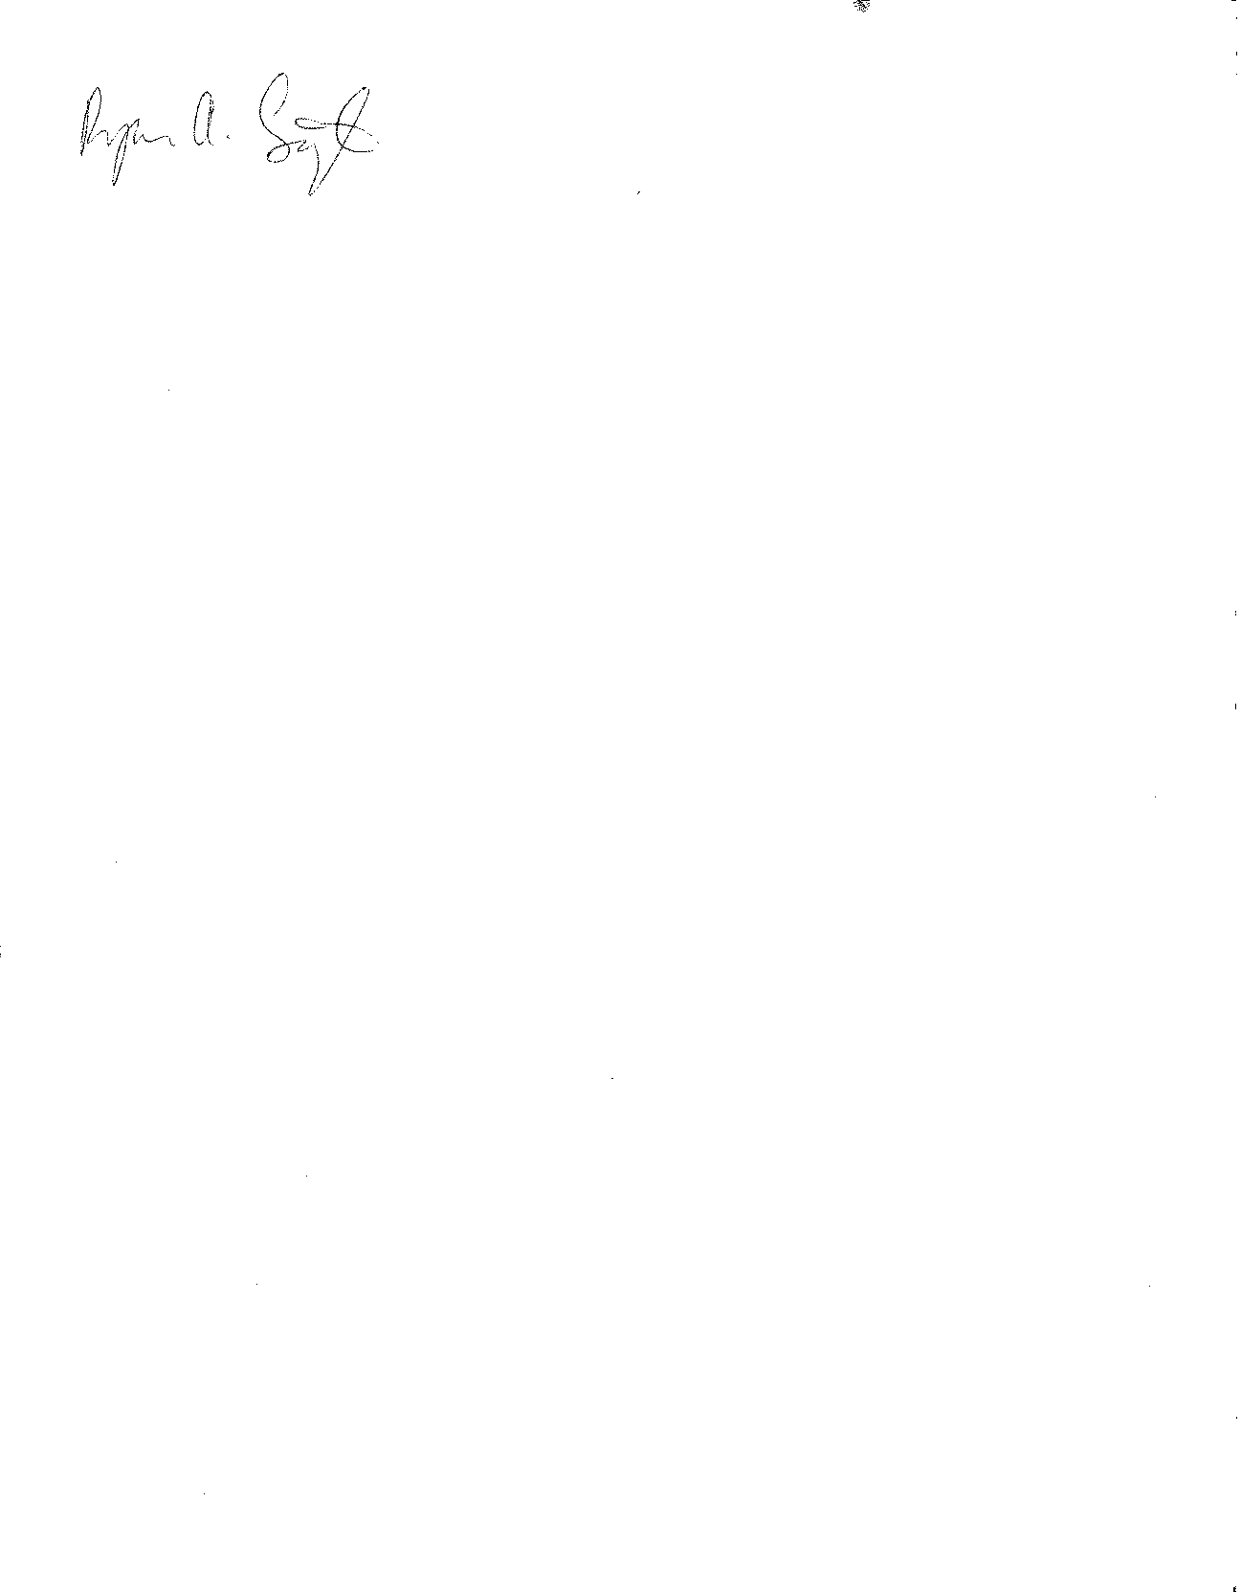

Ryan Light, Associate Professor

Department of Sociology

University of Oregon

Eugene, OR 97403-1291

[light@uoregon.edu](mailto:light@uoregon.edu)