Hot swapping

Implementation in three languages

2015

Florian Grill

FH Wiener Neustadt

20.05.2015

Inhalt

Hot swapping in C# 1

Pointer approach 2

Mono Cecil approach 3

Hot swapping in Java 4

JavaAssist approach 5

ByteBuddy approach 6

# Hot swapping in C#

For this project two methods for hot swapping C# code was evaluated. The First method tries to swap a method by changing its pointer. The second method uses the well-known API Mono.Cecil. The second approach will try to swap a method in a DLL at runtime. Below you can find an image of the current project and some explanations. The project was developed in Visual Studio 2013 and use .Net Framework 4.0.

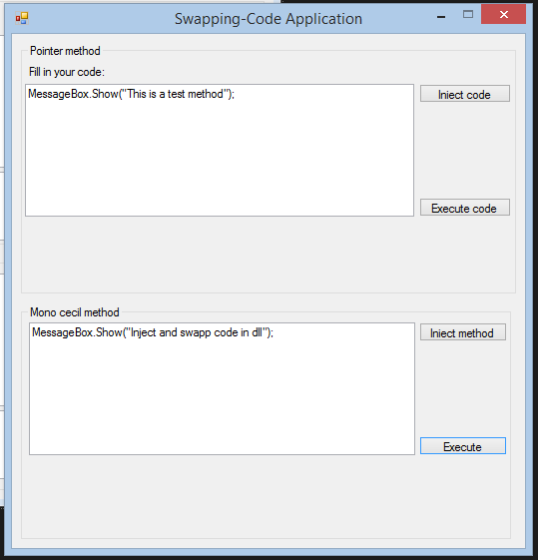

Text field for new code

Interaction area for the two aproaches

## Pointer approach

This approach has been found during researches on the Internet at codeproject1. It was developed by Ziad Elmalki. The following description will summarize the information in this article. All .Net Applications are compiled in CLI (Common Language Runtime). In general processors are not able to run this Intermediate Code directly. This is where the JIT (Just in time compiler) coming into force. The JIT will turn the CLI Code to machine code which the processor can work with. Important is that every method will only be compiled once by the JIT because of performance issues. The JIT will cache the machine code for future calls. Every method have a so called JITStub, it is a chunk of machine code that will invoke the JIT for the specific method. After a method is JIT’ed the code in the stub is replaced by code which calls the machine code directly.

Every class has a so called method table which contains the addresses of all JITStubs of his methods. It is used when as long at the specific method has not already been JIT’ed, because otherwise the machine code which is created by the JIT will call the STUB address directly. This approach of swapping methods will try to change the addresses of the method table so it will point on another method. But because of the described limitations this approach will only work once. After a user clicks the “Execute code” button in the Pointer method section, the code gets JIT’ed and his pointer cannot be changed anymore because he will no longer refer to the method table address. A solution was found by calling the specific method by reflection. It seems that

then there are no limitations of swapping the code but the practical use of this approach is limited.

In the application the user can enter some code in the Textbox which will get compiled by clicking at the button “Inject code”. The program uses the CodeCompileUtil class which surrounds the entered text in the Textbox by a small application skeleton. After compilation it returns the compiler results and in case of successful compilation an assembly object. After that the program reads the method information of the source and destination method which is stored in a MethodBase object. See above code example.

Type program = assembly.GetType("HotSwapping.Container");

MethodBase swapMethod = program.GetMethod("containerMethod", BindingFlags.Instance | BindingFlags.Public);

MethodBase originMethod = typeof(SwapContainer).GetMethod("swapMe", BindingFlags.Instance | BindingFlags.Public);

## 

Now the program has to find the Pointer to these methods. It is important that the two methods must have the same method signature otherwise it is not possible to swap the code. In our example we use .Net 4.0, it is not proved that this method will also work in further releases. The code from Ziad Elmalki shows different solutions for getting the addresses of a specific method. At the time of writing it will support all .Net Framework versions (newest version .Net 4.5). If the program uses .Net Framework 2.0 or higher there is an easier solution to get a method pointer than the solution of Ziad Elmalki. See code below.

private static IntPtr GetMethodAddress20SP2(MethodBase method)

{

unsafe

{

return new IntPtr(((int*)method.MethodHandle.Value.ToPointer() + 2));

}

}

When we have the two pointers we can simple change it and swap the methods during runtime by calling this piece of code.

IntPtr destAdr = GetMethodAddress(dest);

unsafe

{

if (IntPtr.Size == 8)

{

ulong* d = (ulong*)destAdr.ToPointer();

*d = *((ulong*)srcAdr.ToPointer());

}

else

{

uint* d = (uint*)destAdr.ToPointer();

*d = *((uint*)srcAdr.ToPointer());

}

}

My conclusion of this approach is that the practical use is limited. First, this approach works only before the method gets JIT’ed and second it is not guaranteed that the code will work in further .Net Frameworks.

## Mono Cecil approach

This approach tries to use the Library Mono Cecil2 to modify a loaded DLL during runtime and swap a method and populate its method body with new instructions. After successfully compilation of the entered Text in the Textbox by the CodeCompileUtil class, the compiled assembly is saved in a temporary DLL file in the root folder of the program. With Mono Cecil we will read the temporary DLL and the specific method we want to swap. After successful swap we write the new DLL back to Disk. Below you can find the code of the swapping mechanism.

public void swappMethods(Assembly assembly)

{

AssemblyDefinition tempAssembly =

AssemblyDefinition.ReadAssembly("tempfile.dll");

TypeDefinition tempClass = tempAssembly.MainModule.Types.FirstOrDefault(x =>

x.Name == "Container");

MethodDefinition injectMethod = tempClass.Methods.FirstOrDefault(x => x.Name ==

"containerMethod");

// Get the SwappingClass from the dll

TypeDefinition swappingClass =

this.swappingAssembly.MainModule.Types.FirstOrDefault(x => x.Name ==

"SwappingClass");

// Get the swappingMethod from the SwappingLibrary

MethodDefinition swappMethod = swappingClass.Methods.FirstOrDefault(x => x.Name

== "swappingMethod");

// We inject "containerMethod" in the SwappingLibrary.dll

if (swappMethod != null && injectMethod != null)

{

// clear the old method body

swappMethod.Body.Instructions.Clear();

// Get the ILProcessor of the method body

var ilProcessor = swappMethod.Body.GetILProcessor();

// Get the MethodReference of the new method body

MethodReference methodReference = this.importMethod(injectMethod);

Instruction inst = ilProcessor.Create(OpCodes.Call, methodReference);

ilProcessor.Append(inst);

// Write new library back to disk

this.swappingAssembly.Write("SwappingLibrary.dll");

}

}

private MethodReference importMethod(MethodDefinition injectMethod)

{

return this.swappingAssembly.MainModule.Import(injectMethod);

}

The problem with the method is the behaviour how .Net loads and handles DLLs. Once a DLL is referenced it is loaded in the current AppDomain and gets locked. This means it is not possible to modify or update this DLL during your program runs. Unfortunately C# doesn’t provide any possibility to unload a used DLL from the current AppDomain. One workaround is to create a new temporary AppDomain load the DLL and unload it after using. This will also release all used DLLs in this AppDomain so it can modified again. This means in a strict sense that with this approach we are not able to hot swap code because the DLL we use for swapping mechanism is not really loaded during runtime. We only load it for executing and unload it afterwards. Nevertheless for demonstration purpose I integrated this solution in the project. To not locking the DLL when executing its method the program loads the DLL in a temporary AppDomain and calls the function via reflection. Below you can a find short example of using a DLL without locking it.

public void doWorkWithShadow()

{

AppDomainSetup setup = new AppDomainSetup

{

ApplicationBase =

AppDomain.CurrentDomain.SetupInformation.ApplicationBase,

ShadowCopyFiles = "true",

ShadowCopyDirectories = PathHelper.getAssemblyPath(),

};

AppDomain newDomain = AppDomain.CreateDomain("tempDomain2", null, setup); //Create an instance of loader class in new appdomain

var swappingLibrary = newDomain.CreateInstanceAndUnwrap("SwappingLibrary",

"SwappingLibrary.SwappingClass");

Type type = swappingLibrary.GetType();

MethodInfo methodInfo = type.GetMethod("swappingMethod", Type.EmptyTypes);

object instance = Activator.CreateInstance(type);

methodInfo.Invoke(instance, null);

// Unload the application domain and its resources

AppDomain.Unload(newDomain);

}

As described above this approach works only with a workaround. Nevertheless the practical use of this method is also limited for hot swapping. If it is only necessary to modify a compiled DLL without completely recompile it Mono Cecil is one of the best approaches.

# Hot swapping in Java

Also in the Java application two approaches of hot swapping was evaluated. In Java it was much easier to find some libraries and explanations for hot swapping byte code. In this project two libraries were used, the first one is called Javassist3 which makes bytecode manipulation simple and the second one is called ByteBuddy4. The program is a JavaFX (Java 8) application and it was developed in Netbeans. Below you can find an image of the final application.

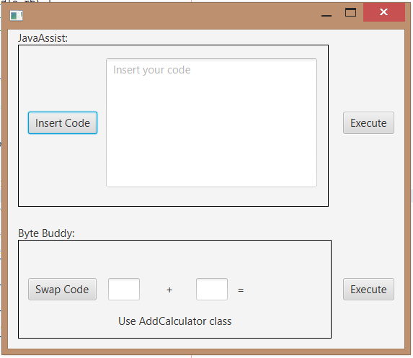

Interaction buttons for execute specific code

ByteBuddy area

JavaAssist area

## JavaAssist approach

The UI of the JavaAssist area is similar to the C# example. The User can enter simple Java code in the Textbox and replace a specific method body by this. The JavaAssist library is very user friendly and easy to use. The code to be injected is represented as strings and can inject to any existing method during runtime. In order to use JavaAssist in the program you have start the VM of your application with following parameters:

java -agentlib:jdwp=transport=dt_socket,server=y,suspend=n,address=8000 Test

Java is compiled into bytecode and it’s stored in a binary file called class file. Each class file represents one Java class or interface. JavaAssist provides a class which is called CtClass. It provides you the possibility to deal with class files. Below is a short example of the used method in the project.

private void swapMethod(String swapCode) {

this.swap = new HotSwapper("8000");

if (this.swap != null) {

ClassPool pool = ClassPool.getDefault();

try {

CtClass target = pool.get("hotswapping.swappingClass.SwappingClass");

target.defrost();

CtMethod targetMethod = target.getDeclaredMethod("swappingMethod");

targetMethod.setBody(swapCode);

swap.reload("hotswapping.swappingClass.SwappingClass",

target.toBytecode());

} catch (CannotCompileException ex) {

} catch (NotFoundException ex) {

} catch (SecurityException ex) {

} catch (IllegalArgumentException ex) {

} catch (IOException ex) {}

}

}

Java Assist provides class for reloading a class at runtime. This class is called HotSwapper. To use this class the program has to be launched with the JPDA (Java Platform Debugger Architecture) enabled. At first we will get the current available class pool which is possible by calling ClassPool.getDefault(). The ClassPool object is a hashtable of CtClass objects which use the class name as key. So we can get the specific “SwappingClass” simply by name. JavaAssist freezes the CtClass object to protect it for further modification. We have to explicitly call the defrost method so that the CtClass object can be modified again. We can then search for the specific method and replace its body by the swapCode variable (has to be a valid java code, otherwise this line will throw an exception). After that we can call the reload function of the HotSwapper class. This method will first unload the specific class and load a new version which is represented by a byte array which contains the new content of the class. My Personal opinion of this approach is that JavaAssist is very easy to use and provides good code documentation. Nevertheless hot swapping only works if the application has JPDA enabled, otherwise the JVM does not allow to dynamically reloading a class.

## ByteBuddy approach

For the second approach I used the library ByteBuddy5 version 0.5.6. It is relative new library and it may have some problems as I will describe below. ByteBuddy is a code genearation library which can create classes during runtime. The application shows the features of ByteBuddy in a simple example. In the lower section of the application you can enter two values in the textboxes and perform a simple calculation. The default class which will perform the calculation looks as shown below.

package hotswapping.swappingClass;

/**

*

* @author Flo

*/

public class SubstractCalculator {

public int calc(int a, int b){

int result = a - b;

System.out.println("SubstractCalculator result is: " + result);

return result;

}

}

With ByteBuddy we will try to replace this whole class by another one. The new class is called AddCalculator class and is shown in the next code snippet.

package hotswapping.swappingClass;

/**

*

* @author Flo

*/

public class AddCalculator{

public int calc(int a, int b){

int result = a + b;

System.out.println("AddCalculator result is: " + result);

return result;

}

}

To enable the HotSwap feature you have to specify the Java agent on the startup of the JVM by using the -javaagent parameter. ByteBuddy even offers the possibility to load a Java agent during runtime when the Java application is run form a JDK version of the JVM. You only have to perform the ByteBuddyAgent.installOnOpenJDK() method. This could be a very convenient alternative to the first solution. In the version 0.5.6 of ByteBuddy there is a bug in the code which prevents you from starting an application with -javaagent parameters. I have contact the developer of ByteBuddy and he promised to fix this error in the next releases of ByteBuddy6. Below you can find the code snippet which will swap the classes.

new ByteBuddy()

.redefine(SubstractCalculator.class)

.name(AddCalculator.class.getName())

.make()

.load(

AddCalculator.class.getClassLoader(),

ClassReloadingStrategy.fromInstalledAgent()

);

After this we will now have redefined the class AddCalculator to become SubstractCalculator. This redefinition will even apply for pre-existing instances. There is just one limitation of Java’s HotSwap feature. Current implementations require that both classes apply the same class schema before redefinition. There is no way to add new methods or new fields to a class when reloading. In general the ByteBuddy Library is a nice little tool which is easy to use and it is worth to try it. According to the official website there are plans to extend the HotSwap feature in the future.

# Python