Cloud Computing und SaaS

Exercise – Virtualization

Hannes Knopf

Where are the images stored?

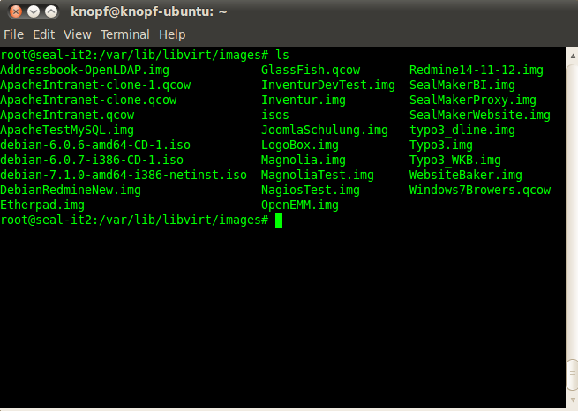

Where are the XML descriptions of your images and how are they structured?

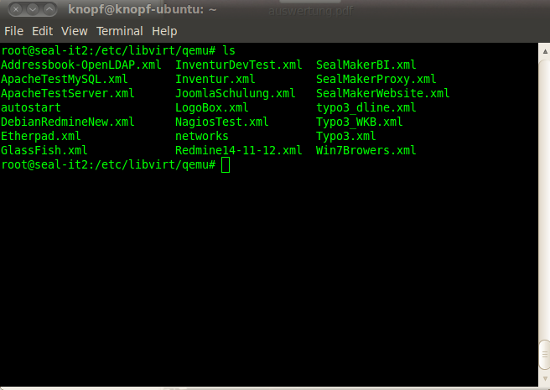
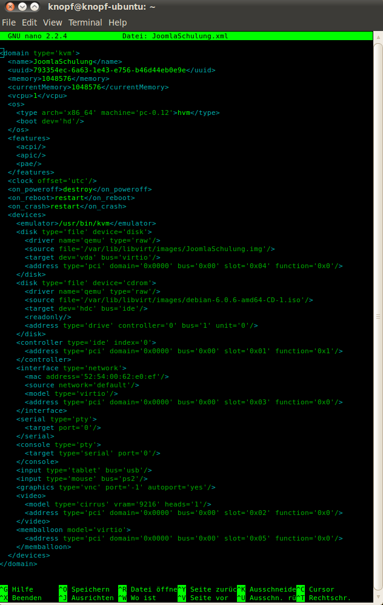
What virsh commands do you need to configure and manage an image?

virsh
list --all
start name
shutdown name
destroy name
suspend name
resume name

Explain the type of network configuration you have chosen.

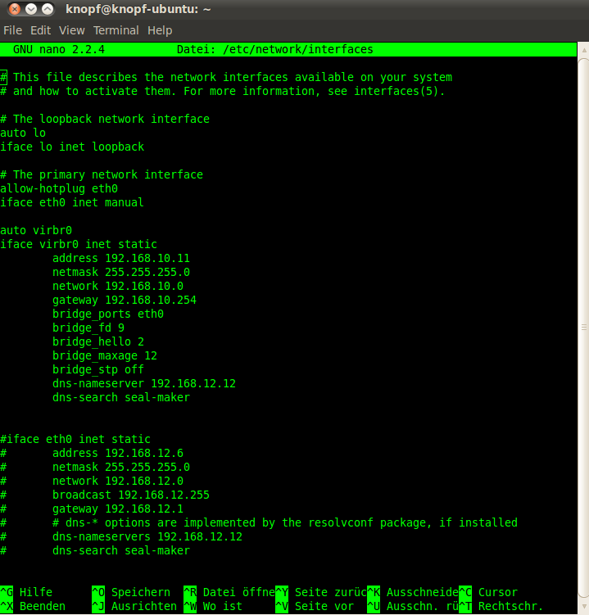
Durch 'bridge' sind auch die virtuellen Maschinen im Netzwerk erreichbar.
Drescribe the virtual machine migration capabilities of KVM.
Requirements
- The VM image is accessible on both source and destination hosts (located on a shared storage, e.g. using nfs).
- It is recommended an images-directory would be found on the same path on both hosts
- The src and dst hosts must be on the same subnet
- Do not use -snapshot qemu command line option.
- For tcp: migration protocol
- the guest on the destination must be started the same way it was started on the source.

- Almost unnoticeable guest down time
- Guest is not involved
- Capability to tunnel VM state through an external program
- ssh/gzip/bzip2/gpg/your own
- Upon success guest continues to run on destination host, upon failure guest continues to run on source host (with one exception)
- Short and Simple
- Easy to enhance
- Hardware independence (almost).
- Support for migration of stopped (paused) VMs.
- Open

