**Aim:** To install XAMPP and initiate an APACHE server with an HTML file.

1. **Install XAMPP**:
   * Downloaded XAMPP from the [Apache Friends website](https://www.apachefriends.org/index.html).
   * Followed the installation instructions for my operating system (Windows).
2. **Start XAMPP**:
   * Open the XAMPP Control Panel.
   * Clicked the **Start** button next to **Apache** to start the web server.

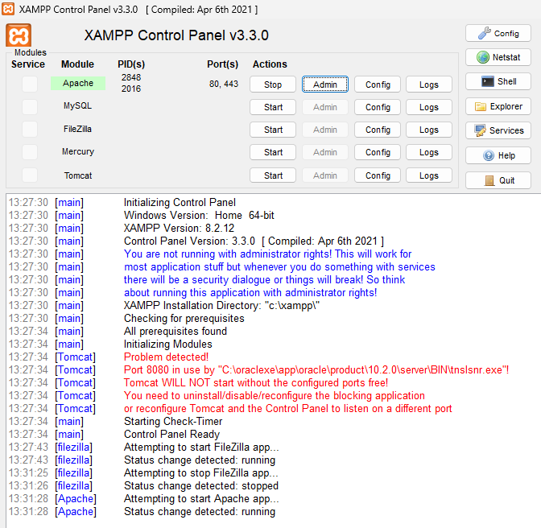

1. **Place Your HTML File**:
   * Located the htdocs folder inside your XAMPP installation directory. This is typically C:\xampp\htdocs on Windows or /Applications/XAMPP/htdocs on Mac.
   * Copy your HTML file into the htdocs folder. You can also create a new folder within htdocs for better organization (e.g., C:\xampp\htdocs\myproject).
2. **Access Your HTML File**:
   * Open your web browser.
   * In the address bar, type localhost/ followed by the path to your HTML file. For example, if your file is named index.html and is directly in the htdocs folder, type localhost/index.html. If it’s in a folder named **light**, type localhost/light/index.html.
   * Press **Enter**. Your HTML file should now be displayed in the browser.



**Conclusion**:

The HTML file was easily accessible through XAMPP and our local client browser using localhost.

**Aim:** To initiate FileZilla Server in XAMPP and using FileZilla Client to access it.

**Step #1: Start FileZilla Server in XAMPP**

1. **Open XAMPP Control Panel**: Launch the XAMPP Control Panel on your computer.
2. **Start FileZilla**: Click the “Start” button next to “FileZilla” to start the FileZilla FTP server.

**Step #2: Configure FileZilla Server**

1. **Administering FileZilla Server**: Click on “ **Admin** ”.
2. **Connect to Server**: When prompted, enter the localhost ( 127.0.0.1 ) & password, then click “OK” to connect to the server.
3. **Add Users**: In the FileZilla Server Interface, go to “Edit” > “Users” to add a new user. Set a username and password for the FTP account.
4. **Set Directory Access**: Under the “Shared folders” section, add the directories you want to access via FTP and set the appropriate permissions (e.g., read, write).

**Step #3: Connect Using FileZilla Client**

1. **Open FileZilla Client**: Launch the FileZilla Client on your computer.
2. **Enter Connection Details**: In the Quick Connect bar, enter the following details:
   * **Host**: 127.0.0.1 (or localhost) /172.16.55.43 ( server’s IPv4 Address )

[ Local IP @ University ]

* + **Username**: The username you set in the FileZilla Server [ light ]
  + **Password**: The password you set in the FileZilla Server [ 12345 ]
  + **Port**: Leave it blank or use 21 (default FTP port)

1. 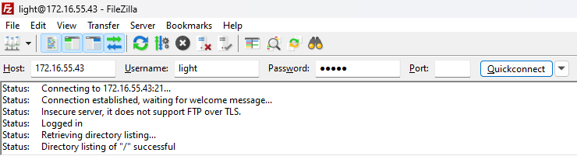**Quick Connect**: Click “Quick Connect” to establish the connection.

**Step #4: Access Local Files**

1. **Navigate Directories**: Once connected, you can navigate through the local directories on the left pane and the FTP server directories on the right pane.
2. **Transfer Files**: Drag and drop files between the local and remote directories to transfer them.

**Conclusion:**

FileZilla Server was initiated in XAMPP, and FileZilla Client was used for file transfers.

**Aim:** Design a website and publish it through the local Apache Server, the website must have:

- *A title*

- *Some text in the body without formatting*

1. **Create a .html file in Notepad Text Editor**
   * The following html code was written:

<html>

<head>

<title>LokeshWho?</title>

</head>

<body>

<div>

<a **href**="<https://lightxlk.github.io/_/>">Lokesh Patra</a>

<ul>

<li><a **href**="#home-section"><span>Home</span></a></li>

<li><a **href**="#about-section"><span>About</span></a></li>

<li><a **href**="#resume-section"><span>Resume</span></a></li>

<li><a **href**="#project-section"><span>Creative Endeavours</span></a></li>

<li><a **href**="#contact-section"><span>Let's Talk</span></a></li>

</ul>

</div>

<br>

Greetings, everyone!

</body>

</html>

1. **Start XAMPP**
   * Open the XAMPP Control Panel.
   * Clicked the **Start** button next to **Apache** to start the web server.
2. **Place Your HTML File**:
   * Located the htdocs folder inside your XAMPP installation directory. This is typically C:\xampp\htdocs on Windows or /Applications/XAMPP/htdocs on Mac.
   * Copy your HTML file into the htdocs folder. You can also create a new folder within htdocs for better organization (e.g., C:\xampp\htdocs\light).
3. **Access Your HTML File**:
   * Open your web browser.
   * In the address bar, type localhost /followed by the path to your HTML file.

* For example, if your file is named inex.html it’s in a folder named **light**, type localhost/light/inex.html, or [**192.168.1.8/light/inex.html**](192.168.1.8/light/inex.html).

[ Local IP @ Home ]

* + Press **Enter**. Your HTML file should now be displayed in the browser.

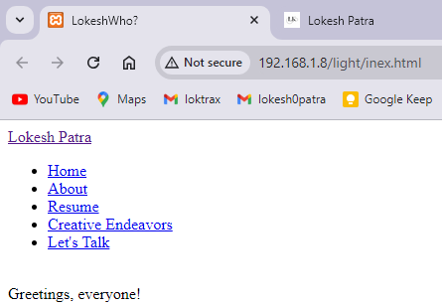

**Conclusion**:

The website was successfully designed and published through the local Apache Server, demonstrating the process of creating and hosting a simple HTML page.

**Aim:** Create a Web page and insert table using Dreamweaver and host it on Apache server using XAMPP.

1. **Install Adobe Dreamweaver**:
   * Downloaded Adobe Dreamweaver 2021 from the [Adobe Dw 21 [ G I P ]](https://getintopc.com/softwares/adobe-dreamweaver-cc-2021-free-download-2261809/).
   * Followed the on-screen instructions to complete the installation.
2. **Create a New HTML File in Dw:**
   * Opened Dreamweaver and setup it in Standard Mode.
   * Go to File > New.
   * Selected HTML and clicked Create.
   * Open the editor, it will show 3 options, Code Split and Design, select Design.
3. **Insert a Table:**
   * Place the cursor where you want the table to appear.
   * Go to Insert > Table.
   * Set the number of rows and columns, and adjust other properties like table width, border thickness, cell padding, and cell spacing.
   * Click OK to insert the table.
4. **Add Content to the Table:**
   * Click inside the table cells to add text or other elements.
   * As the table opens, start formatting it.
   * To merge select cells to merge and click on the merge icon in the properties section below.
   * Similarly, font style, size and alignment can also be changed from the properties bar.

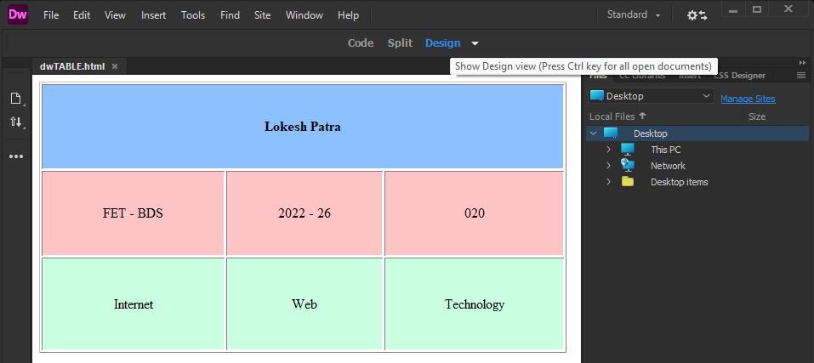

1. **Save the HTML File:**
   * Go to File > Save As.
   * Save the file with a .html extension, as, [ *dwTABLE.html* ].
2. **Start Apache Server:**
   * Open the XAMPP Control Panel.
   * Click Start next to Apache to start the server.
3. **Place Your HTML File:**
   * Located the *htdocs* folder inside your XAMPP installation directory. This is typically C:\xampp\htdocs on Windows or /Applications/XAMPP/htdocs on Mac.
   * Copy your HTML file into the *htdocs* folder. A new folder can be created within *htdocs* for better organization (e.g., C:\xampp\htdocs\light).
4. **Access Your HTML File:**
   * Open your web browser.
   * In the address bar, type localhost /followed by the path to your HTML file.

* For example, if the file is named dwTABLE.html it’s in a folder named light, type localhost/light/inex.html, or <192.168.1.8/light/dwTABLE.html>.

[ Local IP @ Home ]

* + Press Enter. Your HTML file should now be displayed in the browser.

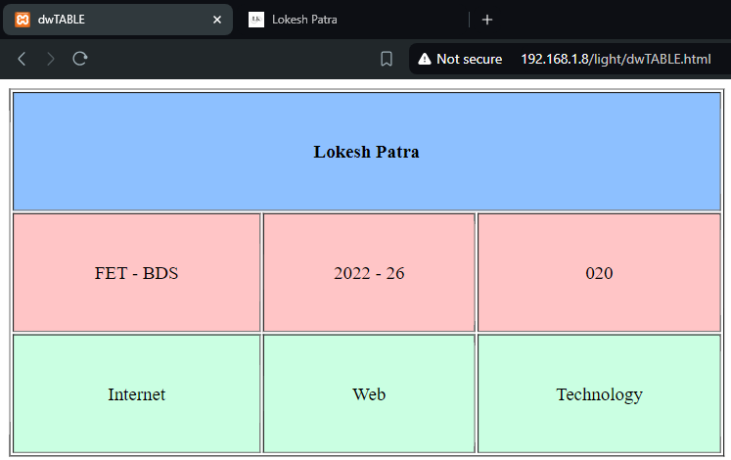

**Aim:** Create a Details page asking for *UserName* & *UserID*, w/ a SUBMIT button, which when clicked, the entered data is saved in a text file and showed in a **.php** file.

1. **Create an HTML File [ *Aadhaar Details* ]**:

<html>

<head>

<title>User Information Form</title>

</head>

<body>

<form action="save_data.php" method="POST">

Name: <input type="text" name="name" required><br>

Aadhaar Number: <input type="number" name="aadhaar" required><br>

<input type="submit" value="Submit">

</form>

</body>

</html>

1. **Create a .php File:**

<?php

if ($_SERVER["REQUEST_METHOD"] == "POST") {

$name = htmlspecialchars($_POST['name']); *// Collect and sanitize input data*

$aadhaar = htmlspecialchars($_POST['aadhaar']);

*// Save data to a file*

$file = fopen("user_data.txt", "a");

fwrite($file, "Name: $name, Aadhaar: $aadhaar\n");

fclose ($file);

*// Display the entered data*

echo "Name: $name<br>";

echo "Aadhaar Number: $aadhaar";

} else {

echo "Invalid request method.";

}

?>

1. **Save the HTML & PHP files:**
   * Go to File > Save As.
   * Save the file with a .html and .php extensions, respectively, as, [ *AadhaarUser.html & save_data.php* ].
2. **Start Apache Server:**
   * Open the XAMPP Control Panel.
   * Click Start next to Apache to start the server.
3. **Place Your HTML File:**
   * Located the *htdocs* folder inside your XAMPP installation directory. This is typically C:\xampp\htdocs on Windows or /Applications/XAMPP/htdocs on Mac.
   * Copy your HTML file into the *htdocs* folder. A new folder can be created within *htdocs* for better organization (e.g., C:\xampp\htdocs\light\lab5).
4. **Access Your HTML File:**
   * Open your web browser.
   * In the address bar, type localhost /followed by the path to your HTML file.

* For example, if the file is named AadhaarUser.html it’s in a folder named light, type localhost/light/inex.html, or [192.168.1.8/light/lab5/AadhaarUser.html](http://192.168.1.8/light/lab5/AadhaarUser.html).

[ Local IP @ Home ]

* + 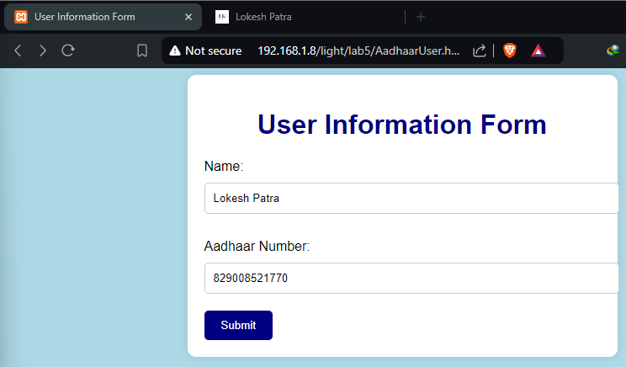Press Enter. Your HTML file should now be displayed in the browser.

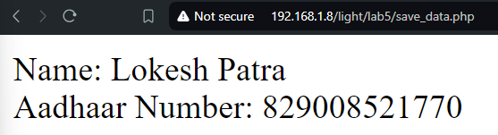

**Aim:**

i. Create a page w/ UserName, Semester, Year to be entered by user. Display it using session & cookies in the same or, a different page.

ii.. Create a page like:

- 3rd Semester BTech.

- 5th Semester BTech.

- 7th Semester BTech.

When the user clicks on any of the above 3 links, using URL Redirection, display Semester & BTech.

***[ #1 ]***

1. **Create an HTML File [ *User Details* ]**:

<html>

<head>

<title>Enter Details</title>

</head>

<body>

<h1>Enter Your Details</h1>

<form action="set_data.php" method="post">

<label for="username">Username:</label>

<input type="text" id="username" name="username" required><br><br>

<label for="semester">Semester:</label>

<input type="text" id="semester" name="semester" required><br><br>

<label for="year">Year:</label>

<input type="text" id="year" name="year" required><br><br>

<input type="submit" value="Submit">

</form>

</body>

</html>

1. **Create the set_data.php file:**

<?php

session_start();

if ($_SERVER["REQUEST_METHOD"] == "POST") {

$username = $_POST['username'];

$semester = $_POST['semester'];

$year = $_POST['year'];

*// Setting session variables*

$_SESSION['username'] = $username;

$_SESSION['semester'] = $semester;

$_SESSION['year'] = $year;

*// Setting cookies*

setcookie('username', $username, time() + (86400 * 30), "/"); *// 86400 = 1 day*

setcookie('semester', $semester, time() + (86400 * 30), "/");

setcookie('year', $year, time() + (86400 * 30), "/");

header("Location: display.php");

exit();

}

?>

1. **Create a display.php file:**

<?php

session_start();

?>

<html>

<head>

<title>Display Details</title>

</head>

<body>

<h1>Details</h1>

<h2>From Session:</h2>

<p>Username: <?php echo isset($_SESSION['username']) ? $_SESSION['username'] : 'Not set'; ?></p>

<p>Semester: <?php echo isset($_SESSION['semester']) ? $_SESSION['semester'] : 'Not set'; ?></p>

<p>Year: <?php echo isset($_SESSION['year']) ? $_SESSION['year'] : 'Not set'; ?></p>

<h2>From Cookies:</h2>

<p>Username: <?php echo isset($_COOKIE['username']) ? $_COOKIE['username'] : 'Not set'; ?></p>

<p>Semester: <?php echo isset($_COOKIE['semester']) ? $_COOKIE['semester'] : 'Not set'; ?></p>

<p>Year: <?php echo isset($_COOKIE['year']) ? $_COOKIE['year'] : 'Not set'; ?></p>

</body>

</html>

1. **Start Apache Server:**
   * Go to File > Save As.
   * Save the file with a .html and .php extensions, respectively, as, [ *details.html, set_data.php* & d*isplay.php*].
2. **Start Apache Server:**
   * Open the XAMPP Control Panel.
   * Click Start next to Apache to start the server.
3. **Place Your HTML File:**
   * Located the *htdocs* folder inside your XAMPP installation directory. This is typically C:\xampp\htdocs on Windows or /Applications/XAMPP/htdocs on Mac.
   * Copy your HTML file into the *htdocs* folder. A new folder can be created within *htdocs* for better organization (e.g., C:\xampp\htdocs\light\lab6\1).
4. **Access Your HTML File:**
   * Open your web browser.
   * In the address bar, type localhost /followed by the path to your HTML file.

* For example, if the file is named details.html it’s in a folder named light, type localhost/light/inex.html, or [192.168.1.8/light/lab6/1/details.html](http://192.168.1.8/light/lab6/1/details.html).

[ Local IP @ Home ]

**[ *#1 Outputs* ]**

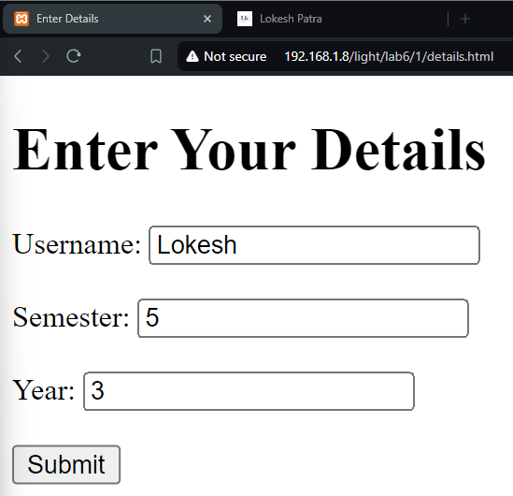

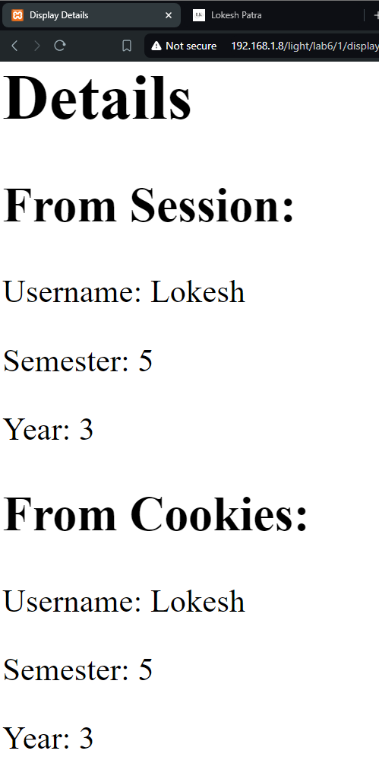

***[ #2 ]***

1. **Create an HTML File [ *Semester Links* ]**:

<html>

<head>

<title>Semester Links</title>

</head>

<body>

<h1>Select Your Semester</h1>

<ul>

<li><a href="redirect.html?semester=3rd">3rd Semester BTech</a></li>

<li><a href="redirect.html?semester=5th">5th Semester BTech</a></li>

<li><a href="redirect.html?semester=7th">7th Semester BTech</a></li>

</ul>

</body>

</html>

1. **Create another HTML file [ For REDIRECTION ]:**

<html>

<head>

<title>Semester Details</title>

</head>

<body>

<h1 id="semester-info"></h1>

<script>

*// Get the URL parameters*

const params = new URLSearchParams(window.location.search);

const semester = params.get('semester');

*// Display the semester information*

if (semester) {

document.getElementById('semester-info').textContent = `${semester} Semester BTech`; }

else {

document.getElementById('semester-info').textContent = 'No semester selected'; }

</script>

</body>

</html>

1. **Start Apache Server:**
   * Go to File > Save As.
   * Save both the files with .html extension, as, [ *base.htm* & *redirect.html* ].
2. **Start Apache Server:**
   * Open the XAMPP Control Panel.
   * Click Start next to Apache to start the server.
3. **Place Your HTML File:**
   * Locate the *htdocs* folder inside your XAMPP installation directory.
   * Copy the HTML files into the *htdocs* folder. A new folder can be created within *htdocs* for better organization (e.g., C:\xampp\htdocs\light\lab6\2).
4. **Access Your HTML File:**
   * Open your web browser.
   * In the address bar, type localhost /followed by the path to your HTML file.

* For example, if the file is named base.htm it’s in a folder named light, type localhost/light/inex.html, or [192.168.1.8/light/lab6/2/base.htm](http://192.168.1.8/light/lab6/2/base.htm) > [*192.168.1.8/light/lab6/2/redirect.html?semester=5th*](http://192.168.1.8/light/lab6/2/redirect.html?semester=5th) [ ***#2 Outputs*** ]

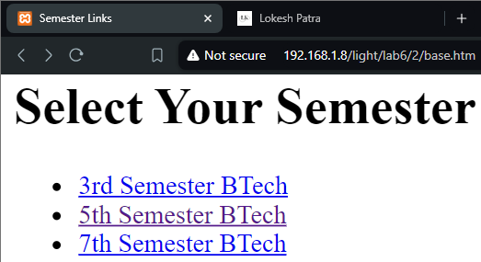

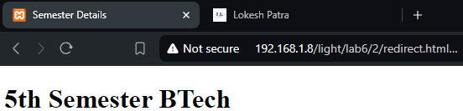

**Aim:** Create an HTML form, w/ fields as:

– RollNo. – Name – Regd. No. – Email – Branch [ **Dynamic Dropdown List** ]

Upon submission, the data must be inserted into a table in an SQL database.

** The options in the Branch List could be ' **DataScience** ', ' **AIML** ', ' **CyberSecuity** '.

1. **Create an HTML File**:

<html>

<head>

<title>Student Registration Form</title>

</head>

<body>

    <h1>Student Registration</h1>

    <form action="submit.php" method="post">

        <label for="rollno">Roll No:</label>

        <input type="text" id="rollno" name="rollno" required><br><br>

        <label for="name">Name:</label>

        <input type="text" id="name" name="name" required><br><br>

        <label for="regdno">Regd. No:</label>

        <input type="text" id="regdno" name="regdno" required><br><br>

        <label for="email">Email:</label>

        <input type="email" id="email" name="email" required><br><br>

        <label for="branch">Branch:</label>

        <select id="branch" name="branch" required>

            <option value="">Select Branch</option>

            <option value="**DataScience**">DataScience</option>

            <option value="**AIML**">AIML</option>

            <option value="**CyberSecurity**">Cyber Security</option>

        </select>

        <br><br>

<input type="submit" value="Submit">

</form>

</body>

</html>

1. **Create a .php File:**

<?php

$servername = "localhost";

$username = "root";

$password = "";

$dbname = "student_registration";

$conn = new mysqli($servername, $username, $password, $dbname);

if ($conn->connect_error) {

die("Connection failed: " . $conn->connect_error);

}

if ($_SERVER["REQUEST_METHOD"] == "POST") {

// Get form data

$rollno = $_POST['rollno'];

$name = $_POST['name'];

$regdno = $_POST['regdno'];

$email = $_POST['email'];

$branch = $_POST['branch'];

$stmt = $conn->prepare("INSERT INTO students (rollno, name, regdno, email, branch) VALUES (?, ?, ?, ?, ?)");

$stmt->bind_param("sssss", $rollno, $name, $regdno, $email, $branch);

if ($stmt->execute()) {

echo "New record created successfully";

} else {

echo "Error: " . $stmt->error;

}

$stmt->close();

}

$conn->close();

?>

1. **Create an SQL Database through phpMyAdmin:**
   1. **Access phpMyAdmin:**
   * Open your web browser and go to <http://localhost/phpmyadmin/>.
   1. **Create the Database:**
   * Click on the "Databases" tab.
   * In the "Create a new database" field, enter the name of your database (e.g., "student_registration").
   * Click the "Create" button.
   1. **Create the Table:**
   * Click on the newly created database (e.g., "student_registration").
   * Click the "Create table" tab.
   * In the "Name" field, enter the name of your table (e.g., "students").
   * For each column, specify the following:

**Field:** The name of the column (e.g., "rollno", "name", "regdno", "email", "branch").

**Type:** The data type for the column (e.g., "INT" for integers, "VARCHAR" for text).

**Length:** The maximum length for text-based columns (e.g., "255" for "VARCHAR").

**Attributes:** Any additional attributes (e.g., "NOT NULL" to make the column mandatory).

* + Click the "Save" button to create the table.

1. **Start Apache Server:**
   * Open the XAMPP Control Panel.
   * Click Start next to Apache to start the server.
2. **Place Your HTML File:**
   * Located the *htdocs* folder inside your XAMPP installation directory. This is typically C:\xampp\htdocs on Windows or /Applications/XAMPP/htdocs on Mac.
   * Copy your HTML and .php files into the *htdocs* folder. A new folder can be created within *htdocs* for better organization (e.g., C:\xampp\htdocs\light\lab7).
3. **Access Your HTML File:**
   * Open your web browser.
   * In the address bar, type localhost /followed by the path to your HTML file.

* For example, if the file is named index.html it’s in a folder named light, type localhost/light/inex.html, or <http://192.168.1.4/light/lab7/>.

[ Local IP @ Home ]

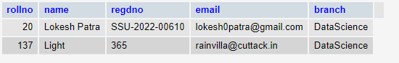

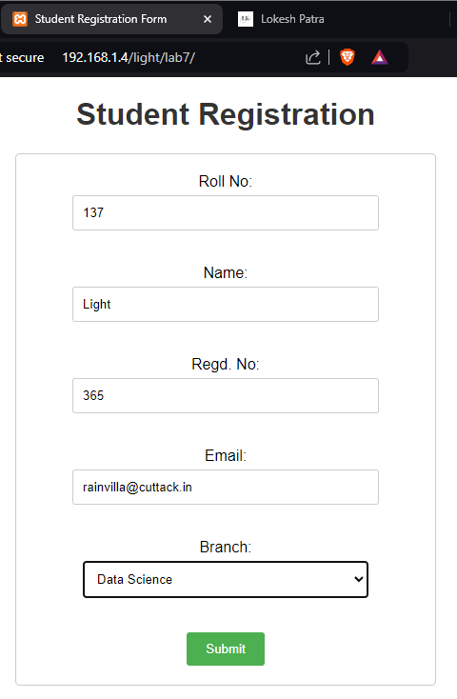

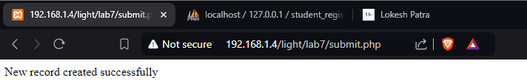

**Aim:** Write an HTML to enter your Phone Number w/ Country Code, EmailID, Residential Address. Validate all 3 of these using JavaScript and the conditions for these fields are as follows:

* Phone Number:
* The length of the mobile number is 10, if Country Code is 2 digits (+91).
* The length of the mobile number is 9, if Country Code is 3 digits and starts with 2 ( +256, +247, etc ).
* The length of the mobile number is 8, if Country Code is 1 digit.
* Email:
* The presence of @.
* Can include periods (.), hyphens (-), and underscores (_).
* Top-Level Domain (TLD): Must include a valid TLD like .com, .net, .org, etc.
* House Address:
* No Special Characters except ',', '-'.
* It can contain Alphanumeric Values ( Use Unicode Values to define them in the code ).

*\*\*Keep an alert code for any issue w/the details entered.*

1. **Create an HTML File**:

<html>

<head>

<title>Form Validation</title>

<script>

function validatePhoneNumber() {

const phoneInput = document.getElementById("phoneNumber").value.trim();

const phoneRegex = /^\+(\d{1,3})\s?(\d{8,10})$/;

const match = phoneInput.match(phoneRegex);

if (match) {

const countryCode = match[1];

const phoneNumber = match[2];

if ((countryCode.length === 1 && phoneNumber.length === 8) ||

(countryCode.length === 3 && phoneNumber.length === 9) ||

(countryCode === "91" && phoneNumber.length === 10)) {

return true;

}

}

alert("Invalid phone number! Please include a valid country code and phone number.");

return false;

}

function validateEmail(){

const email = document.getElementById("email").value;

const emailRegex = /^[^\s@]+@[^\s@]+\.[^\s@]+$/;

if (emailRegex.test(email)) {

return true;

}

alert("Invalid email address!");

return false;

}

function validateAddress() {

const address = document.getElementById("address").value;

const addressRegex = /^[a-zA-Z0-9 ,.\\-]+$/;

if (addressRegex.test(address)) {

return true;

}

alert("Invalid address! Only alphanumeric characters, space, comma, dot, and dash are allowed.");

return false;

}

function validateForm() {

const isPhoneValid = validatePhoneNumber();

const isEmailValid = validateEmail();

const isAddressValid = validateAddress();

return isPhoneValid && isEmailValid && isAddressValid;

}

</script>

</head>

<body>

<h1>Form Validation</h1>

<form action="submit.php" method="POST" onsubmit="return validateForm()">

<label for="phoneNumber">Phone Number (with Country Code):</label>

<input type="text" id="phoneNumber" name="phoneNumber" placeholder ="+91 1234567890" required><br><br>

<label for="email">Email:</label>

<input type="email" id="email" name="email" required><br><br>

<label for="address">Address:</label>

<input type="text" id="address" name="address" required><br><br>

<input type="submit" value="Submit">

</form>

</body>

</html>

1. **Create a .php File:**

<html>

<head>

<title>Submission Result</title>

</head>

<body>

<h1>Form Submission Result</h1>

<?php

$fullPhoneNumber = htmlspecialchars($_POST['phoneNumber'], ENT_QUOTES, 'UTF-8');

$email = htmlspecialchars($_POST['email'], ENT_QUOTES, 'UTF-8');

$address = htmlspecialchars($_POST['address'], ENT_QUOTES, 'UTF-8');

if (preg_match('/^\+(\d{1,3})\s?(\d{8,10})$/', $fullPhoneNumber, $matches)) {

$countryCode = $matches[1];

$phoneNumber = $matches[2];

} else {

$countryCode = "Unknown";

$phoneNumber = "Invalid format";

}

echo "<p><strong>Country Code:</strong> +$countryCode</p>";

echo "<p><strong>Phone Number:</strong> $phoneNumber</p>";

echo "<p><strong>Email:</strong> $email</p>";

echo "<p><strong>Address:</strong> $address</p>";

?>

<br>

<a href="index.html">Go Back to the Form</a>

</body>

</html>

1. **Start Apache Server:**
   * Open the XAMPP Control Panel.
   * Click Start next to Apache to start the server.
2. **Place Your HTML File:**
   * Located the *htdocs* folder inside your XAMPP installation directory. This is typically C:\xampp\htdocs on Windows or /Applications/XAMPP/htdocs on Mac.
   * Copy your HTML and .php files into the *htdocs* folder. A new folder can be created within *htdocs* for better organization (e.g., C:\xampp\htdocs\light\lab8).
3. **Access Your HTML File:**
   * Open your web browser.
   * In the address bar, type localhost /followed by the path to your HTML file.

* For example, if the file is named this.html it’s in a folder named light, type localhost/light/inex.html, or <http://192.168.1.4/light/lab8/this.html>.

[ Local IP @ Home ]

