

Certificate of Submission

This is to certify that Lokesh Patra, Aditya Narayan Purohit, Aakash Kumar Mahato, Rudra Narayan Behera, and Subham Nayak, students of B.Tech. in Computer Science and Engineering at Sri Sri University, have successfully completed and submitted their major project titled:

“Sentiment Intelligence System for Nuanced Product Reviews”

as part of their final academic curriculum. The research project was officially submitted on April 11th 2026.

Throughout the course of this project, the students demonstrated a commendable grasp of the subject matter and showcased exceptional skills in research, analysis, and presentation. We hereby acknowledge their efforts and dedication toward completing this project and commend their commitment to academic excellence.

Project Guide
Dr. Deepak Sahoo
External Examiner

Signatures of the Authors:

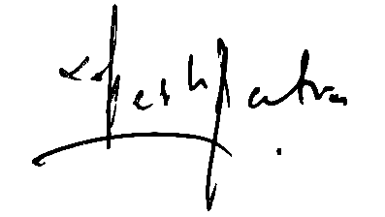


Lokesh Patra Aditya N. Purohit Aakash K. Mahato

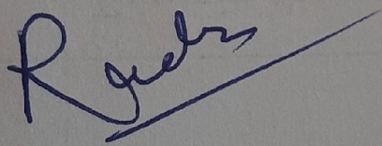

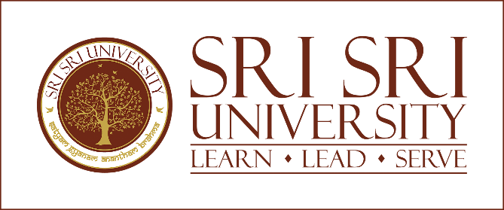
Rudra N. Behera Subham Nayak

