Hadoop实验环境搭建

实验平台
主机：Fedora 19 x86_64
虚拟机：Ubuntu 13.10 x86_64
JAVA 1.7.0_55
Hadoop 1.2.1

主机IP：192.168.56.1 NameNode, JobTracker
slave1：192.168.56.101 DataNode, TaskTracker
slave2：192.168.56.102 DataNode, TaskTracker
slave3：192.168.56.103 DataNode, TaskTracker

主机上的准备

修改Hosts
vi /etc/hosts
192.168.56.1 master
192.168.56.101 slave1
192.168.56.102 slave2
192.168.56.103 slave3

修改hostname为master：
# /etc/hostname
master

安装JAVA
从Oracle官网下载JAVA SDK：http://www.oracle.com/technetwork/java/javase/downloads/index.html
安装JDK包：sudo rpm -Uvh /path/to/binary/jdk-7u55-linux-x64.rpm
选择使用Oracle JDK：
## java ##
sudo alternatives --install /usr/bin/java java /usr/java/latest/jre/bin/java 200000
## javaws ##
sudo alternatives --install /usr/bin/javaws javaws /usr/java/latest/jre/bin/javaws 200000

## Java Browser (Mozilla) Plugin 64-bit ##
sudo alternatives --install /usr/lib64/mozilla/plugins/libjavaplugin.so libjavaplugin.so.x86_64 /usr/java/latest/jre/lib/amd64/libnpjp2.so 200000

## Install javac only if you installed JDK (Java Development Kit) package ##
sudo alternatives --install /usr/bin/javac javac /usr/java/latest/bin/javac 200000
alternatives --install /usr/bin/jar jar /usr/java/latest/bin/jar 200000

安装Hadoop
下载Hadoop：http://mirrors.hust.edu.cn/apache/hadoop/common/
建立hadoop用户：useradd hadoop
建立hadoop文件夹的symbolink：ln -s ~/bin/hadoop-1.2.1 ~/bin/hadoop
把Hadoop解压到~/bin目录下，并更新~/.bashrc
# ~/.bashrc
# hadooop
export JAVA_HOME="/usr/java/latest"
export HADOOP_INSTALL="/home/hadoop/bin/hadoop"
export PATH=$PATH:$HADOOP_INSTALL/bin:$HADOOP_INSTALL/sbin
export CLASSPATH="/home/hadoop/bin/mysql-connector-java-bin.jar"

配置Hadoop
在hadoop-env.sh中需指定JAVA安装路径（JAVA_HOME)
# ~/bin/hadoop/conf/hadoop-env.sh
export JAVA_HOME=/usr/java/latest

在core-site.xml中需指定HDFS的端口号(fs.default.name)和根目录(hadoop.tmp.dir)，这里端口号设为8020，根目录设为~/hadoop_root
# ~/bin/hadoop/conf/core-site.xml
<?xml version="1.0"?>
<?xml-stylesheet type="text/xsl" href="configuration.xsl"?>

<!-- Put site-specific property overrides in this file. -->

<configuration>
<property>
<name>fs.default.name</name>
<value>hdfs://master:8020</value>
</property>
<property>
<name>hadoop.tmp.dir</name>
<value>/home/hadoop/hadoop_root</value>
</property>
</configuration>

在mapred-site.xml中需要设定Mapreduce Job Tracker端口(mapred.job.tracker)和Map reduce的临时文件目录()
# ~/bin/hadoop/conf/mapred-site.xml
<?xml version="1.0"?>
<?xml-stylesheet type="text/xsl" href="configuration.xsl"?>

<!-- Put site-specific property overrides in this file. -->

<configuration>
<property>
<name>mapred.job.tracker</name>
<value>http://master:8021</value>
</property>

<property>
<name>mapred.local.dir</name>
<value>/home/hadoop/hadoop_root/mapred</value>
</property>
</configuration>

在hdfs-site.xml中需设定NameNode持久存储名字空间及事务日志的本地文件系统路径(dfs.name.dir)，HDFS数据路径(dfs.data.dir)和数据需要备份的数量(dfs.replication)，其中备份数量不能超过节点数。
# ~/bin/hadoop/conf/hdfs-site.xml
<?xml version="1.0"?>
<?xml-stylesheet type="text/xsl" href="configuration.xsl"?>

<!-- Put site-specific property overrides in this file. -->

<configuration>
<property>
<name>dfs.name.dir</name>
<value>/home/hadoop/hadoop_root/name</value>
<description> </description>
</property>
<property>
<name>dfs.data.dir</name>
<value>/home/hadoop/hadoop_root/hdfs</value>
<description> </description>
</property>
<property>
<name>dfs.replication</name>
<value>3</value>
</property>

</configuration>

最后配置master和slaves的机器名，即在hosts中写的名字。
~/bin/hadoop/conf/masters
master

~/bin/hadoop/conf/slaves
master
slave1
slave2
slave3

SSH配置
开启SSH服务：sudo service sshd start
使主机可以不用密码SSH登录虚拟机：cat ~/.ssh/id_rsa.pub
将终端输出的内容拷贝到虚拟机中的~/.ssh/authorized_keys
尝试连接虚拟机：ssh 192.168.56.101

虚拟机上的准备

修改Hosts
vi /etc/hosts
192.168.56.1 master
192.168.56.101 slave1
192.168.56.102 slave2
192.168.56.103 slave3

安装JAVA
sudo add-apt-repository ppa:webupd8team/java
sudo apt-get update
sudo apt-get install oracle-java7-installer

安装SSH
sudo apt-get install ssh

安装Hadoop
直接把本机上的Hadoop拷贝过去： scp -r bin/ slave1:~/ # 在本机上执行
更新~/.bashrc，和主机唯一的差别是JAVA_HOME。
# hadooop
export JAVA_HOME="/usr/lib/jvm/java-7-oracle/"
export HADOOP_INSTALL="/home/hadoop/bin/hadoop"
export PATH=$PATH:$HADOOP_INSTALL/bin:$HADOOP_INSTALL/sbin

同理，hadoop_env.sh中也需要相应修改JAVA_HOME。

准备完成后备份虚拟机文件，以防止后续配置出错而导致需要重装。然后将虚拟机文件拷贝两份。然后需要在/etc/hostname中修改host名称为对应的slave1, slave2或slave3。

启动Hadoop
格式化一个新的文件系统：
[hadoop@localhost ~]$ hadoop namenode -format
14/04/26 17:35:02 INFO namenode.NameNode: STARTUP_MSG:
/************************************************************
STARTUP_MSG: Starting NameNode
STARTUP_MSG: host = localhost.localdomain/127.0.0.1
STARTUP_MSG: args = [-format]
STARTUP_MSG: version = 1.2.1
STARTUP_MSG: build = https://svn.apache.org/repos/asf/hadoop/common/branches/branch-1.2 -r 1503152; compiled by 'mattf' on Mon Jul 22 15:23:09 PDT 2013
STARTUP_MSG: java = 1.7.0_51
************************************************************/
14/04/26 17:35:02 INFO util.GSet: Computing capacity for map BlocksMap
14/04/26 17:35:02 INFO util.GSet: VM type = 64-bit
14/04/26 17:35:02 INFO util.GSet: 2.0% max memory = 932184064
14/04/26 17:35:02 INFO util.GSet: capacity = 2^21 = 2097152 entries
14/04/26 17:35:02 INFO util.GSet: recommended=2097152, actual=2097152
14/04/26 17:35:03 INFO namenode.FSNamesystem: fsOwner=hadoop
14/04/26 17:35:03 INFO namenode.FSNamesystem: supergroup=supergroup
14/04/26 17:35:03 INFO namenode.FSNamesystem: isPermissionEnabled=true
14/04/26 17:35:03 INFO namenode.FSNamesystem: dfs.block.invalidate.limit=100
14/04/26 17:35:03 INFO namenode.FSNamesystem: isAccessTokenEnabled=false accessKeyUpdateInterval=0 min(s), accessTokenLifetime=0 min(s)
14/04/26 17:35:03 INFO namenode.FSEditLog: dfs.namenode.edits.toleration.length = 0
14/04/26 17:35:03 INFO namenode.NameNode: Caching file names occuring more than 10 times
14/04/26 17:35:03 INFO common.Storage: Image file /home/hadoop/hadoop_root/name/current/fsimage of size 112 bytes saved in 0 seconds.
14/04/26 17:35:03 INFO namenode.FSEditLog: closing edit log: position=4, editlog=/home/hadoop/hadoop_root/name/current/edits
14/04/26 17:35:03 INFO namenode.FSEditLog: close success: truncate to 4, editlog=/home/hadoop/hadoop_root/name/current/edits
14/04/26 17:35:04 INFO common.Storage: Storage directory /home/hadoop/hadoop_root/name has been successfully formatted.
14/04/26 17:35:04 INFO namenode.NameNode: SHUTDOWN_MSG:
/************************************************************
SHUTDOWN_MSG: Shutting down NameNode at localhost.localdomain/127.0.0.1
************************************************************/
启动Hadoop集群：start-all.sh
注意这里不能使用ctrl + C强制退出，否则会集群会陷入Safe Mode。
其他错误解析：
INFO org.apache.hadoop.mapred.TaskTracker: Failed to get system directory...
需要在mapred目录下创建system目录。（需要在每个node执行）
Can not start task tracker because java.io.IOException: Call to master/192.168.56.1:8021 failed on local exception: java.net.NoRouteToHostException: No route to host
端口被防火墙关闭了，可以选择增加防火墙规则或者关闭防火墙。
成功后可以访问Name node master页面http://master:50070和JobTracker页面http://master:50030。
截图如下所示

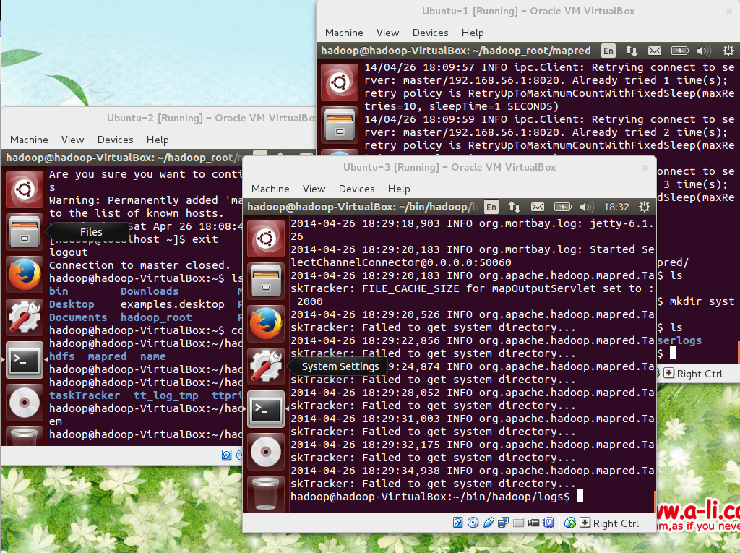
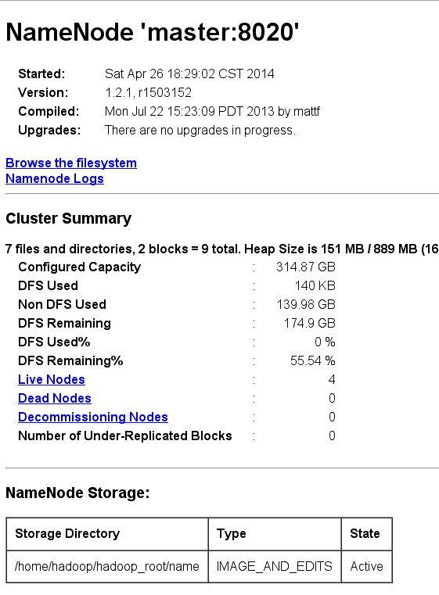

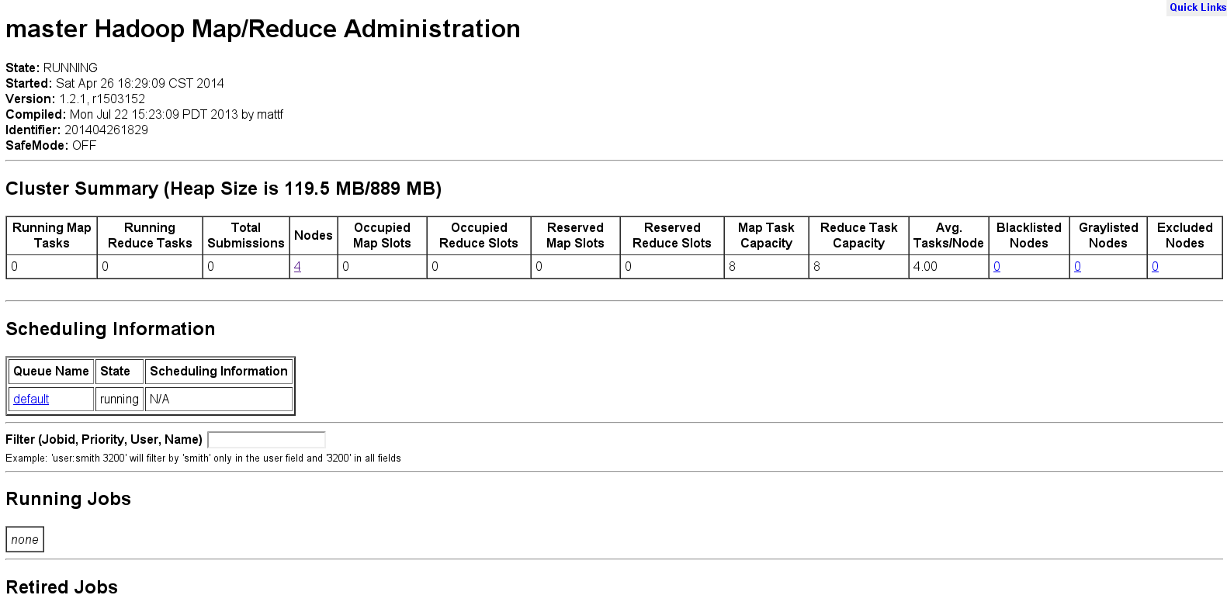
运行Hadoop样例程序计算Pi
[hadoop@master hadoop]$ hadoop jar hadoop-examples-1.2.1.jar pi 3 10
Number of Maps = 3
Samples per Map = 10
Wrote input for Map #0
Wrote input for Map #1
Wrote input for Map #2
Starting Job
14/04/26 22:06:57 INFO mapred.FileInputFormat: Total input paths to process : 3
14/04/26 22:06:57 INFO mapred.JobClient: Running job: job_201404262204_0003
14/04/26 22:06:58 INFO mapred.JobClient: map 0% reduce 0%
14/04/26 22:07:06 INFO mapred.JobClient: map 33% reduce 0%
14/04/26 22:07:08 INFO mapred.JobClient: map 66% reduce 0%
14/04/26 22:07:10 INFO mapred.JobClient: map 100% reduce 0%
14/04/26 22:07:14 INFO mapred.JobClient: map 100% reduce 33%
14/04/26 22:07:15 INFO mapred.JobClient: map 100% reduce 100%
14/04/26 22:07:16 INFO mapred.JobClient: Job complete: job_201404262204_0003
14/04/26 22:07:16 INFO mapred.JobClient: Counters: 31
14/04/26 22:07:16 INFO mapred.JobClient: Job Counters
14/04/26 22:07:16 INFO mapred.JobClient: Launched reduce tasks=1
14/04/26 22:07:16 INFO mapred.JobClient: SLOTS_MILLIS_MAPS=17991
14/04/26 22:07:16 INFO mapred.JobClient: Total time spent by all reduces waiting after reserving slots (ms)=0
14/04/26 22:07:16 INFO mapred.JobClient: Total time spent by all maps waiting after reserving slots (ms)=0
14/04/26 22:07:16 INFO mapred.JobClient: Rack-local map tasks=2
14/04/26 22:07:16 INFO mapred.JobClient: Launched map tasks=3
14/04/26 22:07:16 INFO mapred.JobClient: Data-local map tasks=1
14/04/26 22:07:16 INFO mapred.JobClient: SLOTS_MILLIS_REDUCES=9593
14/04/26 22:07:16 INFO mapred.JobClient: File Input Format Counters
14/04/26 22:07:16 INFO mapred.JobClient: Bytes Read=354
14/04/26 22:07:16 INFO mapred.JobClient: File Output Format Counters
14/04/26 22:07:16 INFO mapred.JobClient: Bytes Written=97
14/04/26 22:07:16 INFO mapred.JobClient: FileSystemCounters
14/04/26 22:07:16 INFO mapred.JobClient: FILE_BYTES_READ=72
14/04/26 22:07:16 INFO mapred.JobClient: HDFS_BYTES_READ=714
14/04/26 22:07:16 INFO mapred.JobClient: FILE_BYTES_WRITTEN=223075
14/04/26 22:07:16 INFO mapred.JobClient: HDFS_BYTES_WRITTEN=215
14/04/26 22:07:16 INFO mapred.JobClient: Map-Reduce Framework
14/04/26 22:07:16 INFO mapred.JobClient: Map output materialized bytes=84
14/04/26 22:07:16 INFO mapred.JobClient: Map input records=3
14/04/26 22:07:16 INFO mapred.JobClient: Reduce shuffle bytes=84
14/04/26 22:07:16 INFO mapred.JobClient: Spilled Records=12
14/04/26 22:07:16 INFO mapred.JobClient: Map output bytes=54
14/04/26 22:07:16 INFO mapred.JobClient: Total committed heap usage (bytes)=623648768
14/04/26 22:07:16 INFO mapred.JobClient: CPU time spent (ms)=2930
14/04/26 22:07:16 INFO mapred.JobClient: Map input bytes=72
14/04/26 22:07:16 INFO mapred.JobClient: SPLIT_RAW_BYTES=360
14/04/26 22:07:16 INFO mapred.JobClient: Combine input records=0
14/04/26 22:07:16 INFO mapred.JobClient: Reduce input records=6
14/04/26 22:07:16 INFO mapred.JobClient: Reduce input groups=6
14/04/26 22:07:16 INFO mapred.JobClient: Combine output records=0
14/04/26 22:07:16 INFO mapred.JobClient: Physical memory (bytes) snapshot=638951424
14/04/26 22:07:16 INFO mapred.JobClient: Reduce output records=0
14/04/26 22:07:16 INFO mapred.JobClient: Virtual memory (bytes) snapshot=2835275776
14/04/26 22:07:16 INFO mapred.JobClient: Map output records=6
Job Finished in 19.799 seconds
Estimated value of Pi is 3.60000000000000000000
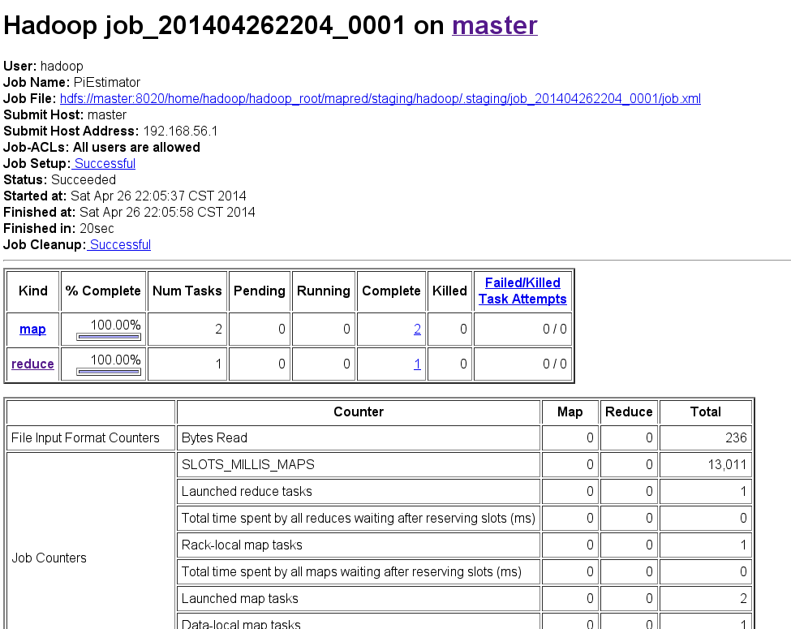

参考文献
- Install Oracle Java JDK JRE 7u55 on Fedora 20 19 CentOS RHEL 6.5 5.10, If not true then false, http://www.if-not-true-then-false.com/2010/install-sun-oracle-java-jdk-jre-7-on-fedora-centos-red-hat-rhel/
- Ubuntu 12.10 Hadoop 1.2.1版本集群配置, 51CTO.COM, http://os.51cto.com/art/201309/411793_all.htm
- Hadoop 机群安装笔记, zhangbin.cc, http://zhangbin.cc/archives/1288

