FINANCIAL LOAN DEFAULT ANALYSIS
Data Analytics Project Report

1. Project Title
Financial Loan Default Analysis: Identifying Patterns in Loan Repayment Using Python and Power BI
Approach: Python + Power BI (Approach 2)
Tools Used: Python, Pandas, Excel, Power BI, DAX
Dataset: Financial Loan Dataset (Kaggle)
Prepared by: Ligi Mathew
Project Type: Data Analytics

2. Introduction
This project falls under the category of banking and financial services, more especially consumer lending. Financial institutions lend money to people for things like business needs, home improvement, and debt consolidation. Credit risk is associated with lending; some borrowers default, and loans that are written off as losses are categorized as "Charged Off."
Understanding which kinds of loans are more likely to be charged off is central to lending decisions such as pricing, approval criteria, and portfolio monitoring. Even a small improvement in identifying higher-risk segments can reduce losses at the scale of tens of thousands of loans.
The purpose of this project is to analyse a financial loan dataset using Python and Power BI, measure the overall default rate, and compare default patterns across loan grades, terms, purposes, loan amounts, and interest rates, so that the findings can support data-driven risk assessment.

3. Problem Statement
Financial institutions need to understand how loan repayment performance differs across borrower and loan characteristics. Financial losses result from a high percentage of charged-off loans, and lenders may price or approve loans in ways that do not accurately reflect the risk if they have no idea where defaults are concentrated.
This project investigates the following question: how do loan default rates differ across loan grades, loan terms, loan purposes, loan amounts, and interest rates, and which segments show the highest risk? The analysis is necessary because it turns raw loan records into clear comparisons that lenders can use to focus monitoring and policy decisions.
The project is descriptive. It examines patterns in historical loan records and does not predict future defaults or establish causal relationships.

4. Objectives
The main objective is to analyse financial loan data and identify patterns associated with loan defaults. The specific objectives are:
- To understand the financial loan dataset and its key attributes.
- To clean and preprocess the dataset using Python, including handling missing values and verifying data quality.
- To calculate key performance indicators (KPIs) such as total loans, defaulted loans, and default rate using DAX in Power BI.
- To compare default rates across loan grades, loan terms, and loan purposes.
- To examine how loan amounts and interest rates differ between charged-off loans and other loans.
- To develop an interactive Power BI dashboard that communicates these patterns clearly.
- To provide practical recommendations that support data-driven lending decisions.

5. Dataset Information
The dataset used in this project is the Financial Loan Dataset, downloaded from Kaggle as an Excel file (financial_loan (1).xlsx).It contains 38,576 loan records and 24 columns, covering loans issued between 1 January 2021 and 12 December 2021, with borrowers from 50 US states. Every record is an individual loan application. The columns describe the borrower (for example annual income, employment length, home ownership, and state), the loan (amount, term, purpose, grade, interest rate, and installment), and the loan outcome (loan status, payment dates, and total payment). A derived variable named default_flag was also created during preprocessing, with a value of 1 for Charged Off loans and 0 for Fully Paid or Current loans. All 24 columns are described in the data dictionary .
The loan status column has three categories: Fully Paid (loans that have been repaid), Charged Off (loans classified as losses), and Current (loans that are still active).
Of the 38,576 loans, 32,145 (83.3%) are Fully Paid, 5,333 (13.8%) are Charged Off, and 1,098 (2.8%) are Current. Charged Off loans are a minority, about 1 in 7, so the dataset is imbalanced. This is why the analysis reports default rates as percentages rather than raw counts.
Suitability of the dataset. The dataset contains the outcome of each loan (loan status) together with the loan grade, term, purpose, amount, and interest rate. This makes it suitable for comparing default rates across segments, which is exactly what the problem statement requires. Its size of 38,576 records is large enough for stable percentage comparisons across most categories.

6. Tools and Technologies Used
- Python: Used for data loading, inspection, cleaning, missing value handling, duplicate checks, and creating the default_flag variable.
- Pandas: Used to load, manipulate, inspect, and clean the dataset, and to produce exploratory charts.
- Microsoft Excel: The original file format of the dataset.
- Power BI: Used to import the cleaned dataset, build visualizations, and develop the interactive dashboard with slicers.
- DAX (Data Analysis Expressions): Used to create measures for key performance indicators, including total loans, defaulted loans, and default rate.

7. Data Preprocessing / Cleaning
Data preparation was performed in Python so that the dataset was consistent and ready for Power BI. The original dataset had 38,576 rows and 24 columns. The main steps were:
- Data loading and inspection. The Excel file was loaded with Pandas, and the number of rows and columns, column names, and data types were reviewed.
- Missing values. Missing values were found in the emp_title (employee title) column and were handled during preprocessing, so no missing values remain in that column
- Duplicate check. The dataset was checked for duplicate records, and none were found, so no rows were removed.
- Default flag creation. A new column, default_flag, was created: 1 for Charged Off loans and 0 for Fully Paid and Current loans. This flag is the basis of the default rate. The decision to treat only Charged Off loans as defaults is explained in the assumptions
- Saving the cleaned data. The cleaned dataset was saved as a local copy and imported into Power BI.
These steps improved data quality and ensured that all later calculations used consistent, complete data.

8. Analysis and Methodology

8.1 Analytical Approach
The analysis followed a structured workflow: data inspection and cleaning in Python, exploratory analysis, KPI calculation with DAX in Power BI, and segment comparisons through interactive visualizations. The comparisons focus on the default rate, which is the share of loans that were charged off.

8.2 Exploratory Data Analysis
Exploratory analysis examined loan status, loan amount, annual income, interest rate, and loan grade. The dataset contains 38,576 loans: 32,145 Fully Paid, 5,333 Charged Off, and 1,098 Current. The charged-off loans represent approximately 13.82% of all records.
The average loan amount is approximately 11,296, the average annual income is approximately 69,644.54, and the average interest rate is approximately 12.05%. Charged-off loans differ from other loans: their average loan amount is about 12,288 compared with 11,136, and their average interest rate is about 13.88% compared with 11.76%.
Figure 1 shows the default rate rising from approximately 5.70% for Grade A to 31.31% for Grade G. Figure 2 shows the distribution of interest rates, which peaks at roughly 10% to 12.5%, with fewer loans at the high end of the range.
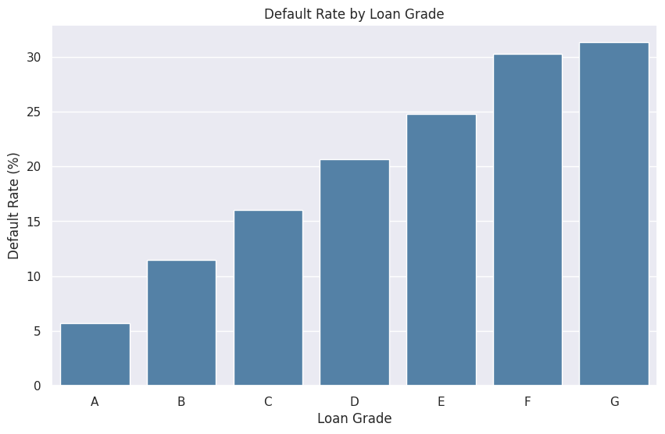
Figure 1: Default Rate by Loan Grade
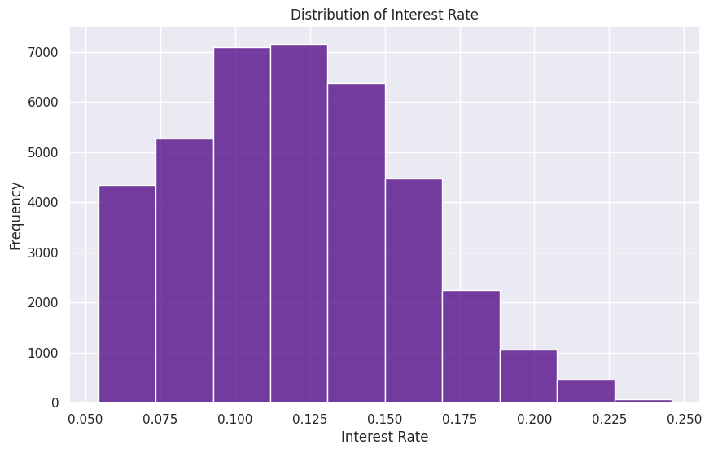
Figure 2: Distribution of Interest Rate

8.3 Default Analysis and Segment Comparisons
The default_flag variable was used to calculate the default rate for the whole portfolio and for each segment: loan grade, loan term (36 and 60 months), and loan purpose. Average loan amount was also compared across grades. These comparisons were built as Power BI visuals and are explained in Section 9.

8.4 DAX Measures
The following DAX measures were created in Power BI to calculate the dashboard KPIs.

Total Loans
Counts all loan records.
Total Loans = COUNTROWS('financial_loan')

Total Defaulted Loans
Counts loans classified as charged off, using default_flag.
Total Defaulted Loans = CALCULATE(
COUNTROWS('financial_loan'),
'financial_loan'[default_flag] = 1
)

Default Rate
Divides defaulted loans by total loans. The measure is formatted as a percentage, and DIVIDE returns 0 if the denominator is zero.
Default Rate =
DIVIDE(
[Total Defaulted Loans],
[Total Loans],
0
)

Average Loan Amount
Average Loan Amount =
AVERAGE('financial_loan'[loan_amount])

Average Interest Rate
Average Interest Rate =
AVERAGE('financial_loan'[int_rate])

8.5 Calculations and Metrics
The key metrics are: total loans (39K), defaulted loans (5K), default rate (13.82%), average loan amount (11.30K), and average interest rate (12.05%). Segment default rates reuse the Default Rate measure, which recalculates for each grade, term, or purpose in a visual.

8.6 Assumptions
Loans classified as Charged Off were treated as defaulted. Fully Paid and Current loans were treated as not charged off. Current loans may still default in the future, so the default rate may understate the final outcome. The analysis is descriptive and shows associations in historical records; it does not establish causation or predict future defaults.

9. Visualizations / Dashboard
The Power BI dashboard summarizes loan performance on a single page. Five KPI cards at the top show total loans, defaulted loans, default rate, average loan amount, and average interest rate. Slicers for Grade, Loan Status, and Term let users filter every visual. Figure 3 shows the final dashboard.
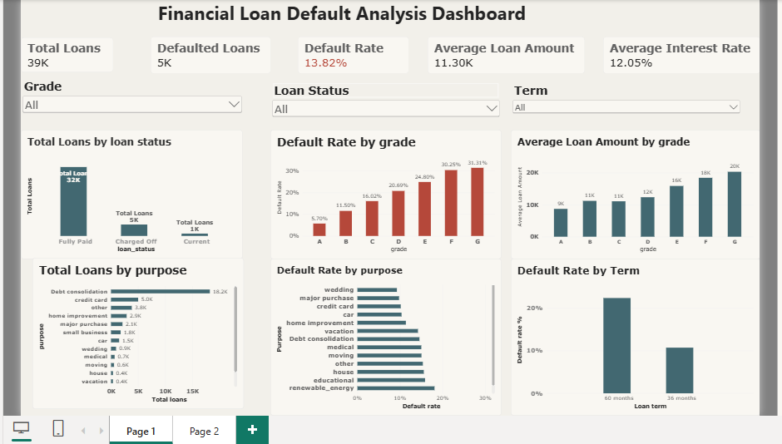
Figure 3: Power BI Financial Loan Default Analysis Dashboard

9.1 Total Loans by Loan Status
What it shows: The number of loans that are Fully Paid, Charged Off, and Current. Variables: loan_status and the count of loans. Why selected: A bar chart makes the size of each category easy to compare. Insight: Most loans (about 32K) are fully paid, about 5K are charged off, and about 1K are current.

9.2 Default Rate by Grade
What it shows: The percentage of loans charged off within each loan grade. Variables: grade and Default Rate. Why selected: A column chart in a warning colour shows the ordered steps from Grade A to G clearly. Insight: The default rate rises with every grade, from 5.70% for A to 31.31% for G. This is the clearest risk signal in the dataset.

9.3 Average Loan Amount by Grade
What it shows: The average loan size for each grade. Variables: grade and Average Loan Amount. Why selected: Placed beside the default rate chart so the two can be read together. Insight: Average loan size rises from about 9K for Grade A to about 20K for Grade G, so the riskiest grades also carry the largest loans.

9.4 Total Loans and Default Rate by Purpose
What it shows: Loan volume and default rate for each loan purpose. Variables: purpose, loan count, and Default Rate. Why selected: Horizontal bars handle long category names well and sort the categories by size. Insight: Debt consolidation dominates volume (18.2K loans, nearly half of the portfolio). Default rates are higher for purposes such as educational and renewable energy, which have small volumes, and lower for purposes such as wedding and major purchase.

9.5 Default Rate by Term
What it shows: The default rate for 36-month and 60-month loans. Variables: term and Default Rate. Why selected: Only two categories exist, so a simple two-bar chart gives a direct comparison. Insight: Loans with a 60-month term default at roughly twice the rate of 36-month loans (about 22% compared with about 11%).

10. Key Findings and Insights
The grade comparison below summarizes the strongest pattern in the data. Values are taken from the dashboard; average loan amounts are rounded to the nearest thousand.
Grade | Default rate | Average loan amount
A | 5.70% | about 9K
B | 11.50% | about 11K
C | 16.02% | about 11K
D | 20.69% | about 12K
E | 24.80% | about 16K
F | 30.25% | about 18K
G | 31.31% | about 20K

- About 1 in 7 loans is charged off. 5,333 of 38,576 loans (13.82%) were charged off. A loss rate of this size makes risk monitoring a core business concern.
- Grade is the strongest differentiator. The default rate rises from 5.70% for Grade A to 31.31% for Grade G, more than five times higher. Grades E, F, and G all exceed 24%, well above the 13.82% portfolio average.
- Riskier grades also borrow more. Average loan size grows from about 9K to about 20K across the grades, so the exposure per loan is largest where the default rate is highest.
- Loan term matters. 60-month loans default at roughly twice the rate of 36-month loans, so a longer term is associated with higher risk.
- Charged-off loans are larger and carry higher interest. Their average loan amount (about 12,288) and interest rate (about 13.88%) are higher than those of other loans (about 11,136 and 11.76%). Interest rates are likely linked to loan grade, so this difference probably reflects the same risk pattern.
- Volume is concentrated in debt consolidation. About 18.2K loans, nearly half of the portfolio, have this purpose, and its default rate is close to the portfolio average. Because of its size, this category has a large effect on total losses.
- Some small categories show high default rates. Educational and renewable energy loans have higher default rates, but on small volumes, so these rates should be read with caution.

11. Recommendations
The recommendations below are linked to the findings in Section 10 and are intended to support, not replace, lender judgement.
- Tighten review for Grades E to G . Apply stricter approval criteria, lower maximum loan amounts, or higher pricing to these grades, where default rates exceed 24% and loan sizes are largest.
- Set term-based policies . Review whether 60-month loans, especially in lower grades, should require stronger repayment checks, since their default rate is about double that of 36-month loans.
- Review how interest rates reflect risk . Check that interest rates charged on higher-risk loans are enough to cover the higher losses observed.
- Monitor concentration in debt consolidation . Track this category separately, because it makes up nearly half of the portfolio and small changes in its default rate affect total losses.
- Investigate small high-default purposes before acting. Collect more data on educational and renewable energy loans to confirm whether their higher rates persist.

12. Limitations
- Dataset scope. The analysis uses one dataset of 38,576 records and 24 original columns, which may not represent all borrowers or lenders.
- Available variables. Repayment history, changes in borrower income, and other obligations were not available.
- Descriptive analysis. The project did not build a predictive model of future defaults.
- Data quality. Missing job titles were handled and no duplicates were found, but the results depend on the accuracy of the original data.
- Definition of default. Only Charged Off loans were counted as defaults. Current loans may still default, so the default rate may be understated.
- Associations, not causes. Differences across grades, amounts, and rates do not establish causation.
- Small categories. Segments with few loans, such as some loan purposes, give less reliable default rates.
- Dashboard scope. The dashboard presents selected indicators; a full credit risk assessment needs more variables.

13. Conclusion
This project addressed the question of how loan default rates differ across loan characteristics. Python and Pandas were used to clean the Kaggle financial loan dataset, handle missing values, check for duplicates, and create a default flag. The cleaned data was analysed in Power BI using DAX measures and an interactive dashboard.
The main finding is that defaults are concentrated in specific segments: the default rate rises from 5.70% for Grade A to 31.31% for Grade G, 60-month loans default about twice as often as 36-month loans, and the riskiest grades also take the largest loans. About 13.82% of all loans were charged off.
These results matter because they show lenders where to focus monitoring, pricing, and approval policies. The project shows how raw loan data can be turned into clear, actionable insights, while its limits (descriptive scope, treatment of current loans, and no causal claims) should be kept in mind.

14. References
- Financial Loan Dataset [Data set]. Kaggle.
- Python Software Foundation. (n.d.). Python documentation. https://docs.python.org/3/
- The pandas development team. (n.d.). pandas documentation. https://pandas.pydata.org/docs/
- Microsoft. (n.d.). Power BI documentation. https://learn.microsoft.com/en-us/power-bi/
- Microsoft. (n.d.). Data Analysis Expressions (DAX) reference. https://learn.microsoft.com/en-us/dax/

15. Appendix

Appendix A: DAX Measures
The five DAX measures (Total Loans, Total Defaulted Loans, Default Rate, Average Loan Amount, and Average Interest Rate) are listed
1. Total Loans
Counts all loan records.
Total Loans = COUNTROWS('financial_loan')
2. Total Defaulted Loans
Counts loans classified as Charged Off.
Total Defaulted Loans =
CALCULATE(
COUNTROWS('financial_loan'),
'financial_loan'[default_flag] = 1
)
3. Default Rate
Calculates the percentage of defaulted loans among total loans.
Default Rate =
DIVIDE(
[Total Defaulted Loans],
[Total Loans],
0
)
4. Average Loan Amount
Calculates the average loan amount.
Average Loan Amount =
AVERAGE('financial_loan'[loan_amount])
5. Average Interest Rate
Calculates the average interest rate across all loans.
Average Interest Rate =
AVERAGE('financial_loan'[int_rate])

Appendix B: Additional Visualizations
Figure 1 (default rate by grade) and Figure 2 (interest rate distribution) are the Python-based charts.

Appendix C: Project Resources
Pythonnotebook:https://colab.research.google.com/drive/1y-Lbik8X8mTpetAN_2hytcNg9e4XdAXb?usp=sharing

