Specific Aims

We propose:
- a new software technology – the Descriptive Video Exchange (DVX) – allowing sighted video viewers to verbally describe what they see in a movie, and seamlessly share those descriptions over the Internet, thus improving widespread accessibility of video for blind and visually-impaired viewers, and
- a program of rigorous research to evaluate 1) the effectiveness of DVX for the recording and distribution of amateur audio description, 2) the effectiveness of automated digital tools for enhancing the presentation of amateur audio description, and 3) the effectiveness of using social networks and online communities for the recruitment of volunteer audio describers.

Audio Description is a powerful method for providing blind and visually impaired video consumers with information about what is taking place on a video screen. Originally developed in the 1970s and early ‘80s (see Pfanstiehl, 1985), the technique involves adding a scripted voice-over to an existing video, written, read, recorded, and produced by audio description professionals. These descriptions use a minimum of carefully selected and timed words to inform blind and visually impaired “viewers” about important on-screen events while keeping the description itself as unobtrusive as possible.

However, long before the invention of professional audio description, and probably going back a hundred years to the era of silent film, blind people have been sitting in darkened theaters poking their loved ones in the ribs and whispering, “What’s going on?”

Amateur film description is a long and well-established fact of life for visually-impaired individuals and their teachers, friends, and families. Yet surprisingly little is known about techniques and best practices for amateur description – a practice which is still by far the main source of audio-described content for blind and visually-impaired viewers. The high production values of professionally-produced audio description may be missing from this approach, but the ready availability of the volunteer resource may offset this disadvantage. As Jim Stovall – a blind professional with decades of experience in the description field, and Executive Director of Narrative Television Network – put it, “Any description is generally better than no description.” (Stovall, 2009)

This project aims to remove significant barriers to innovative research in the area of amateur description for the blind and visually impaired, while addressing several pressing questions in this field. We will achieve these ends by developing a new, Internet-based technology for the creation, deployment and viewing of described video materials. Once developed, we will use the system to conduct quantitative, hypothesis-driven research to evaluate the relative effectiveness of amateur video description. The proposed technology – the Descriptive Video Exchange (DVX) – will implement easy-to-use, modern wiki-style collaborative content creation to allow video describers with a wide range of skills to readily create and share video descriptions with consumers across the spectrum of visual abilities.

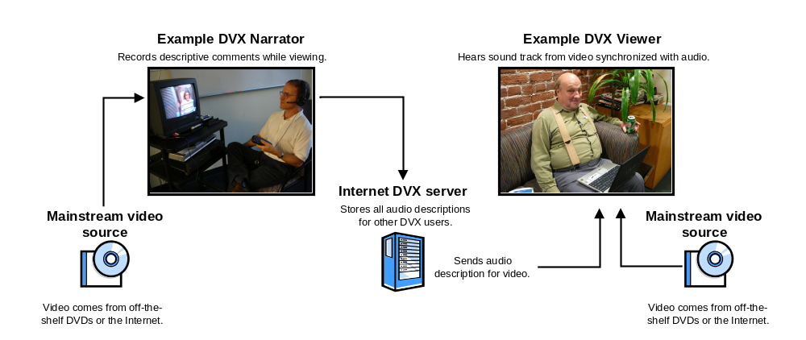
Figure 1: Illustration of amateur narrator and blind viewer using the Descriptive Video Exchange.

Figure 1 shows an abstraction of how the Descriptive Video Exchange will work. The system is thoroughly described in the Research Design and Methods section, but a brief explanation may be helpful at this point.

Video content, whether from the Internet or a DVD, is uniquely identified through a kind of digital “thumb print.” For example, all copies of “Mary Poppins,” have the same identifier. This means it doesn’t matter which copy is used since the identifier is the same. When a describer (also called a narrator) records descriptions for a particular video, the thumb print, descriptive recordings, and a synchronization file are uploaded to the DVX server. When a blind viewer later tries to access a different copy of that DVD or URL, the thumb print is used to identify which DVD or Internet video he or she is using. The audio description files and synchronization file are then seamlessly downloaded and played along with the video by the DVX video player (also called the Client). In this way, the system can be used to describe any video content simply by using off-the-shelf DVDs (e.g., from Netflix or Block Buster) or web videos such as from Youtube.

The broad, long-term objectives of the proposed project are as follows:
- Development of a robust web-based DVX platform to support the production, distribution, and consumption of video description and annotation by a broad base of consumers, creators, and researchers. The system will include:
  - The DVX Client – A computer-based, accessible video player optimized for the recording and playback of the system’s described video materials;
  - Enhanced Playback Functions – A set of software functions built into the DVX Client which will assist viewers to make the most of amateur descriptions;
  - The DVX Server – An Internet-based server located at Smith-Kettlewell for the storage and retrieval of user-generated descriptions;
  - The DVX API – An application program interface (API) to allow developers and researchers to access the descriptions and usage information stored on the server
- Use this system to support rigorous, hypothesis-driven research into the effectiveness of amateur description, as well as the system’s enhanced description playback functions. Proposed research includes:
  - Hypothesis 1 – high-quality amateur descriptions produced with the system are comparable in effectiveness to professionally produced descriptions.
  - Hypothesis 2 – The use of enhanced description playback functions such as automated gap detection, speech compression, and description alert tones improve the effectiveness of amateur description over unenhanced playback.
  - Hypothesis 3 – amateur describers can effectively be recruited through social networking platforms such as Twitter and FaceBook.
- Close collaboration throughout the three-year project with audio description stakeholders to ensure maximum effectiveness of the system and related findings. Stakeholders include:
  - Blind and visually-impaired consumers of described video, including students, seniors, and working professionals;
  - Amateur describers consisting primarily of teachers, friends, and family members of blind and visually-impaired viewers;
  - Professional describers from a variety of backgrounds and organizational affiliations;
  - Academic researchers in the area of audio description tools and techniques.

