- 单标签分类(Multiclass classfication)
  - 通常策略
    - 转化为二分类问题（问题转化模式，将多分类问题转化为多个二分类问题）
      - One-vs.-rest（one-vs.-all,OvA,OvR,OAA）
        - 思想：针对每一类训练一个分类器
        - 输入：L(二分类学习算法)，X，ys
        - 输出：多个分类器fk
        - 训练：根据k构建y，通过L训练得到fk
        - 预测：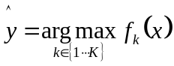
        - 缺点：不同二分类器置信度scale可能不同，one-vs.-rest导致样本不均衡
      - One-vs.-one(OvO)
        - 思想：两两类别训练二分类器
        - 输入：L，（x1，x2)s，ys
        - 输出：K(K-1)/2个分类器f
        - 训练：两两类别样本二分训练
        - 预测：多数投票
        - “Like OvR, OvO suffers from ambiguities in that some regions of its input space may receive the same number of votes”
    - 从二分类拓展（算法自适应模式）
      - 神经网络
        - 最后一层softmax多输出通道
      - K近邻
        - 遍历计算样本距离，多数投票
      - 朴素贝叶斯
        - 最大化后验概率
      - 决策树
        - 根据特征进行树状分割
      - 支持向量机
        - 利用边缘点，最大化超平面边距，最开始只用于二分类，经过后期扩展改进，可以适用于多分类
- 多标签分类(Multilabel classfication)
  - 通常策略
    - 问题转化算法
      - 二分类器相关，针对每一类单独训练一个二分类器，预测为正。”Although this method of dividing the task into multiple binary tasks may resemble superficially the one-vs.-all (OvA) and one-vs.-rest (OvR) methods for multiclass classification, it is essentially different from both, because a single classifier under binary relevance deals with a single label, without any regard to other labels whatsoever.”
      - LP(label powerset)，针对每一个标签组合训练一个单独二分类器，random k-labelsets (RAKEL)
      - 分类器链
    - 自适应算法
      - Boosting: Adaboost.MH和AdaBoost.MR
      - k邻近：ML-KNN
      - 决策树：Clare,MMC,MMDT,SSC“"Clare" is an adapted C4.5 algorithm for multi-label classification; the modification involves the entropy calculations.[9] MMC, MMDT, and SSC refined MMDT, can classify multi-labeled data based on multi-valued attributes without transforming the attributes into single-values. They are also named multi-valued and multi-labeled decision tree classification methods”
      - 核方法
      - 神经网络：BP-MLL
- 多标签数据集的统计指标
  - 数据集的统计指标
    - Label cardinality(标签基数) 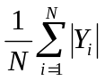
    - Label density(标签密度) 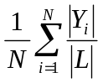,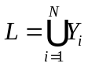
  - 算法的统计指标
    - :true set of labels;:predicted set of labels
      - Hamming loss：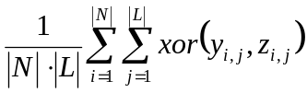,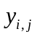是真实值，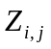是预测值
      - Intersection over Union：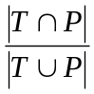
      - Precision, recall ,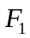score：
        - Precision: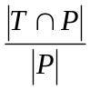
        - Recall: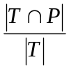
        - score: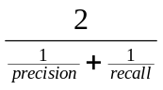
      - Exact match：label set完全正确的正确率

