SUMMER TRAINING REPORT 1
(ES-361)

NIVI AI: Development of an Intelligent
AI-Powered Conversational Assistant

Submitted in partial fulfillment of the requirements
for the award of the degree of

Bachelor of Technology
Department of Computer Science & Engineering

Submitted by:
[YOUR NAME]
[YOUR ENROLLMENT NUMBER]

Dr. Akhilesh Das Gupta Institute of Professional Studies
(Formerly ADGITM)
FC-26, SHASTRI PARK, NEW DELHI

Affiliated to
GURU GOBIND SINGH INDRAPRASTHA UNIVERSITY
Sector - 16C Dwarka, Delhi - 110075, India

2023-27

DECLARATION

This is to certify that the material embodied in this Summer Training Report-1 titled "NIVI AI: Development of an Intelligent AI-Powered Conversational Assistant" being submitted in the partial fulfillment of the requirements for the award of the degree of Bachelor of Technology in Computer Science & Engineering is based on my original work. It is further certified that this work has not been submitted in full or in part to this university or any other university for the award of any other degree or diploma. My indebtedness to other works has been duly acknowledged at the relevant places.

[YOUR NAME]
[YOUR ENROLLMENT NUMBER]

CERTIFICATE FROM THE COMPANY

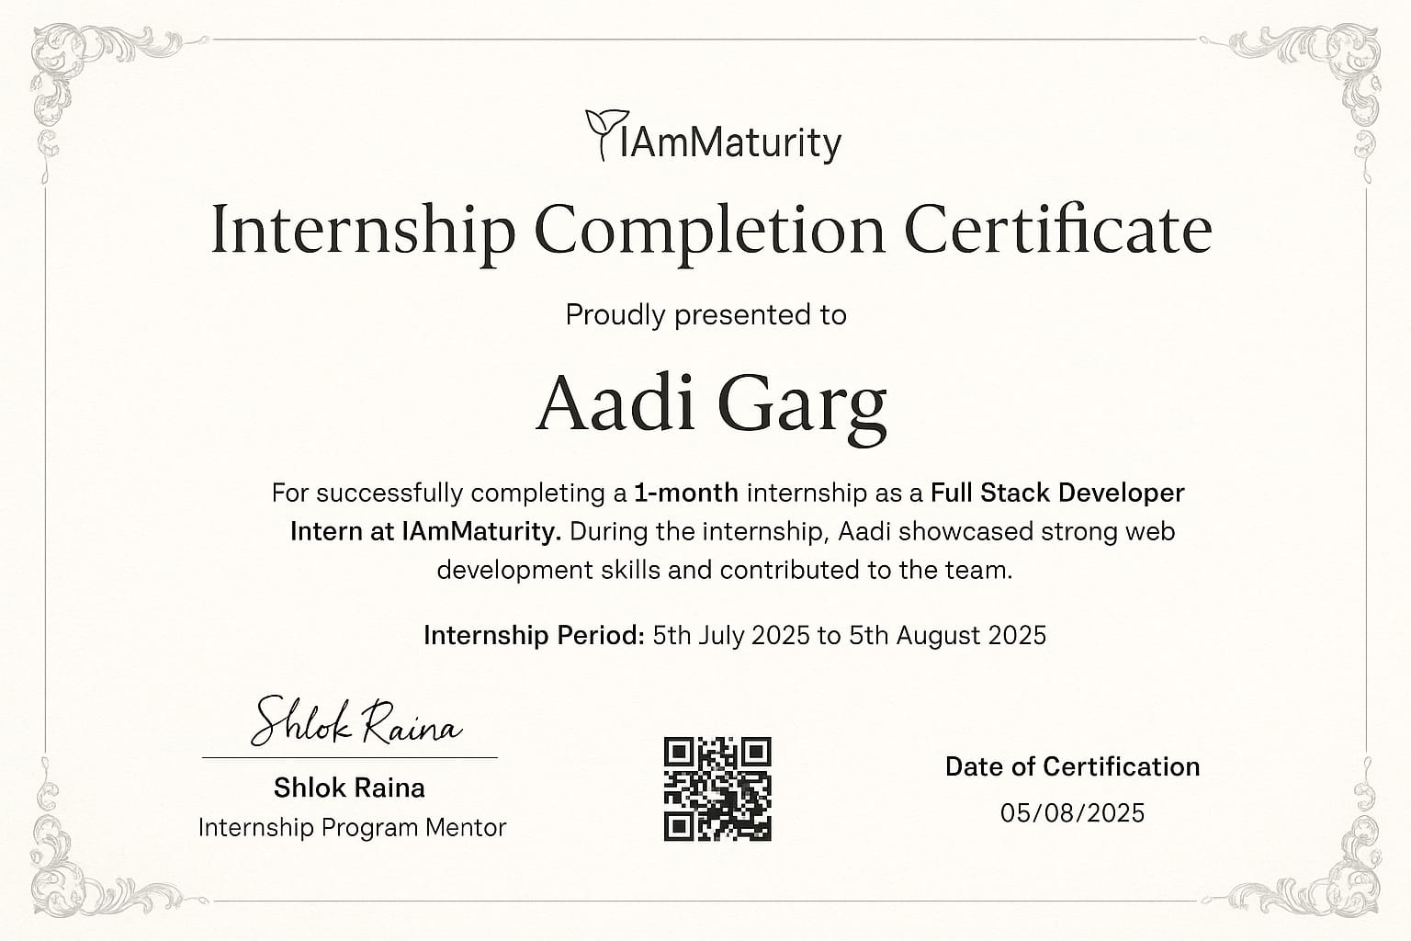
Figure C.1: Internship Certificate

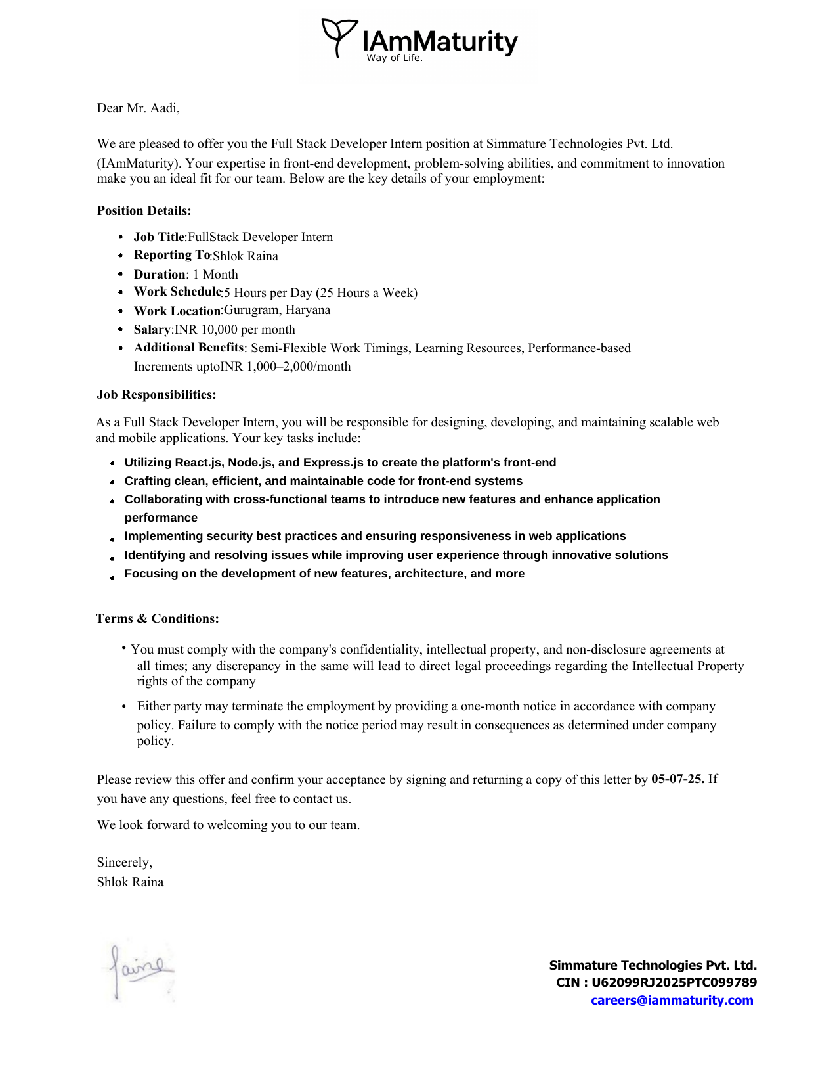
Figure C.2: Offer Letter

ACKNOWLEDGEMENT

I would like to express my sincere gratitude to my training organization for providing me with the opportunity to work on this project. Their guidance, support, and invaluable insights throughout the training period have significantly enhanced my technical skills and professional development.
I am deeply thankful to Dr. Akhilesh Das Gupta Institute of Professional Studies for organizing this summer training program and providing the academic framework that enabled me to undertake this meaningful project. Special thanks to my faculty mentors and the Training and Placement Cell for their continuous support.
I would also like to acknowledge the open-source community and the developers of the various technologies and frameworks used in this project, particularly React, Vite, and Tailwind CSS, which made the development process efficient and enjoyable.
Finally, I extend my heartfelt thanks to my family and friends for their unwavering support and encouragement throughout this journey.

ABSTRACT

This report presents a comprehensive overview of the summer training program undertaken, focused on Full-Stack Web Development and Artificial Intelligence Integration. The training resulted in the development of NIVI AI, an intelligent conversational assistant that leverages modern web technologies and AI capabilities to provide users with an enhanced interactive experience.
The project encompasses the complete development lifecycle, from initial planning and design to implementation and deployment. NIVI AI is built using React.js for the frontend, providing a responsive and intuitive user interface, while integrating advanced AI capabilities for natural language processing and conversation management.
Key features implemented include real-time chat functionality, multi-conversation management, persistent data storage, voice interaction capabilities, analytics dashboard, and comprehensive user authentication system. The application follows modern software development practices including component-based architecture, state management, API integration, and responsive design principles.
The training covered essential concepts in web development including HTML5, CSS3, JavaScript ES6+, React.js framework, RESTful API design, database management, authentication systems, and deployment strategies. Special emphasis was placed on creating a scalable, maintainable, and user-friendly application architecture.
This report details the technical implementation, challenges encountered, solutions developed, and the valuable learning outcomes achieved during the four-week intensive training period.

[TABLE OF CONTENTS, LIST OF FIGURES, AND LIST OF TABLES would be added here with proper page numbering]

CHAPTER 3: PROBLEM STATEMENT

The project aimed to develop NIVI AI, an intelligent conversational assistant...
[Abbreviated for brevity - see Summer_Training_Report_Chapters.docx for full content]
3.4 System Architecture and Diagrams

NIVI AI follows a component-based architecture pattern, separating concerns between presentation, business logic, and data management layers.

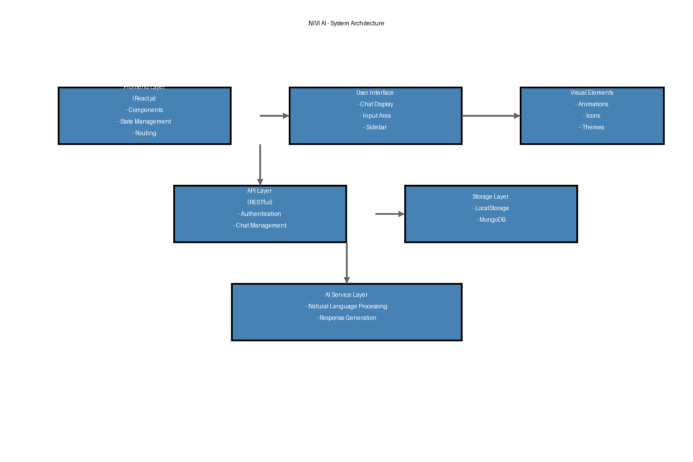
Figure 3.1: System Architecture Diagram

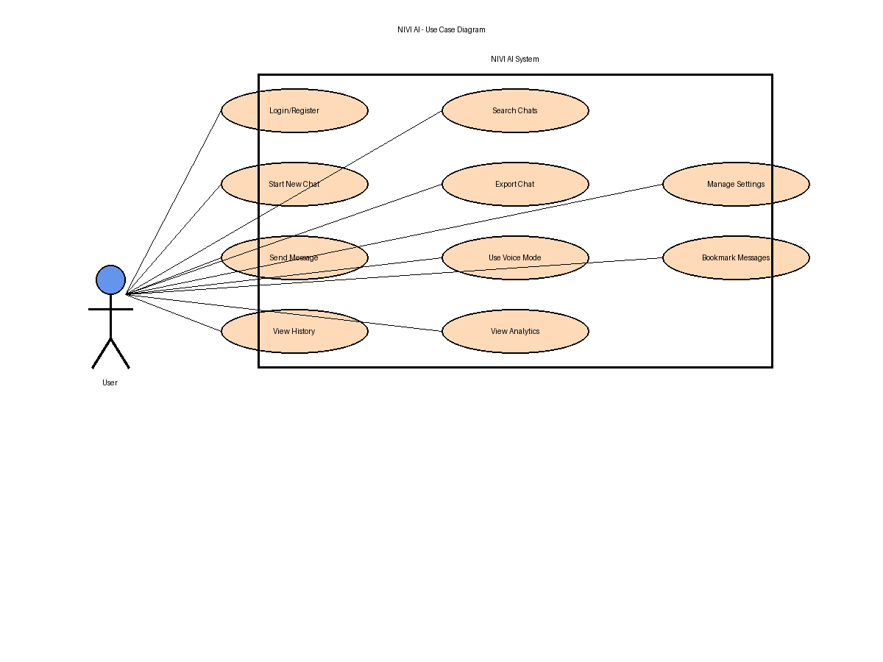
Figure 3.2: Use Case Diagram

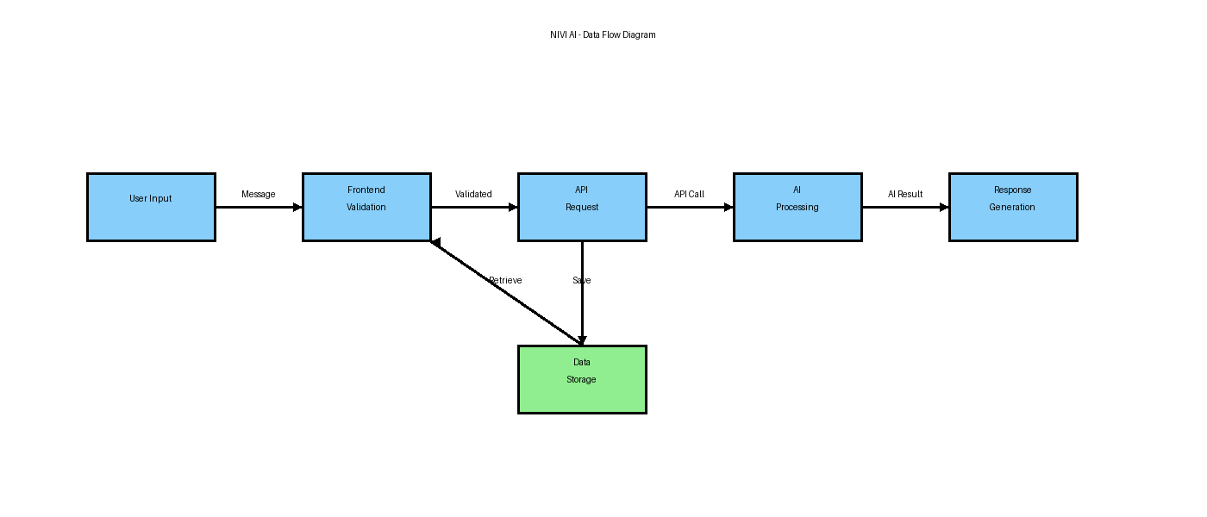
Figure 3.3: Data Flow Diagram

CHAPTER 4: PROJECT ACTIVITIES

The development of NIVI AI involved multiple phases...
[Abbreviated for brevity - see Summer_Training_Report_Chapters.docx for full content]

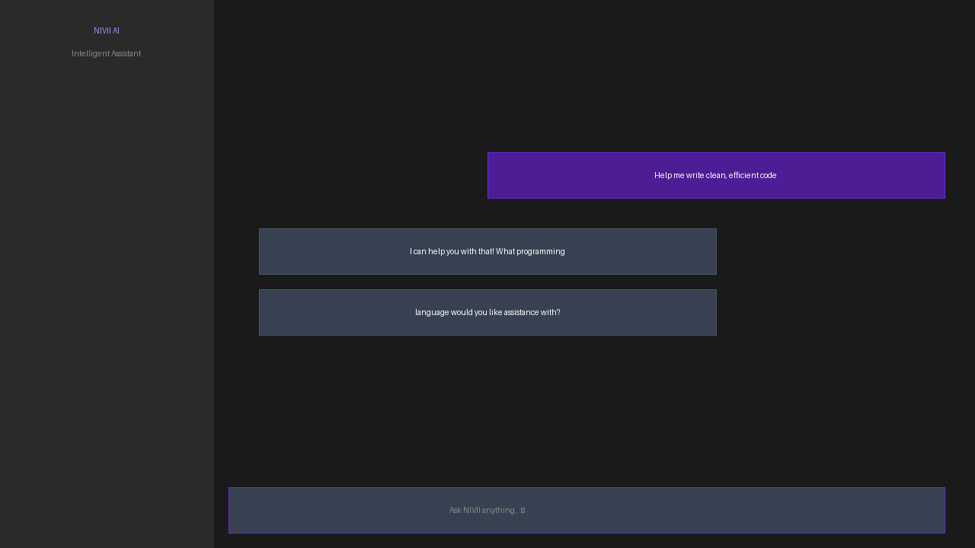
Figure 4.1: NIVI AI Main Interface

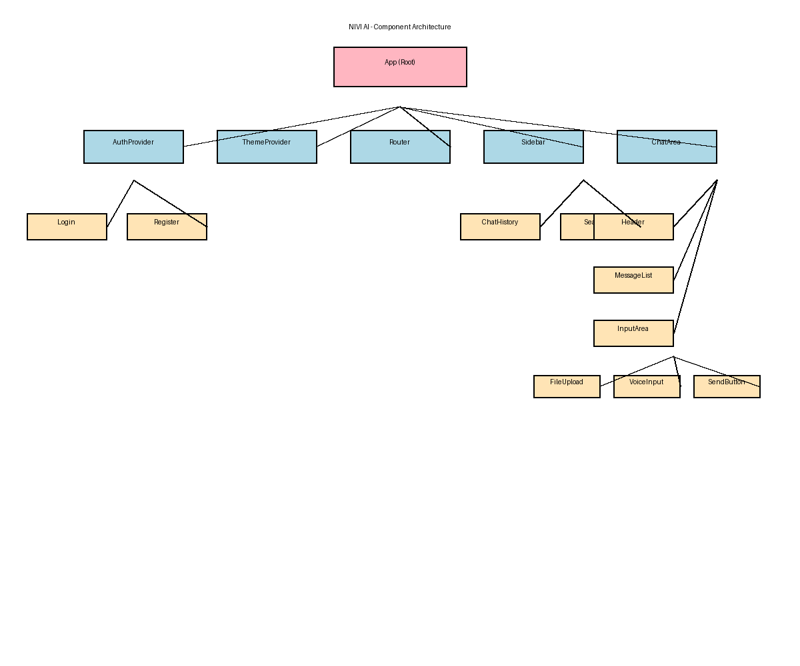
Figure 4.2: Component Architecture

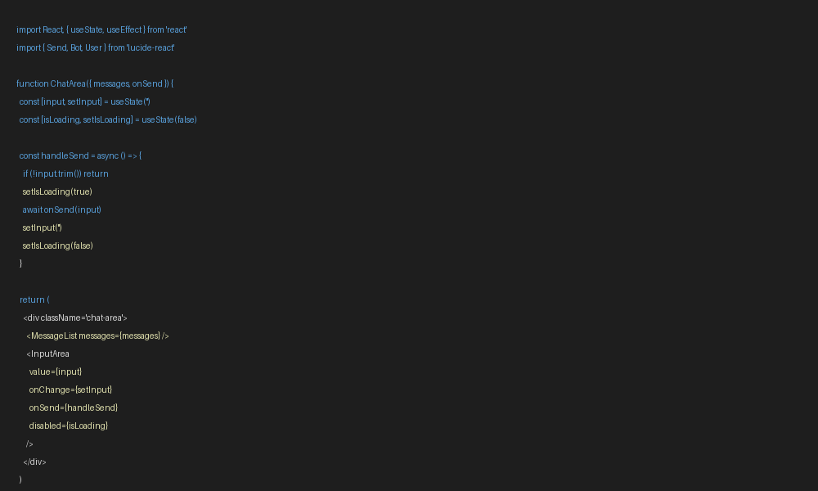
Figure 4.3: Code Structure - React Components

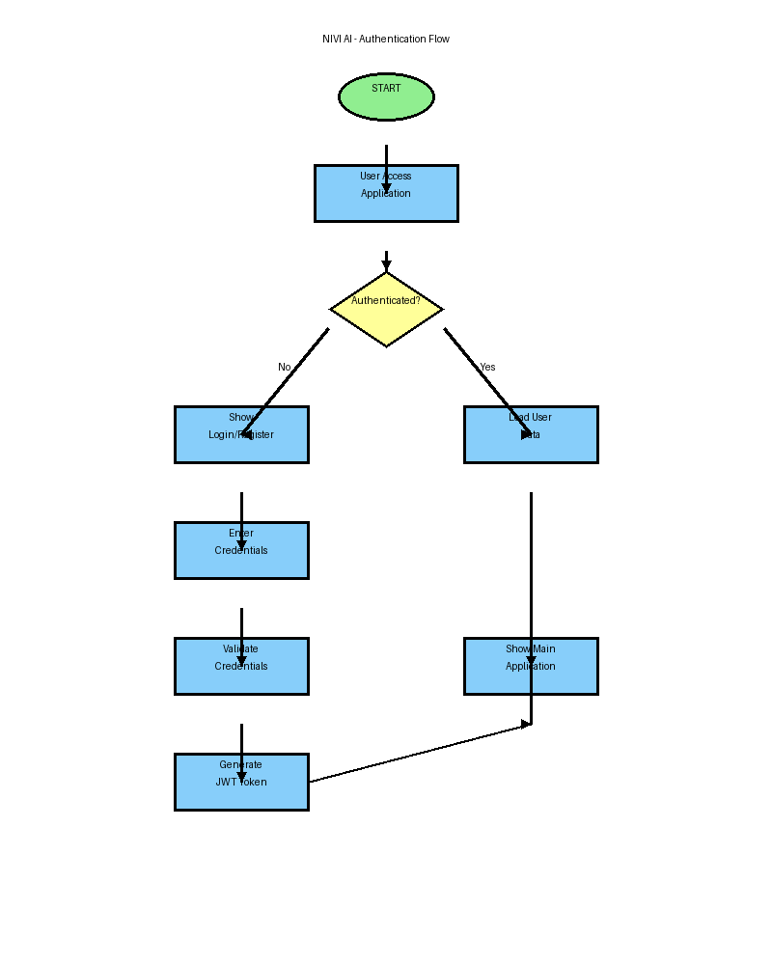
Figure 4.4: Authentication Flow

[IMPORTANT NOTE]
This document contains all IMAGES and DIAGRAMS embedded!
To complete your report:
1. Replace [YOUR NAME] and [YOUR ENROLLMENT NUMBER] with your details
2. Copy ALL CHAPTER CONTENT from Summer_Training_Report_Chapters.docx
3. The images are already embedded and will remain when you paste chapters
4. Add Table of Contents, List of Figures, List of Tables
5. Add page numbers and footer
6. Final review and print!
All images included:
- Internship Certificate
- Offer Letter
- System Architecture Diagram
- Use Case Diagram
- Data Flow Diagram
- Component Architecture
- Code Screenshots
- Authentication Flow
- NIVI AI Interface

