**Report (week 4)**

**Mohamed Hafiz (140647L)**

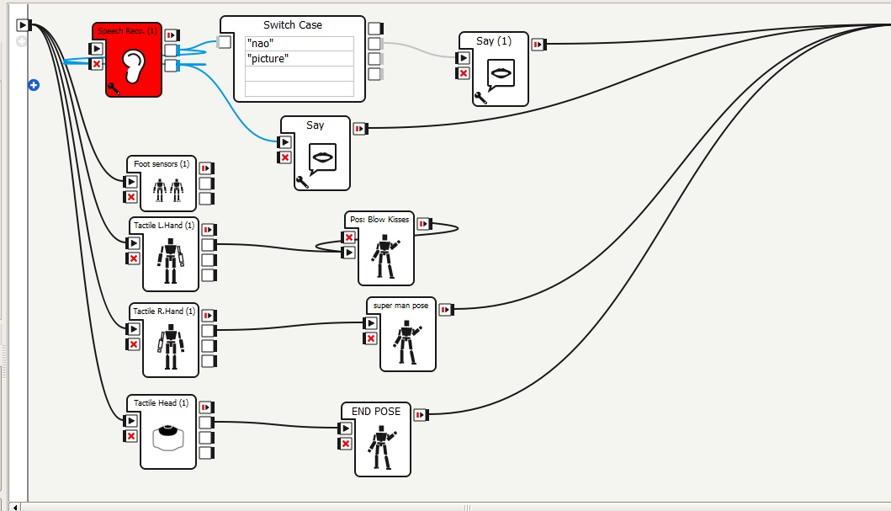

This week I added in a new posture “blow kisses”, as shown in the picture above the posture “blow kisses” will go on continuously in a loop until the head is touched to go back to initial position. It is in a loop because while the robot is repeating the posture, the users can make use of the loop to take a lot of pictures and videos with it. When the users are done, they can simply touch the head sensor and it will stop the loop, hence positioning the robot to its initial state.

As for the speech recognition, it still consist errors and I think it is not ready for testing. I will work on it and hopefully by the end of next week I will fix the errors.

My tasks includes:

* Implementing more postures
* Fix the speech recognition errors
* Make all sensors responsive for the posture to be triggered

Thank you.