ZGC

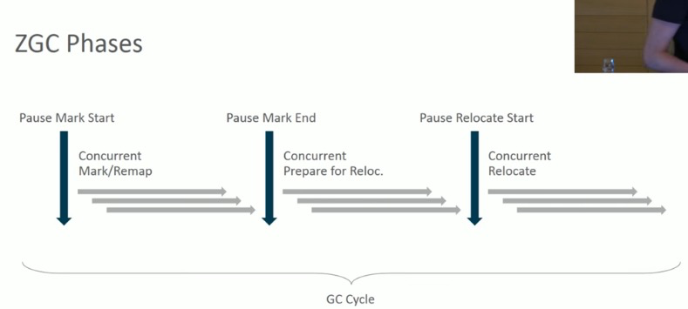

Marking & relocating

**Marking**->who is alive and who is garbage ->live map(bitmap) stores strongly-reachable and/or final-reachable

**Relocation**->relocation set is a set of pages，chosen to be evacuated based on some criteria after marking(e.g. those pages with the most amount of garbage.)

ZGC allocates **a forwarding table** for each page in the relocation set (basically a hash map that stores the address an object has been relocated to(if relocated)).

**Remapping** an object means looking up the new object address in the forwarding table; - 查找跳转表。

|  |  |  |
| --- | --- | --- |
|  | ZGC | Shenandoah |
| Region-based | √ | √ |
| Equally-sized regions | × a multiple of 2M | √ |
| Release memory to OS | × | √ （G1 too） |
|  |  |  |
|  |  |  |

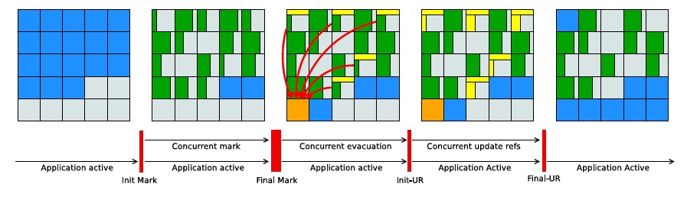

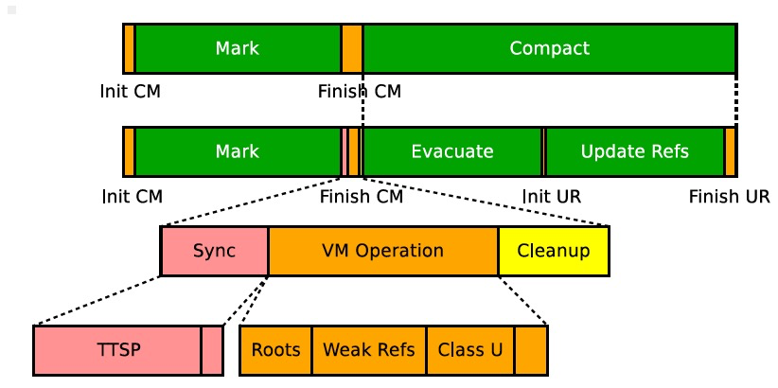

1. <https://dinfuehr.github.io/blog/a-first-look-into-zgc/>
2. <http://hg.openjdk.java.net/zgc/zgc/file/59c07aef65ac/src/hotspot/share/gc/z/zDriver.cpp#l301>
3. <https://openjdk.java.net/jeps/351>