Pulsar Architecture
A distribute pub-sub message system.
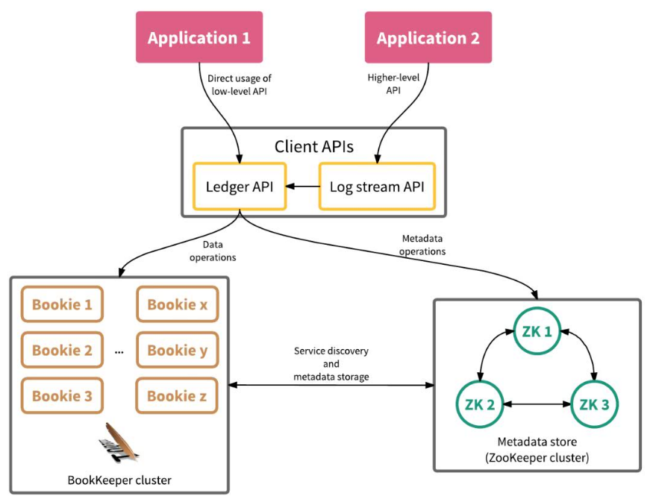
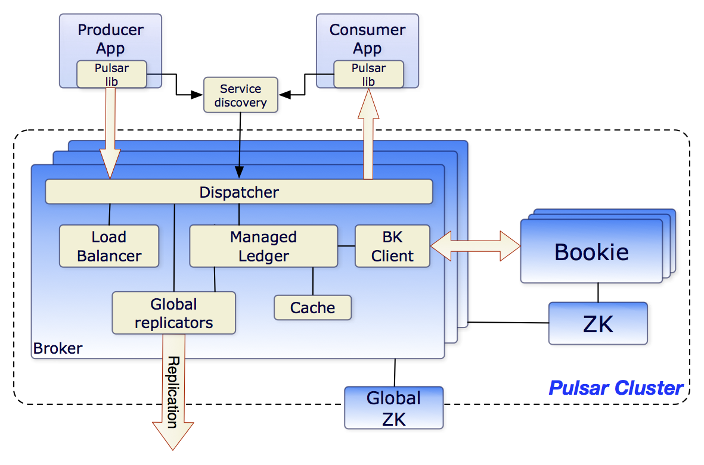
Broker consists of one HTTP server that exposes a REST API for both admin tasks and topic lookup for producers and consumers, and a dispatcher which is a asynchronous TCP server for all data transfer.
Managed ledgers
The managed ledger represents the storage layer for a single topic. 一个managed ledger代表某一个主题的存储层。
A single managed ledger uses multiple Bookkeeper ledgers to store the data. 使用多个Bookies保存数据。

