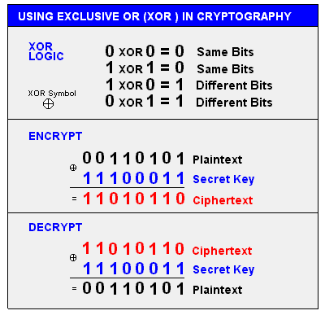

异或逻辑，保证xor(xor(x)) = x

[1] https://www.cs.cmu.edu/~dga/papers/cuckoo-conext2014.pdf