Envoy-and-service-mesh

What is a headless service in kubernetes?

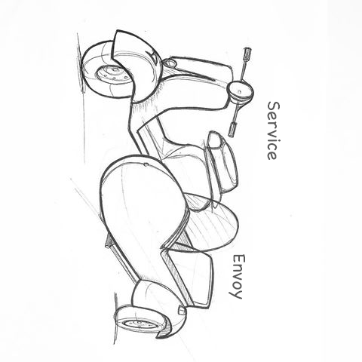

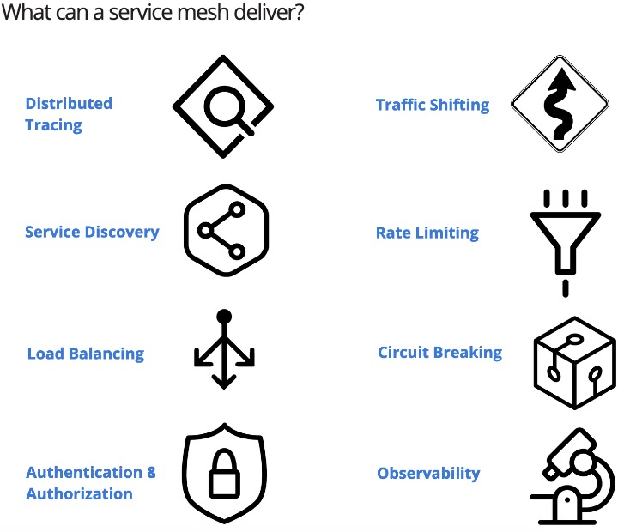

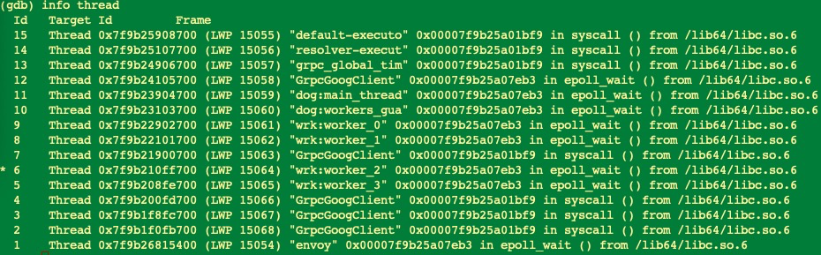

4个GrpcGoogClient线程 - syscall

4个wrk:worker线程 - epoll_wait

envoy主线程 - epoll_wait

dog:main_thread线程 - epoll_wait

dog:workers_gua线程 - epoll_wait

grpc_global_tim线程 - syscall

resolver-executor线程 - syscall

default-executor线程 - syscall

default-executor线程

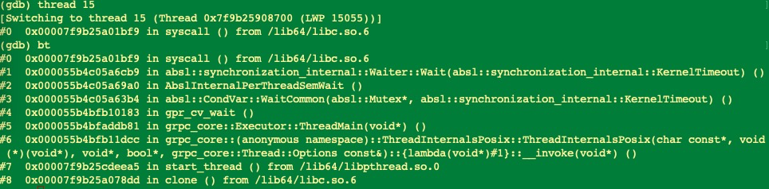

resolver-executor线程

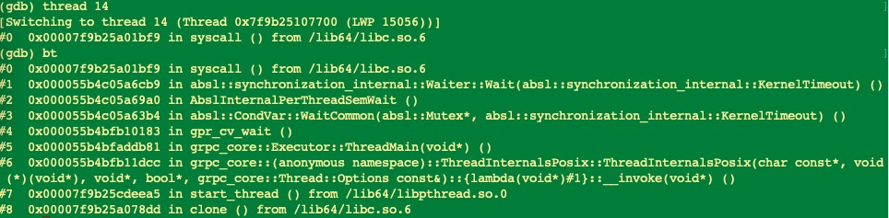

grpc_global_tim线程

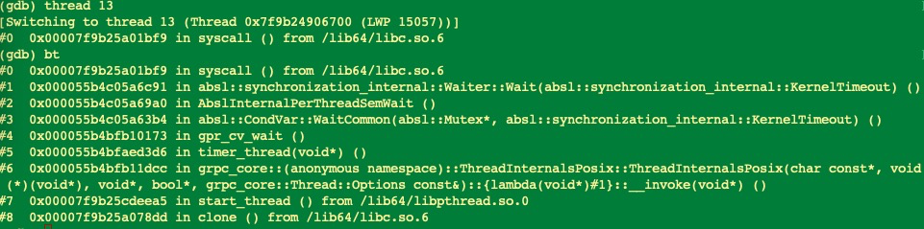

dog:workers_gua线程

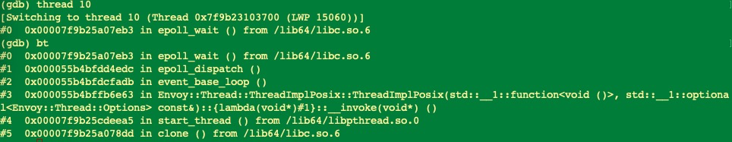

dog:main_thread线程

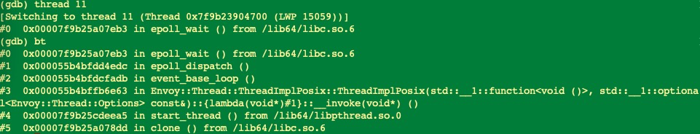

GrpcGoogClient线程

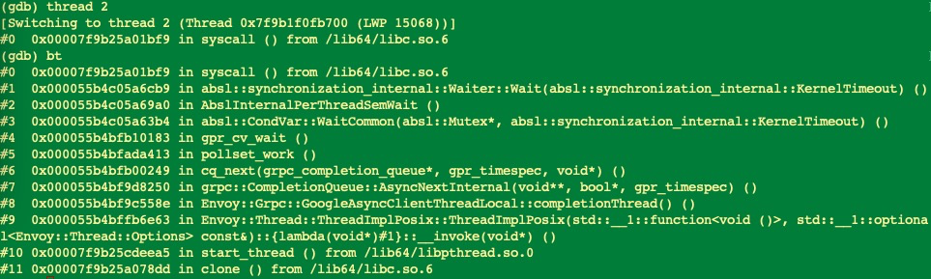

wrk:worker线程

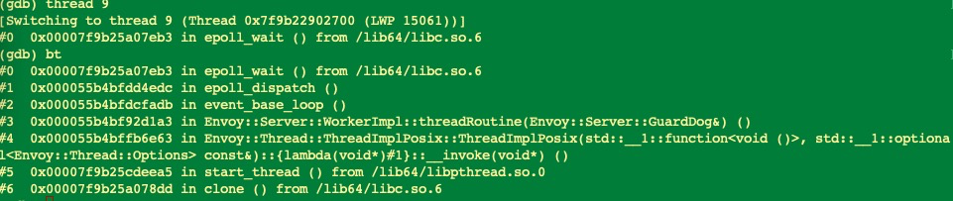

envoy主线程

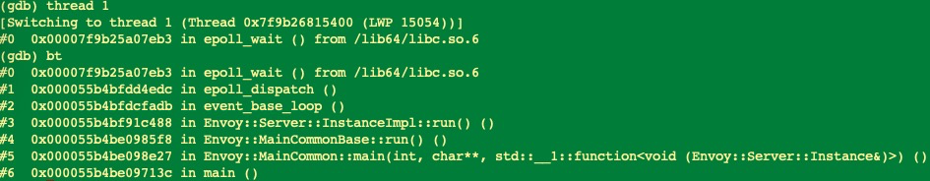

InstanceImpl

[1] <https://www.thoughtworks.com/insights/blog/building-service-mesh-envoy-0>

[2] <https://www.envoyproxy.io/>