zipkin: distributed trace

DevOps: dev+QA+Ops

container更轻量

Linux Namespace & Linux control group - cgroup

each kind of ns isolate one kind of resource

cgroups control how much resource are limited

ns1 ns2 ns3

r - | - | - |

r - | - | - |

r - | - | - |

r - | - | - |

docker is a platform for packaging， distributing and running app

images：something packaged together（apps and its env）

registries: repository that stores images

containers: docker based container is a regular Linux container created from a docker based container image.

docker image is built on top of another image （base image），类似COW，写时拷贝文件，读文件可以共享

rkt （an alternative to docker）- rock-it

Borg -> Omega -> Kubernetes

Kubernetes can be thought of as an operating system for the cluster.

Service discovery(DNS level), scaling, load-balancing, self-healing, and even leader election

hardware level:

master + worker

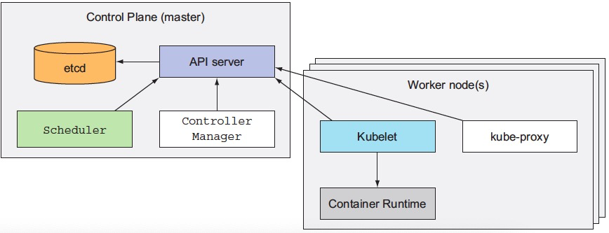

The Control Plane

API Server：通过其和用户和控制层组件交互

Scheduler：调度apps

Controller Manager：复制组件，跟踪工作节点，处理节点失败等。

Etcd：可靠的分布式数据存储，存储集群配置。

The Nodes

Docker，rkt，和其他容器运行时。

Kubelet，和API Server通信并管理所在节点容器

Kube-proxy：load-balances

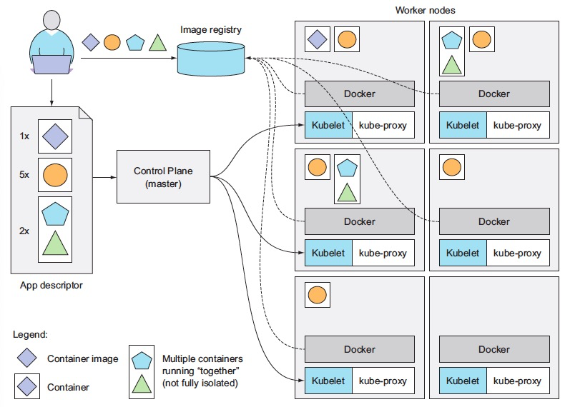 Kubelet instruct the container runtime（docker 。。。） to pull the required container images and run the containers.

The app descriptor groups containers into sets(pods)

控制多少实例，增加或者减少，重新调度

Pod：group of containers

同一个pod中拥有相同的本地地址，localhost，pods are logical hosts。

Kubelet runs all the other components as pods.

Docker logging-drivers

List / schedule pods with label selector

Node > pod > container > image

Kubelet restart container

ReplicationController - monitor pods

Three parts:

Label selector

Replica count

Pod template

RC可以自动扩展 - 根据描述文件修改。

ReplicationSet with more expressive pod selector, alternate replication controllere

DaemonSet