服务注册解决方案对比

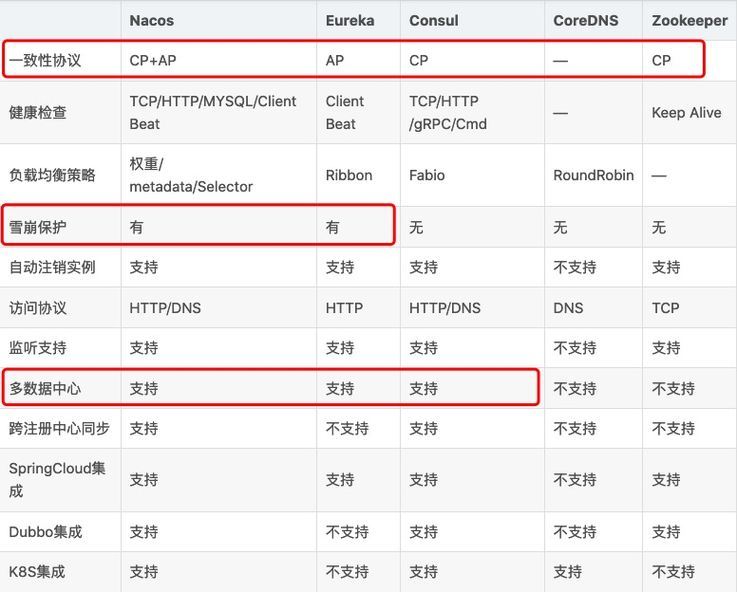

<https://blog.csdn.net/fly910905/article/details/100023415>