MPHY0058 Group Coursework – Heart Rate Estimation

Introduction

Photoplethysmography (PPG) is an optical technique used to detect changes in blood volume within tissue. During each cardiac cycle, changes in blood volume at the fingertip affect the degree of light absorption, causing the sensor to record periodic variations in light. These variations can be analysed to estimate heart rate [1]. And a smartphone cameras can extract pulse-related signals from video footage by recording changes in the brightness of the fingertip [2].

This project estimates heart rate from two datasets using Python. Part A analyses the reflected light signals recorded by an optical sensor. Part B converts fingertip video into a time series by calculating the average grey-scale intensity per frame [3]. The Fast Fourier Transform (FFT) is then used to identify the dominant frequency and convert this into beats per minute (bpm) [4,5]. Both signals are subjected to detrending and band-pass filtering in preparation for this operation [6,7,8,9,10]. A supplementary check is provided based on an estimate of the intervals between detected peaks. The analysis examines the consistency between these methods and considers factors that may influence the results.

2. Part A – Heart Rate from an Optical Sensor

2.1 Data Loading (Notebook section A.1)
The optical sensor data were provided as a headerless comma-separated file (heart_beat_signal.csv) with two columns: time in seconds and the intensity of light reflected from a fingertip in arbitrary units (a.u.). The file was loaded with pandas.read_csv using header=None. Without this argument, the first data row would be read as column names and one sample would be lost.
A function, load_signal(path), was written to load the file and return the time vector t, the signal x and the sampling frequency fs. The sampling frequency was estimated as the reciprocal of the mean time step between consecutive samples, fs = 1 / mean(diff(t)), rather than assumed. Writing loading as a function allows the same code to be reused for other recordings, including the grey-level signal extracted from the video in Part B.
The recording contains 913 samples from 0.033 s to 30.46 s, giving a sampling frequency of 29.97 Hz, which is consistent with a typical 30 frames-per-second phone camera. The time step varied only between 0.0330 s and 0.0340 s, so the signal can be treated as uniformly sampled, which is a requirement for the Fast Fourier Transform (FFT) used in Section 2.4. No missing values were present.

2.2 Raw Signal (Notebook section A.2, Task 1.1)
Figure 1 shows the raw signal against time. Before any processing, a clear periodic pattern is visible, with around 27 cycles in 30 s. Each cycle corresponds to one heartbeat: as arterial blood volume in the fingertip increases during systole, more light is absorbed and less is reflected, followed by a gradual recovery as blood volume falls [1,11]. In this recording each cycle shows a slow rise followed by a sharp drop. The sharp drop is consistent with the rapid systolic increase in blood volume.
Three features of the raw signal motivated the pre-processing described in Section 2.3:
- Baseline drift. The signal is elevated during the first ~4 s and drifts slowly downward across the recording. This is likely caused by changes in finger contact pressure as the finger settles on the sensor.
- A local disturbance at ~16–17 s, where the troughs drop well below the surrounding cycles. This is possibly due to a small finger movement or a respiratory effect.
- Varying peak amplitude between cycles (signal range 8.6–38.3 a.u.).
None of these features carry information about heart rate, and they could bias frequency-domain or peak-based estimates.
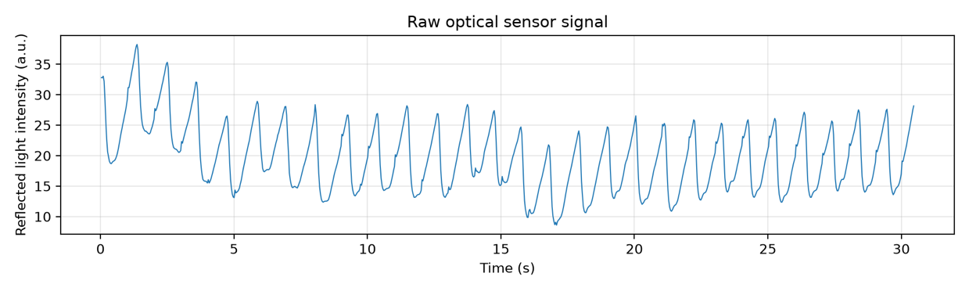
Figure 1. Raw reflected-light intensity from the optical sensor over the 30 s recording. Each cycle corresponds to one heartbeat; baseline drift is visible in the first 5 s.

2.3 Pre-processing: Detrending and Band-pass Filtering (Notebook section A.3)
Two pre-processing steps were applied.
Detrending. A least-squares linear trend was removed with scipy.signal.detrend [6]. The fitted trend fell from approximately 22.5 to 16.8 a.u. over the recording (Figure 2, top). Removing it first centres the signal on zero and reduces transients at the edges of the subsequent filter.
Band-pass filtering. A Butterworth band-pass filter [8] was applied with cut-off frequencies of 0.7 Hz and 3.0 Hz, corresponding to 42–180 beats per minute (bpm). This band covers resting and moderately elevated adult heart rates. It excludes respiratory components (typically 0.2–0.3 Hz) and higher-frequency noise from the sensor and small movements. The band limits were stored once as a constant, HR_BAND = (0.7, 3.0), and used throughout the notebook so that the band can be changed in one place.
The design choices were:
- Butterworth response: it has a maximally flat passband, so the amplitude of components inside the heart-rate band is not distorted [8].
- Third order: this is a compromise between a sharp roll-off at the cut-off frequencies and limited edge transients and numerical stability.
- Zero-phase filtering with filtfilt: the signal is filtered forwards and then backwards, which cancels the phase delay of the filter [12]. This keeps each peak at its true time position, which is essential for the time-domain peak detection in Section 2.5.
The filter is implemented in the function bandpass(signal, fs, band=HR_BAND, order=3), which designs the filter with scipy.signal.butter (specifying cut-offs directly in Hz via the fs argument) and applies it with scipy.signal.filtfilt [6]. As a reusable function, it is applied unchanged to the video-derived signal in Part B.
After filtering (Figure 2, bottom), the signal oscillates regularly around zero between approximately −6 and +8 a.u. The baseline drift and the disturbance at 16–17 s are removed, and every cardiac cycle is clearly resolved. Small irregularities in the first and last ~0.5 s are edge effects of the filter and do not affect the heart-rate estimates.
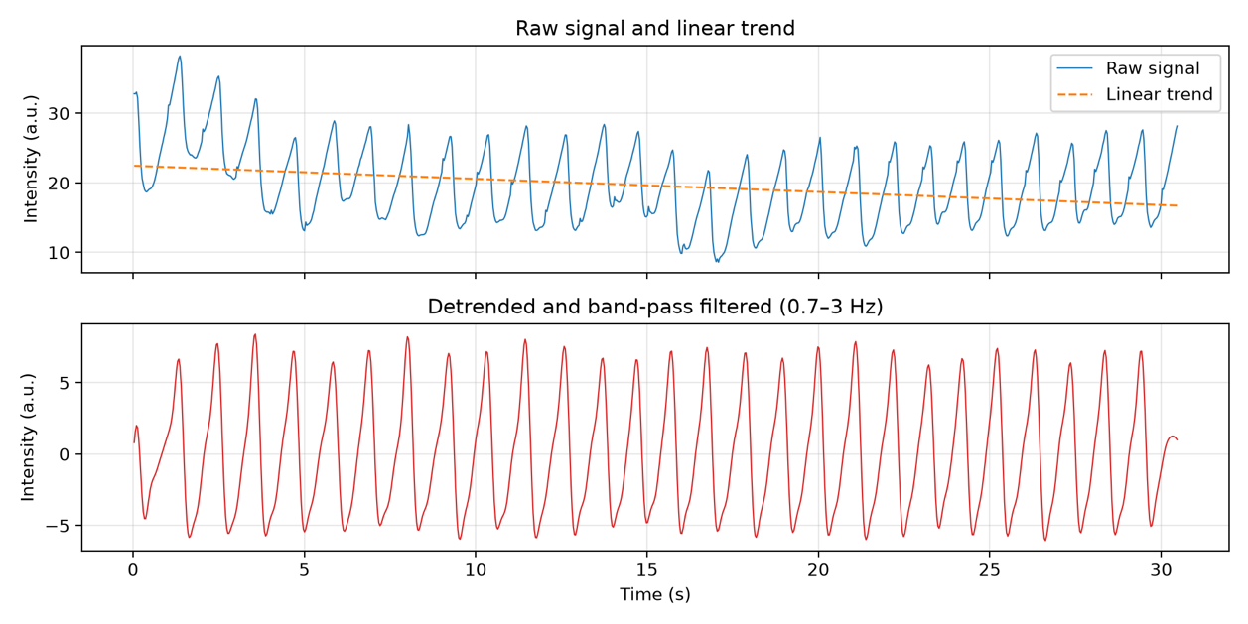
Figure 2. Top: raw signal (blue) and the linear trend removed by detrending (orange dashed). Bottom: detrended signal after zero-phase Butterworth band-pass filtering (0.7–3 Hz).

2.4 Heart Rate from the Frequency Spectrum (Notebook section A.4, Task 1.2)
Because the filtered signal repeats once per heartbeat, its energy is concentrated at the cardiac frequency. The Fast Fourier Transform (FFT) [4,5] decomposes the signal into sinusoidal components, so the heart rate can be read from the frequency of the largest peak in the magnitude spectrum, f_{HR}, as HR = 60 × f_{HR} beats per minute (bpm).
This was implemented in the function estimate_hr_fft(signal, fs, band=HR_BAND), which performs the following steps:
- np.fft.rfft: computes the FFT of a real-valued signal. The spectrum of a real signal is symmetric, with the negative frequencies mirroring the positive ones, so rfft returns only the N/2 + 1 non-negative frequency bins (457 bins for N = 913 samples) [4]. This avoids having to discard the negative half by hand, as would be needed with np.fft.fft.
- np.fft.rfftfreq(N, d=1/fs): returns the frequency in Hz of each bin, using the sample spacing 1/fs.
- np.abs: converts the complex FFT coefficients into a magnitude spectrum.
- Search band: a Boolean mask keeps only the bins inside HR_BAND (0.7–3.0 Hz), and np.argmax returns the bin with the largest magnitude. Restricting the search means that residual drift near 0 Hz or noise above 3 Hz cannot be mistaken for the heart rate, even though the band-pass filter has already attenuated them.
The function returns the heart rate, the peak frequency and the full spectrum, so it can be applied unchanged to the video signal in Part B.
The magnitude spectrum is shown in Figure 3. A single dominant peak occurs at 0.919 Hz, giving a heart rate of 55.1 bpm. Smaller peaks appear at 1.77 Hz and 1.90 Hz, close to twice the fundamental frequency (1.84 Hz), with only 26–28% of the magnitude of the main peak. These form the second harmonic of the heart rate. The pulse waveform is not a pure sinusoid but has a sharp drop followed by a slower recovery (Section 2.2), and any periodic non-sinusoidal waveform contains components at integer multiples of its fundamental frequency. The harmonic appears as two peaks rather than one, most likely because the heart rate varied slightly during the recording (Section 2.6). Selecting the largest peak in the band, rather than the highest-frequency one, therefore correctly identifies the fundamental.
The precision of this estimate is limited by the frequency resolution of the FFT, Δf = fs / N = 29.97 / 913 = 0.033 Hz. The bins on either side of the peak correspond to 53.2 bpm and 57.1 bpm, so the FFT can only report the heart rate in steps of about 2 bpm, and the true value lies within ±1.0 bpm (half a bin) of 55.1 bpm. Because Δf equals 1 / (recording duration), the resolution can only be genuinely improved by recording for longer; zero-padding the signal interpolates between bins but adds no new information. This limitation is discussed further in Section 4.
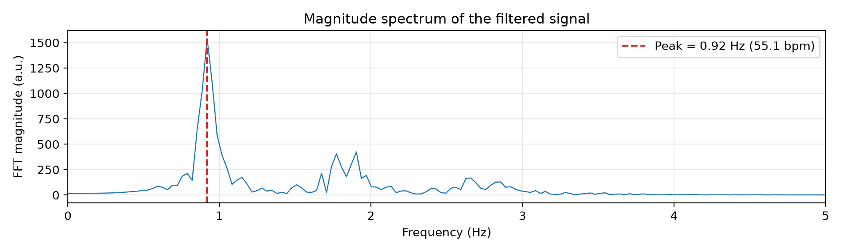
Figure 3. Magnitude spectrum of the filtered optical signal from 0 to 5 Hz. The dominant peak at 0.92 Hz (red dashed line) corresponds to 55.1 bpm; the smaller peaks near 1.8–1.9 Hz are its second harmonic.

2.5 Validation with Peak Detection (Notebook section A.5)
The FFT returns a single dominant frequency for the whole recording and could, in principle, be biased by harmonics or noise. As an independent check, the heart rate was also estimated in the time domain by locating individual heartbeats. Because the two methods rely on different assumptions, agreement between them increases confidence in the result.
This was implemented in the function estimate_hr_peaks(signal, t, fs, max_bpm=180), which uses scipy.signal.find_peaks [6] to locate local maxima in the filtered signal. Two constraints were applied so that each heartbeat is counted exactly once:
- Minimum distance: peaks must be at least int(fs × 60 / max_bpm) = 9 samples (0.30 s) apart. This matches the upper edge of the heart-rate band (180 bpm) and prevents a small shoulder within the same cardiac cycle from being counted as a second beat.
- Minimum height: peaks must be higher than the standard deviation of the filtered signal (4.05 a.u.). All true systolic peaks lie between 6.2 and 8.4 a.u. Without this threshold, 29 peaks were found; the two extra peaks were small bumps at 0.10 s (2.0 a.u.) and 30.33 s (1.3 a.u.) caused by the filter edge effects noted in Section 2.3. Defining the threshold relative to the spread of the signal, rather than as a fixed value, allows the same function to be used on the video signal in Part B, whose amplitude is in different units.
The inter-beat intervals (IBIs) were then calculated as the differences between the time stamps of consecutive peaks, ibi = np.diff(t[peaks]), and the heart rate as 60 / mean(ibi). The zero-phase filtering described in Section 2.3 is important here, because it ensures that the peaks are not shifted in time.
Figure 4 shows the 27 detected beats, between 1.33 s and 29.43 s. Visual inspection confirms that every cardiac cycle is detected once, with no missed or false beats. The 26 inter-beat intervals had a mean of 1.081 ± 0.059 s (mean ± SD; range 0.967–1.201 s), giving a heart rate of 55.5 bpm. This differs from the FFT estimate by only 0.4 bpm, which is within the ±1.0 bpm resolution of the FFT.
The time-domain estimate is also less affected by the short recording. The mean IBI is equal to the time between the first and last detected peaks divided by the number of intervals, so a timing error of one sample (0.033 s) in either of these peaks changes the result by only about 0.1 bpm. However, peak detection depends on parameter choices (minimum distance and height) that may need adjusting for noisier signals, whereas the FFT does not require individual beats to be clearly visible. The two methods are therefore complementary.
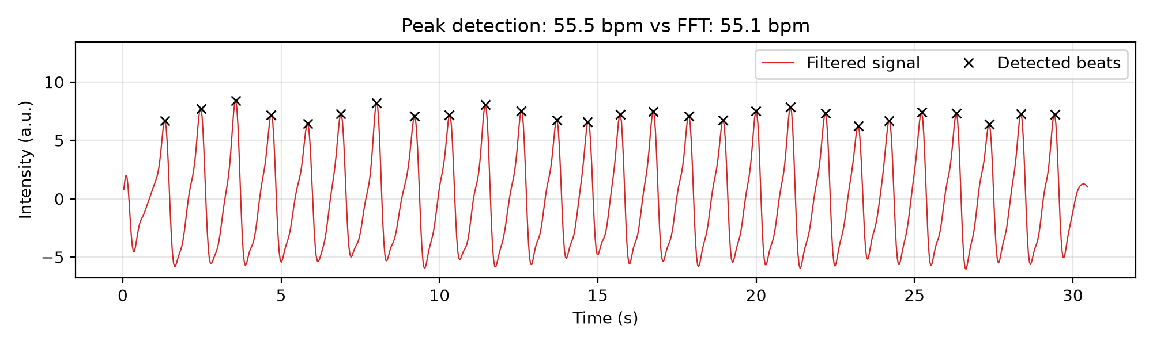
Figure 4. Band-pass filtered optical signal with the 27 heartbeats detected by find_peaks (black crosses). The mean inter-beat interval gives 55.5 bpm, compared with 55.1 bpm from the FFT.

2.6 Summary of Part A Results (Notebook section A.6)
Table 1 summarises the heart rate obtained by the two independent methods. The FFT estimate (55.1 bpm) and the peak-detection estimate (55.5 bpm) differ by only 0.4 bpm. This difference is smaller than the frequency resolution of the FFT for a 30 s recording (0.033 Hz, or ±1.0 bpm at half a frequency bin), so the two methods agree within the precision of the analysis. The heart rate of the subject during this recording is therefore approximately 55 bpm, which is within the normal resting range for a healthy adult.
Table 1. Heart rate estimated from the optical sensor signal.
Method | Heart rate (bpm)
FFT (dominant frequency, 0.92 Hz) | 55.1
Peak detection (27 beats) | 55.5
Beat-to-beat heart rate (mean ± SD) | 55.7 ± 3.1
The beat-to-beat heart rate was obtained by converting each individual inter-beat interval to bpm (60 / ibi). Its mean (55.7 bpm) is slightly higher than the peak-detection estimate (55.5 bpm). This is expected rather than an error: the peak-detection value is calculated as 60 divided by the mean interval, whereas the beat-to-beat mean averages the reciprocals of the intervals, and for intervals that vary the mean of reciprocals is always slightly larger (Jensen’s inequality). The standard deviation of 3.1 bpm shows that the heart rate naturally varied by a few bpm during the 30 s recording, consistent with normal heart rate variability [13]. A single FFT estimate cannot capture this variation, since it reports only the dominant frequency over the whole window. This limitation is discussed further in Section 4.
The results table and the filtered signal were saved as data/partA_results.csv and data/partA_filtered_signal.csv, so the processed data can be reused and are included in the submission.

3. Part B – Heart Rate from a Video Recording

3.1 Video Loading and Grayscale Signal Extraction (Notebook section B.1)
The supplied video, video_of_finger.MOV, records a fingertip placed over a phone camera. Phone-camera photoplethysmography (PPG) uses pulsatile changes in the light recorded from tissue to obtain a signal related to blood-volume changes [2]. The supplied brief does not specify the illumination source or optical geometry. The video was converted into a one-dimensional intensity signal, which was then processed with the filtering function developed in Part A.
A function, load_video_signal(path), was written to return the time vector t_v, the mean grayscale signal v, and the video sampling frequency fs_v. OpenCV’s VideoCapture reads the video frame by frame. Each frame is converted from BGR to grayscale using cv2.cvtColor with COLOR_BGR2GRAY, which applies the weighting Y = 0.299R + 0.587G + 0.114B [3]. The mean of all grayscale pixels in each frame is then calculated. This directly implements the required mean-grayscale measurement and produces one intensity value per frame.
The recording contains 1,852 frames with a reported frame rate of 29.98 Hz. Frame times were calculated as t_{i} = i/f_{s}, assuming uniformly spaced frames, giving a time axis from 0 to 61.7 s. The frame rate is close to the 29.97 Hz sampling frequency in Part A. The bandpass function is reused by supplying the video’s sampling frequency through its fs argument.
Input checks reject videos that cannot be opened, have an invalid frame rate, contain fewer than 10 seconds of decoded frames, or produce a numerically flat signal. The frame rate must exceed 6 Hz so that the selected upper filter frequency of 3 Hz lies below the Nyquist frequency. The 10-second minimum provides seven cycles at the lower band edge of 0.7 Hz; it is a practical minimum rather than a guarantee of accuracy. A try/finally block releases the video resource even if an error occurs.

3.2 Raw Video Signal (Notebook section B.2, Task 1)
Figure 5 shows the mean grayscale intensity against time. Values range from 53.6 to 70.1 on the 0–255 grayscale scale, with a mean of 60.5. Repeated intensity fluctuations are visible throughout the recording, superimposed on a downward-moving baseline.
The baseline does not change uniformly. A step-like decrease occurs around 15–16 s, and smaller variations are visible elsewhere. Changes in finger contact pressure or camera exposure could contribute to these features, although their causes cannot be established from the intensity signal alone. Such baseline changes introduce components unrelated to the periodic signal of interest and motivate the pre-processing described in Section 3.3.
The raw time series was saved as data/partB_mean_gray.csv, containing time in seconds and mean grayscale intensity. This allows the extracted signal to be reused without decoding the video again; detrending and filtering are still required before subsequent analysis.
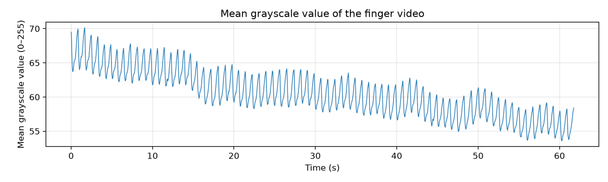
Figure 5. Mean grayscale intensity of the finger video over the 61.7 s recording. Repeated fluctuations are superimposed on a downward baseline drift, with a step-like decrease around 15–16 s.

3.3 Pre-processing: Detrending and Band-pass Filtering (Notebook section B.3)
Two pre-processing steps were applied, following the approach used in Section 2.3.
Detrending. Baseline drift introduces low-frequency variation that can obscure the periodic component of interest. To reduce this contribution, a least-squares linear trend was removed using scipy.signal.detrend [7]. The fitted trend decreases from 65.4 to 55.5 grayscale units, corresponding to a slope of approximately −0.161 grayscale units per second (Figure 6, top). Subtracting this trend removes the overall downward slope. However, it does not fully remove local baseline changes: the mean detrended signal is approximately +0.38 over 10–15 s and −1.09 over 16–21 s, consistent with the step-like decrease observed in the raw signal.
Band-pass filtering. The detrended signal was passed to the existing bandpass(signal, fs, band=HR_BAND, order=3) function using the video sampling frequency. As described in Section 2.3, this function designs a Butterworth band-pass filter with scipy.signal.butter and applies forward–backward filtering with scipy.signal.filtfilt [9,10]. The selected 0.7–3 Hz band corresponds to 42–180 bpm. Filtering attenuates slower baseline variations and higher-frequency components outside this analysis band. Forward–backward filtering produces zero phase, although the filter still changes amplitudes according to frequency.
The processed signal oscillates regularly around zero (Figure 6, bottom). Within the interval excluding the first and last 2 s, its amplitude ranges from approximately −2.6 to +3.1 a.u. Larger excursions of approximately −3.7 to +3.8 a.u. occur during the first second and may include filter edge transients; their origin cannot be determined from the filtered trace alone. The interior interval is used here only to describe the amplitude range, and the code retains the full signal.
After both detrending and filtering, a standard deviation below 1e-8 triggers an error. This numerical check rejects near-flat signals but does not establish that the remaining variation is physiological. The processed signal provides the input for subsequent Hann-windowed FFT analysis and prominence-based peak detection (notebook Sections B.5 and B.7).
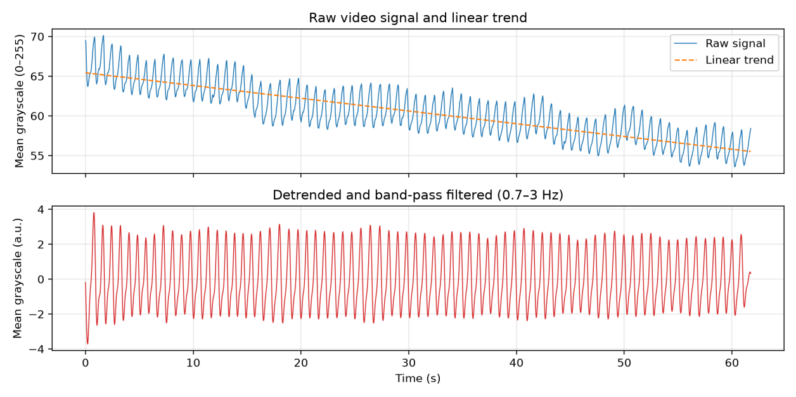
Figure 6. Top: raw mean grayscale intensity and the fitted linear trend. Bottom: the signal after linear detrending and forward–backward Butterworth band-pass filtering at 0.7–3 Hz.

3.4 Hann-windowed FFT and Heart-rate Estimation (Notebook sections B.4–B.6, Task 2)
Prior to applying frequency analysis, the time vector and filtered signal were examined for differing length, non-finite values and a possibly incorrect sampling interval. The heart rate analysis was performed in 1852 filtered samples at 29.978Hz. The reliability of the constructed time axis is confirmed using these tests as previously noted, while the verification of the original frame timing is considered separately in the Discussion.
Heart rate was first derived using video_fft_hr (signal, sampling_rate, band=HR_BAND), then subtracted the residual mean and use the Hann window by using np.hanning to reduce spectral leakage from finite recording [13]. After using that window with the signal, the signal is transformed by using np.fft.rfft, and np.fft.rfftfreq was used for the frequency bins [3]. All FFT magnitudes were divided by the sum of the window coefficients and similarly converted into a single-sided amplitude spectrum (both DC and Nyquist components are not doubled). The spectral amplitude that was maximum in the band 0.7–3.0Hz was chosen and was converted to the heart rate using: HR = 60* f_peak.
Δf = fs_v/N = 0.0162Hz, which is equivalent to roughly 0.97bpm [3]. This gives the spacing of the available FFT estimates (as opposed to a guaranteed measurement-error bound) and we used no zero-padded FFTs [3]. In looking at the spectrum in Figure 7 made clear that the peak within the selected search band is dominant with an estimated heart rate derived from the magnitude of approximately 72bpm. A smaller peak close to twice the dominant frequency is compatible with a harmonic of the non-sinusoidal pulse waveform. The characteristics of the dominant peak chosen to represent pulse frequency. 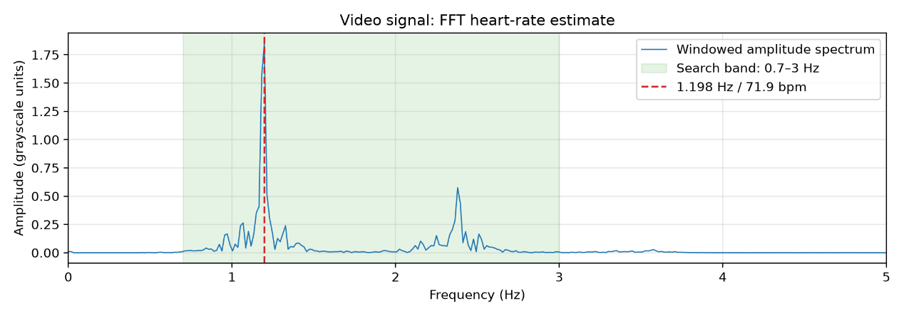
Figure 7. Hann-windowed single-sided amplitude spectrum of the detrended and band-pass filtered video signal. The green shaded region indicates the 0.7–3.0Hz search band. The red dashed line marks the dominant frequency at 1.1978Hz, corresponding to an estimated heart rate of 71.9bpm. The smaller peak near 2.4Hz is consistent with a second harmonic of the pulse waveform.

3.5 Time-domain Consistency Check (Notebook section B.7)
We also estimated the heart rate by looking at the intervals between maxima detected with scipy.signal.find_peaks [14]. The minimum separation, ceil(fs_v / 3), was 10 samples, about 0.334 s, to disfavor detections closer together than the upper analysis frequency supports. A minimum prominence of 0.5 times the filtered signal's standard deviation was employed to filter out smaller fluctuations. In contrast to the height threshold employed in Part A, prominence measures how pronounced a particular peak is relative to a baseline made of its immediate neighbors above [14].
This algorithm detected 73 maxima, giving rise to 72 consecutive peak intervals. Heart rate was calculated as 60 divided by the mean interval, yielding 71.91bpm and an implied mean interval of ~0.834s. This example differs from the FFT estimate of 71.87bpm by only approximately 0.038bpm. Rounding to one decimal place, the two gave the same estimate of 71.9bpm.
Figure 8: General shape of detected peaks matches successive cycles of the filtered waveform. Their mean interval yielding a heart rate estimate at the same level indicates the consistency between time-domain and frequency-domain analysis. It might be argued since this uses the same processed signal for both methods, it cannot serve as an accuracy test against an independent reference. 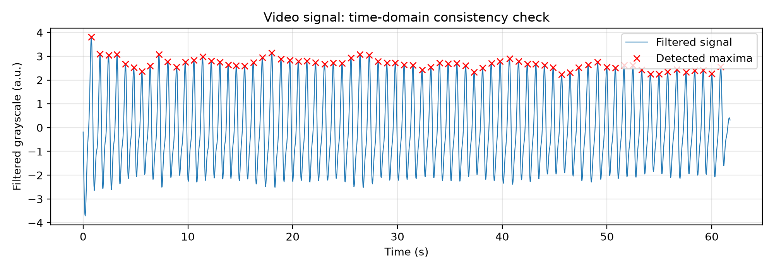
Figure 8. Time-domain consistency check of the video-derived signal after detrending and 0.7–3.0Hz band-pass filtering. The blue curve shows the filtered signal, and red crosses mark the 73 detected maxima. The mean interval between consecutive maxima was approximately 0.834s, giving a heart-rate estimate of 71.91bpm, compared with 71.87bpm from the FFT.

3.6 Segment Analysis and Summary of Results (Notebook sections B.8–B.9)
Temporal consistency was examined using four complete, non-overlapping segments of approximately 15.01s, covering 0–15.01s, 15.01–30.02s, 30.02–45.03s and 45.03–60.04s. The remaining approximately 1.7s of the recording was excluded from this segment analysis but retained in the full-recording estimate.
Each segment was analysed using the same Hann-windowed FFT function. All four returned 71.95bpm, indicating that the same dominant frequency bin was selected throughout the recording. Their frequency-bin spacing was approximately 4.00bpm, so these identical estimates demonstrate consistency at the available spectral granularity rather than an absence of smaller heart-rate fluctuations. The slight difference from the full-recording estimate arises because the shorter segments have a different FFT frequency grid [3].
Overall, the full-recording FFT and peak-interval methods both estimated approximately 71.9bpm. The numerical estimates were saved in data/partB_results.csv. The filtered signal, amplitude spectrum, detected peak locations and segment results were saved as separate CSV files, together with the spectrum and peak-detection figures, to support reproducibility and subsequent inspection.

4. Discussion — Part B
Video decoding was identified as a source of variation in the extracted intensity values: different decoding backends produced different grayscale values from the same source file, with a first-frame mean of 55.7 using FFmpeg compared with 70.5 using AVFoundation on the same computer. Reproducible comparisons should therefore use a consistent decoding pipeline and record the software version and backend. Whole-frame averaging also gives equal weight to every pixel, including peripheral, dark or bright regions that may contain little useful pulsatile information. Comparing the full-frame signal with a central fingertip region of interest could help assess whether excluding these regions improves signal quality.
The time axis was calculated as i/f_{s}, assuming uniformly spaced frames. For a variable-frame-rate recording, this approximation could misrepresent the timing of intensity changes. For this recording, timestamps reported by OpenCV with the FFmpeg backend differed from i/f_{s} by at most 1.3 ms, less than 4% of a typical frame interval. This supports the uniform-spacing approximation for the present analysis. For other recordings, frame timestamps should be checked and the signal resampled onto a uniform time grid where necessary before filtering. The minimum-duration and numerical-flatness checks reject obvious input failures, but do not assess whether the remaining variation is a usable pulse signal.
The full-recording FFT estimate of 71.87bpm closely agreed with the peak-interval estimate of 71.91bpm, differing by approximately 0.038bpm. This agreement supports the interpretation that the dominant spectral component corresponds to the repeated cycles visible in the filtered waveform. The smaller component near 2.4Hz is consistent with a second harmonic, whereas the dominant peak at 1.1978Hz and the approximately 0.834s mean peak interval both support a fundamental rate near 72bpm. Nevertheless, these methods analyse the same signal and may be affected by common artefacts. Agreement therefore demonstrates internal consistency rather than accuracy against an independent reference.
The four segment estimates were identical at 71.95bpm, suggesting that no change large enough to move the selected dominant frequency to another bin was detected. However, the approximately 4bpm bin spacing of the 15-second segments limits the interpretation of this result. Smaller variations can occur without changing the selected bin. The full-recording spacing of approximately 0.97bpm is finer because FFT frequency spacing depends on the sampling frequency and number of samples [3]. Neither spacing nor half of it constitutes a guaranteed error bound: noise, non-stationarity and incorrect spectral-peak selection can produce additional estimation errors.
Several processing choices could affect the estimates. The Hann window reduces leakage but broadens spectral peaks [13], while the Butterworth filter changes the relative amplitudes of frequency components and forward–backward filtering can produce edge transients [8], [9]. The first detected maximum is visibly larger than many subsequent maxima and lies near the recording boundary, so an edge transient may contribute to it. Repeating the analysis after excluding short intervals at both ends would help assess this sensitivity. The prominence threshold of 0.5 times the signal standard deviation should also be checked by varying it moderately and inspecting whether peaks are missed or counted twice. These sensitivity checks were not included in the present results.
The selected 0.7–3.0Hz band restricts possible estimates to 42–180bpm and could exclude pulse rates outside this range. Artefacts within the band may still be retained, so filtering alone does not establish that the remaining variation is physiological. Further validation would require a simultaneously recorded reference, such as ECG or a validated pulse monitor. The difference between the approximately 55bpm estimate in Part A and 72bpm in Part B cannot be interpreted as disagreement between measurement devices because the supplied recordings are not established as simultaneous measurements under identical conditions.

Reference
- Jonathan, E. and Leahy, M. (2010) ‘Investigating a smartphone imaging unit for photoplethysmography’, Physiological Measurement, 31(11), pp. N79–N83. Available at: https://iopscience.iop.org/article/10.1088/0967-3334/28/3/R01
- E. Jonathan and M. Leahy, “Investigating a smartphone imaging unit for photoplethysmography,” Physiological Measurement, vol. 31, no. 11, pp. N79–N83, 2010. doi: 10.1088/0967-3334/31/11/N01. Available at: https://doi.org/10.1088/0967-3334/31/11/N01
- NumPy Developers, "Discrete Fourier Transform (numpy.fft)," NumPy Documentation. Available at: https://numpy.org/doc/stable/reference/routines.fft.html.
- J. W. Cooley and J. W. Tukey, "An algorithm for the machine calculation of complex Fourier series," Mathematics of Computation, vol. 19, no. 90, pp. 297–301, 1965. doi: 10.1090/S0025-5718-1965-0178586-1. Available at: https://doi.org/10.1090/S0025-5718-1965-0178586-1.
- P. Virtanen et al., “SciPy 1.0: Fundamental algorithms for scientific computing in Python,” Nature Methods, vol. 17, pp. 261–272, 2020. Available at: https://www.nature.com/articles/s41592-019-0686-2
- SciPy, “scipy.signal.detrend,” SciPy Documentation. Available at: https://docs.scipy.org/doc/scipy/reference/generated/scipy.signal.detrend.html.
- S. Butterworth, “On the theory of filter amplifiers,” Wireless Engineer, vol. 7, pp. 536–541, 1930. Available at: https://www.changpuak.ch/electronics/downloads/On_the_Theory_of_Filter_Amplifiers.pdf
- SciPy, “scipy.signal.butter,” SciPy Documentation. Available at: https://docs.scipy.org/doc/scipy/reference/generated/scipy.signal.butter.html.
- SciPy, “scipy.signal.filtfilt,” SciPy Documentation. Available at: https://docs.scipy.org/doc/scipy/reference/generated/scipy.signal.filtfilt.html.
- M. Elgendi, “On the analysis of fingertip photoplethysmogram signals,” Current Cardiology Reviews, vol. 8, no. 1, pp. 14–25, 2012. Available at: https://pmc.ncbi.nlm.nih.gov/articles/PMC3394104/
- F. Gustafsson, “Determining the initial states in forward-backward filtering,” IEEE Transactions on Signal Processing, vol. 44, no. 4, pp. 988–992, 1996. Available at: https://ieeexplore.ieee.org/stamp/stamp.jsp?arnumber=553549
- F. Shaffer and J. P. Ginsberg, “An overview of heart rate variability metrics and norms,” Frontiers in Public Health, vol. 5, p. 258, 2017. Available at: https://pmc.ncbi.nlm.nih.gov/articles/PMC5624990/
13. NumPy, “numpy.hanning,” NumPy Documentation, version 2.0. [Online]. Available: https://numpy.org/doc/2.0/reference/generated/numpy.hanning.html. Accessed: Nov. 5, 2026.

14. SciPy, “scipy.signal.find_peaks,” SciPy Documentation, version 1.11.4. [Online]. Available: https://docs.scipy.org/doc/scipy-1.11.4/reference/generated/scipy.signal.find_peaks.html. Accessed: Nov. 5, 2026.

AI声明将最后统一填写

