**Problem background**

The world is undergoing the largest wave of urban growth in history. More than half of the world’s population now lives in towns and cities, and by 2030 this number will swell to about 5 billion. Much of this urbanization will unfold in Africa and Asia, bringing huge social, economic and environmental transformations. Even though urbanization has the potential to usher in a new era of well-being, resource efficiency and economic growth. But cities are also home to high concentrations of poverty. Nowhere is the rise of inequality clearer than in urban areas, where wealthy communities coexist alongside, and separate from, slums and informal settlements. Also more environment pollution will be produced in urban area. The advantages of urbanization will not remedy the disadvantages in many city.

**Problem Description**

Our goal is to establish a set of evaluation system for the level of the smart growth in a city, which can predict and evaluate the potential of the development of a city in next few decades. And also we need to put forward a practical and feasible plan for the city development, so that the city will get higher score in our evaluation system. For the problems above, we use Analytic Hierarchy Process to evaluate whether a urbanization is smart growth or not.

**Method used**

In the process of selection evaluation index, the Analytic Hierarchy Process is adopted, and the degree of smart growth in a city will be evaluate by specific score.

For the selection of indicators we avoid the way of using a large number of absolute amount, but use the data per capita to describe the situation of

# Problem analysis

We can split the big question to into several sub questions, and solve those questions separately.

## Establishing an evaluation system of the success of smart growth of a city

There are many reasons for the success of smart growth of a city, but they are mainly determined by the level of economic development, the sustainability of environment and equity of the society and so on. With quantitative analysis of specific indicators in every aspect, we can figure out quantitative result to evaluate the success of smart growth of a city.

## Evaluating the growth plan of the selected cities based on the evaluation system

We can quantify the factors which affect the success of smart growth from the growth plan. Comparing those factors with ten principles of smart growth, we will find how this plan meet those principles marking the growth plan.

## Developing a growth plan for cities and evaluating their future.

We can start with the contribution of each factor to the success of smart growth. Depending on the contribution of each factor, we can calculate the critical value of those factors which will fit the future smart growth of the city. The growth plan is based on those critical values of factors.

## Comparing the potential of smart growth between two cities.

With the current condition of two cities, we apply our growth plan to those two cities and use cellular automaton to predict the future conditions of those cities. Using the evaluation system, we can calculate the success of smart growth of two cities in the future.

**5.The city merit model from three aspects**

Our final purpose is to access a evaluating system which can judge a city’s level of smart growth. To reach this goal ,we must construct a model which can describe degree of the city’s development. We select following three indicators to make the description and get the overall merit. And Changsha and Dalian will be our selected cities in this problem.

**5.1 Quantifying Environmentally Sustainability**

Our ﬁnal measurement of the ecological aspect of sustainability would be a weighted pollution index. Since not all pollutants damage the environment and peoples health as much as others, each would be individually weighted by a value indicative of the its current yearly damage on the environment. Global warming potential, or GWP, is a measure of how much heat - which damages the environment through global warming - is entrapped in the environment due to an atmospheric pollutant. GWPs of various greenhouse gases are calculated based on the amount of heat they trap relative to the amount of heat trapped by the same mass of CO2 gas (whose GWP is normalized to over a speciﬁed time frame . The Intergovernmental Panel on Climate Change (IPCC) and Kyoto Protocol both use GWP measures as the actual standard to measure emission damage when creating environmental policy. We used the standard 100-year GWP values, shown below for the air pollutants that we were able to get country emission data for:

|  |  |  |  |
| --- | --- | --- | --- |
| Global Warming Potentials (IPCC 2013) | | | |
| Pollutant | 100-year GWP | Pollutant | 100-year GWP |
| Carbon Dioxide (CO2) | 1 | Hydroﬂuorocarbons | 12400 |
| Methane (CH4) | 28 | Perﬂuorocompounds | 11100 |  |
| Nitrous Oxide (N2O | 265 | Sulfur Hexaﬂuoride | 23500 |

For each city we selected, we calculated pollution as:

Pollution =

where A is amount of pollutant p emitted per capita and W is the damage-based weighting of that pollutant based on normalized GWP data.

Following table show the discharge of green house gas in Changsha:

|  |  |
| --- | --- |
| Gas Class | Discharge(1000 tons) |
| Carbon dioxide (CO2) | 17906 |
| Methane (CH4) | 21 |
| Nitrous oxide (N2O) | 84 |
| Total | 18011 |

Following table show the discharge of green house gas in Dalian:

|  |  |
| --- | --- |
| Gas Class | Discharge(1000 tons) |
| Carbon dioxide (CO2) | 16888 |
| Methane (CH4) | 20 |
| Nitrous oxide (N2O) | 68 |
| Total | 16976 |

After calculating the data above, we can conclude the following Figure 1

Figure 1 : two cities view of country Ecological Impact Index (Ei) values

**Strengths and Weaknesses**

Our metric for ecological impact of a city, Ei, is both easily calculable (for it is, in essence, a measure of CO2 equivalence and Non-renewable energy consumption) and encompasses all of the primary environmental impacts of a developing city, based on the Kuznet Curve. Because the Kuznet Curve has been extensively studied in literature and is a widely accepted relationship, we know our model for Ei is sound for the eﬀect of development on pollution.

Regarding weaknesses, this metric overlooks ground and water pollution in favor of air pollution. Because some city in rapid urbanization suffer from the water pollution and ground pollution, this model should readjusted to incorporate other form of pollution.

5.2 **Quantifying Economically prosperous**

Economically prosperous can be measured in many aspects. However, GDP per capita can be a selective method but not a very overall method to merit the level of Economically prosperous. The following paragraph will find a more comprehensive way to evaluate the degree of Economically prosperous.

5.2.1 **Human Development Index**

The Human Development Index, or HDI, is a composite measurement used to measure the quality of life and Economically prosperous in city. The HDI consists of real GDP per capita, life expectancy, adult literacy and years of schooling, which are combined to give a single value between 0 and 1. However, a major weakness of the HDI is that it uses GDP per capita while taking no account of income distribution. This signiﬁes that, if income in unevenly distribution, then the GDP per capita is a misleading and inaccurate measure of the ﬁnancial well being of the people.

5.2.2 **Socioeconomic Development Index**

To make up for the ﬂaws of the HDI, we decided to use an inequality-adjusted measurement of monetary well-being. We deﬁned the function I(x) as the purchasing power (income in terms of local commodities), with x ∈ (0,1) being the income distribution percentile. We accounted for income inequality in an adjusted income distribution by multiplying I(x) for each x with a weight of 1−x. We summed this value, I(x)(1−x), for all x.

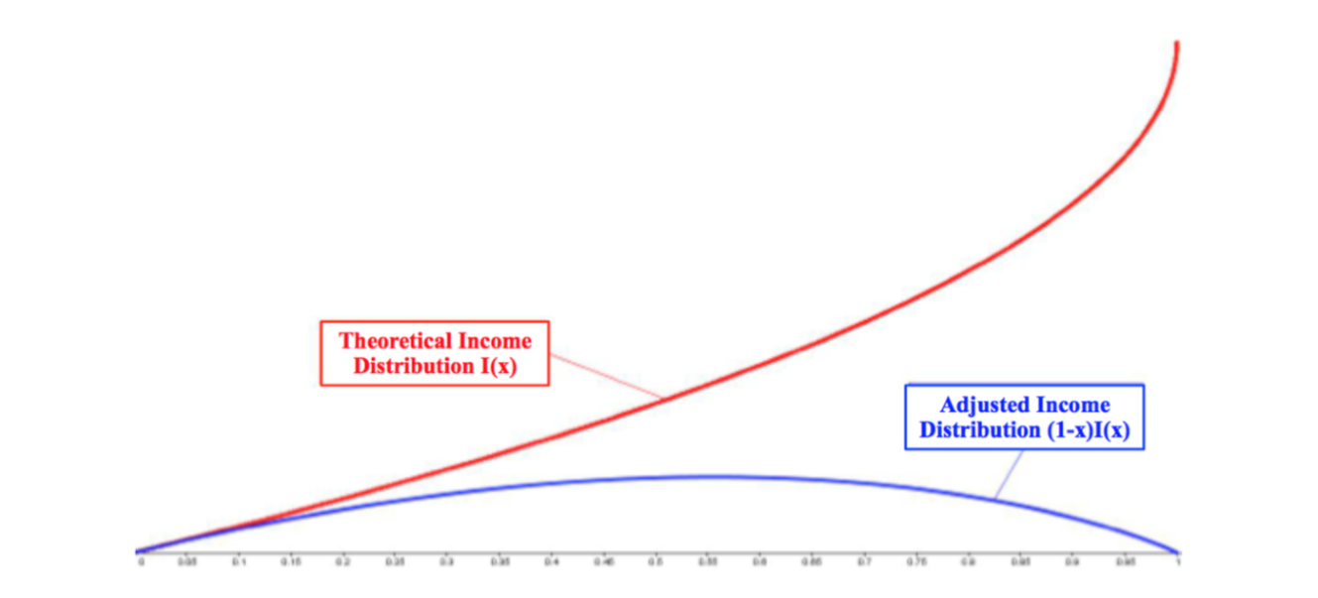

Figure 2 : Graph of the theoretical income distribution I(x) and adjusted income distribution A(x)

We also deﬁne E as the average years of education and *LE* as the average life expectancy. This results in a ﬁnal adjusted economic development function Di for any given city i of:

where Norm indicates data normalization with respect to national-wide maxima and minima, a procedure utilized by the Human Development Index (HDI). We weighted education less, because the number of years of education has less of a factor on socioeconomic development than life expectancy and income, and years of education already shares a strong correlation with those two values.

**Strengths and Weaknesses**

Our model, by accounting for income inequality and share of income by percentile, gives more weight to a fair distribution of wealth throughout the city, valuing equality over mean income. Additionally, because we integrate economic share and inequality within the same integral, we provide a more inclusive metric for measuring wealth than by separately calculating GDP and inequality, before combining values. Thus, when this measure is combined with education and health, we have a more eﬀective measure of the effect of wealth on the daily socioeconomic well-being of the populus. Thus, increasing this metric increases not just money but overall health and well-being.

Regarding weaknesses, because this model combines economy and well being into one value, it can be seen as weak compared to two values. However, it is more eﬃcient to optimize one value than two, so having a sound one value metric is necessary for these purposes. Second, because this metric only combines three sources of information (albeit the three we value as most important), additional values unaccounted for by this metric will have an unmeasured eﬀect on the country’s health and well being.

**5.3 Social equity**

As for the social equity, we concern that income disparity is a critical factor to measure it. The income distribution of a city can be presented by a statistical distribution diagram.

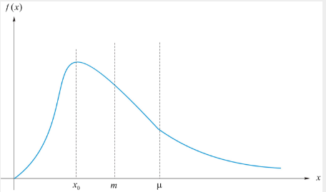

x represents citizens’ income, f(x) represents the ratio of people who receive x income. In the x axis, represents the average income. From this function, we can calculate the ratio of income of people whose income are less than x. We can name this ratio as L(p).

L(p) is the Lorenz Curve of the income distribution of the city. Then we can analyze L(p).

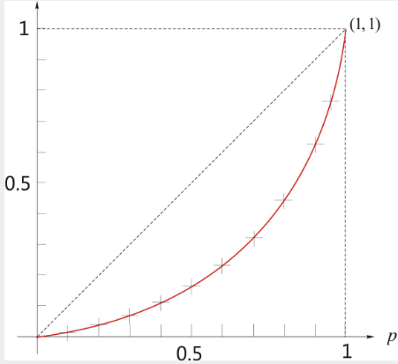

In this diagram, p represents the ratio of population. In the y axis, y represents the ratio of income. Obviously, the higher the curve, the fairer this city are. The dotted line in this diagram indicates that everyone in this city shares equal amount of income, which means that this city is absolutely fair.

Having this diagram, we can calculate Gini coefficient which indicates the fairness of income distribution. The Gini coefficient (G) equals:

The less the G is , the fairer the society are.

Following table show the data about Changsha in 2016:

|  |  |  |  |  |  |
| --- | --- | --- | --- | --- | --- |
| Class of household | Lower income | Lower Middle income | Middle income | Higher Middle income | Higher income |
| Ratio of household | 0.20075 | 0.19886 | 0.20075 | 0.20075 | 0.19886 |
| Household income | 74801.93 | 91765.62 | 110620.38 | 119472.91 | 152470.30 |

Following table show the data about Dalian 2016:

|  |  |  |  |  |  |
| --- | --- | --- | --- | --- | --- |
| Class of household | Lower income | Lower Middle income | Middle income | Higher Middle income | Higher income |
| Ratio of household | 0.20045 | 0.19896 | 0.20215 | 0.20175 | 0.19446 |
| Household income | 70770.91 | 86674.31 | 106789.56 | 114572.09 | 146752.41 |

From statistics we can calculate that the Gini coefficient in Dalian is 0.501, the Gini coefficient in Changsha is 0.507.

**6. Analytic Hierarchy Process**

**6.1 Selection of Evaluation Index of the success of smart growth of a city**

There are many factors that affect the situation of the success of smart growth of a city. Therefore, we should choose the most representative factors to describe and simplify the model. At the same time, we select indicators from the natural, economic, social, sustainable development and other aspects, descripting the current condition of the city as well as the expectations of the future, to ensure that both representative and comprehensive.

Indicators should be properly handled. In this model, the relative parameter values are used instead of the absolute number, which will make the index is more reference and comparability.

Select the indicators that reflect the current smart growth characteristics, and make corresponding adjustments according to different cities.

Select indicators that can be used with data. For some evaluation indicators such as the actual expanding rate of city and the level of pollution of the city, the actual data are hard to get, so we select other comprehensive index which can indirectly reflect the characteristic to replace.

For example, We use the AQI and Ei in the ecological environment to replace the indicators of the city environmental quality. We use the Gini coefficient to evaluate the socially Equitable , using the family income and life expectancy reflect social and economic development level of the city.

## Determining the Weight of Each Index

The weight of each index was obtained by the method of chromatography analysis.

### Establishing Hierarchy Model

Table 1 Evaluation index and Calculation Formula

|  |  |
| --- | --- |
| Category | Index |
| Economically prosperous | The year of education (year) |
| Average life expectancy (year) |
| Average disposable income per capita (yuan) |
| Environmental sustainability | Ecological impact index |
| Air quality index |
| Socially equitable | Gini coefficient |
| Expanding rate | Relatively population increasing rate |
| Relatively land increasing rate |

Table 2 and table 3 shows the current statistics of the selected cities.

Table 2 Changsha

|  |  |  |  |  |  |
| --- | --- | --- | --- | --- | --- |
| year  index | | 2010 | 2012 | 2014 | 2016 |
| Economically prosperous(B1) | The year of education(C1) | 9.58 | 9.60 | 9.67 | 9.64 |
| Average life expectancy(C2) | 79.02 | 79.10 | 79.04 | 79.08 |
| Average disposable income per capita(C3) | 36608.74 | 36708.71 | 36889.21 | 36992.75 |
| Environmental sustainability(B2) | Ecological impact index(C4) | 40900 | 40912 | 40987 | 41010 |
| Air quality index(C5) 1% | 77 | 67 | 71 | 69 |
| Socially equitable(B3) | Gini coefficient(C6) | 0.507 | 0.506 | 0.509 | 0.510 |
| Expanding rate(B4) | Relatively population increasing rate(C7) | 0.0165 | 0.0176 | 0.0188 | 0.0164 |
| Relatively land increasing rate(C8) | 0.0030472 | 0.0030221 | 0.0033214 | 0.0030487 |

Table 3 Dalian

|  |  |  |  |  |  |
| --- | --- | --- | --- | --- | --- |
| year  index | | 2010 | 2012 | 2014 | 2016 |
| Economically prosperous(B1) | The year of education(C1) | 9.42 | 9.51 | 9.38 | 9.44 |
| Average life expectancy(C2) | 80.02 | 80.61 | 79.98 | 80.01 |
| Average disposable income per capita(C3) | 33215.45 | 34879.81 | 35341.23 | 35078.41 |
| Environmental sustainability(B2) | Ecological impact index(C4) | 36712 | 34092 | 35423 | 35543 |
| Air quality index(C5) | 36 | 49 | 57 | 56 |
| Socially equitable(B3) | Gini coefficient(C6) | 0.499 | 0.503 | 0.508 | 0.501 |
| Expanding rate(B4) | Relatively population increasing rate(C7) | 0.00874 | 0.00789 | 0.00872 | 0.00786 |
| Relatively land increasing rate(C8) | 0.0032451 | 0.0045231 | 0.0055678 | 0.0044231 |

As different data sources with different dimensions, we need to transfer these statistics into relative data. To standardizing these data, we use the following formula

For the factor which is the higher the better, we use

For the factor which is the lower the better, we use

In this formula, is the standard value of the ith factor. is the current value of this factor. Using this formula, we can figure out the standard value of those factor listed below.

Table 4 standard value

|  |  |  |  |  |  |  |  |  |
| --- | --- | --- | --- | --- | --- | --- | --- | --- |
| factor  city | C1 | C2 | C3 | C4 | C5 | C6 | C7 | C8 |
| Changsha | 0.667 | 0.750 | 1.000 | 1.000 | 0.200 | 0.000 | 1.000 | 0.911 |
| Dalian | 0.462 | 0.048 | 0.876 | 0.450 | 0.048 | 0.778 | 0.989 | 0.493 |

When comparing the importance of the ith element and the jth element to the last layer of the factor, we use quantitative relative weight aij to describe. Assuming that a total of n elements are involved in the comparison, A=aij(n*m) is called pairwise comparison matrix. The value of aij in the pairwise comparison matrix may refer to Satty’s proposal and be assigned to the following scale. We value aij in 1-9 and their reciprocals.

If aij=1, the element i and the element j are of the same importance to the last layer

of the factor;

If aij=3, the element I is slightly more important than the j element;

If aij=5, the element I is more important than the j element;

If aij=7, the element I is much more important than the j element;

If aij=9, the element I is extremely important, compared with element J;

If aij=2n, n=1, 2, 3, 4, the importance of elements I and j is between aij=2n-1 and aij=2n+1;

aij=1/n, n=1, 2, …, 9, if and only if aji=n.

the judging matrices are listed below:

|  |  |  |  |  |  |
| --- | --- | --- | --- | --- | --- |
| A | B1 | B2 | B3 | B4 | W |
| B1 | 1 | 1 | 3 | 1 | 0.282 |
| B2 |  | 1 | 5 | 3 | 0.421 |
| B3 |  |  | 1 | 1/3 | 0.083 |
| B4 |  |  |  | 1 | 0.214 |
|  |  |  |  |  |  |

CI=0.038, RI=0.900, CR=0.042

|  |  |  |  |  |
| --- | --- | --- | --- | --- |
| B1 | C1 | C2 | C3 | W |
| C1 | 1 | 5 | 3 | 0.637 |
| C2 |  | 1 | 1/3 | 0.105 |
| C3 |  |  | 1 | 0.258 |

CI=0.019, RI=0.580, CR=0.033

|  |  |  |  |
| --- | --- | --- | --- |
| B2 | C4 | C5 | W |
| C4 | 1 | 1/5 | 0.167 |
| C5 |  | 1 | 0.833 |

CI=0.000, RI=0.000, CR=0.000

|  |  |  |
| --- | --- | --- |
| B3 | C6 | W |
| C6 | 1 | 1.000 |

CI=0.000, RI=0.000, CR=0.000

|  |  |  |  |
| --- | --- | --- | --- |
| B4 | C7 | C8 | W |
| C7 | 1 | 5 | 0.833 |
| C8 |  | 1 | 0.167 |

CI=0.000, RI=0.000, CR=0.000

The weighting factor are calculated below:

|  |  |
| --- | --- |
| factors | Weighting factor |
| C1 | 0.180 |
| C2 | 0.030 |
| C3 | 0.073 |
| C4 | 0.070 |
| C5 | 0.351 |
| C6 | 0.083 |
| C7 | 0.178 |
| C8 | 0.036 |

CI=0.005 RI=0.163 CR=0.031

Then we can use the formula

to calculate the comprehensive standard index S. Wi is the weight of one factor. We apply those statistics to this formula and figure out two selected cities comprehensive standard index. Changsha’s S equals to 0.566556, Dalian’s S equals to 0.454957.

**6.3 Task Solution**

**For Task 1:**

We use our evaluating system to judge success of smart growth of a city and after calculating the specific data above, we can give a score of each city. Changsha gets 0.5665 and Dalian gets 0.454957. In our Model, Changsha is more successful in Smart Growth than Dalian.

**For Task 2:**

As for Changsha, the urbanization in Changsha obey the following rules: People-oriented, market-oriented, urban and rural integration, synchronization, ecological civilization, cultural heritage. The urban and rural integration meets the First principle: Mix land use, a single area can have variable function. And the people-oriented meets almost every principle in smart growth. People-oriented means that you need to provide more working opportunity to the migration people. Synchronization meets the third principle: create a range of housing opportunities and choices. With the increase of population, Changsha must meet the needs of a great quantity of population. Through creating a range of housing opportunities and choices, more and more citizen will be given chances to buy houses and work. However, creating housing opportunities needs take community construction seriously. To foster distinctive and attractive communities with a strong sense of place needs to manage land efficiently. The current plan of Changsha, however, seems to ignore this principle. As for ecological civilization and cultural heritage, it meets the sixth principle: preserving open space, farmland, natural beauty, and critical environmental areas. Changsha is a city full of natural scenery. Rapid development as it is, Changsha promulgate several orders to protect natural beauty, which make it attract millions of tourists every year. Changsha plans to construct more subway lines as well, which meet the principle of providing a variety of transportation choices.

Dalian focus on livelihood issues. For the next five years, Dalian aim to construct new airport, more expressway, more subway lines, which provide citizens with more transportation choices. Dalian will improve communities in urban areas and rural areas. This will strengthen and direct development towards existing communities, which meets the seventh principle. Furthermore, Dalian will preserve open space, farmland, natural beauty, and critical environmental areas through preserving and constructing natural scenery and cultural heritage, which meets the sixth principle.

Whether those plans of two cities are successful according to our plan needs to compare their plans with factors in our metric. As for Dalian, it aims to construct 50 public kindergarten and 80 compulsory education schools for the next 5 years. This will increase the year of education per capital which is factor one. Constructing more hospitals contributes to average life expectancy which is factor two. Reducing PM2.5 concentration will increase air quality index. In 2020, the average disposable income per capita will double. Needless to say, these plans have close connection with our 8 factors in our evaluation model. The comprehensive standard index will increase, which shows the success of smart growth of Dalian.

As for Changsha, it aims to reduce carbon discharge, this will reduce ecological impact index. Changsha will also construct 13 forest park and 8 wetland park, which will improve the air quality index. Changsha will restrict migrants living, which contribute to the reduction of relatively population increasing rate. From this point of view, there are some plans which fit our factors in our evaluation model, which will increase the comprehensive standard index of Changsha.

1. The plan of next two decades for selected cities

Changsha as the provincial capital of Hunan is a second-tier city of China.According to our mathematical model constructed before,the final evaluating result is ~~.Also Dalian located in Liaoning is another second-tier city, its result from out evaluating systme is ~~.In this section, we propose a set of measures that could be founded by the ICM in order to promote the sustainable development in Changsha and Dalian over the next decade.And then we will use our metric explaining above to evaluate the success of our smart growth plans.Key features we must take into account for the development of Changsha and Dalian has been listed as following.

1. Avoiding the blindness of development, we have to make it explicit where to focus our fund or labour geographically.
2. Considering the lack of land and the low availability of land usage currently,we will make our suggestions for the problem to slow down the expanding rate of the selected city.
3. Fast life pace of people in city has extracted too much time of us.Also our suggestions will be proposed in order to enhance the quality of life.
4. How to balance the economic development and environmental deterioration is another kernel problem. We will make some limits to control the population,the discharge of pollution gas or greenhouse gas and so on expecting to get a satisfying result from our evaluating model.

7.1 Distribution of educational and medical resource

Knowing where to focus money and aid in a city’s development is quintessential to the efficiency of country development.In order to solve this problem,we created an automata model designed to determine optimal aid location with respect to both population density and resource (fund and labour).

It is a known fact that resources distribution and population dynamics are intertwined.To model the growth of population and resources over time, we created a paired system of iterated microeconomic and agent-based behavioral functions to define the rules of a 2-dimensional Cellular Automata, looking at the effect of various starting paradigms. We modeled the diffusion of both resources and population as cofactors of each other, based on an adjusted version of Epstein's agent-based sugarscape model for social simulation.





Approximating with and setting = 1, we can translate the paired differentials for W(t) and P(t) into a system of iterated functions to calculate Population and Resources of a city through Cellular Automata. These iterative functions can be written as shown below, withBirth Rate and  = Life Expectancy. Both andare functions of Resources, such that  is a calculated best fit logarithmic curve, and  is the Preston curve for life expectancy as a function of national GDP. Thus, we can write our iterative equations as follows:

(5)

(6)

where

(7)

In this case,  represents the coefficient of employment (the percentage of Resources that

is distributed via employment of a cell's neighbors), and  represents the coefficient of

migration (the percentage of the population that migrates each iteration). In essence,resources is given to each neighbor as a fraction of current wealth, and population grows as both a function of itself and a function of migration. Net migration is based off of the migration percentage of the population that exit the cell and enter the neighboring cells, in proportion with which neighbors have the highest resources per person (GDP/capita).Equations 5 and 7 include summations of a cell's neighbors, which represent the value of

the entire neighborhood. The results of our cellular automata model over the course of 20 years are shown below.

Resource Distribution Population Distribution Resource Distribution Population Distribution

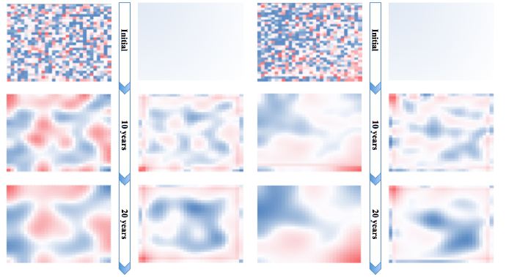

1. Random initial resource distribution (b)Trended initial wealth distribution

Figure 5: Comparison of two seeds: random and biased resource distribution with even initial population distribution. For the red-blue gradients on the resource and population automata,red indicates higher values of resource and population while blue indicates lower values.

Figure 5 shows the results of both a random initial resource distribution and biased initial resource distribution (concentrated in the bottom right corner) after 10 and 20 years,allowing us to see the spatial-economic equilibrium of resource as a function of time. We see the natural segregation of resource, and the corresponding segregation of population density,over the course of time, indicating natural increase in resource inequality given no external factors.

Therefore, we can see that resource segregates itself to areas of lower population, thus increasing income disparity.Here we propose the first suggestion for the city development plan. As the cellular automata model has indicating, we need to focus our efforts on the areas with less resources.We need to locate more junior school and medical institution and invest more funds in these areas.Through these methods ,we aim at improving the average years of education by 0.1% and the average life expectancy by 0.002%.

7.2 **Other components of our plan**

From mentioned above, we can concluded that how we improve the distribution of educational and medical resources in our city. In the following paragraph, we focus on several aspects, such as environment, administration, urbanization.

**7.2.1 Environment plan**

According to researches by some institutions, CO2 produced by private car was a major sources of the discharge of green house gas. Therefore, our plan propose to invest 300 million in popularizing the electronic vehicle and other using non-carbon energy vehicle. The table below show electronic vehicle the superiority in discharge of gas against traditional vehicle.

|  |  |  |
| --- | --- | --- |
| Pollution Gas | Discharge of traditional vehicle | Discharge of electronic vehicle |
| CO | 0.0394 | 0 |
| HC | 0.0046 | 0 |
| NOx | 0.0022 | 0.041 |
| CO2 | 16.85 | 11.6358 |
| SO2 | 0.0022 | 0.02838 |

Other plan which try to control the deterioration of the environment will be appropriately close the factory producing high level of pollution and developing public transportation. Through our plan, we aim to reduce the discharge of CO2 by 30%.

7.2.2 government administration

To measure the economic prosperous in a city, we should focus on the average disposable income per capita. The direct way to increase the disposable income is to reduce tax which each citizen needs to take. However, the reduction of tax will make the government can not have the enough money to improve the city. So we need some methods.

The following table show the tax rate in Beijing in 2014:

|  |  |  |
| --- | --- | --- |
| level | Income should tax | rate(%) |
| 1 | Lower 1455 | 3 |
| 2 | Between 1455 and 4155 | 10 |
| 3 | Between 4155 and 7755 | 20 |
| 4 | Between 7755 and 27255 | 25 |
| 5 | Between 27255 and 41255 | 30 |
| 6 | Between 41255 and 57505 | 35 |
| 7 | Above 57505 | 45 |

The following table show the tax rate in Beijing in 2016:

|  |  |  |
| --- | --- | --- |
| level | Income should tax | rate(%) |
| 1 | Lower 1600 | 3 |
| 2 | Between 1600 and 4300 | 10 |
| 3 | Between 4300 and 7900 | 20 |
| 4 | Between 7900 and 27400 | 25 |
| 5 | Between 27400 and 41400 | 30 |
| 6 | Between 41400 and 57700 | 40 |
| 7 | Above 57700 | 50 |

As for Beijing, the government increase the income standard which need tax. In 2014, you earn 1455 yuan and you need to tax, but in 2016, you only will tax when your income overcome 1600.So most of citizen reduce their actual tax and only a few higher income person should increase their expectancy of tax.

This tax rate reform not only increase the disposable income of citizen, but also balance the socially equitable. Except this, we also need other operation, such as increase the common salary and reduce the item price in the city. The most important thing is to reduce the number of officer and try to use internet and computer to replace them.

Through that way, the government can reduce the outcome of officers’ salary and increase the citizens’ welfare and strengthen the life quality of people and socially balance. We aim to increase average disposable income per capita by 5% per year and reduce Gini coefficient by 0.1% per year.

7.2.3 Urbanization Scheme

As the development of economy urbanization has been pushed by the general trendency. As a result of this many problems appear.Along these problems two of them are concerned generally.First is how to control the speed of population expanding, the other is how to increase the availability of land usage and slow down the speed of land increasing.

The reasons leading to city population expanding include exorbitant birthrate,rural population swarming into city. How to control the exorbitant birthrate is knew as one of our basic state policies, we have to persist in it and keep the birthrate stable.So here we pay more attention on diversion of the population flew from rural area. Strengthen the housing management to control the population . We have made suggestions below.

Support the development of housing rental regulations, promote the organization of management mode, according to the law to manage rental housing, continue to manage the group renting problem.Strengthen energy saving, environmental, technical, safety and other standards, improve tax collection and management, and promote the optimization and upgrading of the service industry.Through these method we are aiming at slow down the relatively population increasing rate and control it up to 1% per year.

Then we propose the measures to increase the availability of land usage. Mix land use is one of the effective methods.Suitable mix land use is conducive to the intensive use of land, industrial upgrading and transformation, improve the efficiency of infrastructure utilization, reduce traffic pressure and improve the vitality and attractiveness of the city and other advantages.Mitigating the imbalance of resource distribution can also keep the city system healthy and increase the availability of land usage. The imbalance of resource distribution and how to resolve the problem was discussed in 7.1. Througn these method we control the relatively land increasing rate up to 2.32%

The following picture taken by QuikScat from NASA show us the land usage of Beijing from 2004 to 2009.

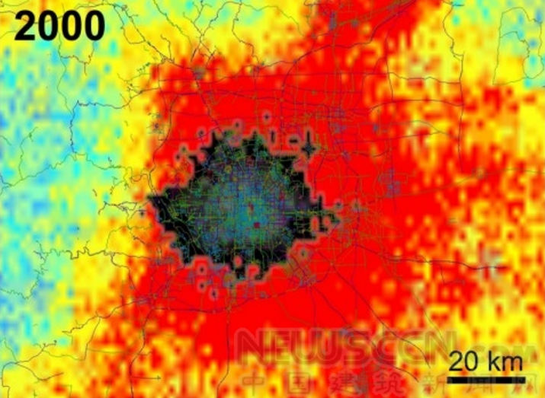

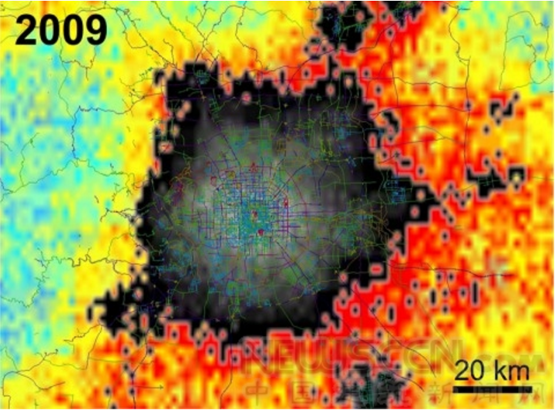

According to the calculation of the 2000-2009 infrastructure, the results show that during this period of time, the size of Beijing expanded 4 times. Gray and black represent buildings, tall buildings in the city's commercial centers are represented by light grey, and other colors represent areas that have not yet been. The degree of change is represented by a different color: blue green represents the least change, yellow and orange indicate a change, and red indicates the greatest change

7.3 potential prediction and comparison

Table 2 Changsha

|  |  |  |  |  |  |
| --- | --- | --- | --- | --- | --- |
| year  index | | 2030 | 2032 | 2034 | 2036 |
| Economically prosperous(B1)0. | The year of education(C1)0.08%-0.12% | 9jj | 9.784 | 9.856 | 9.64 |
| Average life expectancy(C2) 0.0017%-0.0023% | 79.05 | 79.13 | 79.07 | 79.08 |
| Average disposable income per capita(C3) 4%-6% | 92508.5 | 92761.1 | 93217.2 | 36992.75 |
| Environmental sustainability(B2) | Ecological impact index(C4) 1.3%-1.7% | 54272.3 | 54288.2 | 54387.7 | 41010 |
| Air quality index(C5) -0.8%-- -1.2% | 63.615 | 55.3533 | 58.658 | 69 |
| Socially equitable(B3) | Gini coefficient(C6) -0.08%--- 0.12% | 0.4975 | 0.4965 | 0.4994 | 0.510 |
| Expanding rate(B4) | Relatively population increasing rate(C7)0.8%-1.2% | 0.01994 | 0.021263 | 0.02271 | 0.0164 |
| Relatively land increasing rate(C8)1.7 %-2.3% | 0.004711 | 0.0046726 | 0.00513536 | 0.0030487 |

Table 3 Dalian

|  |  |  |  |  |  |  |  |  |
| --- | --- | --- | --- | --- | --- | --- | --- | --- |
| year  index | | 2030 | 2032 | 2034 | 2016 | |  | |
| Economically prosperous(B1) | The year of education(C1) | 9.6006 | 9.69233 | 9.44 | 9.44 |  | |
| Average life expectancy(C2) | 80.0504 | 80.6406 | 80.01 | 80.01 |  | |
| Average disposable income per capita(C3) | 83933.8 | 88139.5 | 35078.41 | 35078.41 |  | |
| Environmental sustainability(B2) | Ecological impact index(C4) | 48715 | 45238.4 | 35543 | 35543 |  | |
| Air quality index(C5) | 29.74 | 40.48 | 56 | 56 |  | |
| Socially equitable(B3) | Gini coefficient(C6) | 0.4896 | 0.4935 | 0.501 | 0.501 |  | |
| Expanding rate(B4) | Relatively population increasing rate(C7) | 0.010559 | 0.0095319 | 0.00786 | 0.00786  0.00814 |  | |
| Relatively land increasing rate(C8) | 0.0050174 | 0.0069934 | 0.0044231 | 0.0044231 |  | |

According to our previous plan, we estimate the condition of Changsha and Dalian by 2036. As we had the current situation about 8 factors in Analytic Hierarchy evaluation model, we follow the plan developed in 7.1 and 7.2 to predict selected cities future condition. Each factor is given a growth rate interval

Table 4 standard value

|  |  |  |  |  |  |  |  |  |
| --- | --- | --- | --- | --- | --- | --- | --- | --- |
| factor  city | C1 | C2 | C3 | C4 | C5 | C6 | C7 | C8 |
| Changsha(0.640138) | 0.6673(0.636)  (0.865014) | 0.750(0.653)  (0.868136) | 1.000(0.499)  (0.742114) | 1.000(0.604)  (0.829368) | 0.200(0.692)  (0.894374) | 0.000(0.667)  (0.880269) | 1.000(0.606)  (0.851521) | 0.911(0.590)  (0.828781) |
| Dalian(0.648283) | 0.462(0.655)  (0.8804) | 0.048(0.657)  (0.874083) | 0.876(0.490)  (0.736547) | 0.450(0.609)  (0.829123) | 0.048(0.688)  (0.899647) | 0.778(0.659)  (0.866071) | 0.989(0.644)  (0.851521) | 0.493(0.596)  (0.824546) |
|  |  |  |  |  |  |  |  |  |

7.4 Plan supports for 50% additional population

Suppose the population of each city will increase by an additional 50% by 2050