Tizen课程项目报告  
《数学工具》

## 项目简介

一个简单的数学工具，很方便的把用户输入的一串数字转化为柱状图，折线图或者饼状图，再通过截屏等手段导出图片，使得数据大小关系一目了然。

## 需求分析

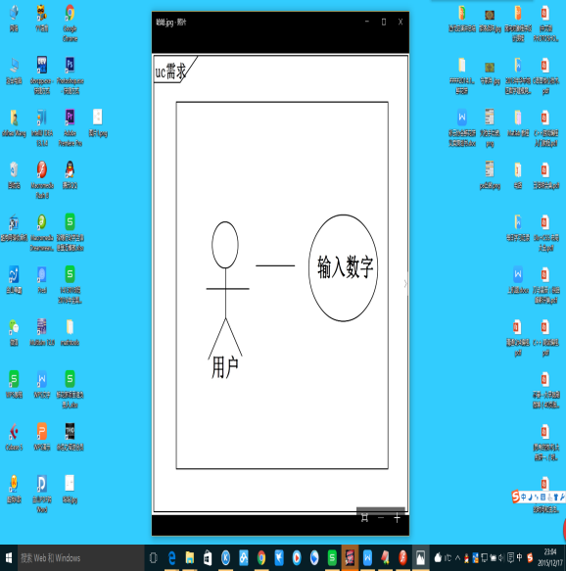

## 概要设计

Mathtool基于TIZEN web project开发，主要使用了Html与Javascript技术。通过save存储用户输入的数字，zhuChart、zheChart和bingChart方法中绘出对应的图像。。

|  |  |
| --- | --- |
| 接口 | 接口功能 |
| save | 保存用户输入的数字 |
| zhuChart | 绘制柱状图 |
| zheChart | 绘制折线图 |
| bingChart | 绘制饼状图 |

## 核心算法

Mathtool核心算法代码如下图所示。

|  |
| --- |
| localStorage.clear; //清空内存  var number=[]; //保存数据到数组  function save(){  var num=document.getElementById("number").value;  number.push(num);  };    function zhuChart(){  var canvas=document.getElementById("myCanvas"); //获得绘图环境  var context=canvas.getContext("2d");  var width_canvas=parseInt(canvas.width);//设置画布参数  var height_canvas=parseInt(canvas.height);  context.translate(width_canvas/10,height_canvas*4/5);//调节绘图基准  context.clearRect(-width_canvas/10,-8*height_canvas/10,width_canvas,height_canvas);  draw_Sites(context,height_canvas,width_canvas);  var max=0; //数据处理  for(var i=0;i<number.length;i++){  if(max<number[i])  max=number[i];  }  var per=width_canvas*0.8/(2*number.length+1);  var pos_num=0;  if(number.length<5){  pos_num=per/2;  }else if(number.length>=5 && number.length<10){  pos_num=per/4;  }else{  pos_num=0;  }  for(var i=0;i<number.length;i++){  var x=(2*(i+1)-1)*per;  var y=-number[i]/max*(0.65*height_canvas);  context.beginPath();  context.moveTo(x,0);  context.lineTo(x,y);  context.lineTo(x+per,y);  context.lineTo(x+per,0);  context.closePath();  context.fillStyle="black";  context.fill();  context.strokeText(number[i],x+pos_num,y-5);  }  context.translate(-width_canvas/10,-height_canvas*4/5);//调节绘图基准  }    function zheChart(){  var canvas=document.getElementById("myCanvas"); //获得绘图环境  var context=canvas.getContext("2d");  var width_canvas=parseInt(canvas.width);//设置画布参数  var height_canvas=parseInt(canvas.height);  context.translate(width_canvas/10,height_canvas*4/5);//调节绘图基准  context.clearRect(-width_canvas/10,-8*height_canvas/10,width_canvas,height_canvas);  draw_Sites(context,height_canvas,width_canvas);  var max=min=0; //数据处理  for(var i=0;i<number.length;i++){  if(max<number[i])  max=number[i];  if(min>number[i])  min=number[i];  }  var per=width_canvas*0.8/(number.length+1);  var pos_num=0;  if(number.length<5){  pos_num=per/2;  }else if(number.length>=5 && number.length<10){  pos_num=per/4;  }else{  pos_num=0;  }  context.beginPath();  var x0=per;  var y0=-number[0]/max*(0.65*height_canvas);  context.moveTo(x0,y0);  for(var i=0;i<number.length;i++){  var x=((i+1))*per;  var y=-number[i]/max*(0.65*height_canvas);  context.lineTo(x,y);  }  context.strokeStyle="black";  context.stroke();  for(var i=0;i<number.length;i++){  var x=((i+1))*per;  var y=-number[i]/max*(0.65*height_canvas);  context.beginPath();  context.arc(x,y,5,0,Math.PI*2,false); //绘制圆弧  context.closePath();  context.fillStyle="rgba(0,0,0,0.5)";  context.fill();  context.strokeText(number[i],x-5,y-8);  }  context.translate(-width_canvas/10,-height_canvas*4/5);//调节绘图基准  };  function bingChart(){  var canvas=document.getElementById("myCanvas"); //获得绘图环境  var context=canvas.getContext("2d");  var width_canvas=parseInt(canvas.width); //设置画布参数  var height_canvas=parseInt(canvas.height);  context.translate(width_canvas/2,height_canvas/2);//调节绘图基准  context.clearRect(-width_canvas/2,-height_canvas/2,width_canvas,height_canvas);    var add=0; //数据处理  for(var i=0;i<number.length;i++){  add += parseFloat(number[i]);  }  var cont_deg=0;  var deg=0;  for(var i=0;i<number.length;i++){  deg=number[i]/add*Math.PI*2; //获得占比角度  cont_deg=cont_deg+parseFloat(deg);  context.beginPath();  context.moveTo(0,0);  context.lineTo(width_canvas/3*Math.cos(cont_deg),width_canvas/3*Math.sin(cont_deg));  context.arc(0,0,width_canvas/3,cont_deg,cont_deg-deg,true);  context.closePath();  var color=Math.round(Math.random()*1000000);  context.fillStyle="#"+color;  context.fill();  context.strokeText(number[i],width_canvas*3/8*Math.cos(cont_deg-deg/2),width_canvas*3/8*Math.sin(cont_deg-deg/2));  }  context.translate(-width_canvas/2,-height_canvas/2);//调节绘图基准  };    function draw_Sites(context,height_canvas,width_canvas){ //绘制坐标轴  var x1=8*width_canvas/10; //作图对角线  var y1=-7*height_canvas/10;  context.beginPath(); //绘制坐标轴  context.moveTo(0,y1);  context.lineTo(0,0);  context.lineTo(x1,0);  context.strokeStyle="rgba(0,0,0,1)";  context.stroke();  var m1=height_canvas/80;//绘制箭头一  var n1=width_canvas/30;  context.beginPath();  context.moveTo(-m1,y1+n1);  context.lineTo(0,y1);  context.lineTo(m1,y1+n1);  context.strokeStyle="rgba(0,0,0,1)";  context.stroke();  var m2=width_canvas/30;//绘制箭头2  var n2=height_canvas/80;  context.beginPath();  context.moveTo(x1-m2,n2);  context.lineTo(x1,0);  context.lineTo(x1-m2,-n2);  context.strokeStyle="rgba(0,0,0,1)";  context.stroke();  } |

## 软件功能界面

