PUSL2079: Topics in Business Analytics & Intelligence

Group E

Rathnayake Rathnayake - 10899210

**Title: Improving Fisheries Management and Marine Conservation in Sri Lanka through Smart Data Analysis**

* **Introduction**
* **Part 01: Case Study Analysis**
* **Problem Identification**
* **Analytical Techniques Used**
* **Critical Evaluation and Suggestions**
* **Part 02: Designing a Business Intelligence Solution**
* **Problem Definition**
* **Data Collection and Preparation**
* **Exploratory Data Analysis (EDA) and Visualization**
* **Ethical Considerations**
* **Conclusion**
* **References**

**Introduction**

For coastal communities, Sri Lanka's marine ecosystem serves as a vital centre of biodiversity. Threats, however, come from climate change, habitat deterioration, and irresponsible fishing. This study looks at creative ways to improve fisheries management and marine conservation through the use of smart data analysis and business analytics. A better understanding of fish stocks, fishing habits, and ecosystem health can be attained by stakeholders through the use of cutting-edge technologies and analytical tools. Targeted conservation efforts, sustainable fishing methods, and efficient resource management are made possible by this data-driven strategy. Proactive measures against new dangers are further enabled by predictive modelling and real-time monitoring. Sri Lanka can protect its marine ecosystems and ensure the livelihoods of coastal residents by integrating business analytics and smart data analysis.

**Part 01: Case Study Analysis**

* **Problem Identification**

The authorities in charge of managing Sri Lanka's coastal fisheries struggle to keep an eye on fish populations, control fishing, and enforce conservation measures. They aim to use smart data analysis and business analytics to address these issues. These instruments will make it possible to track fish populations, analyse fishing vessel movements, and identify illicit fishing within marine protected areas. In order to protect the marine ecology and the means of subsistence for coastal people, authorities want to improve their ability to make well-informed decisions, manage resources sustainably, and enforce laws. They do this by utilising cutting-edge technologies.

* **Analytical Techniques Used**

Fisheries management authorities examine fishing vessel behaviour, fish migration patterns, and habitat quality using state-of-the-art data analytics approaches like as acoustic telemetry, satellite remote sensing, and machine learning algorithms. Predictive modelling is also used to forecast fish populations, maximise fishing limits, and develop marine conservation strategies. By utilising these cutting-edge techniques, authorities are better equipped to make well-informed decisions, manage resources sustainably, and take proactive steps to save the marine environment and the livelihoods of coastal populations.

* **Critical Evaluation and Suggestions**

There is room for improvement, notwithstanding the novel nature of the project to use business analytics and smart data analysis for fisheries management. First and foremost, improved data integration and interoperability are required between various data sources, such as biological monitoring initiatives, environmental sensors, and ship monitoring systems. Second, including stakeholder participation and community-based monitoring programmes can increase the efficacy and acceptability of fisheries management strategies.

**Part 02: Designing a Business Intelligence Solution**

* **Problem Definition**

Raising fisheries management and marine conservation efforts in Sri Lanka is a vital imperative that may be achieved by strategically utilising business analytics and intelligent data analysis. Our main goal is to create a strong business intelligence system that can be used to precisely monitor fish populations, analyse fishing vessel actions, and enforce marine conservation laws. This system enables detailed examination of fishing vessel movements, tracking of fish migration patterns, and assessment of habitat quality by integrating cutting-edge data analytics tools like machine learning algorithms, satellite remote sensing, and acoustic telemetry.

Predictive modelling techniques will also make it possible to plan ahead for fish stocks, optimise fishing quotas, and formulate marine conservation policies with knowledge. Fisheries management authorities may make wise judgements, guarantee sustainable resource utilisation, and proactively address conservation concerns by coordinating the application of this novel method. The ultimate goal of this project is to assist the long-term livelihoods of coastal communities that depend on the health of the marine ecosystem.

* **Data Collection and Preparation**

Our analytical efforts will be based on a wide range of data sources, including satellite imagery, fishery observer reports, tracking data from fishing vessels, and environmental sensor readings. These priceless datasets will come from a variety of sources, such as respected international organisations, prestigious academic institutions, and fishery management bodies. We hope to obtain a thorough understanding of the dynamics of marine ecosystems and fishing activities within Sri Lanka's territorial seas by utilising such extensive sources.

Meticulous preprocessing methods will be used to fully utilise these datasets, guaranteeing data relevance and quality throughout the analysis process. This would require a number of processes, including data integration to combine diverse datasets in an easy-to-use manner, data cleaning to address mistakes and inconsistencies, and spatial analysis to identify trends and patterns in specific geographic areas. By fine-tuning the data using these preprocessing techniques, we may build a strong basis for further analytical work, which will enable precise evaluations, well-informed choices, and efficient implementation of marine conservation policies. With this coordinated effort, we hope to use data-driven insights to protect Sri Lanka's marine biodiversity and strengthen the fisheries' sustainability for the benefit of the country's current and future generations.

* **Exploratory Data Analysis (EDA) and Visualization**
* different data sources used for analysis or monitoring.

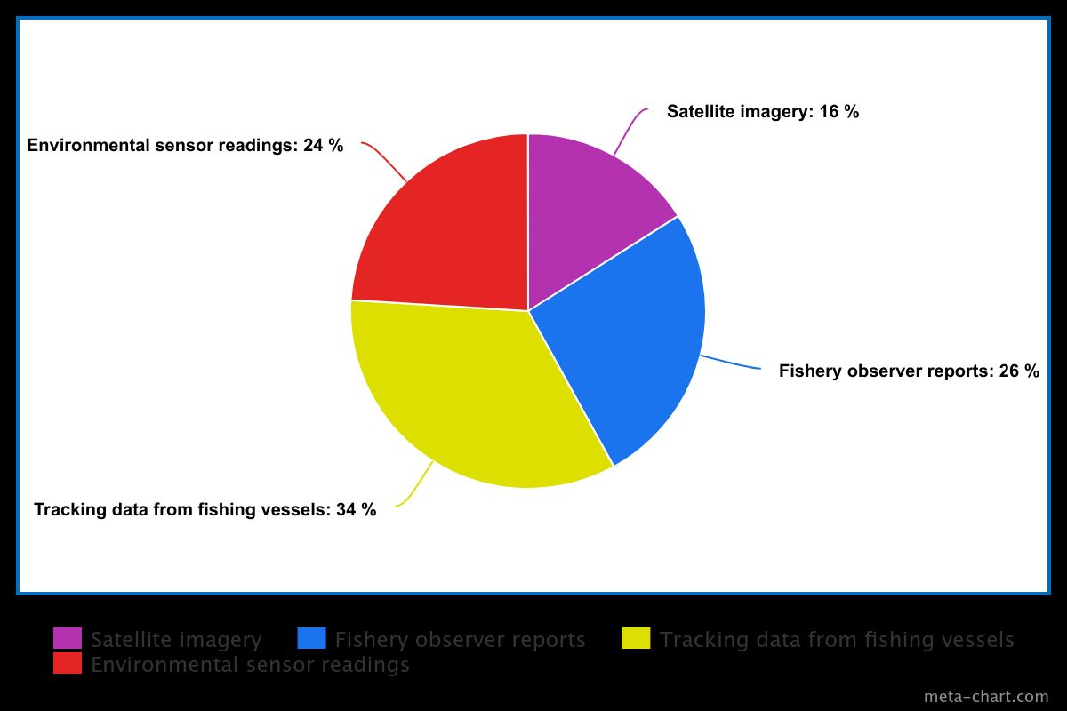

* ethical considerations

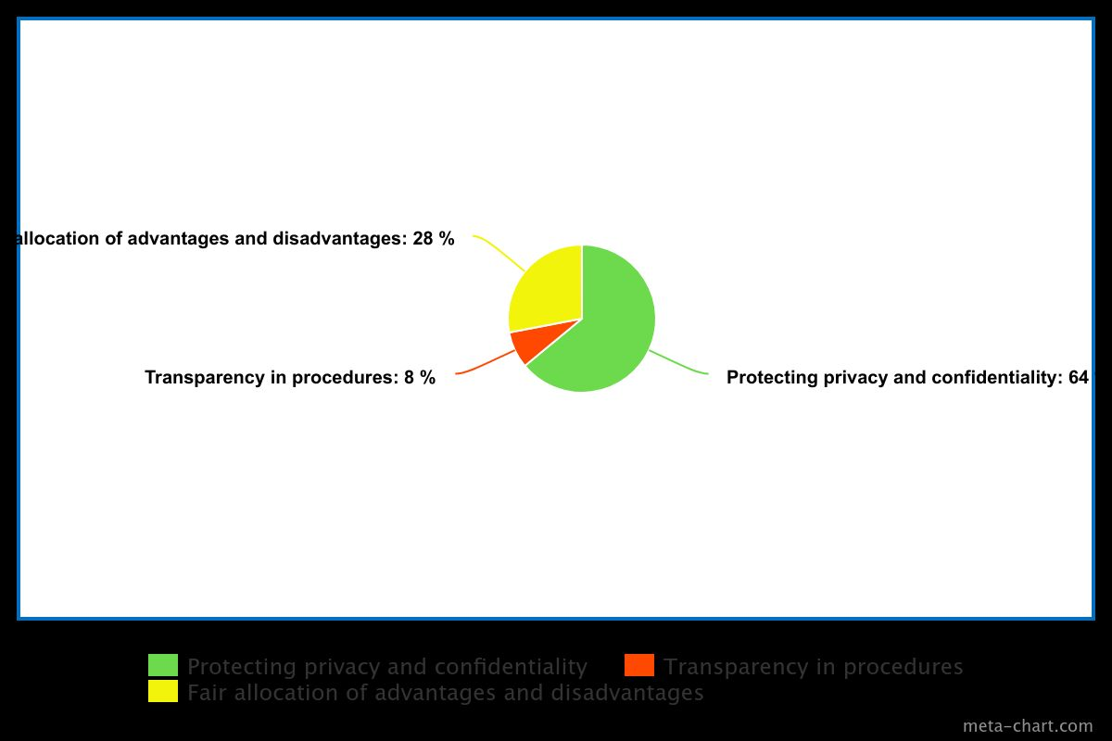

* fish population

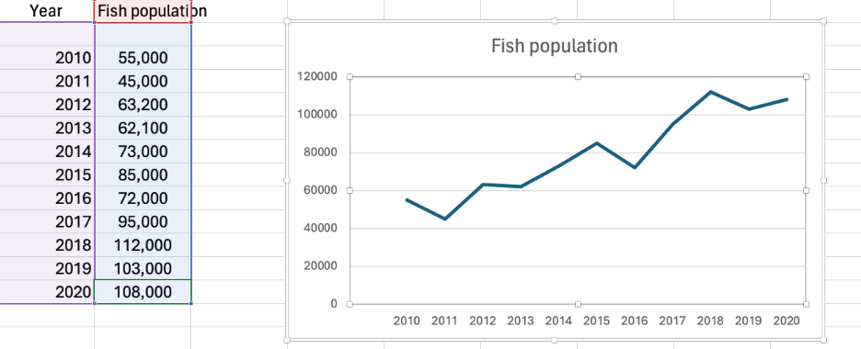

* ER diagram

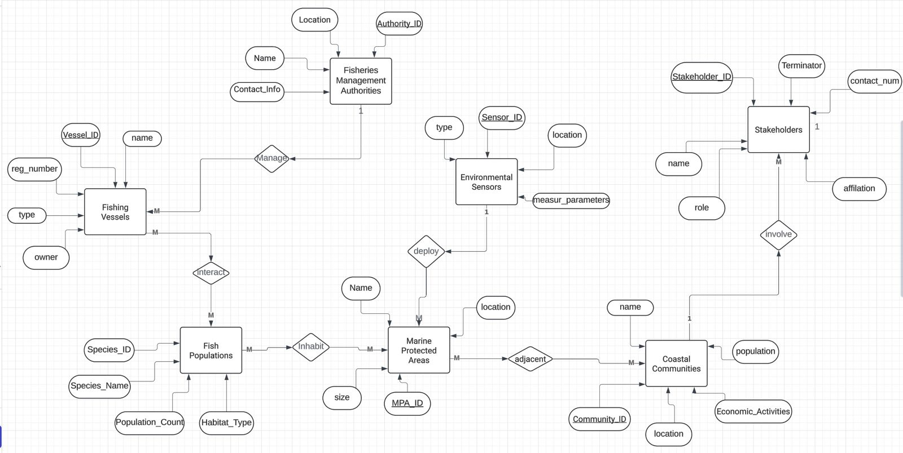

* **Ethical Considerations**

When using business analytics and smart data analysis to improve fisheries management and marine conservation in Sri Lanka, ethical considerations are crucial. These factors include protecting the privacy and confidentiality of sensitive data, such as information about fish populations, fishing vessel movements, and marine habitats. It also entails making sure that the procedures for gathering, analysing, and making decisions are transparent in order to build stakeholder trust and encourage responsibility. Furthermore, ethical issues encompass the fair allocation of advantages and disadvantages linked to fisheries management strategies, upholding the rights and interests of pertinent stakeholders, such as fishermen, coastal communities, and marine conservation organisations.

**Conclusion**

In conclusion, there is a revolutionary chance to transform Sri Lanka's efforts at marine conservation and fisheries management through the use of business analytics and smart data analysis. A number of complex issues, including overfishing, habitat degradation, and the effects of climate change, are threatening marine ecosystems. By utilising data-driven insights, stakeholders may make well-informed decisions to solve these issues. We can optimise resource allocation, reduce environmental risks, and promote sustainable fishing

practices that ensure the long-term viability of coastal fisheries by taking pre-emptive actions supported by predictive modelling and geographical analysis.

Moreover, the incorporation of ethical considerations is critical to these efforts' credibility and success. All facets of data collecting, analysis, and decision-making procedures must be based on transparency, accountability, and inclusivity. Ensuring fair participation and benefit-sharing necessitates the defence of the rights and interests of coastal communities, fishermen, and marine conservation organisations. We can promote a culture of responsible stewardship, protect marine biodiversity, and strengthen the resilience of coastal ecosystems for future generations by placing a high value on moral values and cooperative methods.

**References**

1. Food and Agriculture Organization of the United Nations. (2018). Sri Lanka National Aquatic Resources Research and Development Agency: Country fact sheet on fisheries management. Retrieved from <http://www.fao.org/fishery/nalo/search/en>.
2. National Aquatic Resources Research and Development Agency. (2023). Annual report on fisheries management in Sri Lanka. Colombo, Sri Lanka.