Layer-Wise Analysis of Emotion and Speaker Information in WavLM Speech Representations
Lihong Xu
Student ID 560746714
Abstract
This study compares a compact acoustic baseline with four frozen WavLM Base+ layers for acted-expression recognition and speaker identification. The analysis uses 672 RAVDESS speech recordings from 24 actors. A common linear support vector machine is evaluated with separate emotion and identity protocols. Layer 4 achieves the highest mean emotion macro-F1, 0.7909, compared with 0.5795 for the acoustic baseline and 0.7888 for layer 8. Its speaker-identification accuracy is 0.9702. These results show that strong emotion recognition and accessible identity information coexist in the tested representations. Acoustic distributions and confusion patterns connect these results to pitch, amplitude, duration and spectral properties.

一 Introduction

1.1 Research context
Speech emotion recognition combines acoustic feature design, classification and corpus selection [1]. Spectral shape, pitch and energy provide interpretable cues, while self-supervised speech models offer learned representations. WavLM jointly uses masked prediction and denoising during pretraining to support a range of speech tasks [3]. Its hidden layers provide a basis for examining expression and identity information within one frozen model.

1.2 Research questions
The analysis asks which of WavLM layers 1, 4, 8 and 12 best supports actor-independent recognition of neutral, happy, sad and angry expressions; how readily each representation identifies the actor; and how the learned vectors compare with traditional acoustic features. The two tasks are evaluated separately, then compared across representations.

二 Data and acoustic representations

2.1 Speech selection and labels
The source is the audio-only speech portion of RAVDESS [2]. Labels are parsed from the seven-field recording name: modality, vocal channel, expression, intensity, statement, repetition and actor. Modality 03 and vocal channel 01 select speech audio. Expression codes 01, 03, 04 and 05 select neutral, happy, sad and angry. All 24 actors are retained, with 28 selected recordings per actor.
Expression | Recordings per actor | Total recordings
Neutral | 4 | 96
Happy | 8 | 192
Sad | 8 | 192
Angry | 8 | 192
Total | 28 | 672

Neutral recordings have normal intensity; the other three categories include normal and strong intensities. Both statements and repetitions are retained. Original channels are averaged, and recordings are resampled to 16 kHz. Recording duration and amplitude are preserved.

2.2 Traditional signal processing

2.2.1 Spectral and cepstral features
The MATLAB pipeline uses the ELEC5305 AudioAnalysis functions. Complete spectral frames contain 400 samples (25 ms), separated by a 160-sample hop (10 ms), with a symmetric Hamming window and a 512-point FFT. Forty triangular filters use the course Slaney spacing: 13 linear and 27 logarithmic filters. The adapter aligns these filters with the one-sided FFT bins. MFCCs use log10 filterbank magnitude and the course orthonormal DCT-II. Thirteen coefficient means and sample standard deviations provide 26 features.

2.2.2 Pitch energy and temporal features
F0 is estimated with course autocorrelation on separate 800-sample (50 ms), unwindowed, mean-removed frames at the same hop. The search range is 62.5–500 Hz. Candidates require harmonic ratio at least 0.6, pitch-frame RMS at least 10% of its recording maximum, and a local autocorrelation peak. Isolated deviations greater than half an octave from neighboring frames are rejected, followed by removal of runs shorter than three frames and reflected three-frame median smoothing. The recording vector retains the median and full range of accepted F0 values.
Unwindowed short-frame RMS is computed as follows, where x denotes a frame and N its number of samples:
$RMS=\sqrt{\frac{1}{N}\sum_{n=0}^{N−1}{{x[n]}^{2}}}$ (1)
RMS mean and sample standard deviation, full recording duration, and the mean and sample standard deviation of the magnitude-weighted spectral centroid add five features. Together with the 26 MFCC and two F0 descriptors, the acoustic baseline has 33 dimensions.

三 Frozen WavLM and evaluation methods

3.1 Layer extraction and mean pooling
The pretrained microsoft/wavlm-base-plus model receives the complete prepared 16 kHz waveform. The model is in evaluation mode with gradients disabled. Transformer layers 1, 4, 8 and 12 are extracted, with the input hidden state excluded from layer numbering. Each utterance is processed individually without padding or truncation. The model feature extractor has do_normalize=false. A layer sequence is reduced to a 768-dimensional utterance vector by temporal mean pooling:
$z_{u,l}=\frac{1}{T_{u}}\sum_{t=1}^{T_{u}}{h_{u,t}^{\left(l\right)}}$ (2)
Here u identifies an utterance, l the transformer layer and T the number of model time frames. The cache contains 672 × 4 × 768 float32 values, associated with recording IDs, actors, expressions and layers.
Model revision: 4c66d4806a428f2e922ccfa1a962776e232d487b.

3.2 Separate evaluation protocols
Emotion recognition uses six actor-independent outer folds, each containing 560 training recordings from 20 actors and 112 test recordings from four actors. Three actor-grouped inner folds within each outer training set select the classifier parameter. Each utterance receives one held-out emotion prediction for each representation.
Speaker identification uses a different split: 504 training recordings and 168 test recordings, comprising 21 training and seven test utterances for every actor. Three stratified inner folds within its training partition select the classifier parameter. The identity test recordings are distinct from its training recordings.

3.3 Linear probes and parameter selection
All five representations use the same classifier family: a linear-kernel SVM with balanced class weights, implemented using scikit-learn [4]. A StandardScaler is fitted inside each training pipeline. For feature j, standardization is:
${\overset{\sim }{x}}_{j}=\frac{x_{j}−μ_{j}}{σ_{j}}$ (3)
The mean and scale in Equation (3) are estimated from the current training subset. The C grid is {0.001, 0.01, 0.1, 1, 10}, with random seed 5305. Inner selection maximizes emotion macro-F1 or speaker accuracy, respectively. After selection, the pipeline is refitted on the corresponding full training partition and evaluated on its held-out data.

3.4 Metrics and layer comparison
For class k, precision and recall use true positives TP, false positives FP and false negatives FN. Emotion macro-F1 averages class-wise F1 over the four categories:
${F1}_{k}=\frac{2{TP}_{k}}{2{TP}_{k}+{FP}_{k}+{FN}_{k}},{F1}_{macro}=\frac{1}{K}\sum_{k=1}^{K}{{F1}_{k}}$ (4)
Accuracy is the proportion of correctly classified utterances. Results include mean outer-fold macro-F1 and its sample standard deviation, pooled out-of-fold macro-F1 and accuracy, and per-class precision, recall and F1. Speaker accuracy is calculated on its separate 168-utterance test set. The descriptive best layer is ranked by mean outer-fold emotion macro-F1. An additional procedure selects both layer and C using only each outer training set, then evaluates that choice on the outer test actors.

四 Classification results

4.1 Overall comparison
Features | Emotion mean F1 ± SD | Pooled F1 | Emotion accuracy | Speaker accuracy
Acoustic | 0.5795 ± 0.0444 | 0.5876 | 0.6027 | 0.9583
Layer 1 | 0.6942 ± 0.0369 | 0.7025 | 0.7098 | 0.9226
Layer 4 | 0.7909 ± 0.0505 | 0.7946 | 0.8036 | 0.9702
Layer 8 | 0.7888 ± 0.0521 | 0.7903 | 0.7991 | 0.9167
Layer 12 | 0.7541 ± 0.0627 | 0.7579 | 0.7574 | 0.8690

Layer 4 has the highest observed mean-fold emotion macro-F1, 0.7909, compared with 0.5795 for the acoustic baseline, an increase of 0.2114. Layer 8 reaches 0.7888, only 0.0020 below layer 4. This small difference is not sufficient to establish a reliable ordering between those two layers. The mean-fold and pooled F1 values differ because F1 is nonlinear.
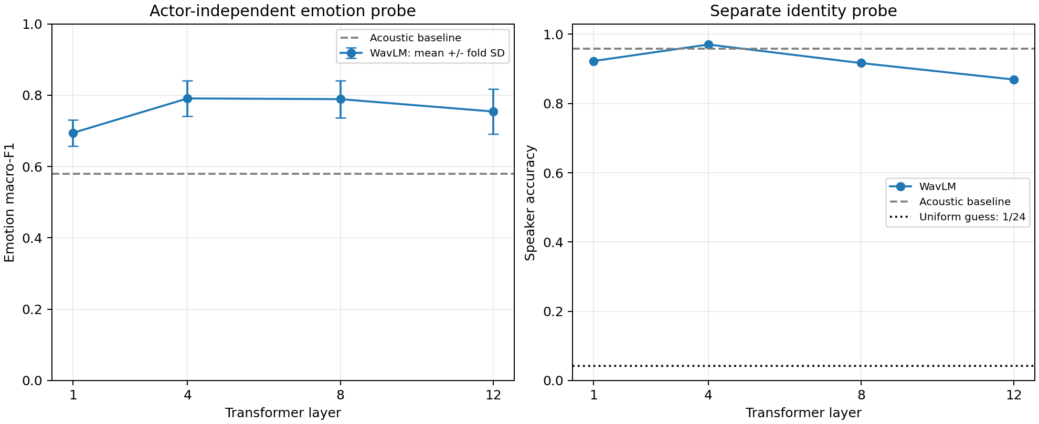
Figure 1. Emotion macro-F1 by layer with fold standard deviation, and separate speaker accuracy.
Speaker accuracy is 0.9583 for the acoustic baseline and 0.9226, 0.9702, 0.9167 and 0.8690 for WavLM layers 1, 4, 8 and 12. Layer 4 is strongest on both observed metrics. The dotted speaker reference in Figure 1 is uniform guessing over 24 identities, or 1/24.

4.2 Training-based layer selection
The training-only layer-selection procedure chooses layer 8 in outer folds 1, 2 and 5, and layer 4 in folds 3, 4 and 6. Its pooled outer-test macro-F1 is 0.7766 and its accuracy is 0.7827. This evaluates a selection procedure without using the outer test labels to choose the layer. The fixed-layer comparison identifies layer 4 descriptively from the comparison results.

4.3 Emotion confusion patterns
The acoustic baseline frequently confuses sad with neutral: 53 sad recordings are predicted as neutral, while 32 neutral recordings are predicted as sad. The corresponding counts for layer 4 decrease to 29 and 12. Happy-to-angry errors decrease from 37 to 10. Layer 4 therefore improves several prominent error patterns rather than only the majority category.
Expression | Acoustic precision | Acoustic recall | Layer 4 precision | Layer 4 recall
Neutral | 0.4060 | 0.5625 | 0.6475 | 0.8229
Happy | 0.6437 | 0.5833 | 0.8042 | 0.7917
Sad | 0.5663 | 0.4896 | 0.7861 | 0.7083
Angry | 0.7286 | 0.7552 | 0.9202 | 0.9010

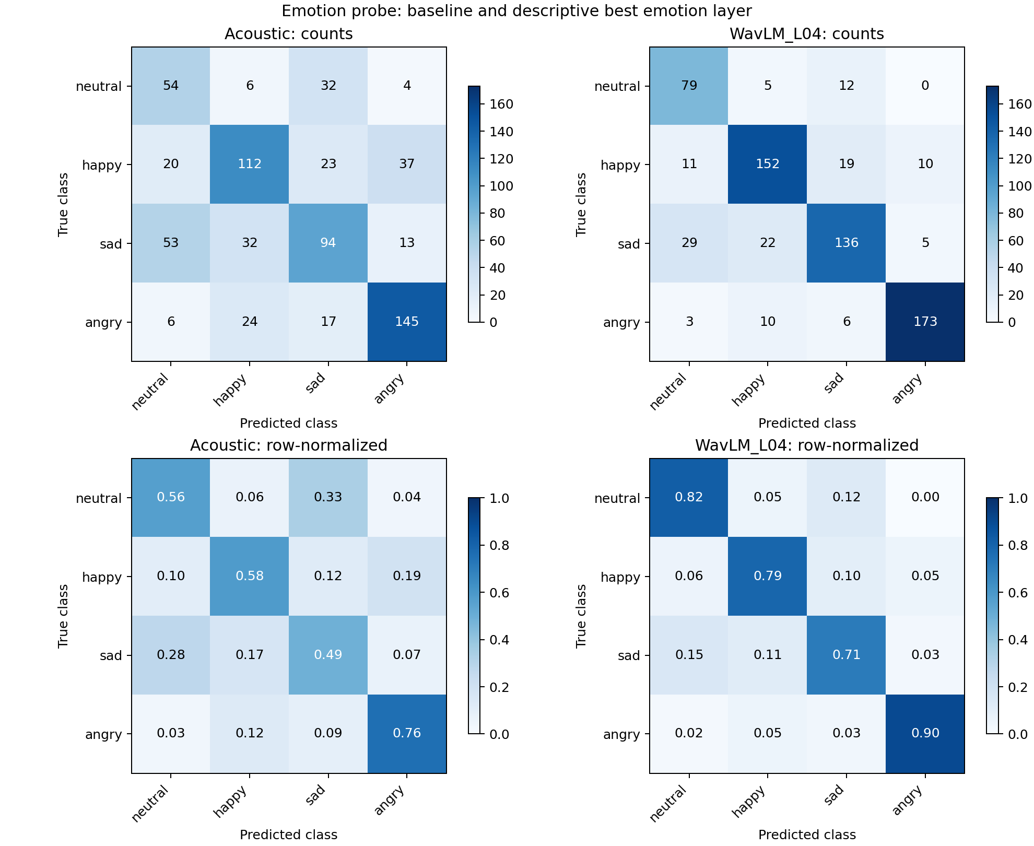
Figure 2. Held-out emotion confusion matrices for the acoustic baseline and layer 4.
The row-normalized panels show the distribution of predictions within each true class. Layer 4 recalls are 0.823 for neutral, 0.792 for happy, 0.708 for sad and 0.901 for angry. Sad remains the least recalled class, despite improvement over the acoustic recall of 0.490.

4.4 Speaker identification
The acoustic baseline correctly identifies 161 of 168 speaker-test recordings, while layer 4 correctly identifies 163. Each row of the speaker confusion matrix contains seven recordings, so one error changes that actor’s recall by 1/7. The strong diagonal shows that both representation types preserve identity cues under this within-actor protocol.
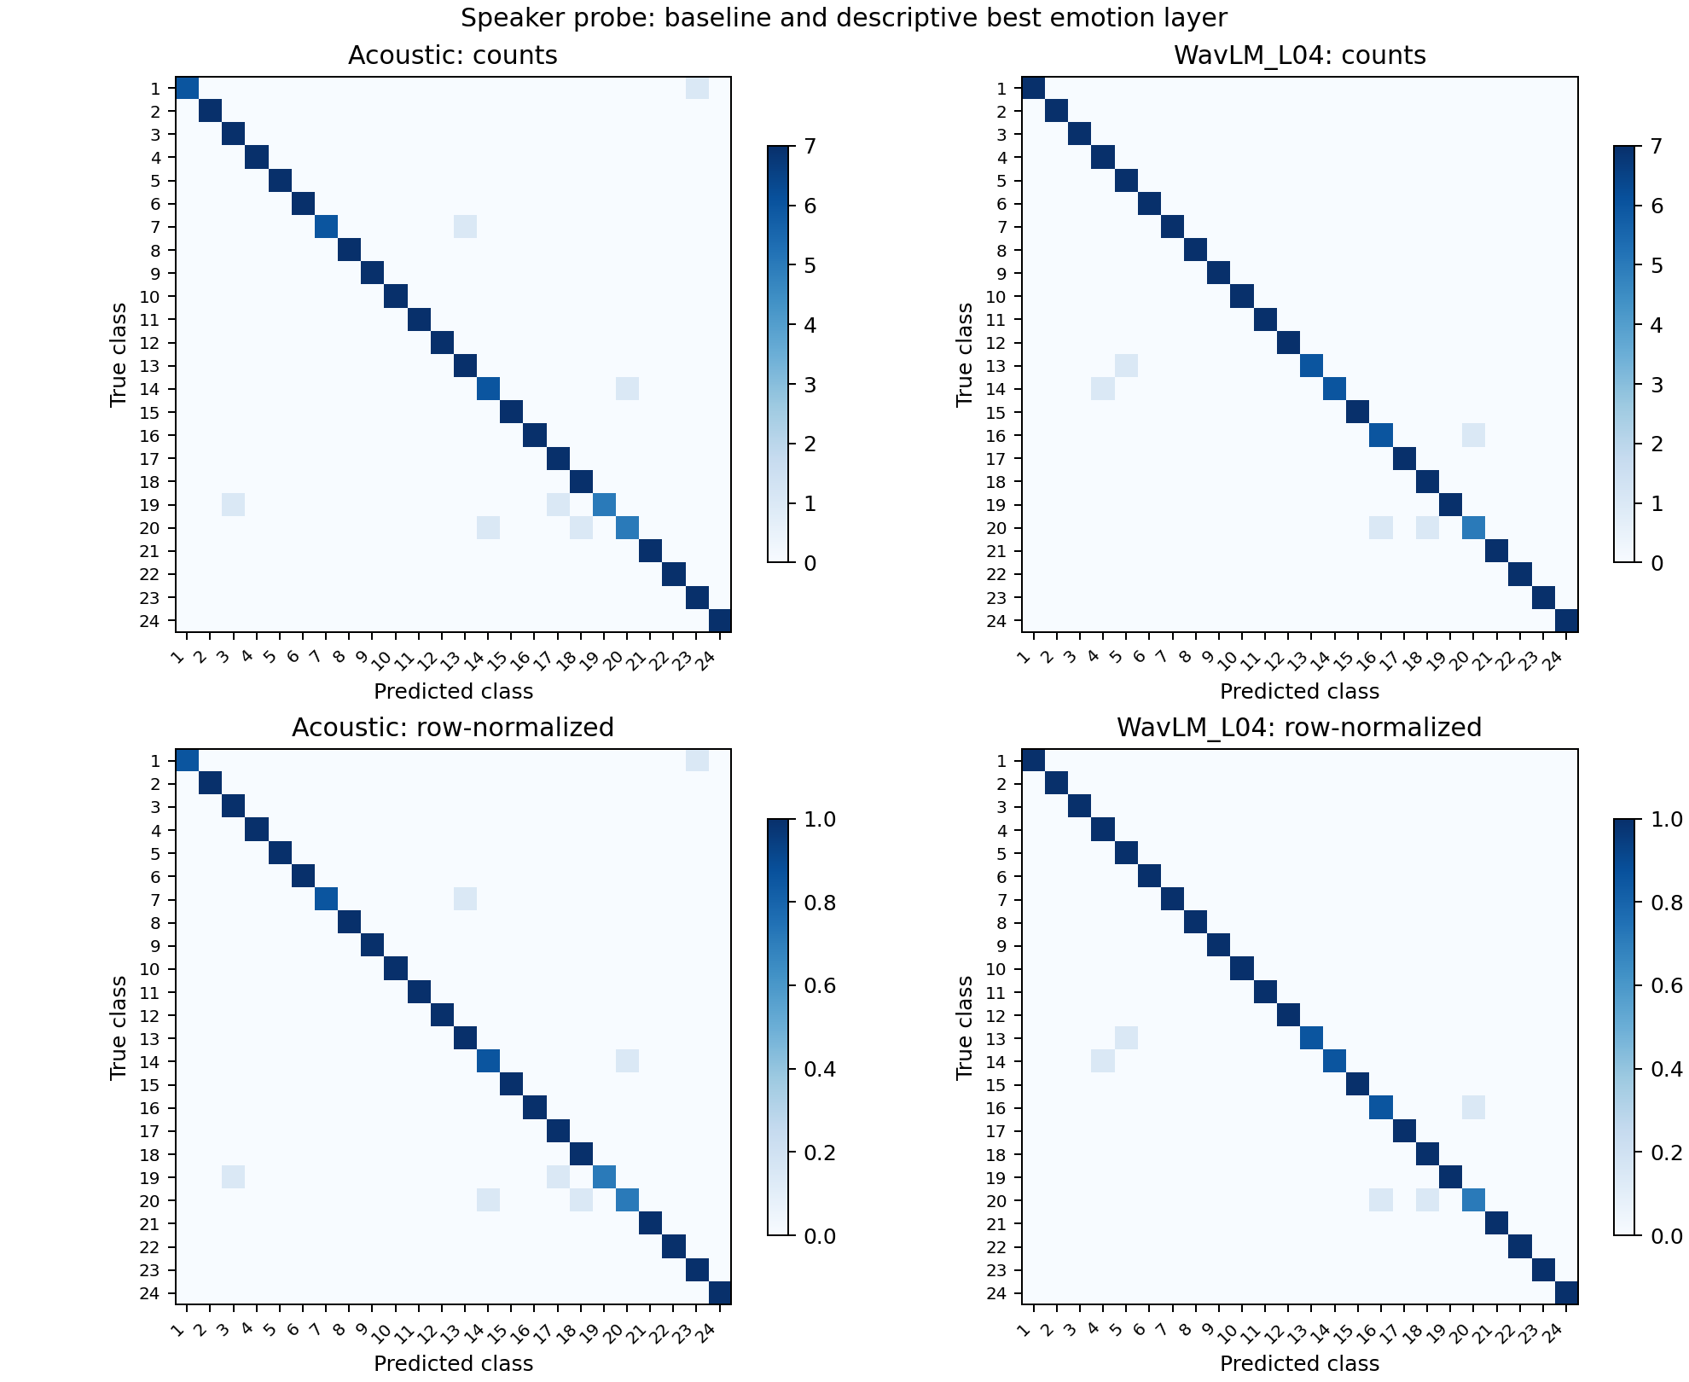
Figure 3. Separate identity-test confusion matrices for the acoustic baseline and layer 4.

4.5 Emotion and identity across layers
Figure 4 compares the two task scores for each representation. Identity accuracy decreases from layer 4 through layer 12, while emotion performance is highest around layers 4–8. The acoustic baseline identifies speakers well but has much lower emotion macro-F1. The observed pattern therefore does not form a simple monotonic trade-off between the two tasks.
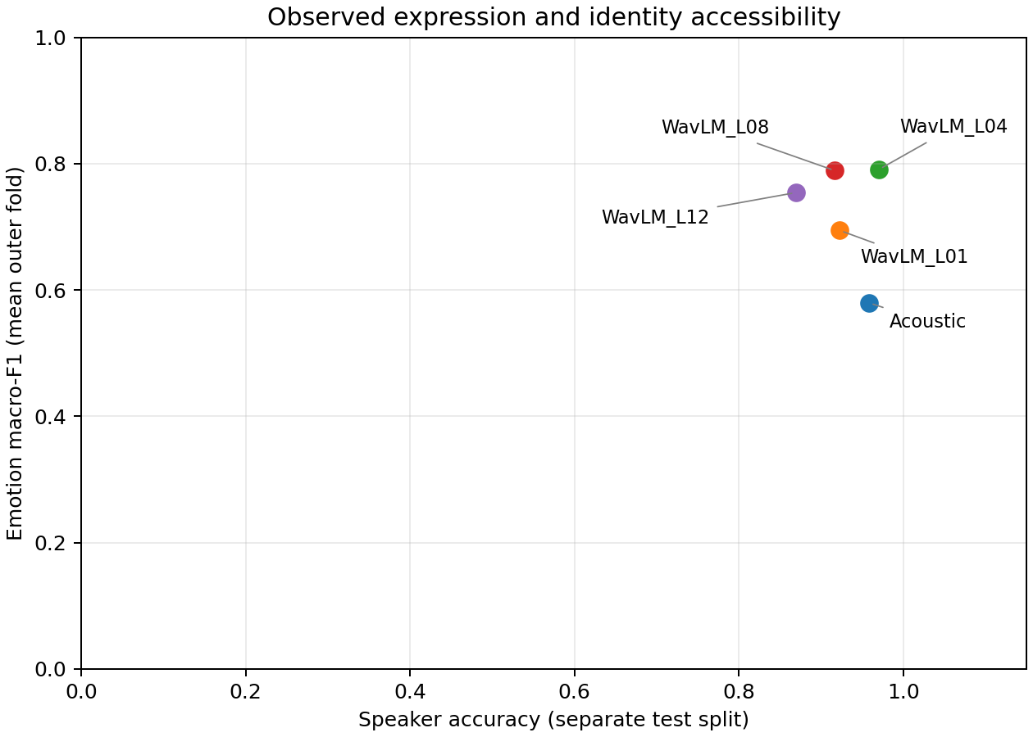
Figure 4. Emotion and speaker accessibility with each tested layer labelled.

五 Acoustic interpretation

5.1 Category distributions
Descriptor | Neutral | Happy | Sad | Angry
Median F0 (Hz) | 173.9 | 235.3 | 192.2 | 254
F0 range (Hz) | 77.67 | 151.2 | 91.09 | 143.5
RMS amplitude | 0.002395 | 0.008731 | 0.003335 | 0.01742
Duration (s) | 3.503 | 3.62 | 3.67 | 3.837
Centroid (Hz) | 2014 | 2104 | 2048 | 2197

Angry and happy recordings have higher median F0 and RMS than neutral recordings. Happy has the largest category-median F0 range, while angry has the longest category-median duration and highest spectral centroid. These patterns connect pitch modulation, amplitude, timing and spectral balance to the acted categories. The distributions overlap, so no single descriptor cleanly separates all four expressions.
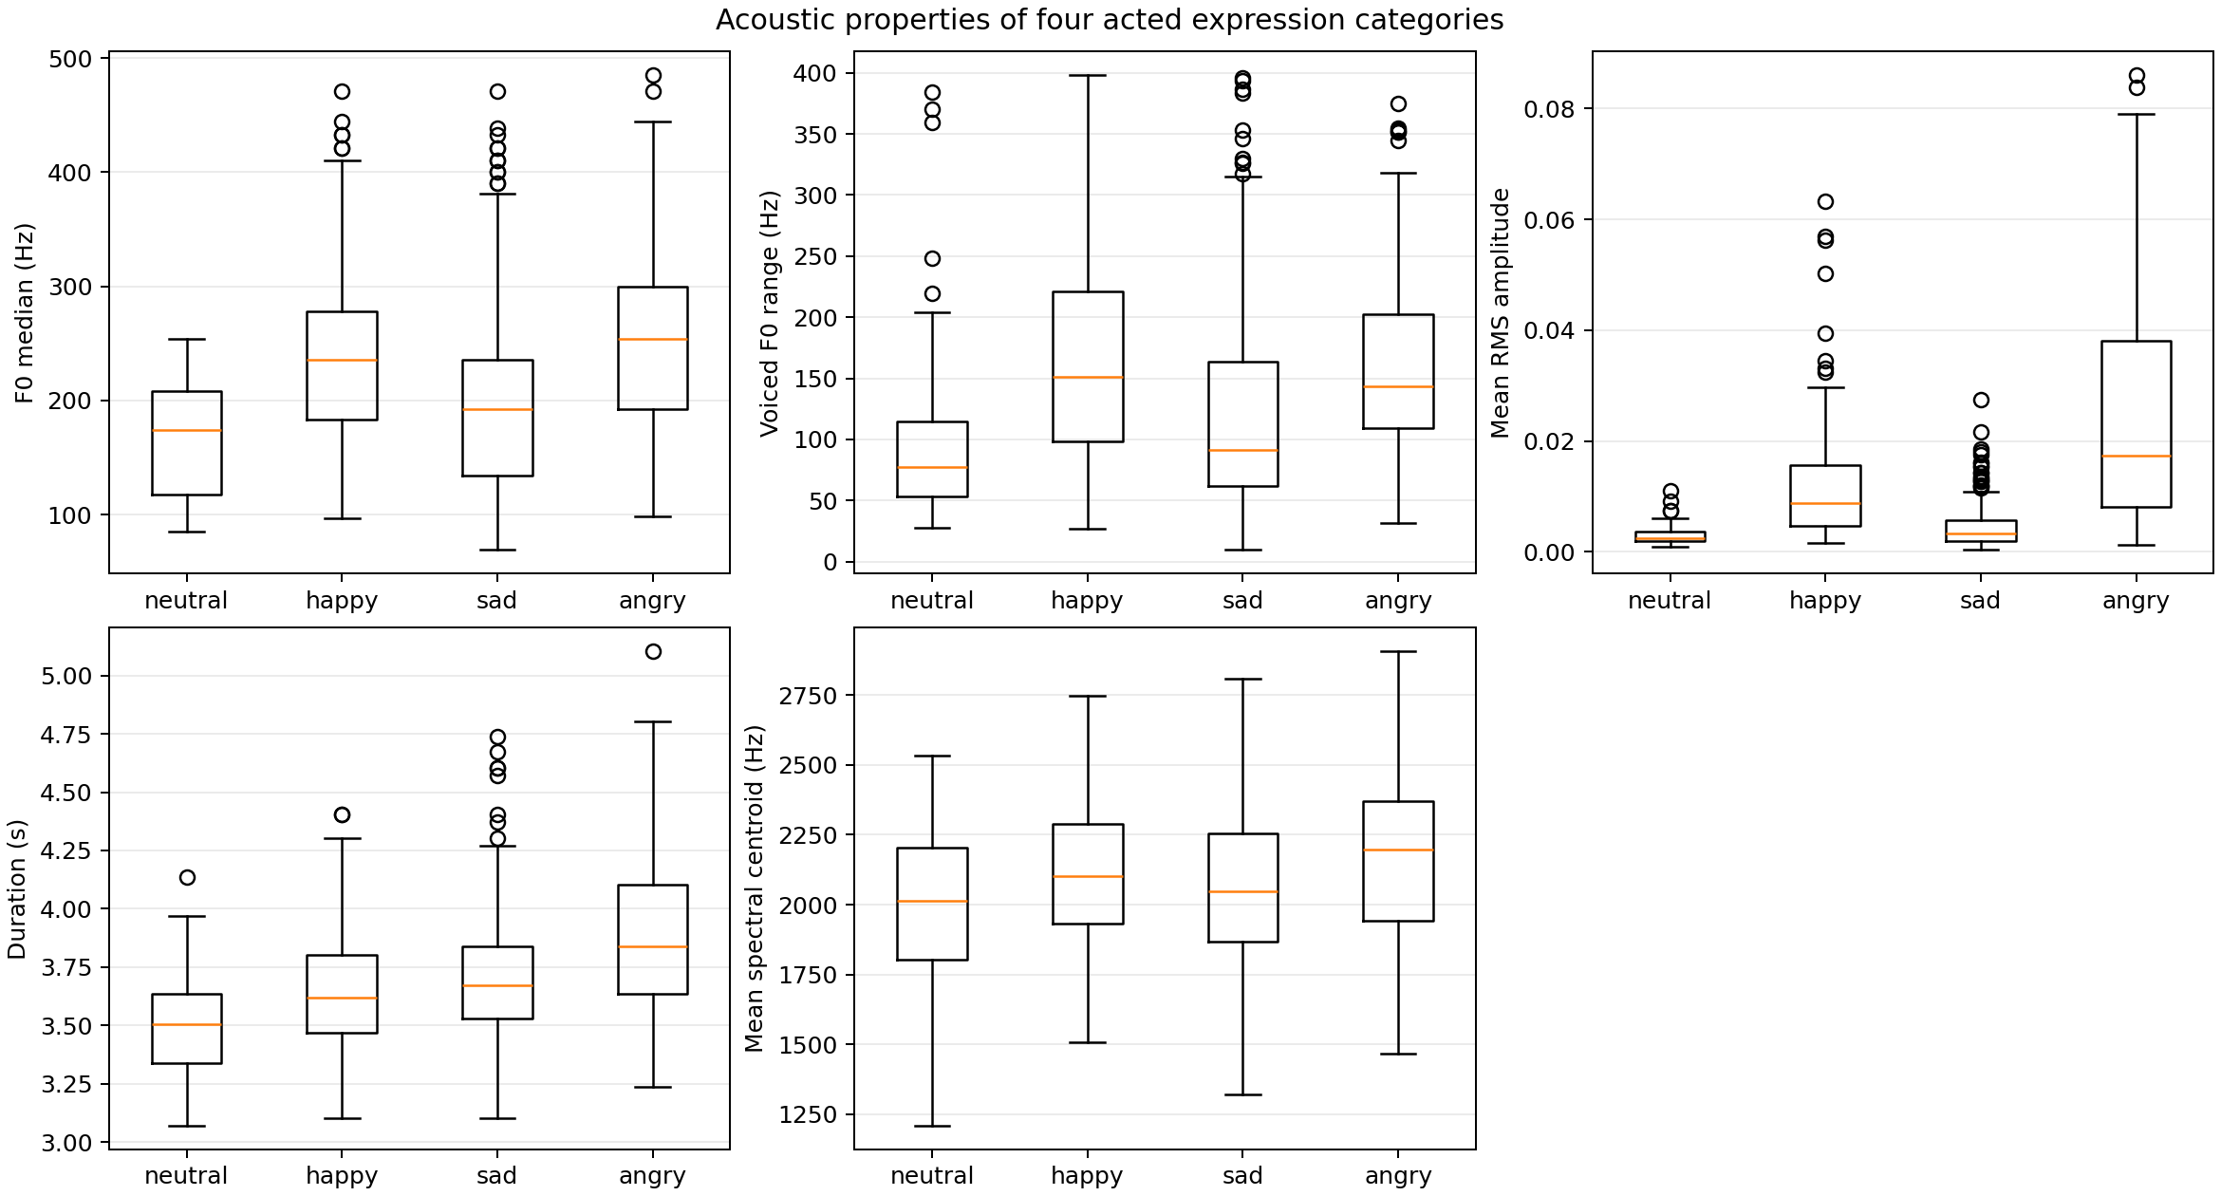
Figure 5. Distributions of five acoustic descriptors across the four expression categories.

5.2 Relation to recognition patterns
Neutral and sad have relatively low RMS medians and overlapping pitch distributions, consistent with their prominent confusion in the acoustic classifier. Happy and angry have higher pitch and amplitude, but differ in their distributions of duration and spectral balance. WavLM layers 4 and 8 improve recognition while retaining strong speaker accessibility, indicating that their learned vectors support a more useful linear separation of these expression classes than the compact recording-level summaries.
The pooled distributions combine actor-specific vocal properties and recording intensities. In particular, neutral has only normal intensity, whereas the other categories combine normal and strong recordings. This corpus structure contributes to the observed expression-level amplitude distributions.

六 Discussion and conclusion

6.1 Layer-wise findings
Across the selected layers, intermediate WavLM representations provide the highest emotion scores. Layer 4 achieves mean-fold macro-F1 0.7909 and pooled accuracy 0.8036, while layer 8 produces closely comparable results. The later layer 12 has lower speaker accessibility than layer 4 and lower emotion performance than layers 4 and 8. These results support comparing layers rather than treating the final transformer layer as the automatic choice.

6.2 Expression and speaker information
Strong identity accuracy coexists with strong actor-independent emotion recognition in layer 4. Speaker accessibility therefore does not, by itself, determine emotion recognition quality. The two probes use different splits and measure different predictive tasks; their joint pattern describes accessibility under the chosen linear classifiers rather than a causal effect of identity information. The six emotion folds provide actor-independent estimates, while the training-only layer-selection result gives a complementary evaluation of how a layer can be chosen for new test actors.

6.3 Conclusion
The compact acoustic baseline provides an interpretable reference, while all four tested WavLM layers improve mean-fold emotion macro-F1. Layers 4 and 8 are the strongest tested emotion representations, and layer 4 also produces the highest observed speaker accuracy. The classification results, acoustic distributions and confusion matrices together show how emotion and identity cues coexist in frozen speech representations.

七 References
[1] M. El Ayadi, M. S. Kamel, and F. Karray, “Survey on speech emotion recognition: Features, classification schemes, and databases,” Pattern Recognition, vol. 44, no. 3, pp. 572–587, 2011, doi: 10.1016/j.patcog.2010.09.020.
[2] S. R. Livingstone and F. A. Russo, “The Ryerson Audio-Visual Database of Emotional Speech and Song (RAVDESS): A dynamic, multimodal set of facial and vocal expressions in North American English,” PLOS ONE, vol. 13, no. 5, Art. no. e0196391, 2018, doi: 10.1371/journal.pone.0196391.
[3] S. Chen et al., “WavLM: Large-scale self-supervised pre-training for full stack speech processing,” IEEE Journal of Selected Topics in Signal Processing, vol. 16, no. 6, pp. 1505–1518, 2022, doi: 10.1109/JSTSP.2022.3188113.
[4] F. Pedregosa et al., “Scikit-learn: Machine learning in Python,” Journal of Machine Learning Research, vol. 12, no. 85, pp. 2825–2830, 2011. Available: https://jmlr.org/papers/v12/pedregosa11a.html.

