Bootdo笔记
- Security登录认证
现象:
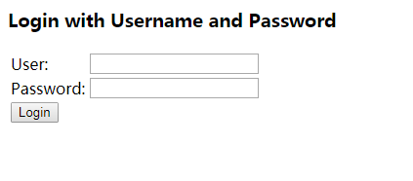
解决:
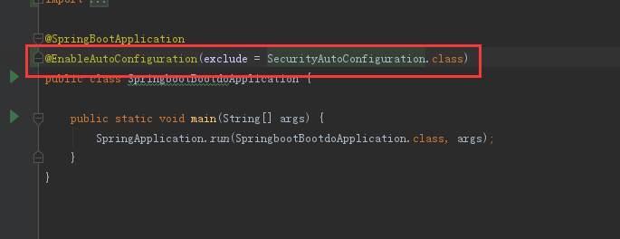
@EnableAutoConfiguration(exclude = SecurityAutoConfiguration.class)
取消Security认证

