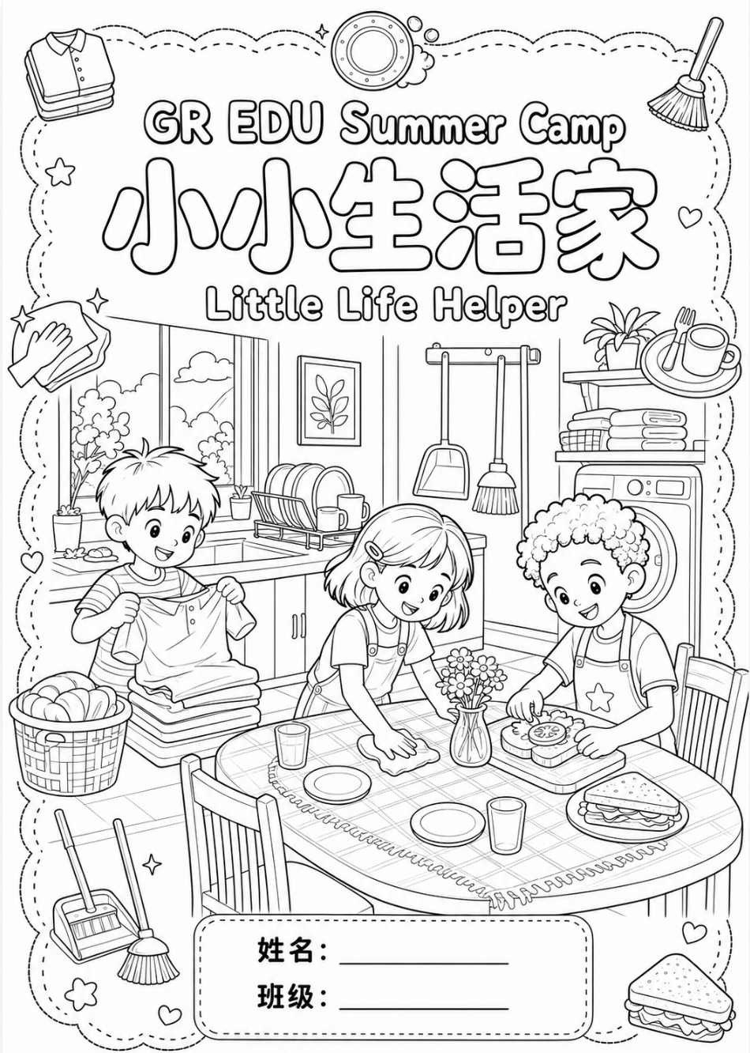
Day 2 · 整理和收纳达人 Organizing & Storage Master

一、选一选。
1 🎒 整理书包的第一步是什么？ What is the first step to organize your backpack?
☐ A. 直接把新东西塞进去 Just stuff the new things in.
☐ B. 先把书包里的东西全部拿出来 Take everything out of the backpack first.
☐ C. 马上拉上拉链 Zip it up right away.
2 🥤 水杯应该放在书包的哪里？ Where should the water bottle go?
☐ A. 侧边口袋，盖子拧紧 In the side pocket, with the lid tightened.
☐ B. 和作业本放在一起 Together with the homework notebooks.
☐ C. 书包底部，压在书下面 At the bottom, under the books.
3 📚 大课本和文件夹应该放在哪里？ Where do big textbooks and folders belong?
☐ A. 前面的小口袋 In the small front pocket.
☐ B. 大夹层，靠近背部竖着放 In the big compartment, upright and close to your back.
☐ C. 铅笔盒里 Inside the pencil case.
4 🧊 厚外套和被子太占地方，用哪种收纳工具最好？ Which tool works best for bulky coats and quilts?
☐ A. 真空压缩袋 Vacuum storage bag.
☐ B. 旋转收纳盘 Lazy Susan turntable.
☐ C. 洞洞板 Pegboard.
5 🍶 柜子后面的小瓶子很难拿到，用哪种收纳工具？ Which tool helps you reach small bottles at the back of a cabinet?
☐ A. 洞洞板 Pegboard.
☐ B. 旋转收纳盘 Lazy Susan turntable.
☐ C. 真空压缩袋 Vacuum storage bag.
6 👕 哪种方法叠衣服最省空间？ Which way of folding clothes saves the most space?
☐ A. 揉成一团塞进去 Squeeze it into a ball and stuff it in.
☐ B. 卷卷叠衣法 The roll-up folding method.
☐ C. 摊开平放在上面 Lay it flat and open on top.
7 🧳 整理行李箱的正确顺序是哪一个？ What is the correct order for packing a suitcase?
☐ A. 把东西都拿出来分类 → 叠衣服 → 用小袋子收纳 → 分区摆放 Take all out and sort → fold → use pouches → pack by zones.
☐ B. 先分区摆放 → 再拿出来 → 叠衣服 → 收纳 Pack by zones → take out → fold → store.
☐ C. 随便塞进去 → 关上箱子 → 再打开整理 Stuff it in → close it → open and redo it.

二、连一连
把词语和图片连起来。 Draw a line from each word to its picture.
乱 | 🎒  backpack
分类 | 🗂  sort
收拾 | 🌀  messy
书包 | 📥  put back
放回 | 🧹  tidy up

三、描一描, 写一写 / Trace and Write (分类 · 书包 · 收拾)
