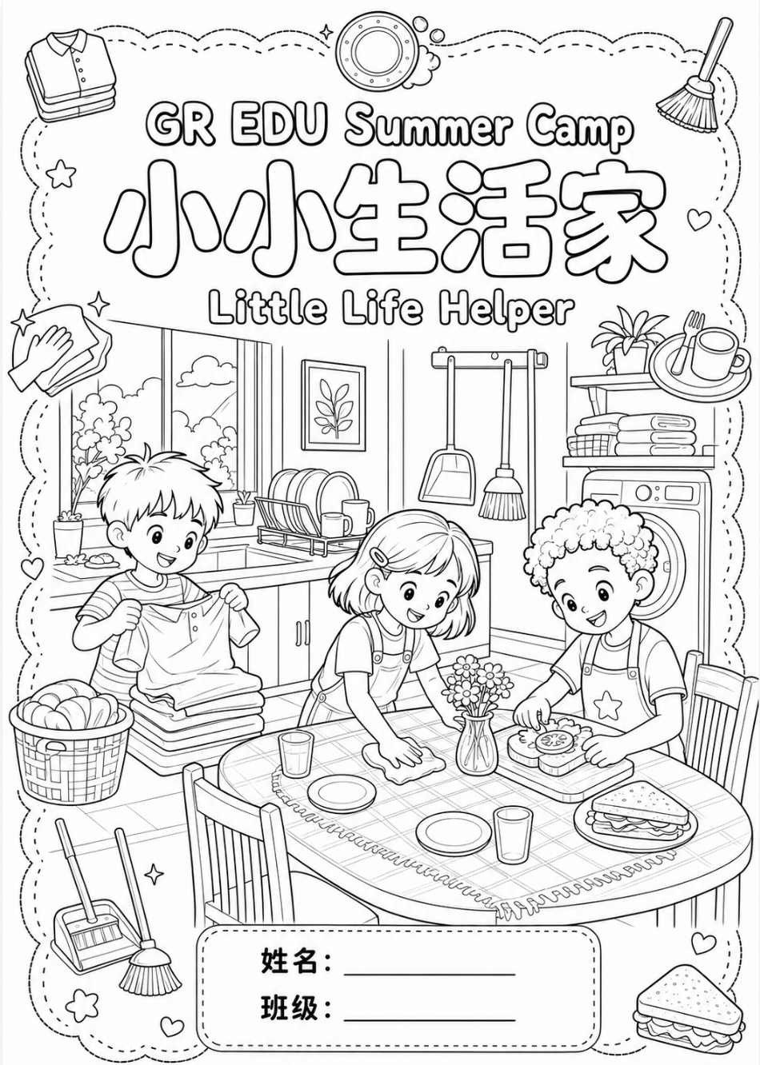
Day 4 · 友善我先行 · 接人待物 Kindness & Good Manners

一、选一选。
1 💛 友善是什么意思？ What does being kind mean?
☐ A. 只跟自己喜欢的人玩 Only play with the friends you like.
☐ B. 好好说话、帮助别人、避免矛盾 Speak kindly, help others, avoid fights.
☐ C. 谁最厉害就听谁的 Follow whoever is the strongest.
2 ✏️ 同学帮你捡起铅笔，你应该说什么？ A classmate picks up your pencil. What do you say?
☐ A. 「谢谢你！」 "Thank you!"
☐ B. 「你早就该帮我了。」 "You should have helped me sooner."
☐ C. 什么也不说 Say nothing.
3 🦶 你不小心踩到别人的脚，应该说什么？ You accidentally step on someone's foot. What do you say?
☐ A. 「你干吗站在这里？」 "Why are you standing here?"
☐ B. 「对不起，你没事吧？」 "Sorry! Are you OK?"
☐ C. 「我又没看见。」 "Well, I didn't see you."
4 🙇 别人对你说「对不起」，你可以说什么？ Someone says sorry to you. What can you say?
☐ A. 「没关系。」 "It's OK."
☐ B. 「就是你的错！」 "It IS your fault!"
☐ C. 不理他 Ignore them.
5 🖊️ 你想借同学的笔，怎么说最友善？ You want to borrow a classmate's pen. What is the kindest way?
☐ A. 「把笔给我！」 "Give me the pen!"
☐ B. 「请问，我可以借一下你的笔吗？」 "Excuse me, may I borrow your pen?"
☐ C. 不用说，拿了就用 Just take it without asking.
6 🚪 家里来客人了，小主人应该怎么做？ A guest comes to your home. What should you do?
☐ A. 继续玩，不说话 Keep playing and say nothing.
☐ B. 说「你好，欢迎来我们家！」，请客人坐下 Say "Hello, welcome!" and invite them to sit.
☐ C. 躲进自己的房间 Hide in your room.
7 💬 「我话语」的四个步骤是哪一个？ What are the four steps of an "I-message"?
☐ A. 客观描述 → 表达感受 → 说明原因 → 提出需求 Describe → say how you feel → say why → say what you hope for.
☐ B. 先指责 → 再生气 → 再不理人 Blame → get angry → stop talking.
☐ C. 大声说 → 让别人听我的 Speak louder → make others obey.

二、连一连
把词语和图片连起来。 Draw a line from each word to its picture.
尊重 | 🍪  share
朋友 | 🙏  respect
友善 | 🙋  help
帮助 | 💛  kind
分享 | 🤝  friend

三、描一描, 写一写 / Trace and Write (朋友 · 友善 · 帮助)
