**20200922 Homework**

**1. Calculate the entropy of**

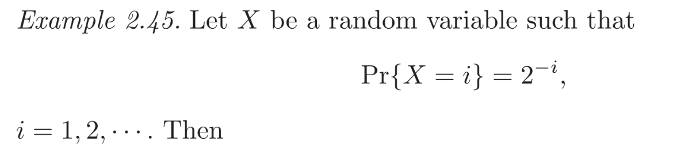

and that of

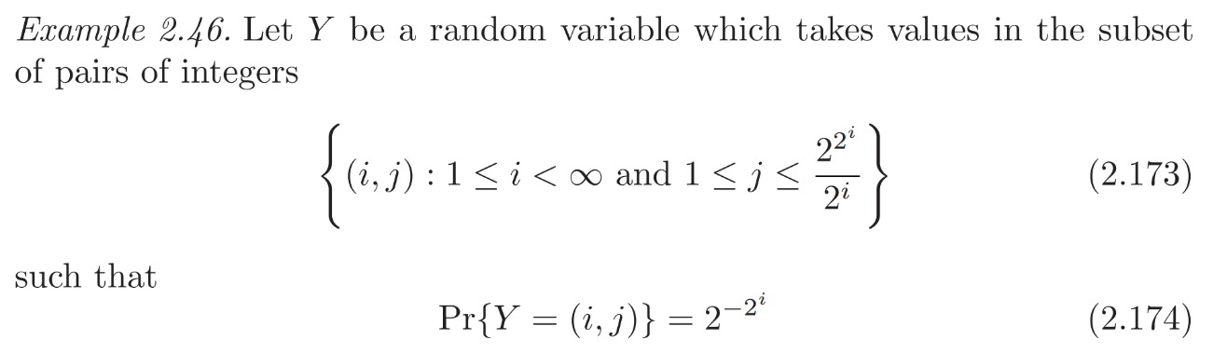

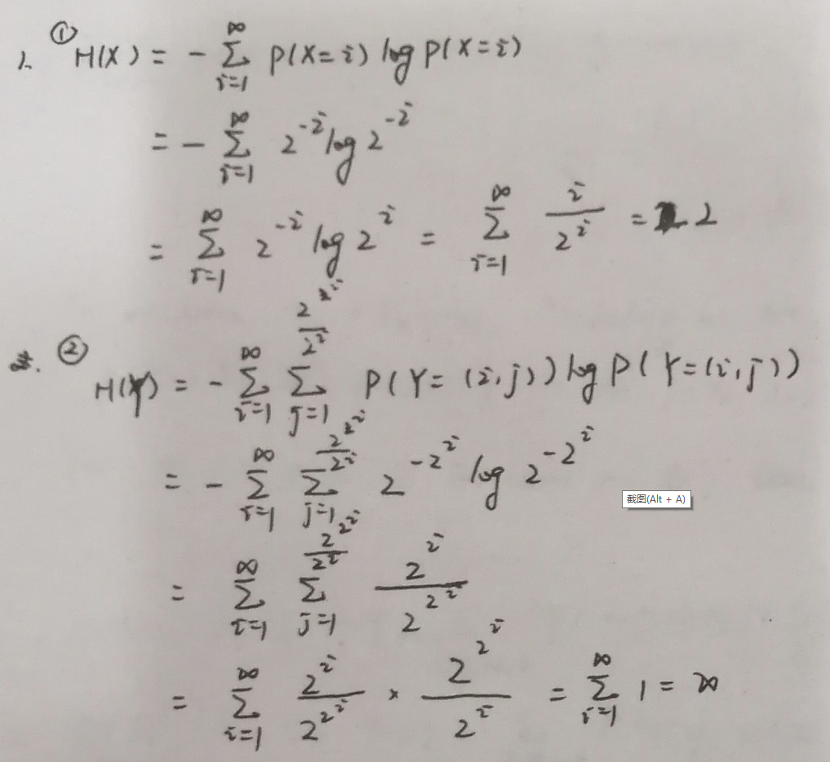

**2. Try to prove the equivalence of three definitions of the Markov chain with *n* nodes.**

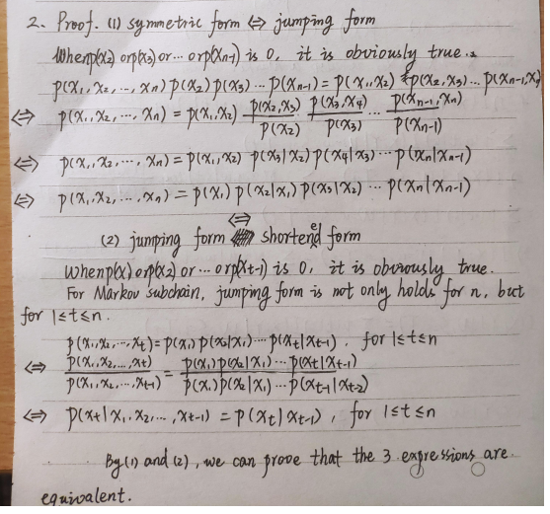

**3. If is a Markov Chain, please show that**

**is also a Markov chain by using the three equivalent definitions only.**

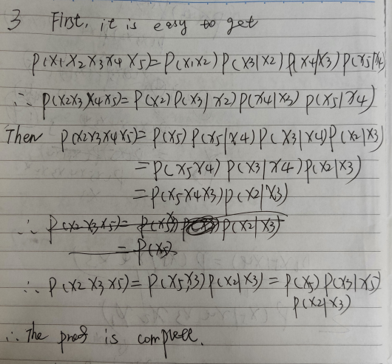

**4. Present the definitions of**

1. **What are the relationships among the three measurements?**

