**20201024 Homework**

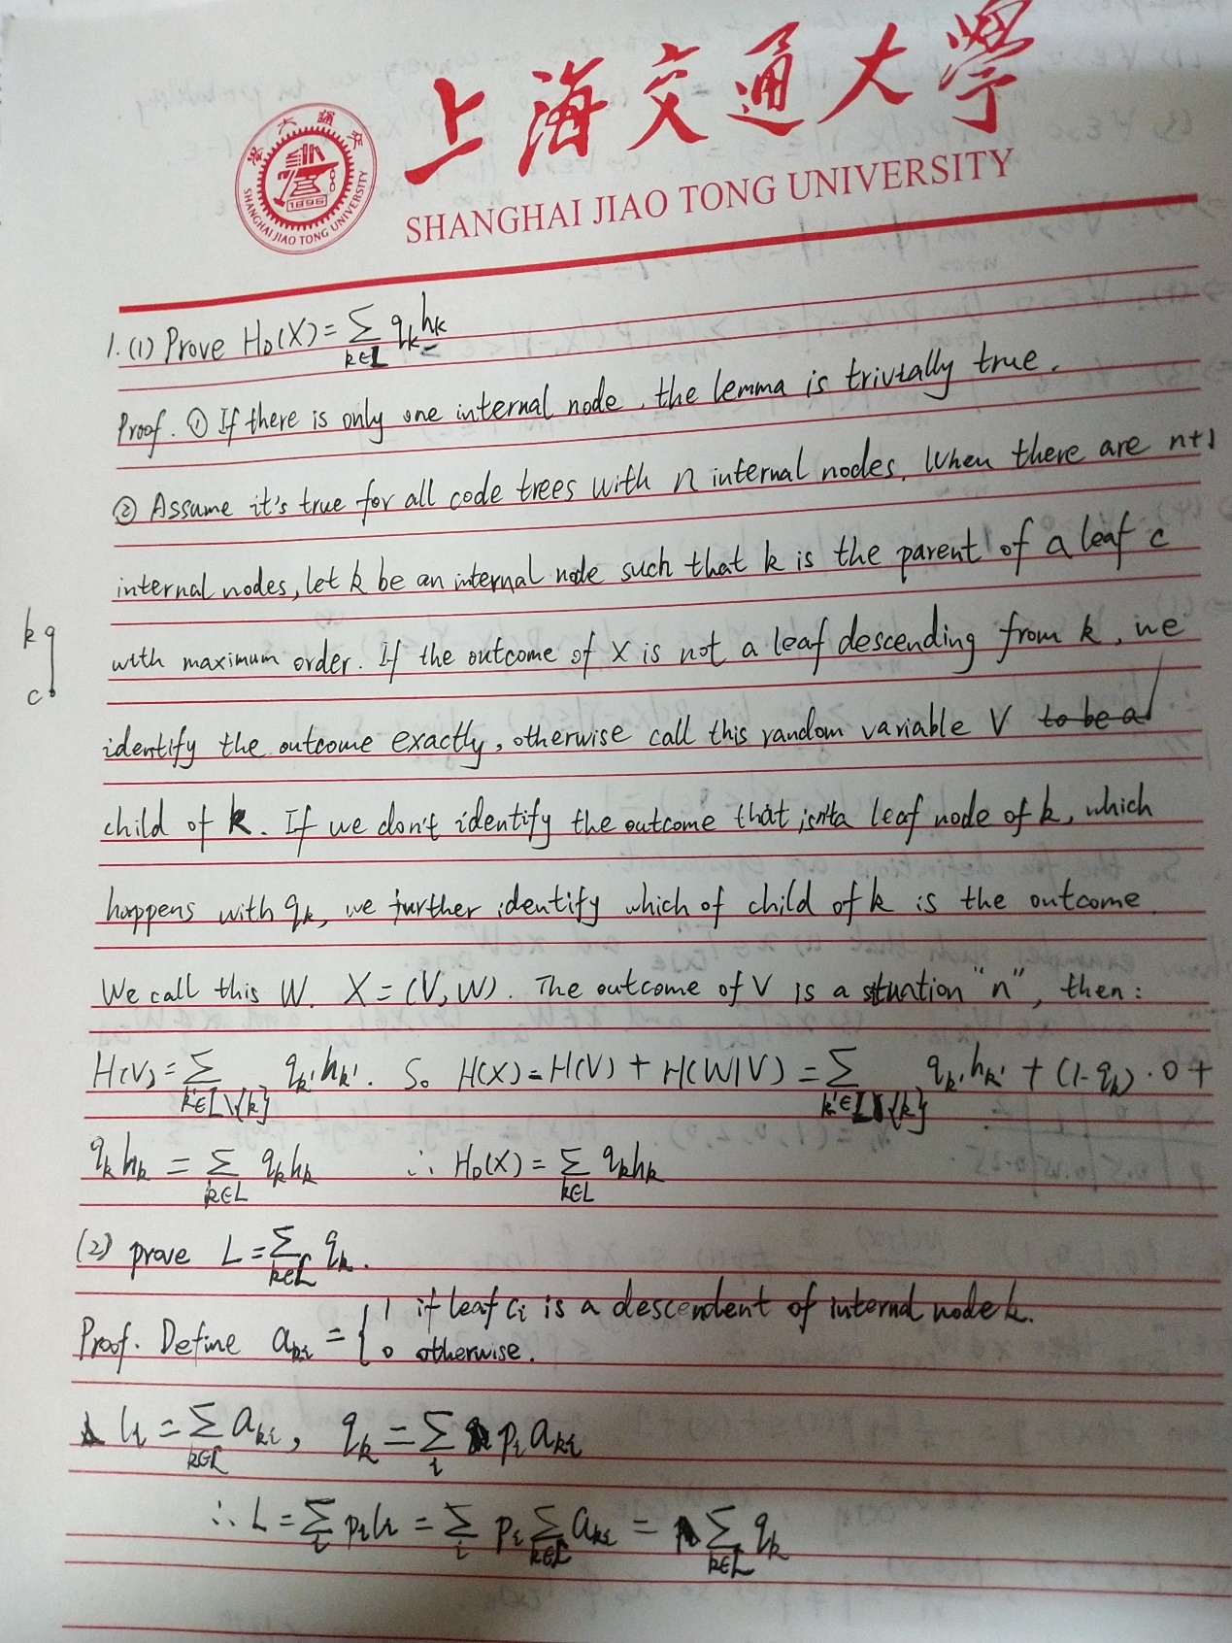

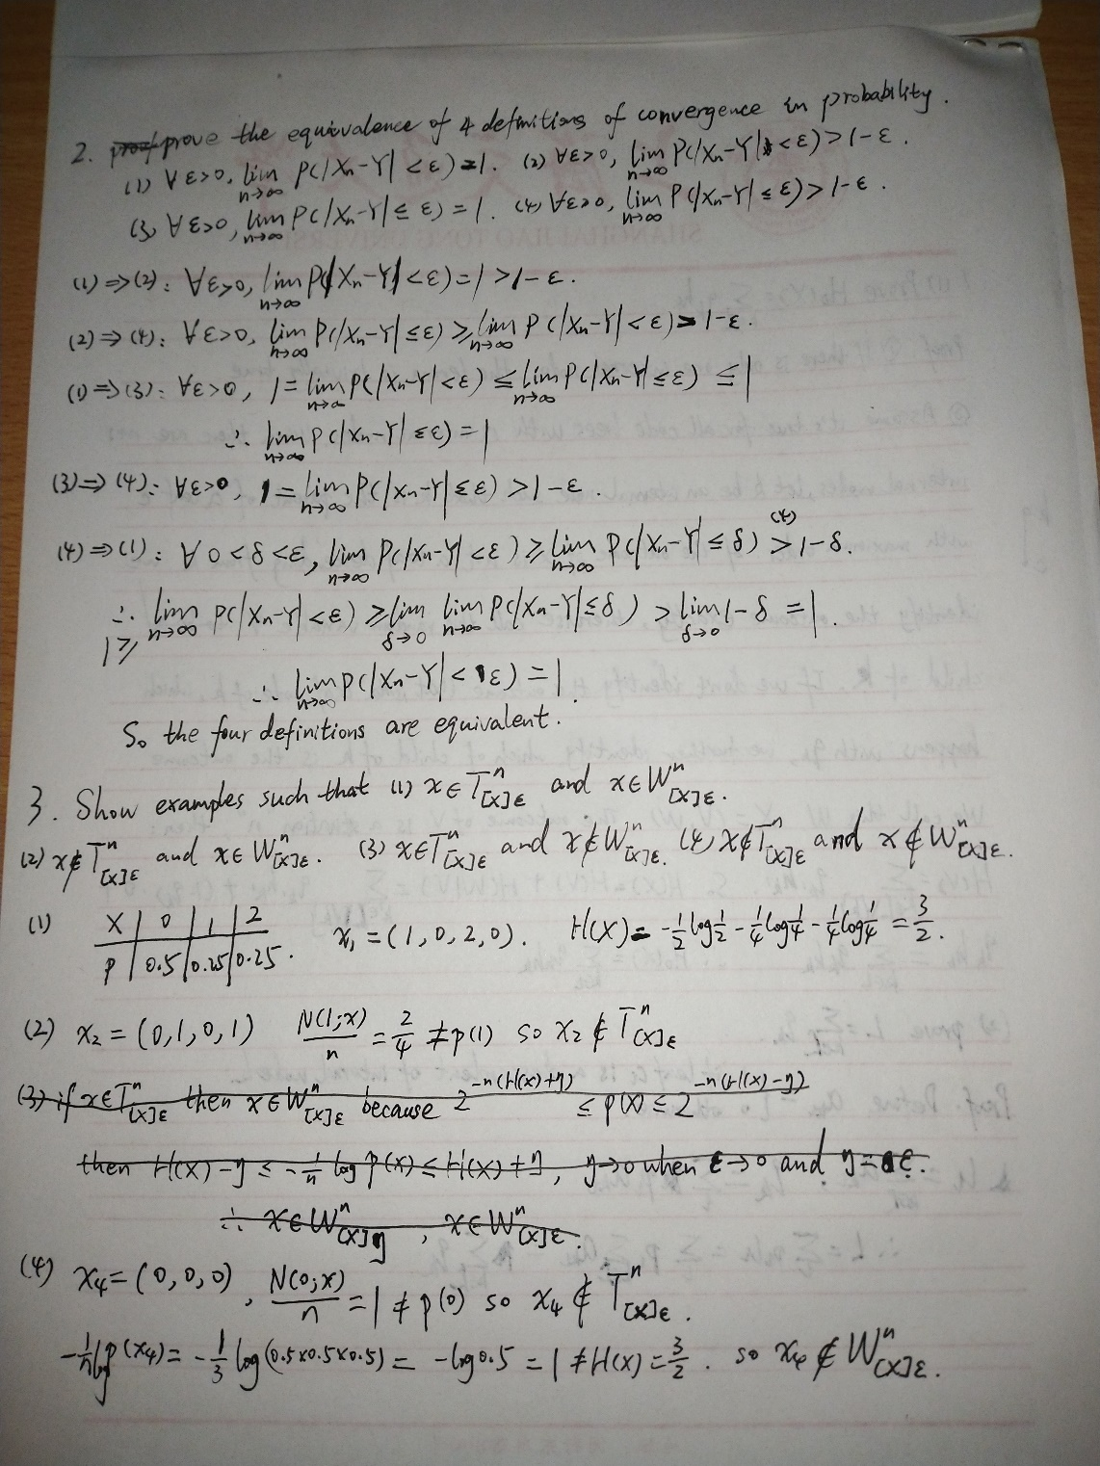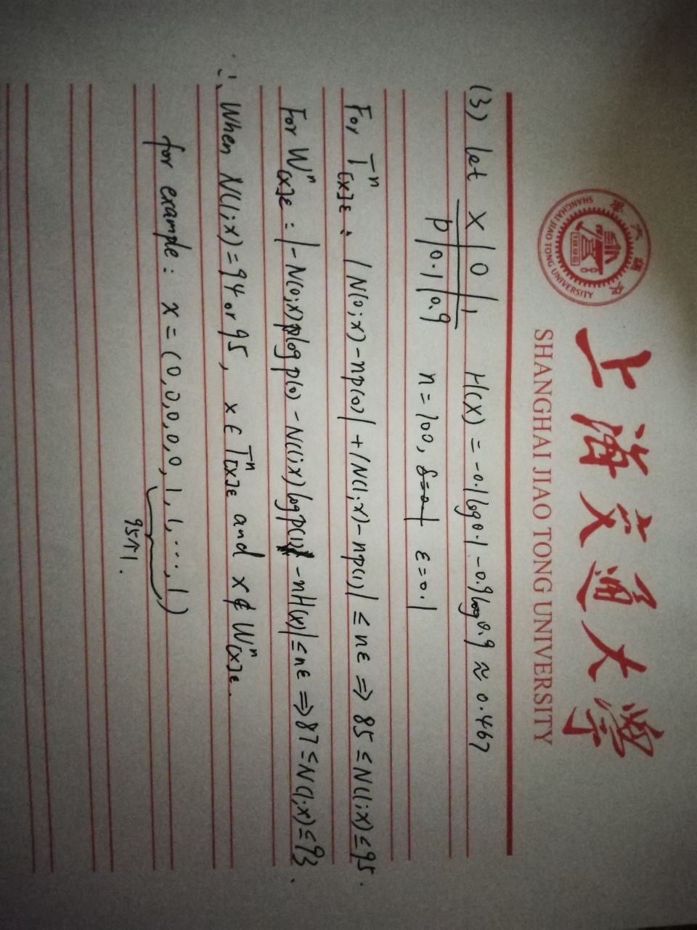

1. **Prove the following two lemmas of Local Redundancy Theorem**

* **Lemma 4.19.** . (maybe following example will show you an easier description than the textbook in the proof.)

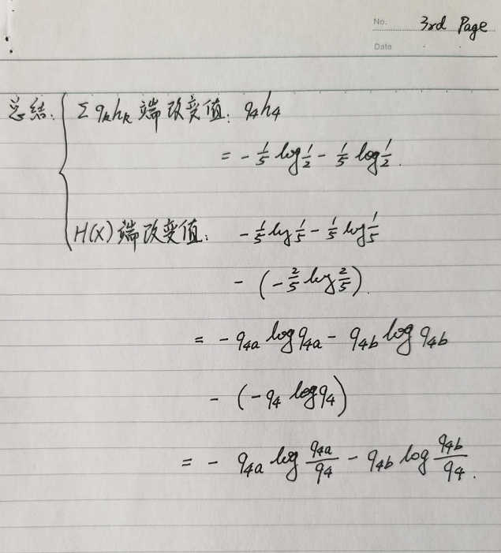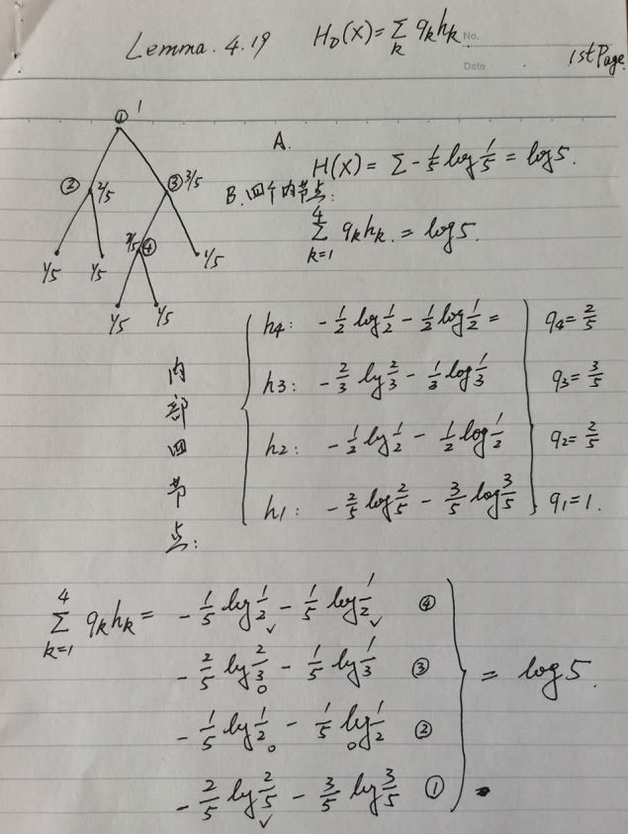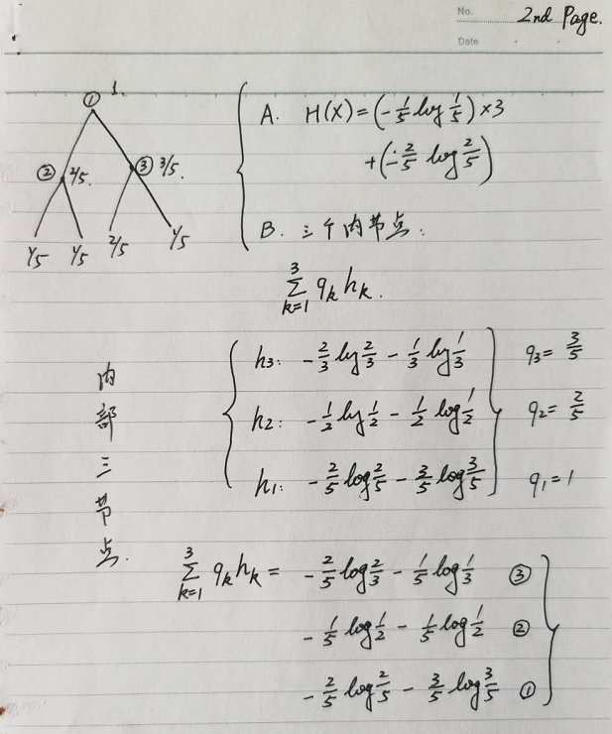

* **Lemma 4.20.**

1. **Prove the equivalence of four definitions of convergence in probability.**
2. **Show examples such that**
3. and
4. and
5. and
6. and