When runing the code, open the project with visual studio on windows 10.

Then change the following 3 lines.

Argv[1] is the path of the data graph,

Argv[2] is the path of the query graph,

Argv[3] is the path of edge similarity file path.

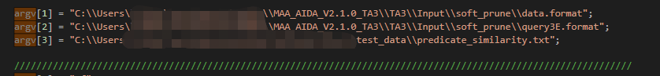

Edge similarity file:

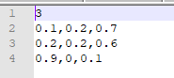

The above is an edge similarity file example. The first line of the file is a number denotes how many different edge types in the data graph.

The following lines is a n by n matrix, each element denote the similarity of different edge type. They are splited by “,”. The i-th row of j-th column of the matrix denotes the similarity of edge-type-I and edge-type-j.