In file data_structure.h

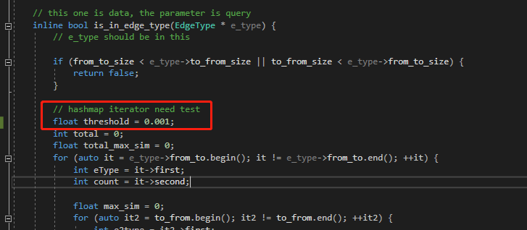

Threshold is used to control the similarity of edge types. If the edge similarity is great than threshold, we think it is a good mapping.

Let’s see the experiment results on the data graph and query graph in test_dataset fold.

First, we set threshold to 0.001, this means we could tolerance large dissimilarity between edges.

The results are shown below.

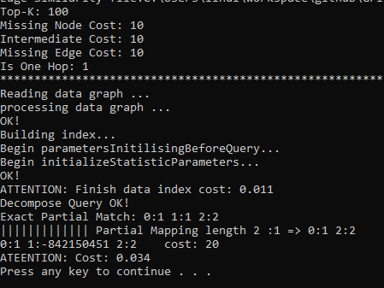

Then, we set threshold to 0.8.

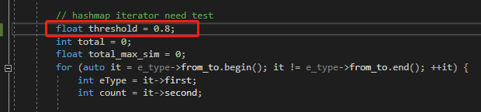

The results are shown below.

