**CS251**

# Homework 3:

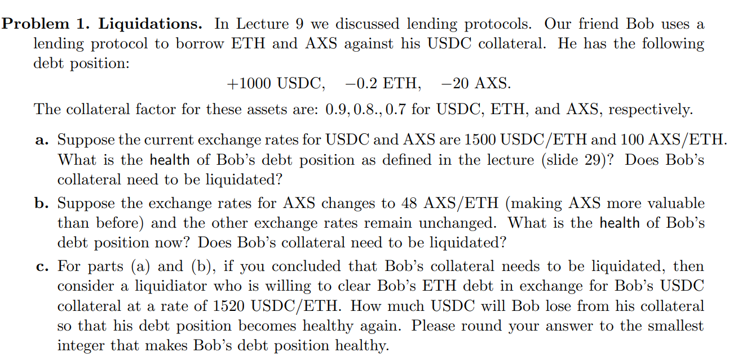

Bob’s debt position:

* 1000 USDC
* 0.2 ETH
* 20 AXS

Collateral factor:

0.9 for USDS, 0.8 for ETH, 0.7 for AXS

1. Exchange rate: 1500 USDC/ETH, 100 AXS/ETH

ETH debt value = 0.2 x 1500 = 300 USDC

AXS debt value = 20 x 1500/100 = 300 USDC

Borrow capacity = 1000 x 0.9 = 900 USDC

health = 900/(300+300) = 1.5 > 1 (healthy)

→ Bob’s collateral does not need to be liquidated.

1. Exchange rates for AXS changes to 48 AXS/ETH

AXS debt = 20 / 48 x 1500 = 625 USDC

health = 900 / (300+ 625) = 900/925 = 0.973 < 1 (unhealthy)

→ Bob’s collateral needs to be liquidated.

1. Liquidator clear Bob’s ETH debt at rate of 1520 USDC/ETH

Remaining collateral after liquidation:

1000 - 0.2 x 1520 = 1000 - 304 = 696 USDC

New health = 696 x 0.9 / 625 = 1.002 > 1

→ So, Bob will lose 304 USDC to become healthy again.

New debt position:

* 696 USDC
* 0 ETH
* 20 AXS

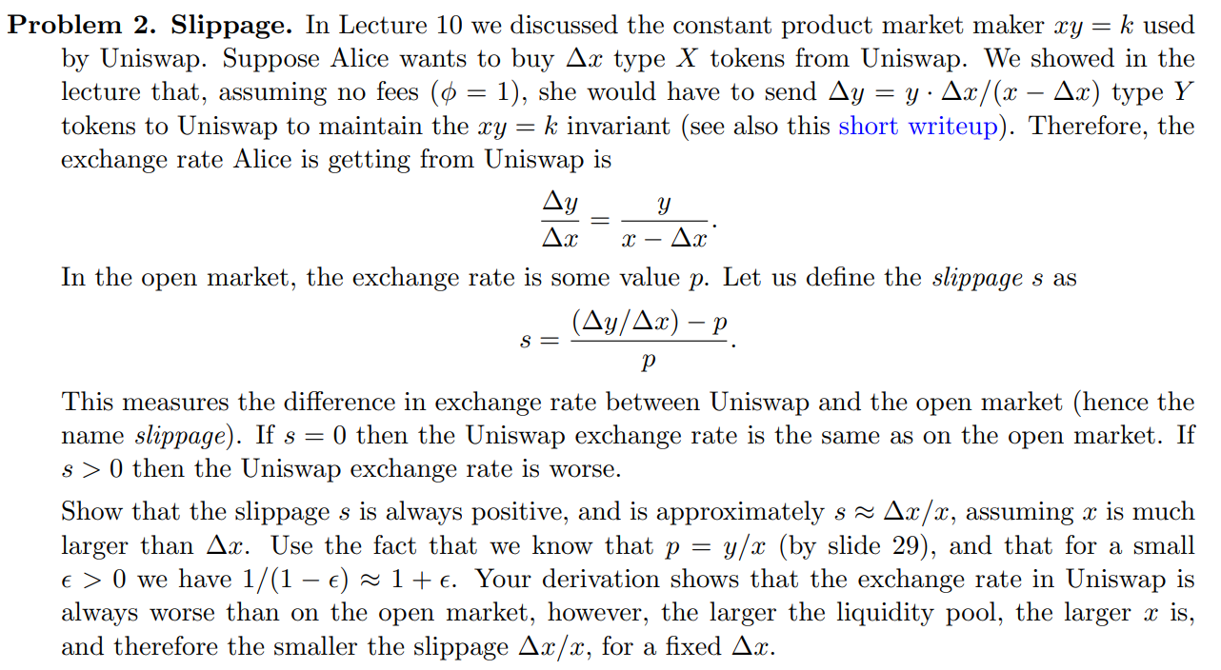

S =  =  > 0

→ The slippage s is always positive

→ The exchange rate in Uniswap is always worse than on the open market

