S0

--

S12

S10

Car Wash State Transition Diagram
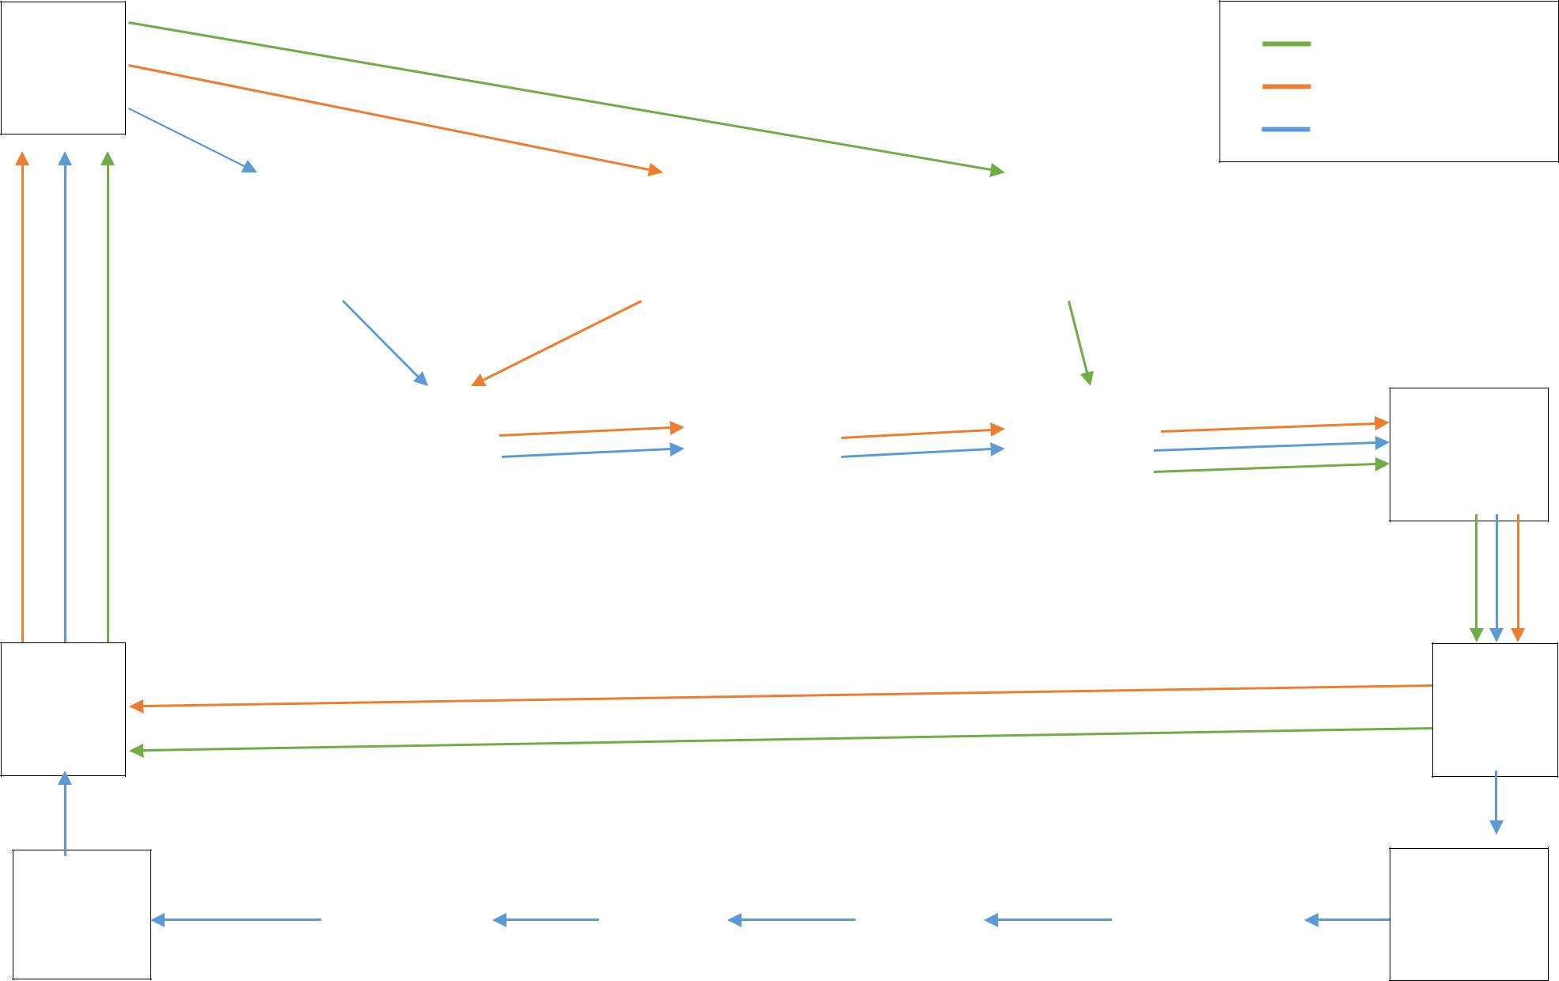

S3 |  | S2 |  | S1

S4 |  | S11 |  | S5

 |  |  |  | S15
S9 |  | S8 |  | S15 |  | S14

Basic
Extra
Platinum

S13

S6

S7

