Title: , Autonomous Helicopter Navigation System, Control System Design Document

*“A Project”*

Prepared by Date _______________

,

Checked by Date _______________

,

Approved by Date _______________

, Student Manager 2010

Authorised for use by Date _______________

Dr Luis Mejias, Project Coordinator

**QUT Avionics**

Queensland University of Technology

CRCSS-EESE, GPO Box 2434

Gardens Point Campus

Brisbane, Australia, 4001.

Telephone (+61 7) 3864 1772

Facsimile (+61 7) 3864 1517

e-mail luis.mejias@qut.edu.au

web <http://code.google.com/p/ahns10/>

This document is Copyright 2010 by the QUT. The content of this document, except that information which is in the public domain, is the proprietary property of the QUT and shall not be disclosed or reproduced in part or in whole other than for the purpose for which it has been prepared without the express permission of the QUT

**Revision Record**

|  |  |  |  |
| --- | --- | --- | --- |
| Document Issue/Revision Status | **Description of Change** | **Date** | **Approved** |
|  | Initial Issue |  |  |

**Distribution List**

|  |  |  |  |
| --- | --- | --- | --- |
| **Name** | **Affiliation** | **Distribution Date** | **Approved** |
| Avionics Lab File Archive | QUT Avionics |  |  |

**Foreword**

The AHNS flight control system’s establishing high level objective requires the design of an autopilot to enable stability augmented flight and autonomous position hold. This objective was specified in three system requirements that establish the design architecture as a cascaded PID design consisting of separate attitude and position controllers; or equivalently the two autopilot modes of operation.

Prior to examining controller design the basic control inputs of the platform were established to be throttle, roll, pitch and yaw. Attitude control therefore required the use of three PID control loops for the three angular control loops. The angular quantities controlled in these loops and how to design stability augmentation were iteratively explored in three designs. The final attitude control design is promising given its similarities to other hardware and software attitude control techniques. The iterative design process was described to justify the development of the final design.

A similar method was followed in describing the altitude controller design. The position and altitude controller designs however could not be iterated extensively due to perceived risks to personnel, the platform and other property in the flight tests required. Nevertheless design considerations are presented and note made to the implementations of all control loops in the flight control software. Acceptance testing is recommended for all attitude control loops and the altitude position control loop.

**Table of Contents**

Paragraph Page No.

1 Introduction 8

1.1 Scope 8

1.2 Background 8

2 Reference Documents 9

2.1 QUT Avionics Documents 9

2.2 Non-QUT Documents 9

3 High Level Objectives, System Requirements and Acceptance Testing 10

4 Quadrotor System Control Inputs 12

5 Attitude Control Design 14

5.1 Initial Design – Static Angle Set Point Control 14

5.2 Revised Design – Dynamic RC Angle Set Point Control 16

5.3 Final Design – Dynamic RC Angle Rate Set Point Control 18

6 Position Control Design 19

7 Conclusions 22

8 Recommendations 23

**List of Figures**

Figure Page No.

Figure 1 - Quadrotor motor control input effects [RD/5] 12

Figure 2 - Attitude Angle Static Control Loop 14

Figure 3 - Static Angle Control in Test Rig Small Step Disturbances 15

Figure 4 - Attitude Angle Dynamic Control Loop 16

Figure 5 - Dynamic Angle Control Oscillations 17

Figure 6 - Dynamic Angle Control Oscillations during Yawing Flight 17

Figure 7 - Final Attitude Control Loop 18

Figure 8 - Cascaded Position Controller Design 19

Figure 9 - Altitude Control Loop 20

Figure 10 - Effect of Dropping Battery Voltage on Attitude Hold with no trim adjustment 21

Figure 11 - GU-344 3 Axis Gyro [RD/7] 21

**List of Tables**

Table Page No.

Table 1 - Flight Control System Requirements 10

Table 2 - Flight Control Acceptance Tests 11

**Definitions**

|  |  |
| --- | --- |
| AHNS | Autonomous Helicopter Navigation System |
| QUT | Queensland University of Technology |
| HLO | High Level Objective |
| SR | System Requirement |
| GCS | Ground Control Station |
| RC | Radio Control |
| AT | Acceptance Test |
| IR | Infra-red |
| PID | Proportional, integral and derivative error |
| PWM | Pulse Width Modulation |
| MCU | Mode Control Unit |
| USART | Universal Synchronous/Asynchronous Receiver/Transmitter |
|  |  |
|  |  |

# Introduction

The Autonomous Helicopter Navigation System (AHNS) project by definition requires a flight control system to manoeuvre the aircraft during flight. Developing an attitude control system to enable flight is a challenge with astatically unstable and non-linear quadrotor platform. Taking this further in an attempt to enable localised autonomous flight further increases the system complexity and risks. This document describes the design process followed for the flight control subsystem and the final designs created and implemented. It documents the quadrotor dynamics used during controller design, attitude controller revisions and the position controller.

## Scope

The scope of this document is the design and initial implementation of the attitude and position controllers. Implementation level details such as engine control signals and radio control (RC) signals are purposely abstracted at the design stage to avoid hardware and software interface complications.

## Background

AHNS projects have always aimed to develop flight control systems for indoor airborne platforms. The results from previous years have confirmed the ability to control at least altitude whilst a safety pilot controls the attitude assisted by a hardware RC rate gyro. In AHNS 2010 this alternative to complete flight control was not considered due to the wish to explore different software and hardware based implementations and designs.

# Reference Documents

## QUT Avionics Documents

|  |  |  |
| --- | --- | --- |
| RD/1 | AHNS-2010-SY-HL-001 | AHNS, High Level Objectives of |
| RD/2 | AHNS-2010-SY-SR-001 | AHNS, System Requirements of |
| RD/3 | AHNS-2010-SY-TR-002 | Attitude with IMU Test Report |

## Non-QUT Documents

|  |  |  |
| --- | --- | --- |
| RD/4 | Design and Control of an Indoor Micro Quadrotor | Bouabdallah, S, P Murrieri and R Siegwart. 2007. "Design and Control of an Indoor Micro Quadrotor." In Advances in unmanned aerial vehicles: state of the art and the road to autonomy, ed. K. P. Valavanis: Springer Verlag. |
| RD/5 | IEEE Design and control of an indoor micro quadrotor | Bouabdallah, S., P. Murrieri and R. Siegwart. 2004. "Design and control of an indoor micro quadrotor." In IEEE INTERNATIONAL CONFERENCE ON ROBOTICS AND AUTOMATION: IEEE. |
| RD/6 | AeroQuad | AeroQuad – The Open Source Quadcopter. 2010.  Available: http://aeroquad.com/ (accessed October 20 2010) |
| RD/7 | GAUI | GU-344 Gyro. 2010.  Available: http://eng.gaui.com.tw/d981119/html/shopping_view.asp?sn=1028# (accessed October 20 2010). |
| RD/8 | Energy-efficient autonomous four-rotor flying robot controlled at 1 khz | D. Gurdan, et al., "Energy-efficient autonomous four-rotor flying robot controlled at 1 khz," in IEEE International Conference on Robotics and Automation, Roma, Italy, 2007, pp. 361-366. |

In the event of any conflict between this document and any RD referenced herein, such conflict shall be notified to Dr Luis Mejias.

In the following text, RD/x identifies referenced documents, where "x" denotes the actual document.

# High Level Objectives, System Requirements and Acceptance Testing

The development of a flight control system was explicitly requested by the customer and captured in the high level objectives in HLO-4 Autonomous Hovering Flight. The objective was to develop an autopilot to enable sustained indoor autonomous hovering flight. For future compatibility it was also to be designed to enable future ingress and egress manoeuvre to longitudinal and hovering flight.

System requirements for the flight control system are summarised in Table 1. SR-B-10 originated from discussion with the customer and from recommendations of previous AHNS groups. To meet this requirement the final controller design was to be tested using AT-10 in an inspection of the control methodology. SR-D-03 and SR-D-04 are concerned with the ability of the final controller design to control attitude and position respectively; both with minimum RC pilot input. Subjective testing of these requirements is avoided by applying specific acceptance testing standards from Table 2.

Table - Flight Control System Requirements

|  |  |  |
| --- | --- | --- |
| SR-B-10 | The autopilot control methodology shall be based on cascaded PID control loops. | AT-10 |
| SR-D-03 | The autopilot shall provide stability augmented flight. | AT-13 |
| SR-D-04 | The autopilot shall provide autonomous station keeping capability within a 1 meter cubed volume of a desired position. | AT-14 |

Table - Flight Control Acceptance Tests

|  |  |  |
| --- | --- | --- |
| AT-10 | Inspection | The control implementation will be reviewed to ensure PID control is implemented and includes saturation, rate limiters, anti-windup considerations as required. |
| AT-13 | Inspection | The platform will receive movement commands to move in a direction and speed. The platform must move as desired while in stable flight. |
| AT-14 | Testing Log Data | The platform will receive a command to station keep at a fixed co-ordinate for one minute. The telemetry data received at the GCS will be analysed to ensure that it did not move outside a 1 meter cubed volume of the desired position. |

# Quadrotor System Control Inputs

The quadrotor configuration is that used in [RD/4] and [RD/5] and shown in Figure 1 [RD/5]. The configuration is such that all engines produce upwards thrust with the pair1 and 3 rotating counter to the pair 2 and 4. Motion is commanded by exploiting the torque and thrust forces produced by each engine on the quadrotor.

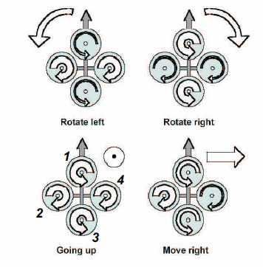

Figure - Quadrotor motor control input effects [RD/5]

A process of control abstraction described in [RD/4] and RD/5] is used to determine the required individual engine commands. This is necessary to implement any attitude and position control in hardware as the engine speed controllers are driven by pulse width modulated (PWM) signals. To accelerate the quadrotor vertically the thrust force of each engine is increasing or decreasing. This obviously requires the respective change of motor speeds. The control input force is thus

$$U_{1}=T_{1c}+T_{2c}+T_{3c}+T_{4c}$$

To vary roll or pitch, asymmetric engine thrust is produced between engines 1 and 3 or 2 and 4. The control inputs are therefore

$$U_{2}=-T_{2r}+T_{4r} \\ U_{3}=T_{1p}-T_{3p}$$

The effect of these attitude controls on position should be noted as pitch and roll variations also lead to longitudinal and lateral motion respectively [RD/4; RD4]. The final control input available with this engine configuration is yaw.Yaw is controlled by exploiting the opposing torque of the two engine pairs, 1 and 3 and 2 and 4 [RD/5]. Thus decreasing the speed of one pair will cause the aircraft to yaw in the direction of their propeller rotations. The control inputs force is therefore

$$U_{4}=T_{2y}+T_{4y}-\left(T_{1y}+T_{3y}\right)$$

Although these effects are well understood and the rigid body equations of motion are provided along with MATLAB/Simulink simulation means in [RD/4] and [RD/5]it is still not possible to use this information to gain tune.The design stage of the controller is therefore based around determining the required states for control and the PID design variations to be implemented and tested. Provisions have been included in the design of the software and hardware systems to log all state and control data for facilitation of linear system model development.

To determine the individual engine thrust and thus speeds required due to a combination of collective, roll, pitch and yaw commands ($U_{1},U_{2}, U_{3} and U_{4}$) the following mixing matrix is applicable:

$$\left[\begin{aligned}T_{1} \\ T_{2} \\ T_{3} \\ T_{4}\end{aligned}\right]=\left[\begin{matrix}1 & 0 & 1 & -1 \\ 1 & -1 & 0 & 1 \\ 1 & 0 & -1 & -1 \\ 1 & 1 & 0 & 1\end{matrix}\right]\left[\begin{matrix}U_{1} \\ U_{2} \\ U_{3} \\ U_{4}\end{matrix}\right]$$

The attitude controller is therefore based on three attitude control PID loops; roll, pitch and yaw. For position control the z or attitude input, $U_{1}$ has a dedicated control loop. Body-frame x and y coordinate control loops have been previously implemented as providing set points to the pitch and roll attitude control [RD/5]. This approach is therefore followed as it confirms the need for a cascade position control design. For cascade position control it is therefore imperative that a suitable attitude controller is designed, implemented and tested.

# Attitude Control Design

In stability augmentation mode the attitude controller is to maintain the quadrotor at a level attitude, without considering the altitude of the aircraft or its position. Attitude controller design was therefore based entirely on controlling the roll, pitch and yaw dynamics of the quadrotor with the possibility of RC signals being used to correct drift. An iterative design, implementation and testing process was used for each proposed PID control loop architecture.

## Initial Design – Static Angle Set Point Control

The initial design of the attitude control was based on control of the filtered angles and angular rates provided by the state estimation subsystem. The roll, pitch and yaw control loop architecture was identical and is shown in Figure 2. The setpoint or reference angle was designed to be static and changeable only through the GCS. This reduced the role of the RC pilot to controlling the throttle, as roll, pitch and yaw control outputs ($U_{2},U_{3},U_{4}$) where autopilot controlled. At the implementation stage the possibility of superposition using weighted addition in the mode control unit (MCU) was added for augmented (or blue) mode.

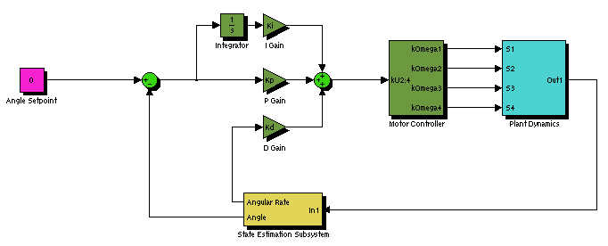

Figure - Attitude Angle Static Control Loop

Each control loop was tested in a SIMULINK rigid body simulator before implementation. This suggested the quadrotor would remain at a stable attitude provided three gains (proportional, integral and derivative) and four loop parameters were provided (maximum output, minimum output, neutral or trim output and integrator anti-wind up limit). After implementation the roll and pitch control loops were tested in a test rig, on a bungee and unrestricted. Yaw on the other hand was left untested due to the lack of a final yaw angle state estimation solution.

The design had its gains tunned initially in the test rig using angle information from the on board state estimation and IMU as described in [RD/3]. The test concluded that the rig’s dynamics had a profound impact on the attitude stability. Nevertheless Figure 3 illustrates that the controller performed better when control disturbances in the form of changing setpoints were introduced. Unrestricted testing of the angle controllers was used to confirm this observation.



Figure - Static Angle Control in Test Rig Small Step Disturbances

During a series of bungee and unrestricted controller tests it became apparent that the controller gains could not be tuned. The process for unrestricted tunning was to trim the quadrotor on the ground, then give the autopilot control over the roll and pitch whilst the pilot controlled yaw and throttle. This process never gave convincing results as the RC pilot was unable to correct for position drift and disturbances when near the ground without overriding the controller. A controller design where the pilot was able to correct for the sources of drift with modification of the control loop setpoints was therefore required; removal of the sources of drift such as state estimation and initial disturbances being other, but least practical, solution.

## Revised Design – Dynamic RC Angle Set Point Control

In the case of static setpoints, the GCS operator took on the role of emulating an outer-loop position controller in updating the setpoints to attempt to correct for position drift and initial disturbances. The dynamic setpoint angle controller design however moved this responsibility to the RC pilot and the RC transmitter. As Figure 4 shows the roll or pitch RC channel provides an adjustment to the setpoint of their respective attitude control loops. In this way the duty cycle of the RC pulse, 1000-2000 micro-seconds was mapped to an angle value of $±{15}^{∘}$. Note that assigning a yaw RC pulse a heading angle of $±{180}^{∘}$ or $0^{∘} to {360}^{∘}$ did not make sense and thus the yaw angle setpoint remained static.

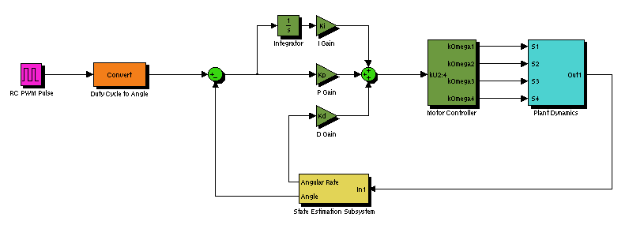

Figure - Attitude Angle Dynamic Control Loop

In terms of implementation this design was considerably more complex as the mode control unit was required to capture and forward the pulse duty cycle values via USART connection to the flight computer. Unrestricted flight testing was however more promising with the pilot having the ability to overcome initial disturbances provided the scaling range of angles was broad enough. Indeed the scaling of the pulse to an arbitrary range $±{15}^{∘}$ was difficult to justify given movement in the centre of gravity or simply battery could overcome the effectiveness of the controller and RC pilot. Nevertheless two short flights were achieved with roll and pitch angle plots shown in Figure 5 and Figure 6.

The RC pilot attempted to not provide significant angular corrections in flight as modification of the angular setpoints by as little as 5 degrees resulted in divergent system behaviour. To counter divergent oscillations proportional gain was decreased and derivative gains was increased. These adjustments did provide some improvement, particularly derivative gain. The oscillations were however impossible for the pilot to correct due to a lack effective yaw control causing the quadrotor to continuously rotate around its centre of mass.

During the final flight tests the range of appropriate proportional gains became extremely limited, with the derivative gain term beginning to dominate. Although state estimation was providing sound results, the delay in estimation and likelihood of estimate overshoots suggested that an attitude control solution independent of the angle estimation be sought.



Figure - Dynamic Angle Control Oscillations



Figure - Dynamic Angle Control Oscillations during Yawing Flight

## Final Design – Dynamic RC Angle Rate Set Point Control

The final attitude control design reflects the lessons learnt from the previous two controller deisng and testing iterations. To minimise the risk of the design not providing platform stabilisation other methods such as AeroQuad [RD/6] and a three axis RC feedback gyro [RD/7] were reviewed. Successful RC gyro flight reinforced the understanding that angular rates, even raw or lowpass filtered IMU rates, can form the basis of quadrotor attitude control.

The control loop architecture for the rate driven attitude controller is shown in Figure 7. The loop design is generic and thus can be used for roll, pitch and yaw rates without modification for modulus control of heading error. There are also fewer parameters and gains to select with the maximum and minimum output parameters rendered redundant by engine saturations enforced in the MCU. The concept of a dynamic setpoint is retained but arbitrary scaling is avoided by performing loop calculations in micro-seconds high of a PWM signal. The pulse time is in the range 1000-2000 micro-seconds with 1500 micro-seconds corresponding to a centred RC transmitter and rate of $0^{∘}/s$. RC Transmitter pulses are therefore no longer scaled, instead the IMU rate or state estimation rate is mapped from the limits of the IMU gyros, $±{300}^{∘}/s$, to the limits of the PWM signal.

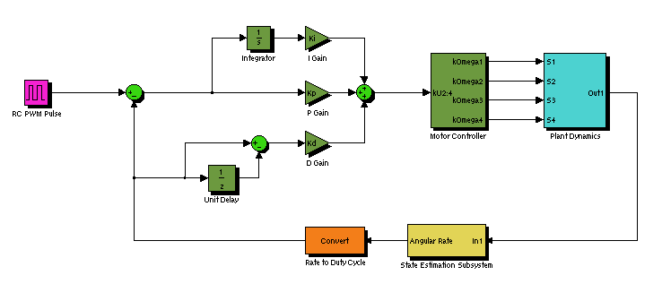

Figure - Final Attitude Control Loop

The design does however share the implementation complexity of flight critical MCU and flight computer USART communications. It also has the possibility of too much RC pilot control, for this reason an RC control factor is introduced to avoid full RC deflection generating $±{300}^{∘}/s$ control. It should also be noted that controllers based on rates and the difference in rates have been developed to control angles but these still retain a core architecture based on rates.

# Position Control Design

The autopilot control was described in SR-B-10 as taking the form of a cascaded proportional, integral and derivative controller. That is, the autopilot design consists of cascaded position and attitude PID control loops as shown in Figure 8. In operation the autonomous station keeping mode position control uses information from the localisation subsystem to drive the attitude control loops.

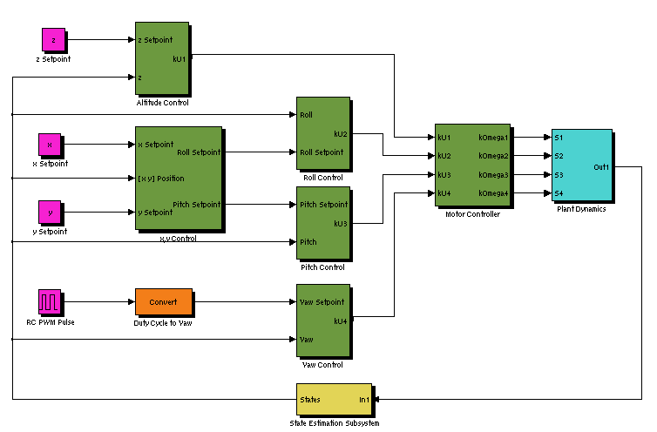

Figure - Cascaded Position Controller Design

Figure 8 shows that the interface between the attitude control blocks (dotted) and the position control blocks (dashed) are is the roll, pitch and yaw control setpoints. The attitude controller design this was originally designed for was one using on angles as setpoints. Use of it with an angular rate based attitude controller without modification is therefore not possible. The position controllers are required to monitor the angles to ensure they not exceed stable limits. Certainly the position controllers are also required to ensure the angular rates are at least not kept constant as this would signify continuous rotation around a quadrotor axis.

An implementation of the x,y position controller based on position error body frame rotations and PID generated pitch and roll angle commands was undertaken however it was abandoned when it became apparent testing the system safely was not possible. Risks to personnel, equipment and the quadrotor itself were difficult to mitigate to levels that justified attempting autonomous position.

Altitude controller design is unlike the other position control loops in that the output can be provided directly to a quadrotor control input. In the designed, implemented and tested altitude controller the throttle command output is generated from the PID control loop of Figure 9. The altitude control design has the standard PID gains and an integral anti-wind up limit parameter. As the output is directly linked to engine control however the MCU is entrusted with determining control saturation.

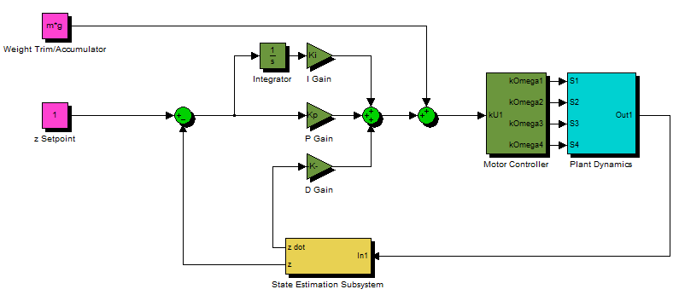

Figure - Altitude Control Loop

The remaining parameter of the altitude controller is the neutral setpoint which provides the thrust required to support the quadrotor when the error of the control loop is zero. This thrust force is constant however as the battery voltage drops, so too does the thrust provided by the engine at a fixed PWM value. The result is the slowly lowering altitude hold of . Sustained altitude hold therefore requires the controller to be designed with autonomous update of this trim. The approach suggested in [RD/8] where an accumulator was used to count the trim up when below height and down when above height was tried and is implemented. The increment amount and how to control ascent rate was however left for testing. Configuring these parameters through testing has resulted in platform damage, leading to the conclusion that further testing safety measures should be devised before fully autonomous altitude control is achievable with the current design.



Figure - Effect of Dropping Battery Voltage on Attitude Hold with no trim adjustment

A final point of note for position control design is its ability to work with a multitude of attitude control methods provided these accept throttle, roll, pitch and yaw commands. Specifically in the attitude control design (dotted) could be and indeed was substituted for a commercial solution (the three axis RC gyro of ); in doing so the testing and implementation of the cascaded PID designs is modularised.

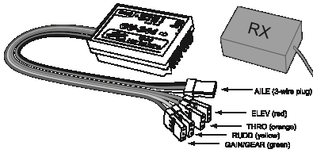

Figure - GU-344 3 Axis Gyro [RD/7]

# Conclusions

This document has described the high level objective, system requirements and design of the flight control subsystem. The single high level objective to provide a controller for indoor hovering flight has been broken into three system requirements that guide the design by specifying a cascaded PID design consisting of attitude and position control; or equivalently stability augmentation mode and position control.

Although a final attitude control design is provided based on angular rates, the iterative design process has been described to justify the development of the final design. A similar method was followed in documenting the altitude controller design. The position and altitude controller design however could not be implemented, tested and revised extensively due to perceived risks to personnel, the platform and other property in the flight tests required.

# Recommendations

It is recommended that acceptance testing be undertaken on the attitude control and the control methodology used. The altitude control loop of position control should also undergo acceptance testing.