Title: , , Onboard Hardware Systems, Design Document for

*“A Project”*

Prepared by Date _______________

,

Checked by Date _______________

,

Approved by Date _______________

, Student Manager 2009

Authorised for use by Date _______________

Dr Luis Mejias Project Coordinator

**QUT Avionics**

Queensland University of Technology

CRCSS-EESE, GPO Box 2434

Gardens Point Campus

Brisbane, Australia, 4001.

Telephone (+61 7) 3864 1772

Facsimile (+61 7) 3864 1517

e-mail luis.mejias@qut.edu.au

web <http://code.google.com/p/ahns10/>

This document is Copyright 2009 by the QUT. The content of this document, except that information which is in the public domain, is the proprietary property of the QUT and shall not be disclosed or reproduced in part or in whole other than for the purpose for which it has been prepared without the express permission of the QUT

**Revision Record**

|  |  |  |  |
| --- | --- | --- | --- |
| Document Issue/Revision Status | **Description of Change** | **Date** | **Approved** |
|  | Initial Issue |  |  |

**Distribution List**

|  |  |  |  |
| --- | --- | --- | --- |
| **Name** | **Affiliation** | **Distribution Date** | **Approved** |
| Avionics Lab File Archive | QUT Avionics |  |  |

**Executive Summary**

The onboard systems and telemetry portion of the AHNS project deals with the acquisition of data from the helicopter. Data flows to the ground station from the various onboard sensors via the onboard Robostix processor. The Robostix completes the necessary conversions and bit manipulations for output to the onboard Xbee radio modem. The data is then transmitted at a defined rate to the ground station receiver. The ground station radio modem receives the transmitted data and a MAX-232 chip converts the data from logic levels to RS-232 levels where it is then fed into the ground station PC.

**Table of Contents**

Paragraph Page No.

1 Introduction 8

1.1 Background 8

1.2 Scope 8

2 Reference Documents 9

2.1 QUT Avionics Documents 9

2.2 Non-QUT Documents 9

3 Onboard Systems 10

3.1 Payload Restrictions 10

3.2 Onboard Systems Architecture 11

4 Power System Design 13

4.1 High Voltage Power System 14

4.1.1 High Voltage Harness 14

4.1.2 Voltage Divider 16

4.1.3 Main Power Switch 16

4.2 Low Voltage Power System 18

5 Autopilot Hardware Design 20

6 Altitude Sensor 25

7 Heat Considerations 26

8 Vibration Dampening and Mounting 28

9 Conclusions 29

**List of Figures**

Figure Page No.

Figure 1 - Total weight of payload 11

Figure 2- System Design Overview 12

Figure 3 - Voltage Regulators on ESC 13

Figure 4 - High Voltage Distribution System Schematic 14

Figure 5 - High Voltage Power Harness 15

Figure 6 - Voltage Divider Connected to ADC Harness 16

Figure 7 - Main Power Switch 17

Figure 8 - Power Harness in Airframe 17

Figure 9 - Voltage Divider and Switch on Airframe 18

Figure 10 - Low Voltage Power System 19

Figure 11 - PCB Markings for Pin 1 20

Figure 12 – Final Autopilot Schematic 21

Figure 13 - Final PCB Layout 23

Figure 14 - Maxbotix EZ0 Ultrasonic Altimeter 24

Figure 15 - Mounting of Heat Emitting Components 25

**List of Tables**

Table Page No.

Table 1 - Initial Design Mass Calculation 10

Table 2 - Bit Calculations With Byte Segment Padding 13

**Definitions**

|  |  |
| --- | --- |
| AHNS | Autonomous Helicopter Navigation System |
| PCB | Printed Circuit Board |
| MTOW | Maximum Take-Off Weight |
| UART | Universal Asynchronous Receiver/Transmitter |
| ADC | Analogue-to-Digital Converter |
| IMU | Inertial Measurement Unit |
| MCU | Mode Control Unit |
| PCB | Printed Circuit Board |
| DIP | Dual Inline Package |
| FC | Flight Computer |
| FET | Field Effect Transistor |
| RTF | Ready To Fly |
| GPS | Global Positioning System |
|  |  |
|  |  |
|  |  |
|  |  |
|  |  |
|  |  |
|  |  |

# Introduction

In order to successfully achieve all platform and control based system requirements, a functional hardware system must be developed. This encompasses the actual autopilot circuit board as well as the complete power system. In addition to this, considerations need to be made in relation vibration dampening and heat dissipation. Finally, all interfaces to non PCB mounted sensors need to be designed.

## Background

The hardware used in the initial design was sourced from the initial trade studies detailed in RD/3. These initial designs were further developed throughout the course of the project.

## Scope

The purpose of this document is to detail the development and design of all parts of the onboard electronics.

# Reference Documents

## QUT Avionics Documents

|  |  |  |
| --- | --- | --- |
| RD/3 | AHNS-CT-TS-001 | Communications and Telemetry Trade Study |
| RD/4 | AHNS-SY-SR-001 | AHNS System Requirements Document |
| RD/5 | AHNS-SY-IC-001 | AHNS System Interface Control Document |

## Non-QUT Documents

|  |  |
| --- | --- |
| RD/1 | “Wiki: MikroKopter.de” 2009. [Online] Available: <http://www.mikrokopter.de/ucwiki/en/MikroKopter> [Accessed: Sep 10 2010]. |
| RD/2 | “ATmega128 Datasheet.” 2008 [Online] Available: <http://www.atmel.com/dyn/resources/prod_documents/doc2467.pdf> [Accessed Apr 23 2009]. |

In the event of any conflict between this document and any RD referenced herein, such conflict shall be notified to Dr Luis Mejias.

In the following text, RD/x identifies referenced documents, where "x" denotes the actual document.

# Onboard Systems

Before a successful design can be implemented, all relevant system requirements must be considered. The most important of these is the maximum payload requirement. If the final quad-copter system exceeds its MTOW, it will not be able to fly and consequently, very few project requirements can be achieved.

## Payload Restrictions

Several physical limitations need to be considered when determining the maximum allowable payload weight. The first of these is the total maximum thrust that is able to be produced by the propulsion system. It can been seen that if the total weight of the helicopter exceeds the maximum available thrust, the quad-copter will be unable to commence or sustain flight. In addition to this rudimentary limitation, there are other factors at work, which further impose constraints. One such factor is the ability for an aircraft to be controllable with a given weight. That is, as the flying weight approaches the limit of thrust, the motors can easily be saturated while performing certain manoeuvres. This will lead to a degraded ability to perform manoeuvres required for basic performance. It can be seen in the Mikrokopter Wiki page that the base airframe weighs 1kg. Each motor, with a selected propeller is capable of generating 500g of thrust. This means that the combined maximum thrust of the four motors is 2kg. It was decided that the MTOW should not exceed 1.4kg and hence the payload should not exceed 400g, as per the system requirement stated in RD/4. It can be seen in Figure 1 that the payload was designed to weigh 400g. A subsequent test was carried out to ensure that the quad-copter was able to perform correctly with this configuration.

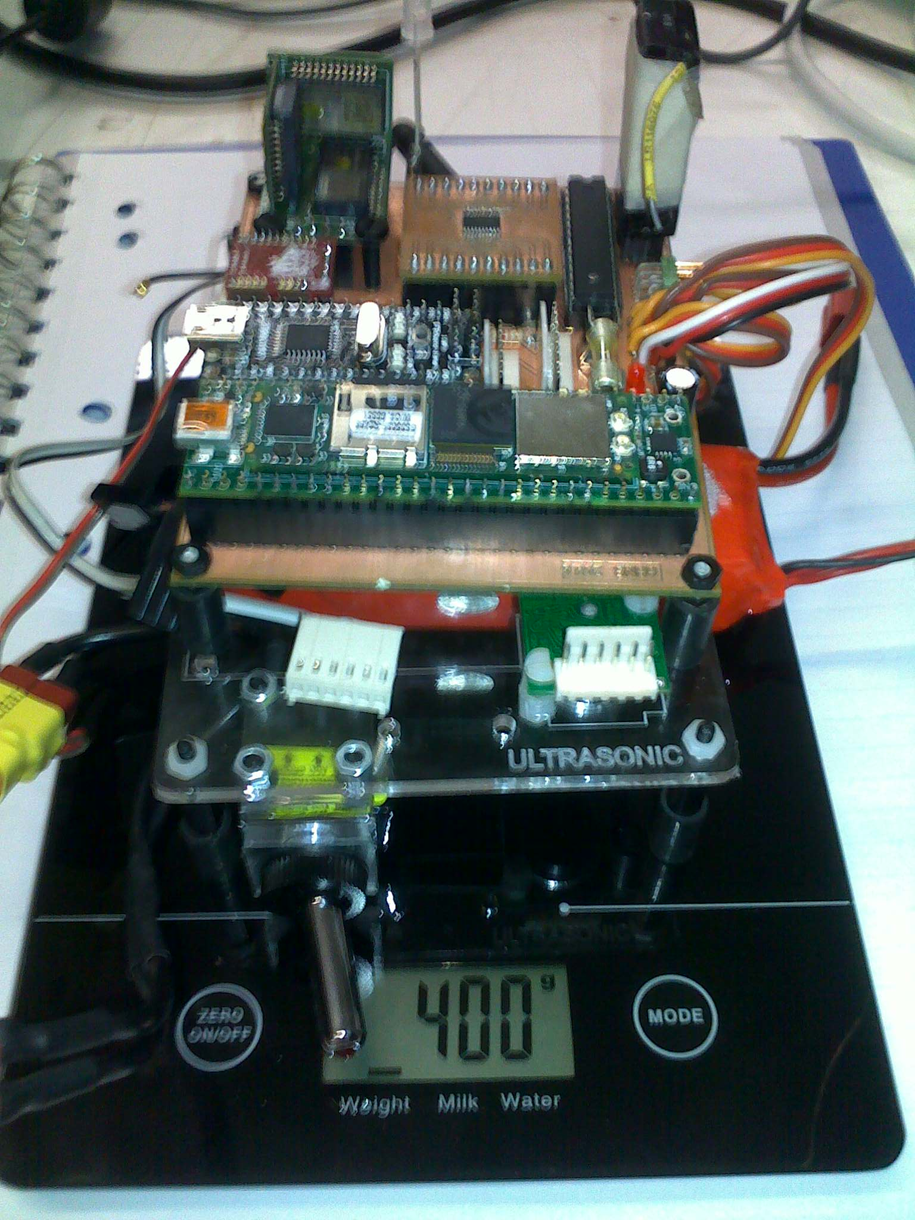

Figure - Total Weight of Payload

## Onboard Systems Architecture

The initial design utilised the hardware selected in various trade studies during the planning phase of the project. Throughout the course of the project many revisions were made to the inital design due to hardware limitations discovered during the implementation stage. Figure 2 shows the final hardware architecture as used on the project. It can be seen that the flight computer is as the centre of the system. It manages all the high and low level control of the system. To the left of this is the MCU which acts as the pulse capture and generation unit. It can pass pulse widths straight through fomr the RC Rx to the Gyro in manual mode or generate pulses from autopilot commands during manual flight. The IMU is connected directly to the flight computer as it is seen as a critical component for maintaining attitude stabilisation. To account for the deficiency in necessary UARTs, an Arduino was used to expand this capability. Connecting to the flight computer through USB, it allows the Magnetic Compass and Camera to be connected. The camera connection is for passing optical flow data to the flight computer. This is a feature that was not implemented in 2010, but can be added to future implementations. Finally, the Arduino is also used for capturing analogue data from the ultrasonic sensor and battery voltage. There are additional ADCs available for future addition of coulomb counters and temperature sensors.



Figure - System Design Overview

# Power System Design

The autopilot power system is a fundamental component in ensuring project success. The entire system requires a constant 5 volt regulated power supply to function correctly. In 2009, a standalone voltage regulator was added to the system to provide the necessary power. This was not required in 2010 as the ESCs chosen were able to perform this role. It was observed that the ESCs were fitted with two 5 volt regulators. The LF50A regulators, shown in Figure 3, are each capable of delivering 1 amp each. This means that when they are configured in parallel, as they are on the board, they are capable of supplying 2 Amps. As these are already fitted to the ESCs, and will be mounted to the airframe regardless of use, it was decided that these would be used as the source of 5 volt power. Within this section, the 5 Volt power distribution will be known as the “low voltage power system” and the 12 Volt power distribution system will be known as the “high voltage power system”.

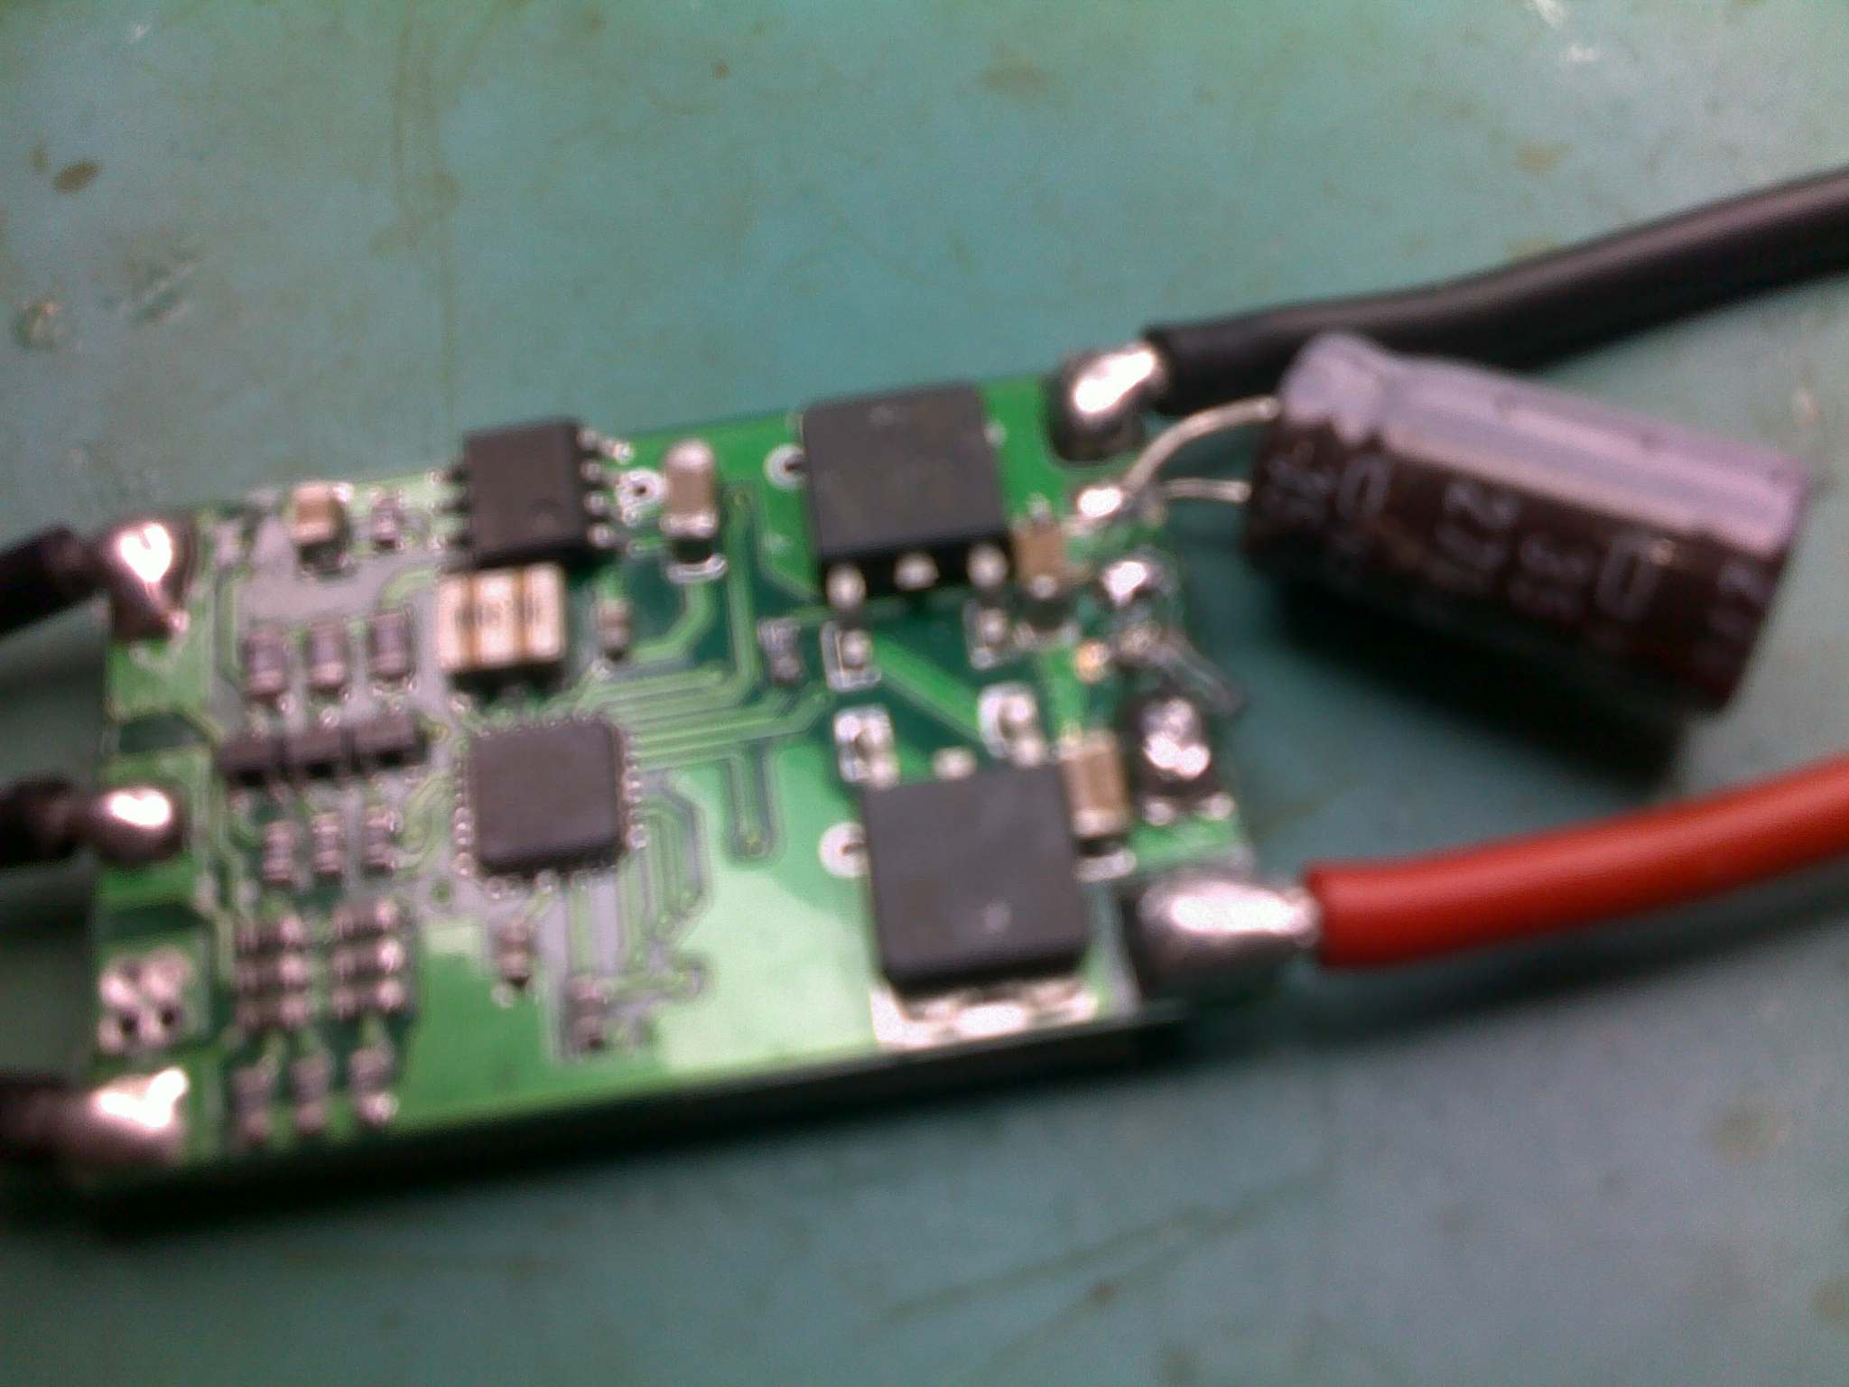

Figure - Voltage Regulators on ESC

## High Voltage Power System

The high voltage power system refers to the distribution of all 12 Volt power throughout the airframe. The source for the power is the flight battery and needs to breakout to the four ESCs. In addition to this, a line needs to be tapped off this to measure the battery voltage. Figure 4 shows a functional diagram of the high voltage power distribution system. It includes the voltage divider resistors that are required for measuring the battery voltage. This is discussed in more detail in the next section.

### High Voltage Harness

The high voltage power distribution harness, shown in Figure 4, is divided into two major but similar sections. These are the positive side of the system and the negative side. These sections were made in parallel as duplicates of each other. Once they were made, a wire was attached to mark the positive side and negative side. This is illustrated in Figure 5.



Figure - High Voltage Distribution System Schematic

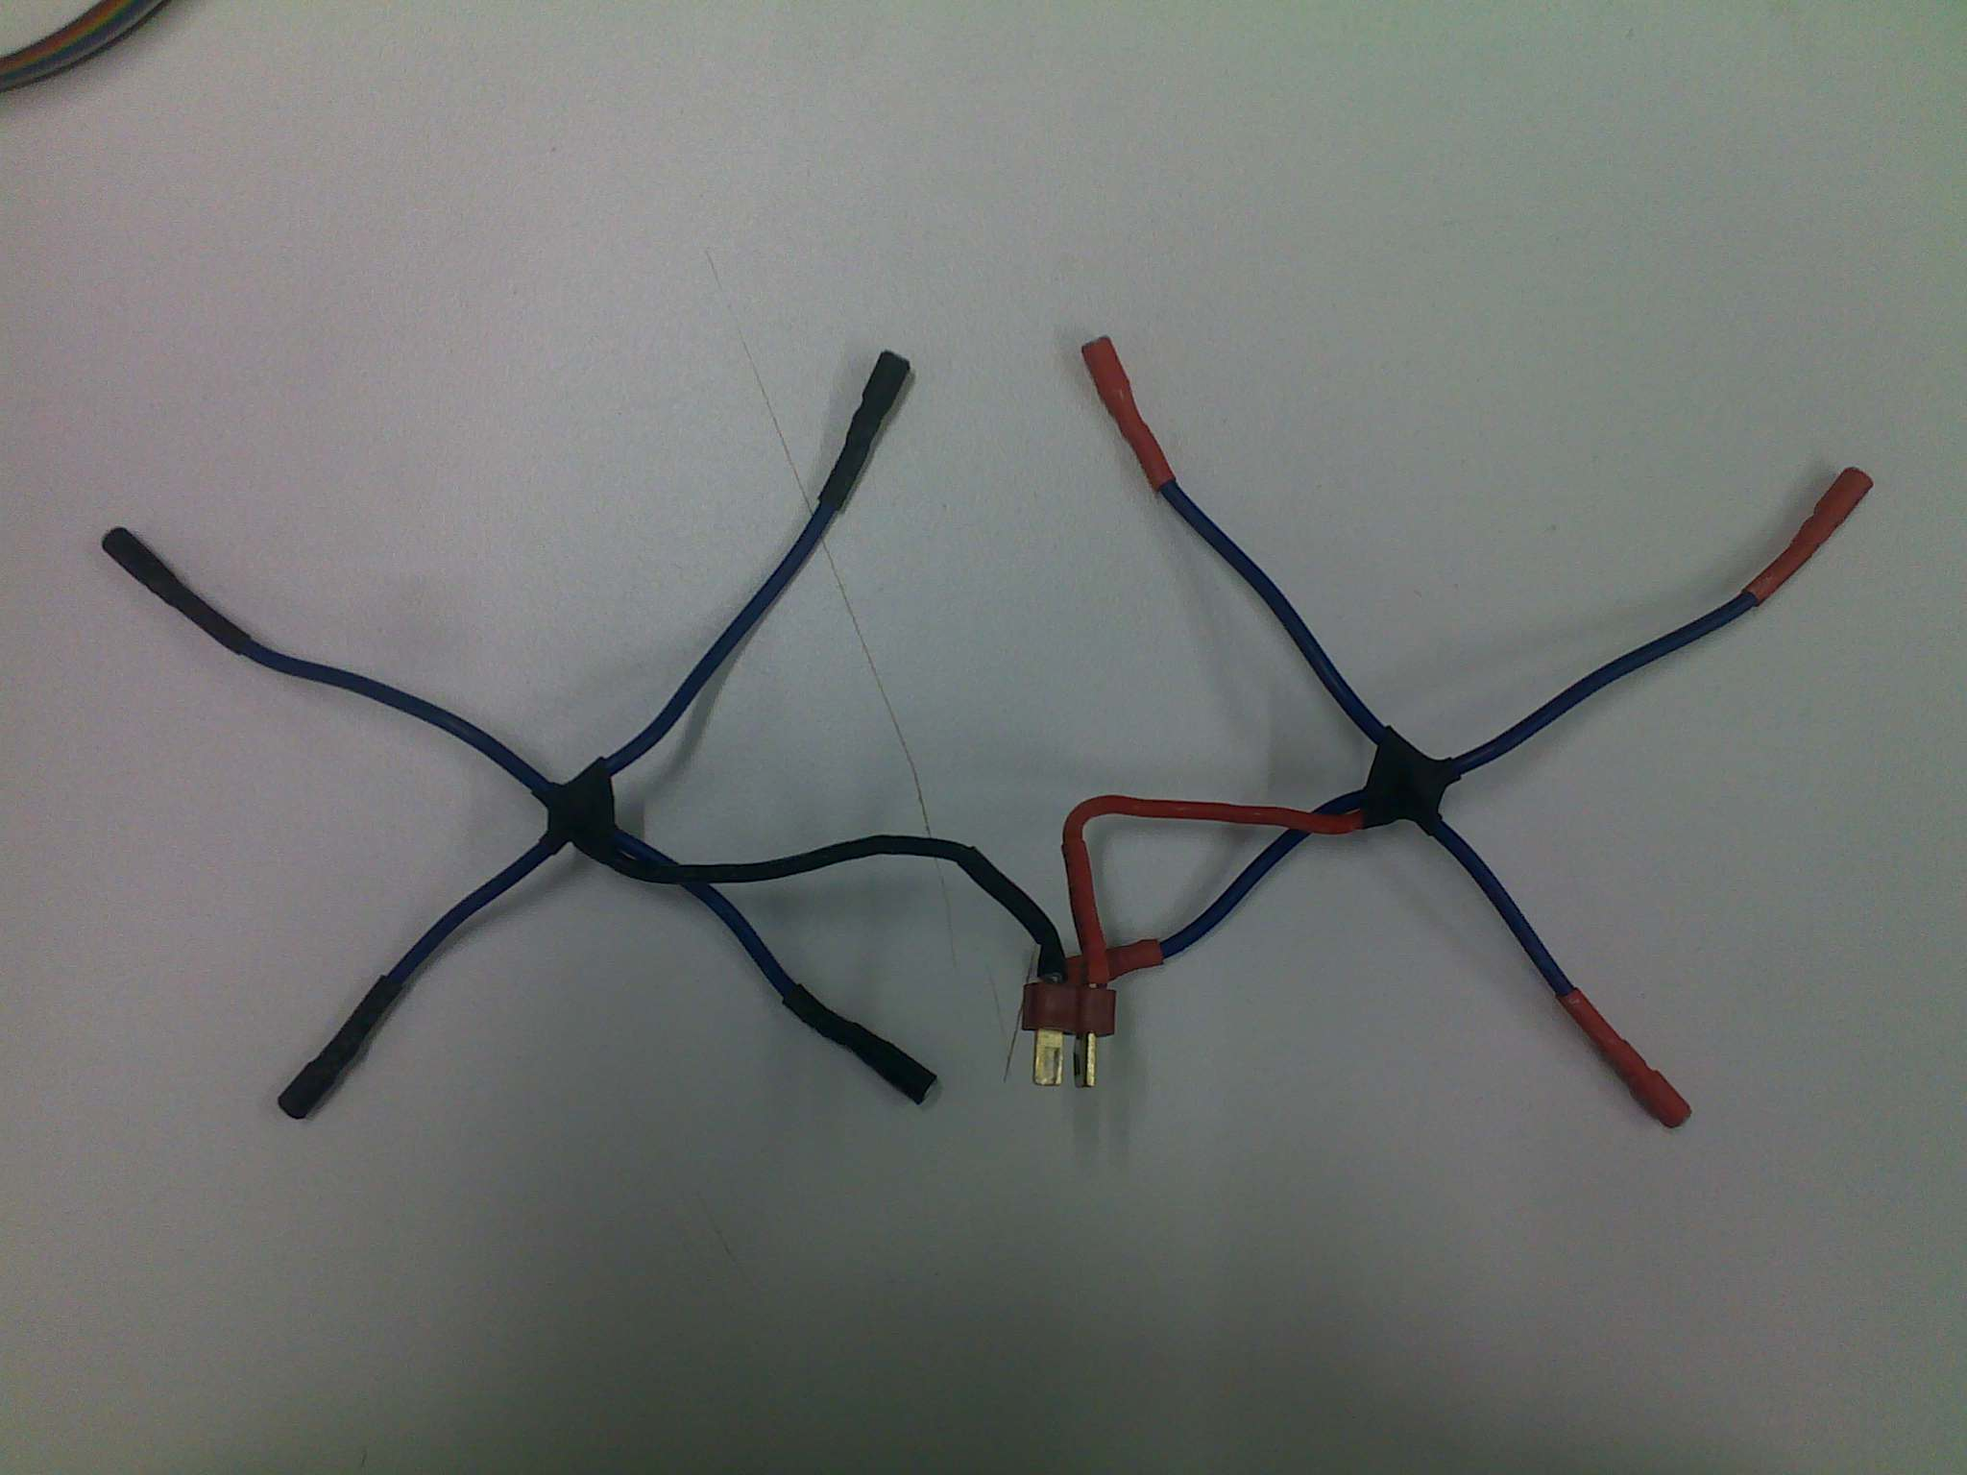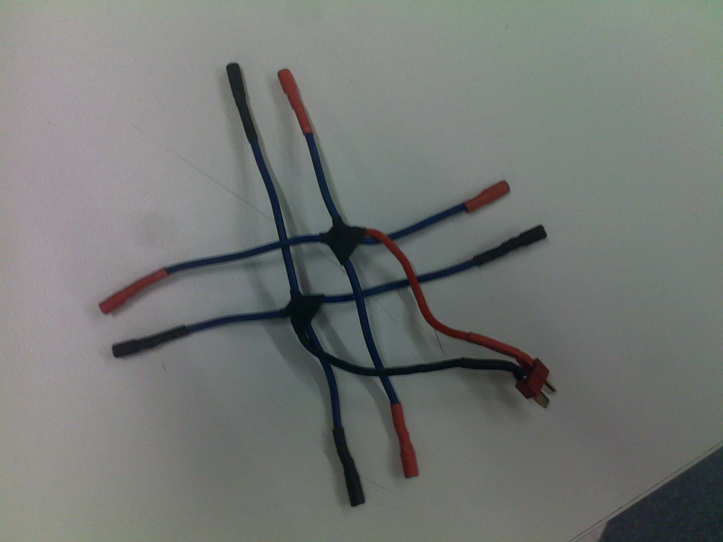

Figure - High Voltage Power Harness

### Voltage Divider

The voltage dividing resistors were made as separate modular pieces to allow for easy access during repair and maintenance. In addition to this, they are integrated into the ADC harness which also connects to the ultrasonic altimeter. The voltage divider was designed with the assumption that the maximum voltage reached on the high voltage side would be 14 Volts. The values were chosen such that they would be high enough to ensure there is negligible current through resistors, while being low enough to ensure they are not affected by the input resistance of the ADC. The final resistor values were 56k and 100k this can be seen in Figure 4. The divider can be seen in in the bottom left of Figure 5 connected to the ADC harness.

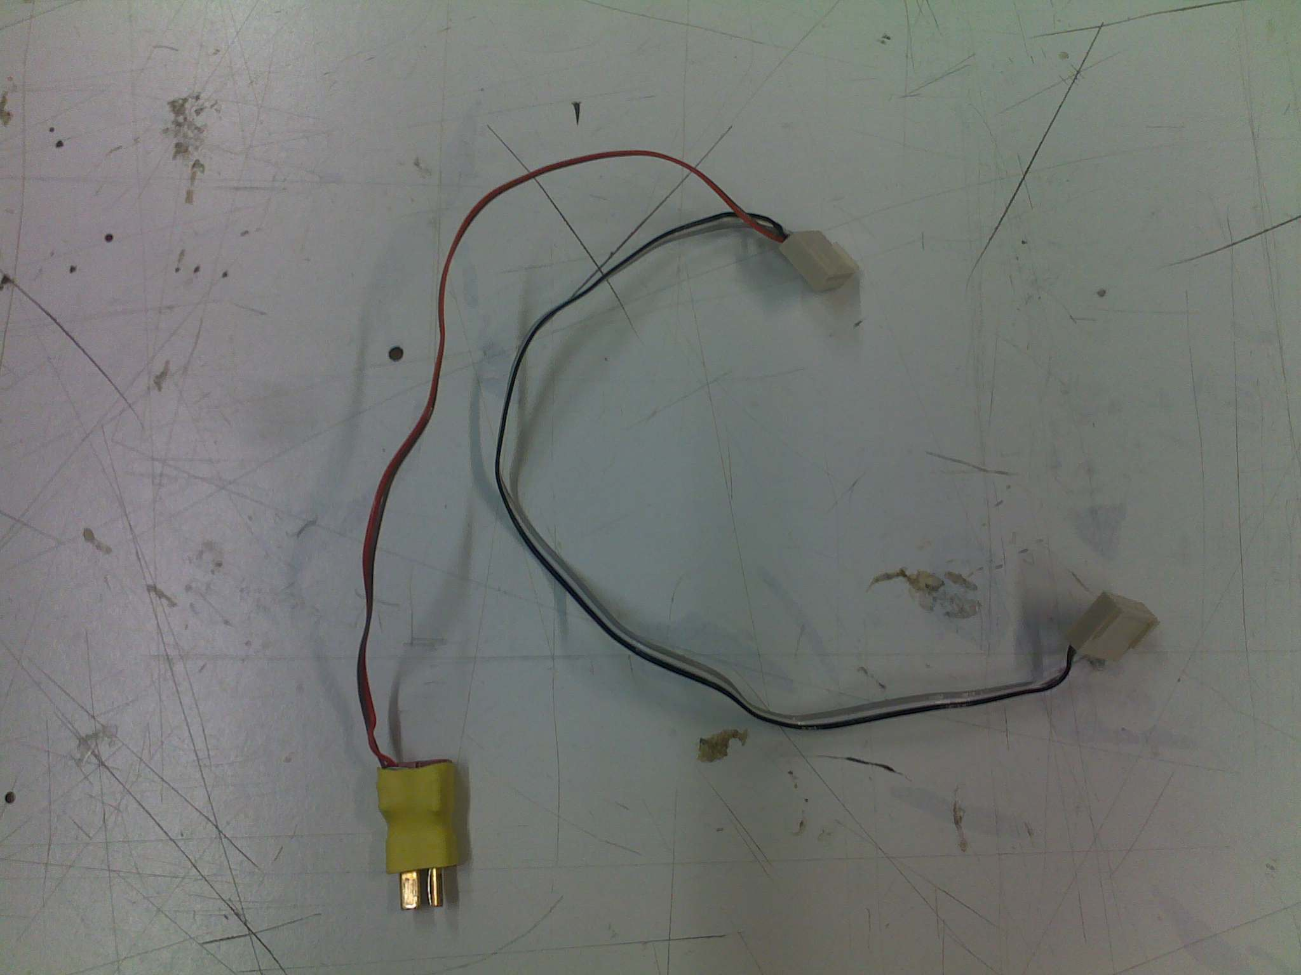

Figure - Voltage Divider Connected to ADC Harness

### Main Power Switch

The main power switch that was selected is rated at 20 AMPS. As a result is was large and difficult to mount. As with the voltage divider, it was made as a separate module that could be detached during repairs and maintenance. As the switch is illuminated, it requires the system ground to be connected to it. This can be seen in Figure 7. The switch controls the entire system. That is, if it is turned off, all electronic components are turned off. This includes the ESCs.

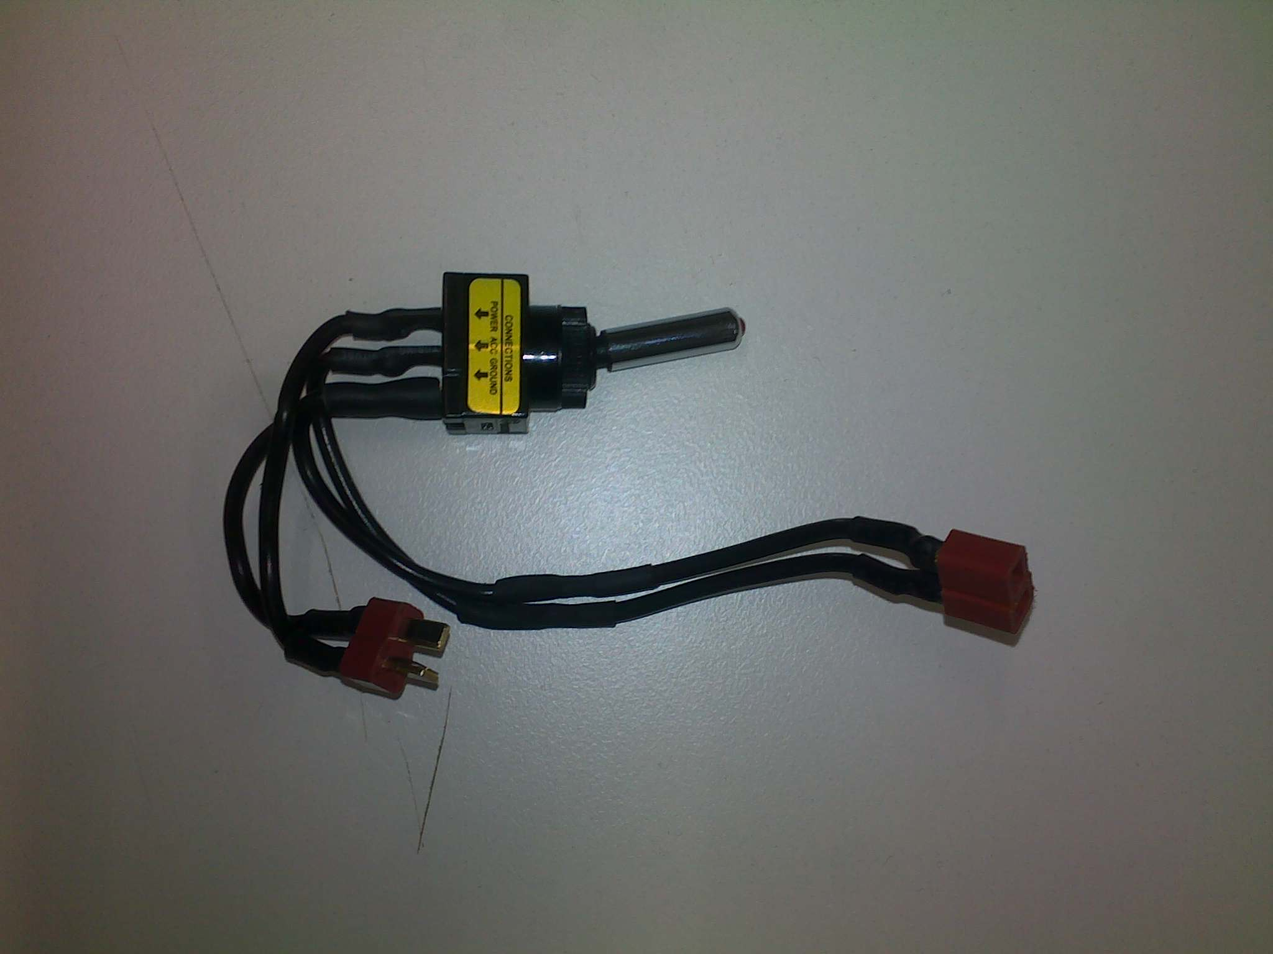

Figure - Main Power Switch

Once the high voltage harness, voltage divider and main power switch were made, they could be installed in airframe. The power harness needed to be installed early as it is attached ot the actual airframe. This can be seen in Figure 8.

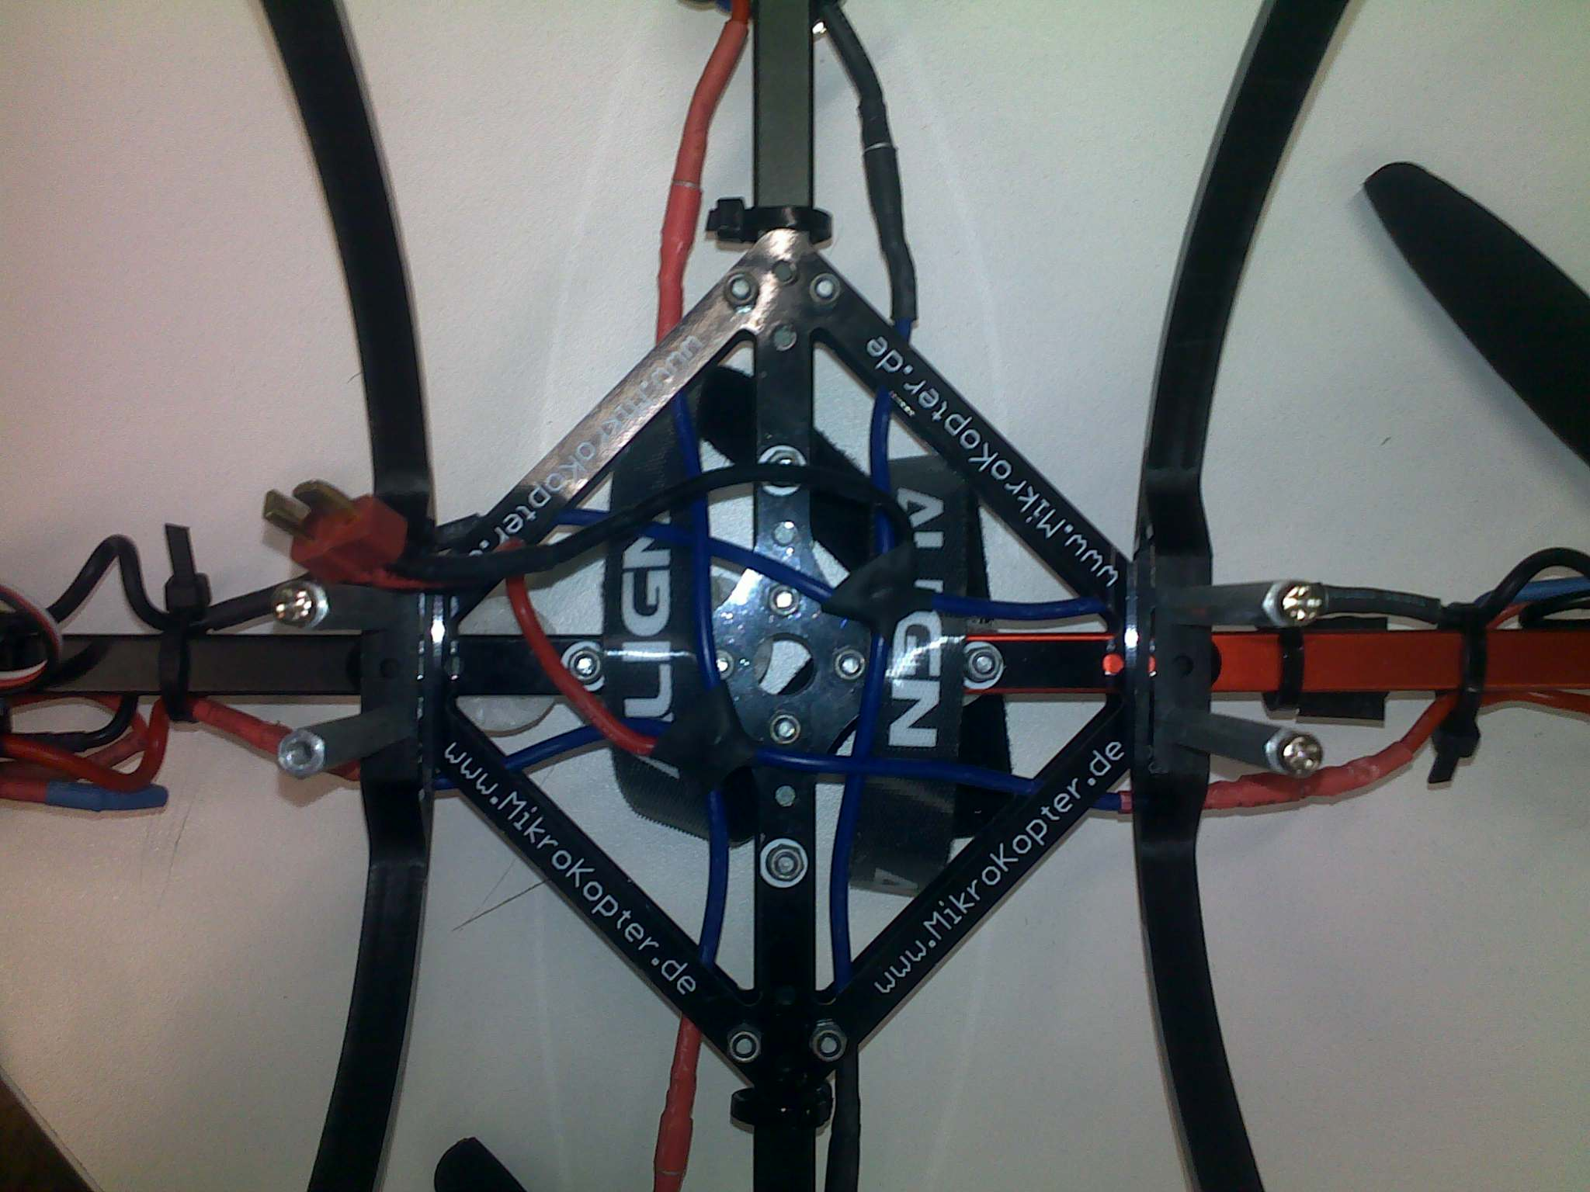

Figure - Power Harness in Airframe

The switch and voltage divider were installed at later times. These components can be seen in Figure 9.

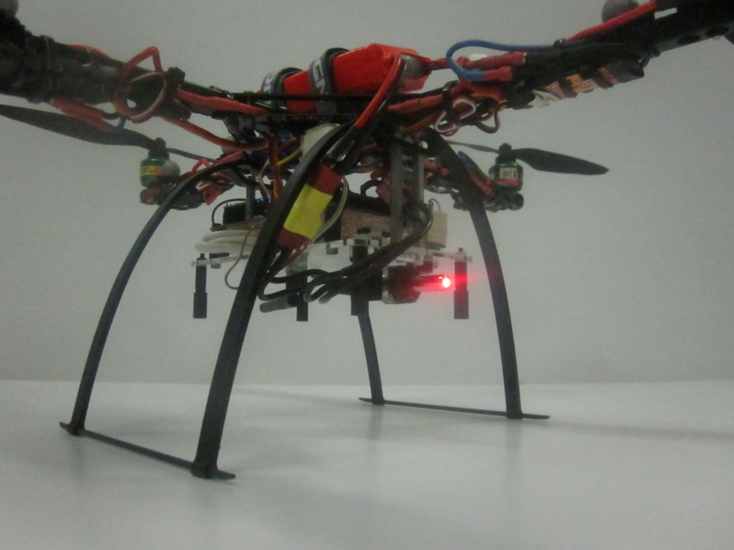

Figure - Voltage Divider and Switch on Airframe

## Low Voltage Power System

The low voltage power systems refers to all parts of the platform that operate at 5 Volts. As mentioned previously, the 5 Volt regulation is carried out by the regulators fitted to the ESCs. The LF50A regulators are fitted with short circuit and over temperature protections. This means that if either of these two conditions is met, the device shuts down to recover. Under normal circumstances this would lead to a complete power failure. In this case however, as there are four ESCs connected, each with two regulators, the system is powered by a total of eight regulars. As such, if any single regulator reaches a shut down conditions, the remaining seven will be able to continue powering the system. As each individual regulator is capable of powering the entire system, up to seven failures can occur on any one flight. Alternatively if any of the malfunctions during a flight test, the offending ESC’s power line can be disconnected and flight testing can resume with the remaining six regulators.



Figure - Low Voltage Power System

The low voltage power is connected directly to the autopilot board and is decoupled by a 100uF capacitor. The Autopilot board distributes the power to all other systems on the platform.

# Autopilot Hardware Design

The autopilot PCB is an essential component of the AHNS project. The project uses a single PCB design which acts to minimise complexity and reduce wire count. As there are external sensors and devices, the use of wires in unavoidable. By reducing the number of wires and using a ground plane on the PCB, both emitted and received EMI can be reduced. Another risk commonly found on undergraduate projects is the risk of not plugging connecters into their appropriate sockets or reverse polarising the connector. This often leads to a complete failure of one or more devices in the system. To mitigate this risk, the AHNS design has separate headers on the PCB for each individual component. Where possible, the amount of similar connectors has been reduced. This makes the chance of connecting a plug into a wrong socked very unlikely. In addition to this, where possible, polarity checked connectors have been utilised. Finally, to ensure all DIP sockets have PIN 1 clearly marked with an offset connector. This has been highlighted in Figure 11 and can be seen clearly in Figure 13.

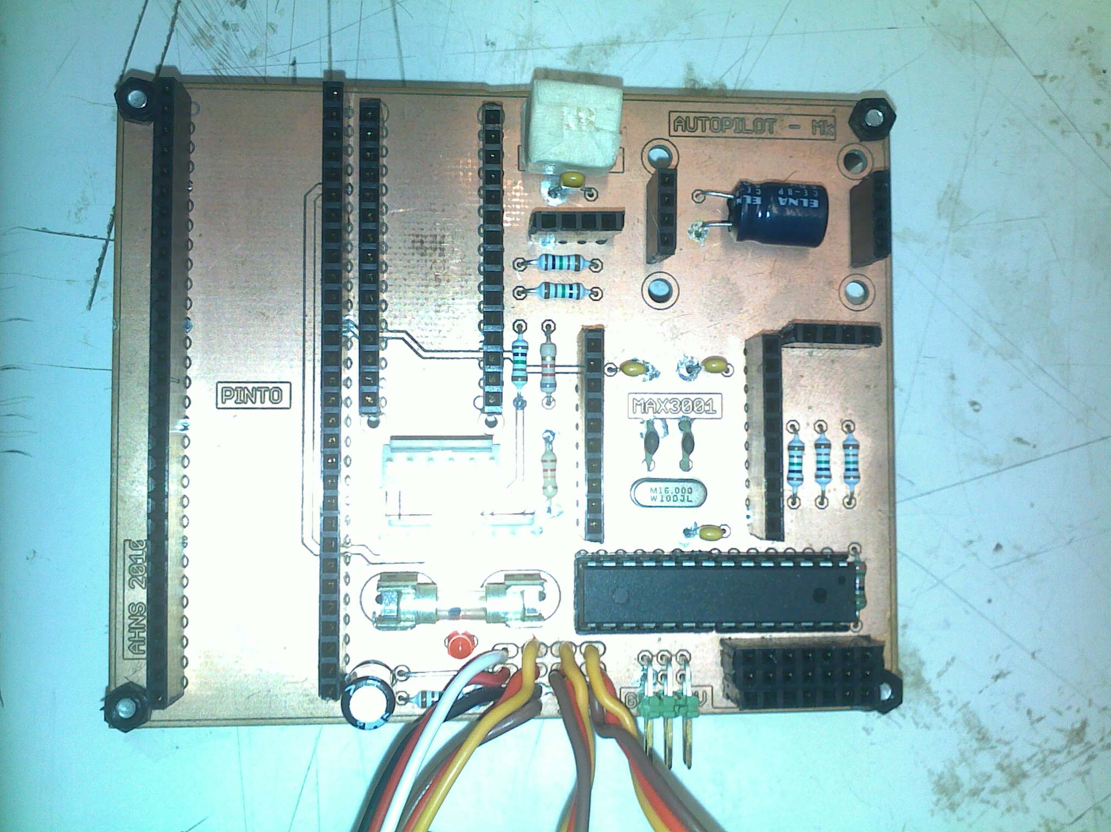

Figure - PCB Markings for Pin 1

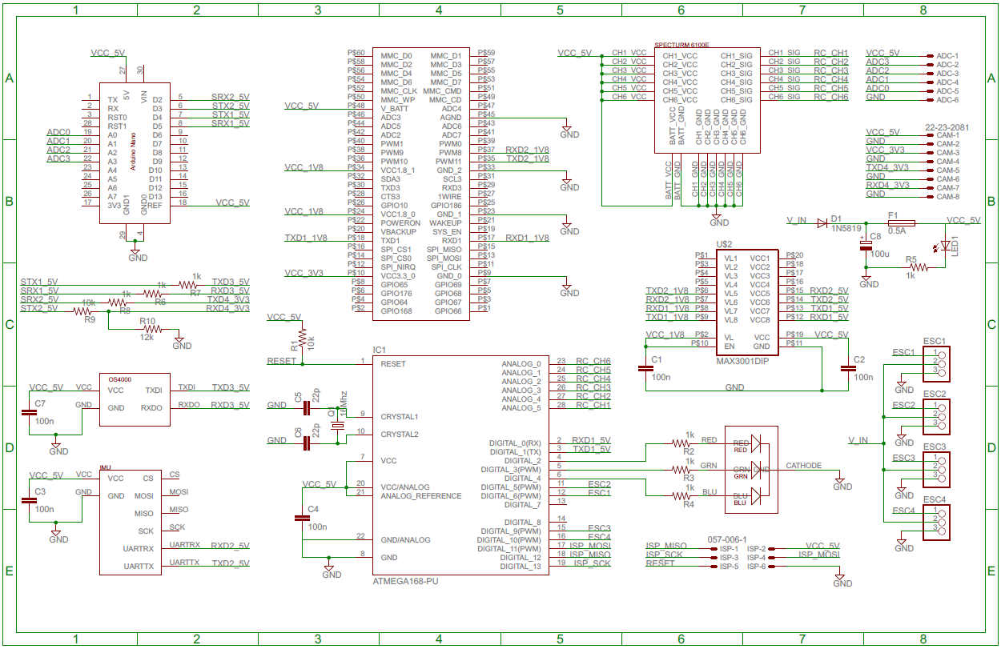

Figure – Final Autopilot Schematic

Table - Autopilot Bill of Materials

|  |  |  |
| --- | --- | --- |
|  | Component | QTY |
| Passive  Components | Resistor - 1/2W - 1k | 8 |
| Resistor - 1/2W - 10k | 2 |
| Resistor - 1/2W - 12k | 1 |
| Capacitor - 22p | 2 |
| Capacitor - 100n | 5 |
| Capacitor - 100u | 1 |
| Diode – 1N5819 | 1 |
| Active  Components | LED - TriColour - 5mm | 1 |
| LED - Red - 3mm | 1 |
| MAX3001 (on breakout board) | 1 |
| ATMEGA328 DIP28 | 1 |
| Crystal - 16MHz | 1 |
| Modules | PINTO DIP for OVERO COM | 1 |
| Arduino Nano | 1 |
| Sensor Dynamics - Inertial Measurement Unit | 1 |
| OS4000 Compass Module | 1 |
| Hardware | Header, Locking - 6PIN - Male | 1 |
| Header, Locking - 8PIN - Male | 1 |
| Header, Terminal - 3PIN - Male | 4 |
| Header, Terminal - 4PIN - Female | 3 |
| Header, Terminal - 7PIN - Female | 3 |
| Header, Terminal - 10PIN - Female | 2 |
| Header, Terminal - 15PIN - Female | 2 |
| Header, Terminal - 30PIN - Female | 2 |
| Header, IDC - 6PIN - Male | 1 |
| M205 PCB Fuse Holder | 2 |
| M205 Fuse - 1Amp | 1 |
| IC Socket - 14PIN - Narrow | 2 |

shows the final autopilot schematic with all components and modules laid out. To make the diagram less cluttered nodes have been used extensively. This can be slightly difficult to read on paper. The original Eagle file is available on the SVN and is best read in Eagle editor as it highlights selected nodes. The only connection not marked on the diagram is the USB cable that links the Arduino Nano with the FC. Table 1 shows the Bill of Materials for the complete Autopilot. It shows all the components and modules necessary for building the autopilot. Figure 13 shows the final PCB layout that was used or the autopilot. The drawing also shows the placement of each components and module. To create a duplicate board, the original Eagle file is available in the SVN. All previous versions are available here as well.

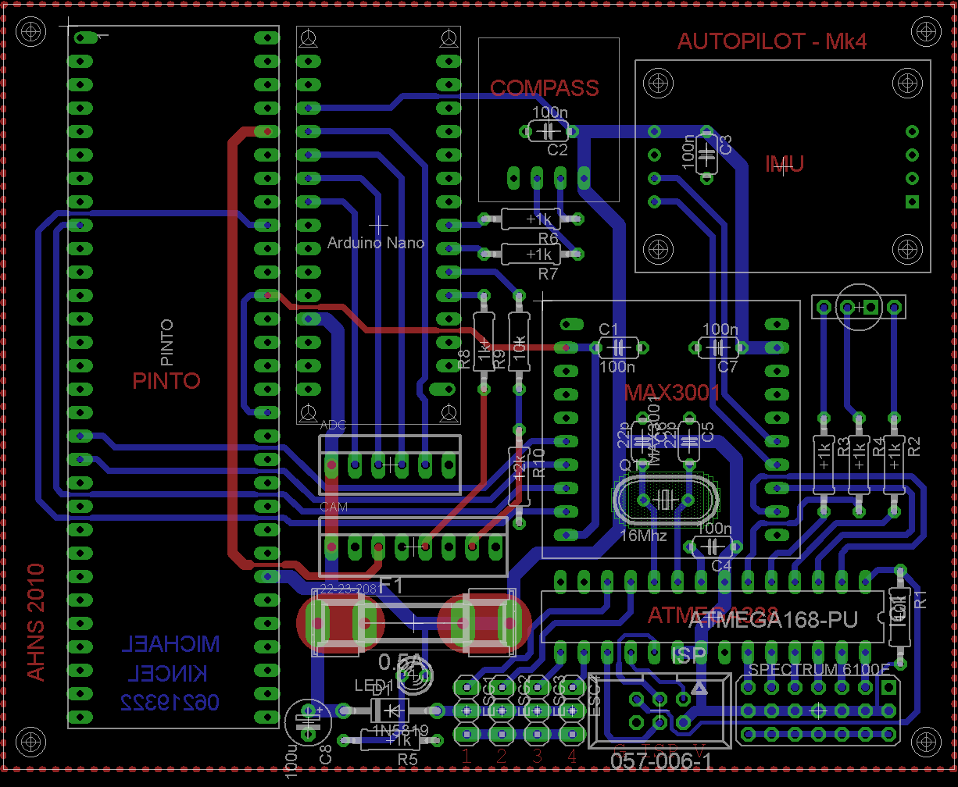

Figure - Final PCB Layout

The RC Rx module inserts into the bottom right corner of the board, beside this is the programming port for the MCU and the four ESC connections. Above the fuse are the ADC and Camera connections. Both of these have a 5 Volt pin and the Camera connection has a 3.3 volt pin a well. Pin assignment can be seen on the schematic in Figure 12.

Figure 14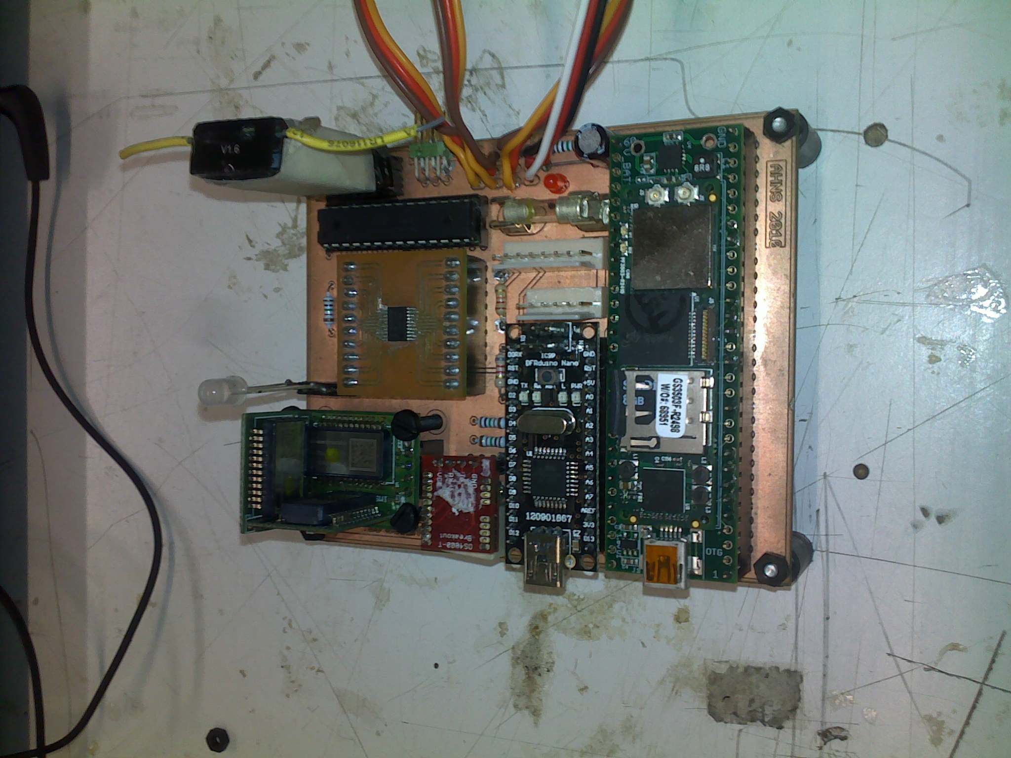 shows the final assembled autopilot with all components mounted in their final location. This picture can be used as a reference for future duplicates.

Figure - Final Assembled Autopilot

# Altitude Sensor

In order to determine the altitude of the helicopter a Maxbotix ultrasonic altimeter was used, as shown in Figure 11. This type of sensor emits a brief ultrasonic pressure wave and measures the time delay from transmission to receiving it again. In principle, half the measured time multiplied by the speed of sound can determine an approximate distance. This sensor was mounted on the lowest electronics tray to have an unobstructed view of the ground. By contrast, an IR sensor was going to be used. This was later replaced with the ultrasonic sensor due to the potential of interference with the Vicon system. The sensor has a useable range of 15cm to 6 metres. This is inside the operating altitude of the aircraft.

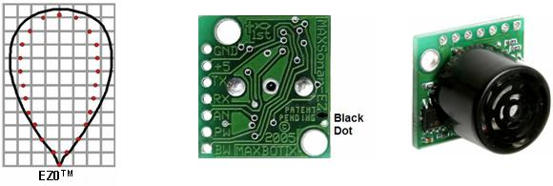

Figure - Maxbotix EZ0 Ultrasonic Altimeter

The output of the sensor is provided as an analogue voltage that changes depending on the distance. This sensor is connected to one of the analogue inputs of the Arduino. The voltage output response was characterised, and a function implemented in flight computer. This function gives accurate altitude measurements to the state estimation system. The physical connected is achieved through the analogue harness shown earlier in Figure 6.

# Heat Considerations

There are a total of five major heat emitting components on the AHNS platform. These are the four ESCs and the actual flight computer itself. Several special considerations had to be made to ensure these devices received adequate cooling.

The ESCs have two sources of heat on them, the first are the voltage regulators, as seen in Figure 3. The second are the FETs on the other side. These FETs are shown with and without their heatsink attached in Figure 15. This heatsink increases the ESCs ability to keep the FETs cool. To further assist in this cooling process, the ESCs have been attached to the airframe underneath the propellers, as seen in Figure 16. This means that the ESCs are using the entire airframe as a large heatsink. This effect is observable by touching the airframe after running the autopilot for a few minutes. The airframe becomes considerably warmer. Another advantage of this mounting regime is that as the engines are running they pass air over those parts of the airframe. Air is also passed over the actual ESCs themselves, leading to an even greater increase in cooling efficiency.

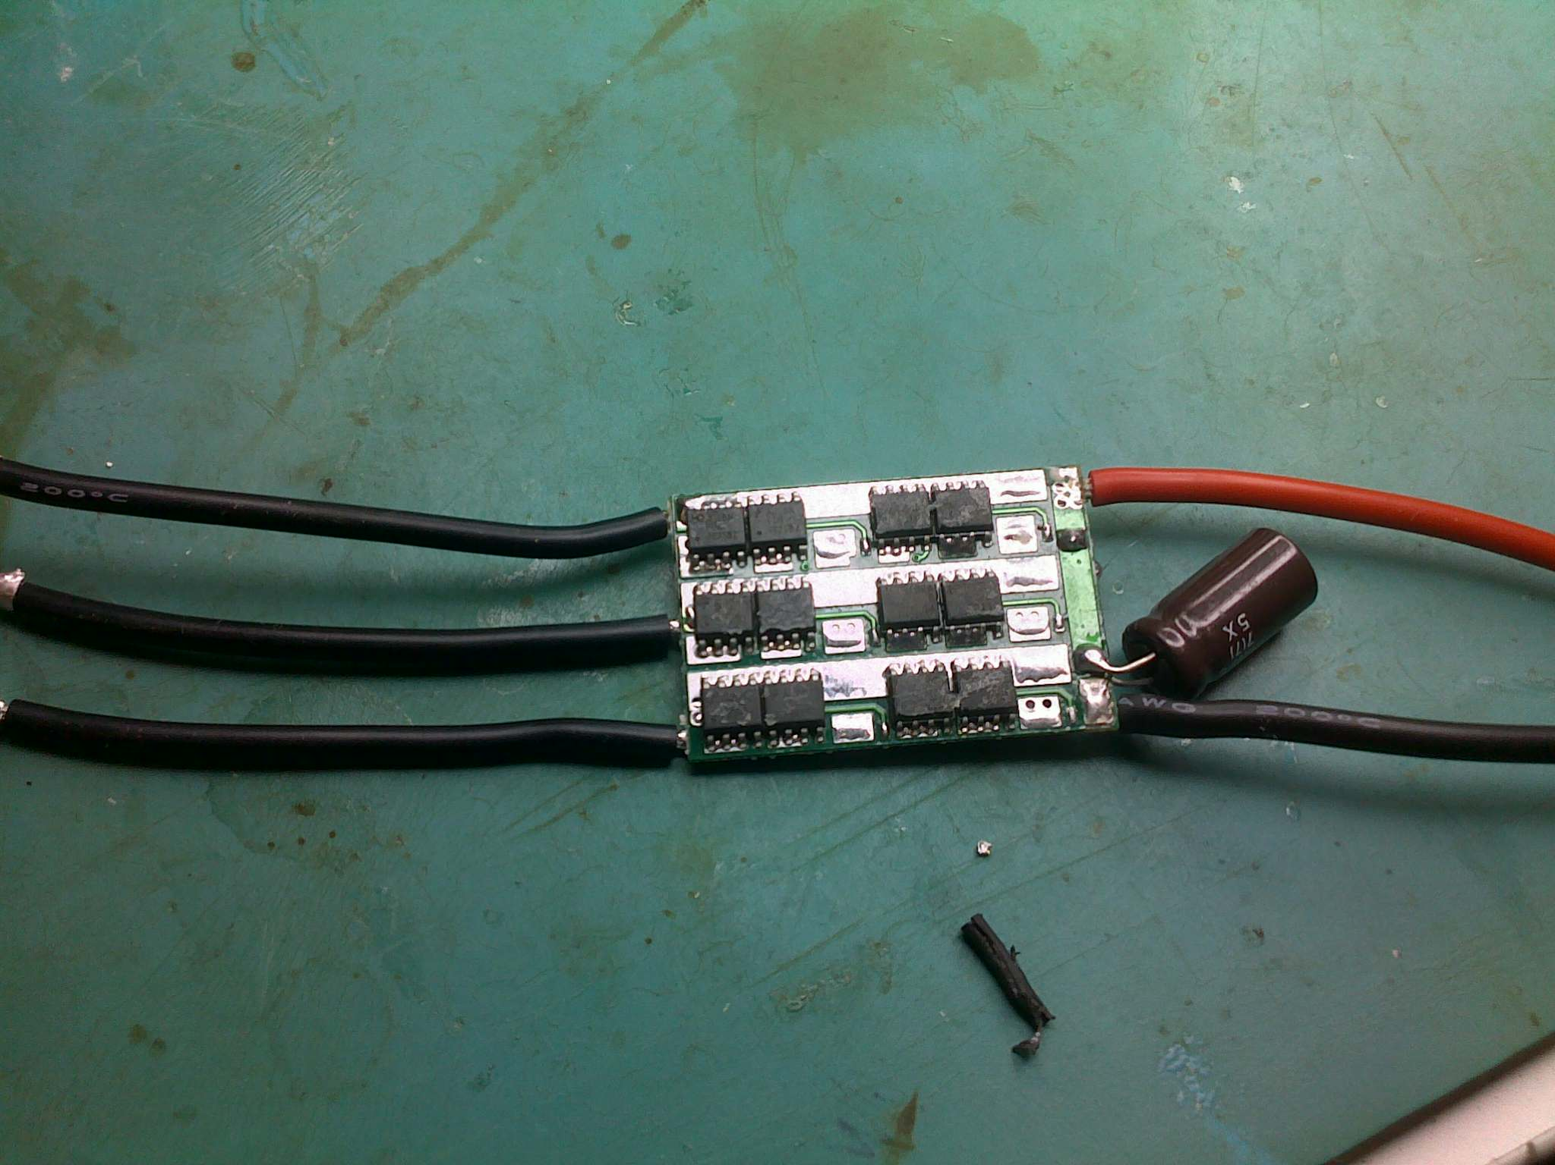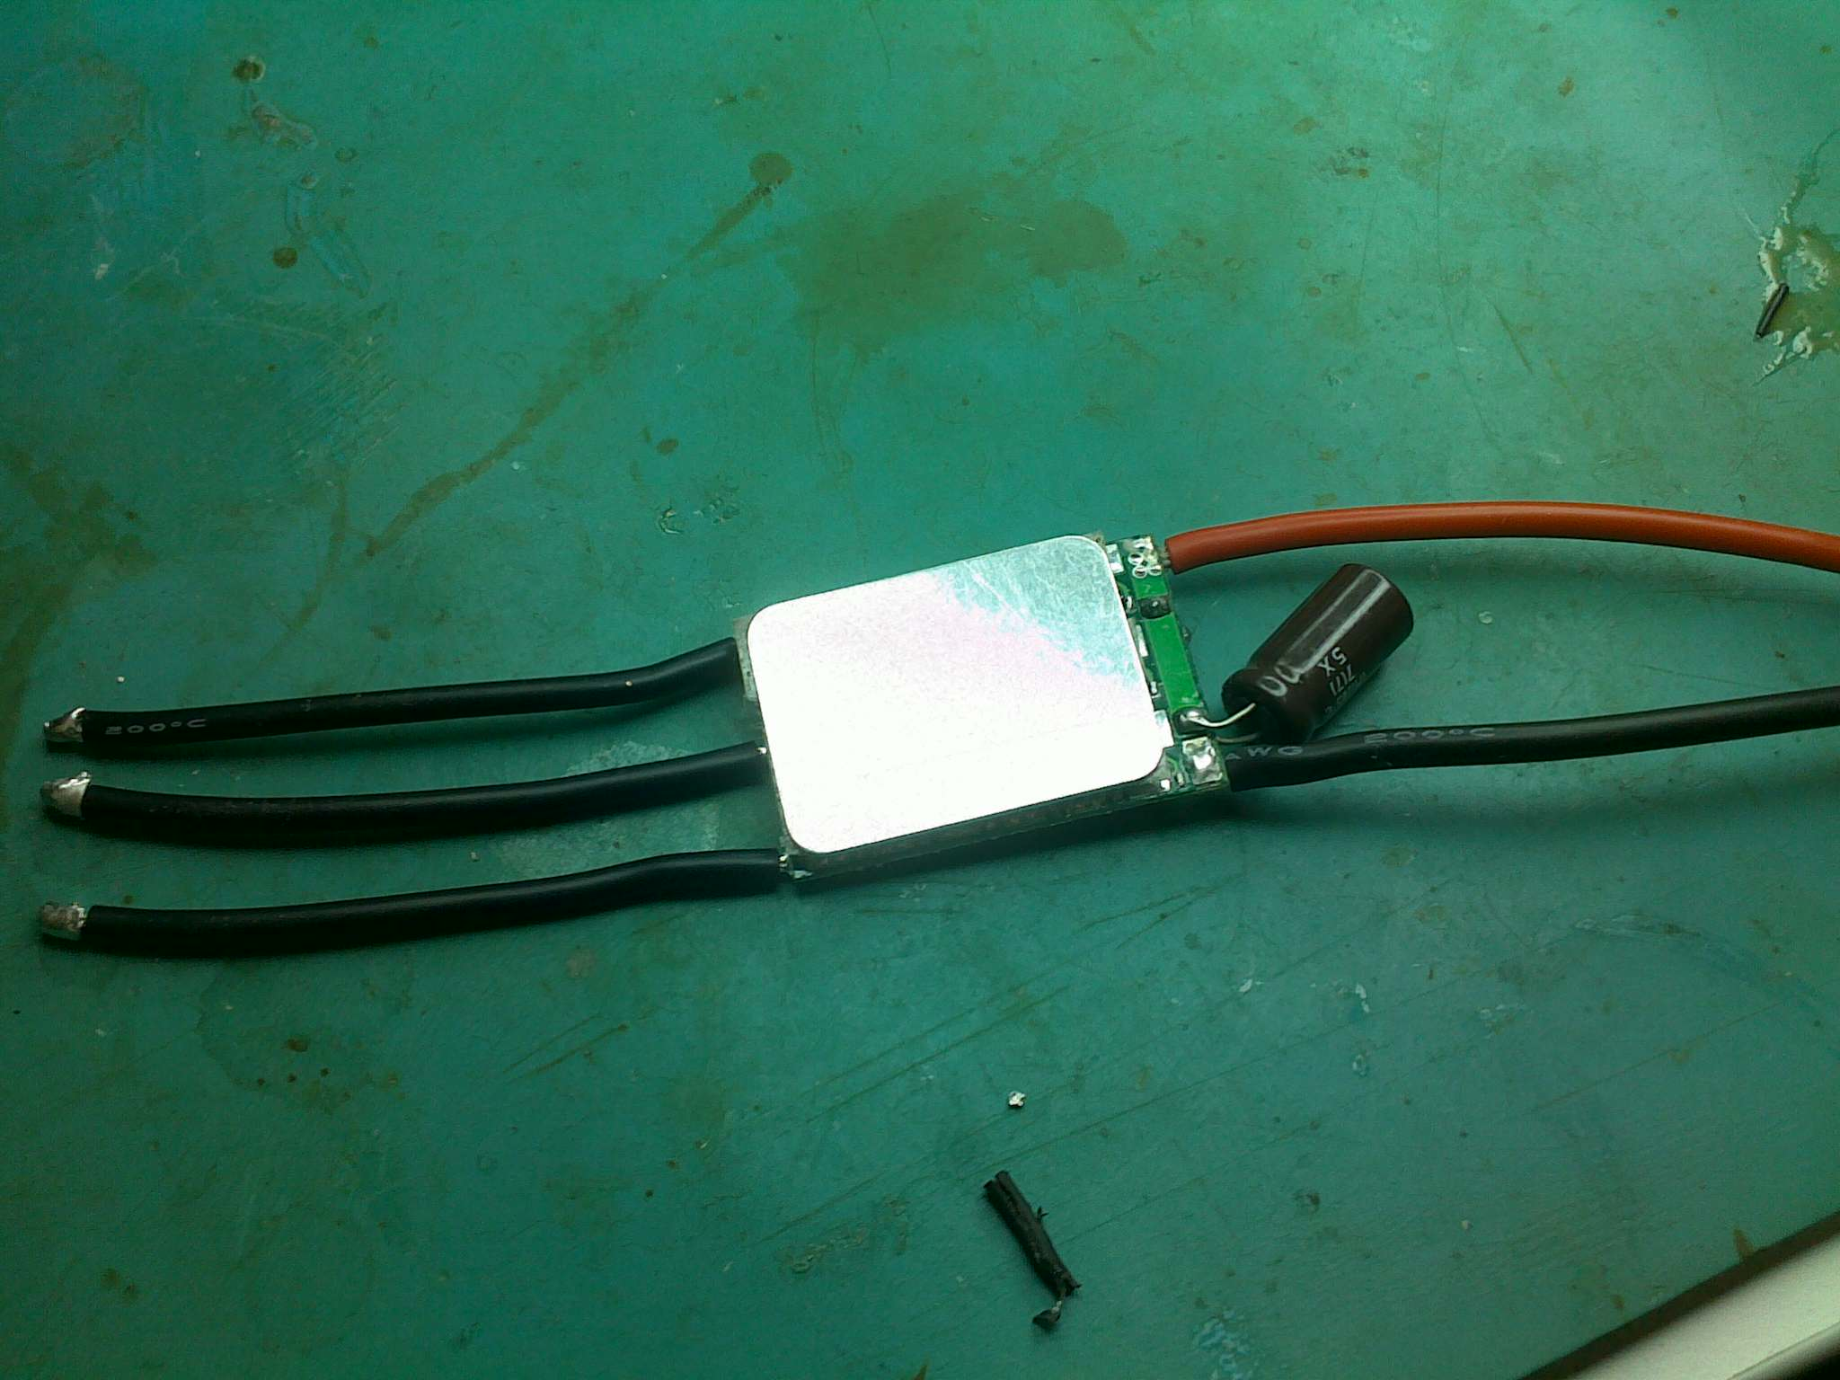

Figure - ESC FETs With and Without Heatsinks

The other element that requires special heat considerations is the flight computer. To ensure this does not overheat, it was decided that the mounting would not be done inside an enclosure. If this design was continued, the FC would be confined within a small area with no possibility of air passing over it. By mounting it on an open air tray, the heat generated by the FC is free to radiate away from the device. In addition to this, as the engines are running, air is able to pass over the FC, further enhancing the cooling effect. Figure 17 shows the FC mounted on the open air electronics tray in the middle of the platform.

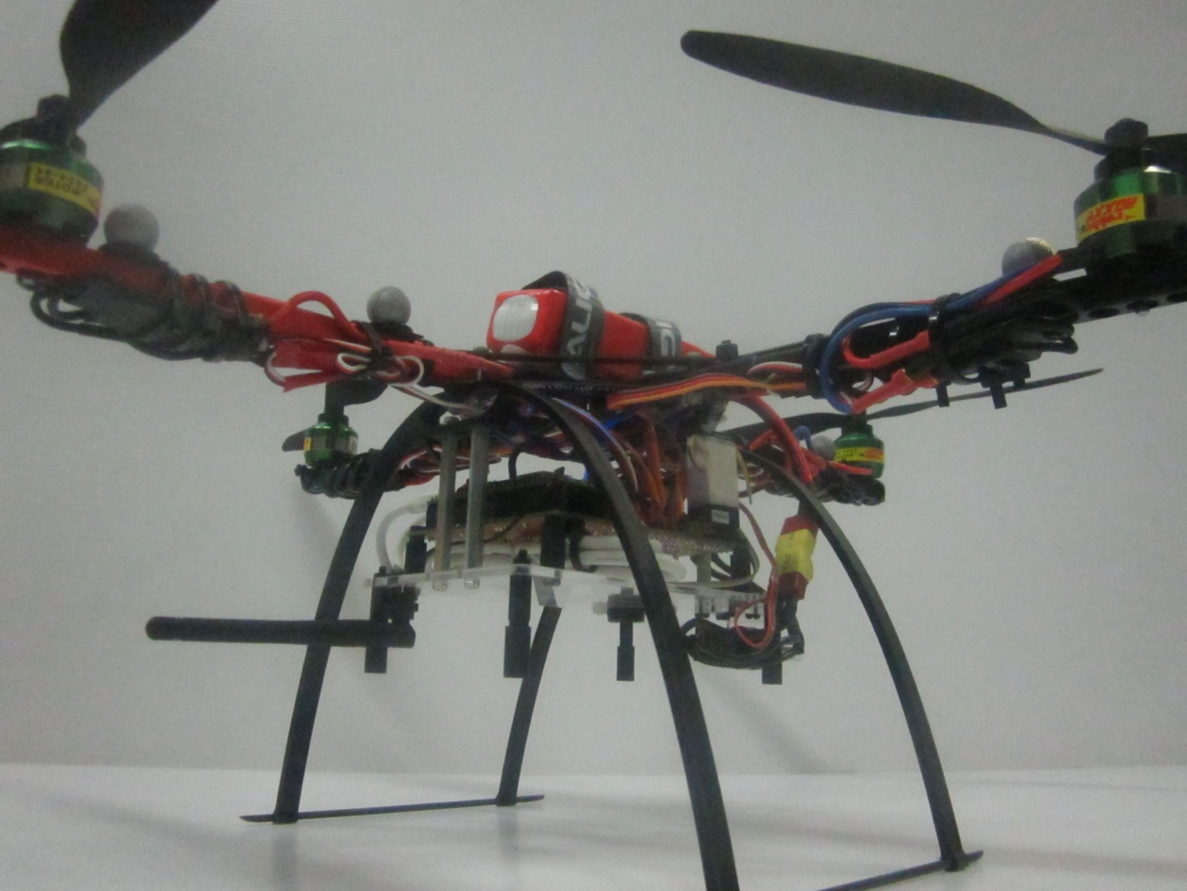

Figure - Mounting of Heat Emitting Components

# Vibration Dampening and Mounting

Helicopter platforms are prone to vibrations. There are four main rotors attached to the platform. As these are not perfectly balanced, they will induce a vibration with a frequency equal to the period of rotation. Also each propeller spins at a slightly different speed. This means there is a total of four fundamental frequencies of vibration, each with varying amplitude. A harmonic of each is also induced at twice the fundamental frequency. This is a result of the propeller passing over the frame. Isolation of the delicate sensors and processing hardware from vibration is an important consideration in the design of the mounting systems. The airframe was acquired from Mikrokopter. The company sells an RTF autopilot for use in GPS environments. This is mounted on the company’s proprietary vibration dampening. These have been proven to work successfully on their autopilot, which has similar sensors. It was therefore decided that these would be acquired and adapted to mount the AHNS 2010 autopilot.

The autopilot is mounted onto to electronics tray by four of these vibration dampeners. Three of these vibration dampeners have been mounted in Figure 18.

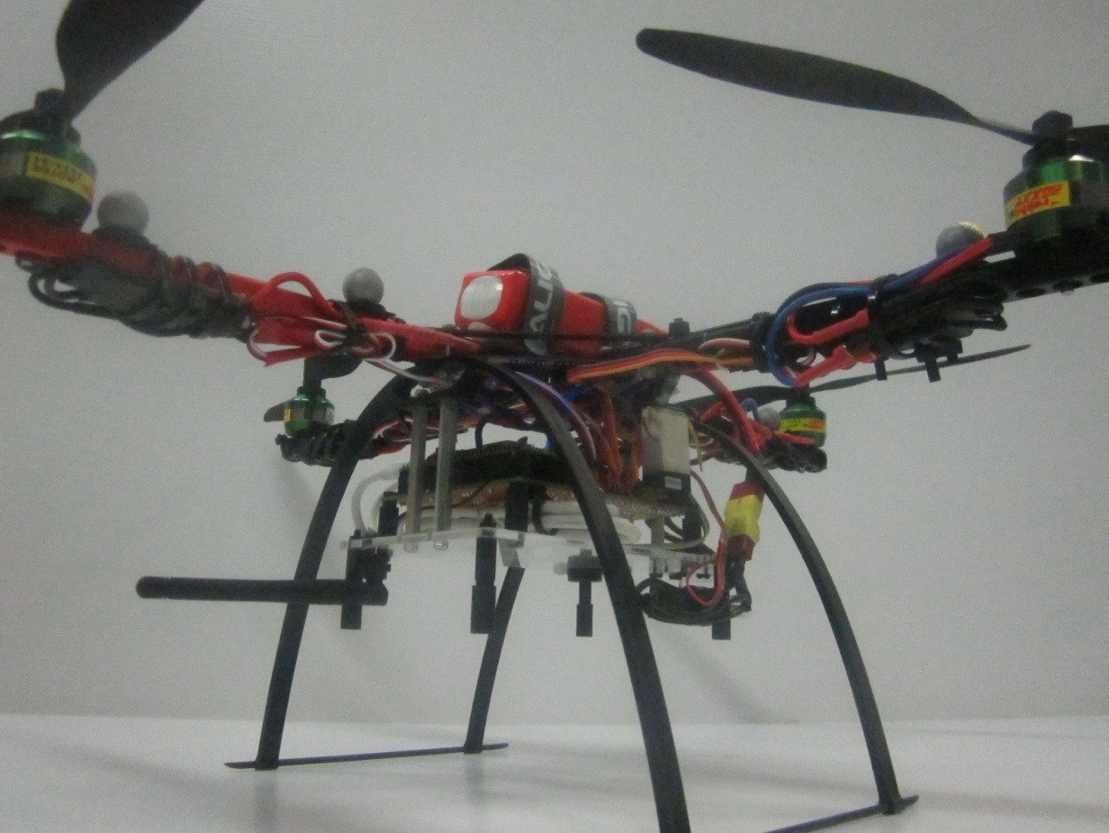

Figure - Autopilot Mounting

# Conclusions

This document has detailed the onboard hardware systems design for the AHNS 2010 project. The onboard systems are comprised of the power system as well as the autopilot. This document has detailed the design of both of these components. In addition to this, steps were taken to ensure all devices onboard the platform received sufficient cooling and vibration isolation.