Title: , Autonomous Helicopter Navigation System, System Level, Testing Apparatus Design Document

*“A Project”*

Prepared by Date _______________

,

Checked by Date _______________

Michael Kincel,

Approved by Date _______________

, Student Manager 2010

Authorised for use by Date _______________

Dr Luis Mejias, Project Coordinator

**QUT Avionics**

Queensland University of Technology

CRCSS-EESE, GPO Box 2434

Gardens Point Campus

Brisbane, Australia, 4001.

Telephone (+61 7) 3864 1772

Facsimile (+61 7) 3864 1517

e-mail luis.mejias@qut.edu.au

web <http://code.google.com/p/ahns10/>

This document is Copyright 2010 by the QUT. The content of this document, except that information which is in the public domain, is the proprietary property of the QUT and shall not be disclosed or reproduced in part or in whole other than for the purpose for which it has been prepared without the express permission of the QUT

**Revision Record**

|  |  |  |  |
| --- | --- | --- | --- |
| Document Issue/Revision Status | **Description of Change** | **Date** | **Approved** |
|  | Initial Issue |  |  |

**Distribution List**

|  |  |  |  |
| --- | --- | --- | --- |
| **Name** | **Affiliation** | **Distribution Date** | **Approved** |
| Avionics Lab File Archive | QUT Avionics |  |  |

**Foreword**

This document outlines the design choices used for the axis restricted and bungee cord testing apparatuses. These platforms were designed and constructed throughout the first semester for testing over the holidays and semester 2. The axis-restricted design allows testing control with one axis at a time, thus allowing to refine all axis gains. The bungee cord testing allows freedom in all attitude axes, but restricts the platforms position. Their purpose is to reduce the likelihood of damage to personal, equipment and surrounding area that is commonly found in unrestricted testing.

**Table of Contents**

Paragraph Page No.

1 Introduction 8

1.1 Scope 8

1.2 Background 8

2 Reference Documents 9

2.1 QUT Avionics Documents 9

2.2 Non-QUT Documents 9

3 Design 10

3.1 Objectives of Design 10

3.2 Design Outline 10

3.2.1 Axis Restricted Apparatus 10

3.2.2 Bungee Cord Apparatus 12

4 Implementation 13

4.1 Axis Restricted Apparatus 13

4.2 Bungee Cord Apparatus 13

5 Conclusions 15

6 Recommendations 16

**List of Figures**

Figure Page No.

Figure 1 – Illustration of Axis Restricted Testing Rig (Cinema 4D) 11

Figure 2 – Beam Attaching to Helicopter / Beam Attaching to Frame (Cinema 4D) 11

Figure 3 – Axis Restricted Testing Platform 13

Figure 4 – Bungee Rope Testing Platform 14

**List of Tables**

No Tables.

**Definitions**

|  |  |
| --- | --- |
| AHNS | Autonomous Helicopter Navigation System |
| QUT | Queensland University of Technology |
| HLO | High Level Objective |
| MDF | Medium-Density Fibreboard |
|  |  |
|  |  |
|  |  |
|  |  |
|  |  |
|  |  |
|  |  |

# Introduction

The Autonomous Helicopter Navigation System 2010 will utilise a test stages approach, which in tales the platform being tested in restricted environments prior to the final testing stage. This will be achieved by an axis-restricted platform for testing attitude, and a elastic rope apparatus for testing position and attitude.

## Scope

The scope of this document is limited to the design and implementation of the testing apparatuses for the AHNS platform, and does no mention testing procedures or outcomes.

## Background

Autonomous Helicopter Navigation System 2010 has introduced quad-copter helicopters for the first time, and no previous testing apparatuses have been used. With the use of the testing platforms the risk of damage to platform or personal will be decreased, and the time used to repair the airframe will be saved.

# Reference Documents

## QUT Avionics Documents

None.

## Non-QUT Documents

|  |  |  |
| --- | --- | --- |
| RD/1 | http://www.brisbanebearings.com/products_23.html?frm_data1=12&frm_data1_type=large | Lazy Susan Ball Bearing, Brisbane Ball Bearings |

In the event of any conflict between this document and any RD referenced herein, such conflict shall be notified to Dr Luis Mejias.

In the following text, RD/x identifies referenced documents, where "x" denotes the actual document.

# Design

The 2010 Autonomous Helicopter Navigation System will be tested using several stages of restrictions to ensure the safety of team members and damage to the platform is mitigated. Two testing apparatuses was built to restrict the platform during this testing. The following section outlines the design choices throughout the semester, and outlines all designs implemented.

## Objectives of Design

There were no high-level objectives or system requirements regarding the testing platforms, but several design goals were established prior to commencement of design. The following list outlines the informal requirements for both test apparatuses.

* The designs will secure the platform to ensure that it does not move from desired location, even with maximum thrust applied.
* The design will reduce outside effects that would not be present in unrestricted flight-testing.
* The testing apparatuses will not require modifications to the platforms design, and will not need a large length of time to add or remove.

These informal requirements will be factored into all design choices of the testing apparatuses.

## Design Outline

To satisfy the design objectives outlined in section 3.1, it was decided that two apparatuses were to be designed for restricting the AHNS platform during testing. This section will outline the design choices for each testing platform.

### Axis Restricted Apparatus

The axis restricted testing apparatus was designed to only allow the platforms attitude to rotate around one axis, while restricting the helicopters position. The main concept utilises a large frame, which supports the helicopter through two beams that connect into the main spars of the platform. The addition of ball bearing rotation connectors to interface the frame and beams will reduce friction from rotation to allow natural movement. Figure 1 illustrates the axis-restricted system, with the helicopter attached to the main frame by the two beams. The ball bearing connectors are installed behind the square metal connection interface (shown in Figure 2 b)

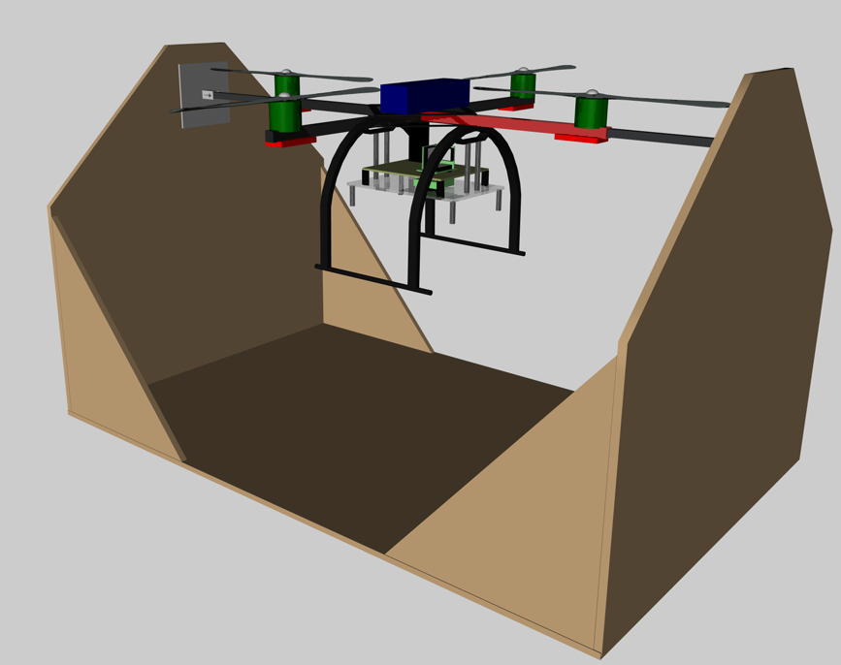

Figure – Illustration of Axis Restricted Testing Rig (Cinema 4D)

Figure 2 illustrates the connection method between the helicopter and the main frame. The metal beam will slide into the square bar of the helicopter with a tight fit, thus allowing quick instillation. The beam will then attach to a manufactured metal plate with tightener to lock the helicopter into place.

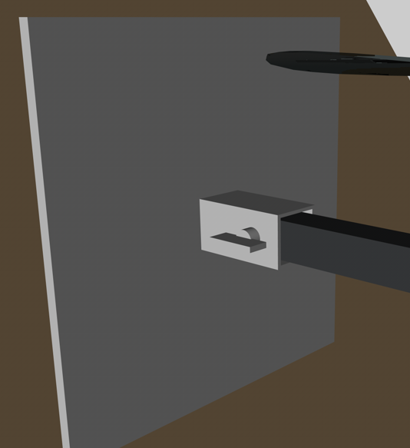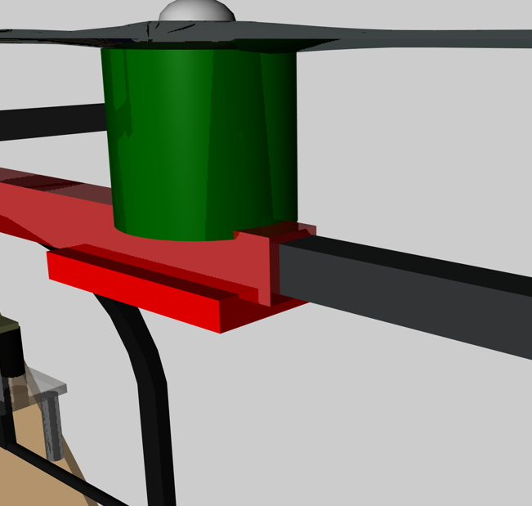

Figure – Beam Attaching to Helicopter / Beam Attaching to Frame (Cinema 4D)

### Bungee Cord Apparatus

The bungee cord apparatus was designed to allow the helicopter to have full attitude control, but restrict the position to a limited area. This system also allows for the helicopters power to be cut at any time with no fear of damaging the platform. The system contains a length of bungee cord connected to a supporting beam on a roof that suspends the helicopter. A rod that protrudes from the centre of the helicopter to above the platform is used to connect the bungee cord and helicopter. Carabineers are also used to allow quick separation from the testing platform.

# Implementation

## Axis Restricted Apparatus

The main frame was constructed with 12 mm thick Medium-Density Fibreboard (MDF), with the use of wood glue and screws to attach the cut pieces together. The metal rods used to suspend the helicopter were manufactured to the correct size to ensure a tight fit into the square bar of the platform. Welded plates were made to attach the metal rods to the main frame, with the ball bearing connected behind using rivets. The ball bearing rotation joints chosen in RD/1 were Lazy Susan, due to their ease in mounting and low costs. Due to the engine shaft protruding into the square beam of the helicopter, the two engines on the axis being rotated had to be removed. This has no effect to the test, as the engines were not contributing to the rotation.

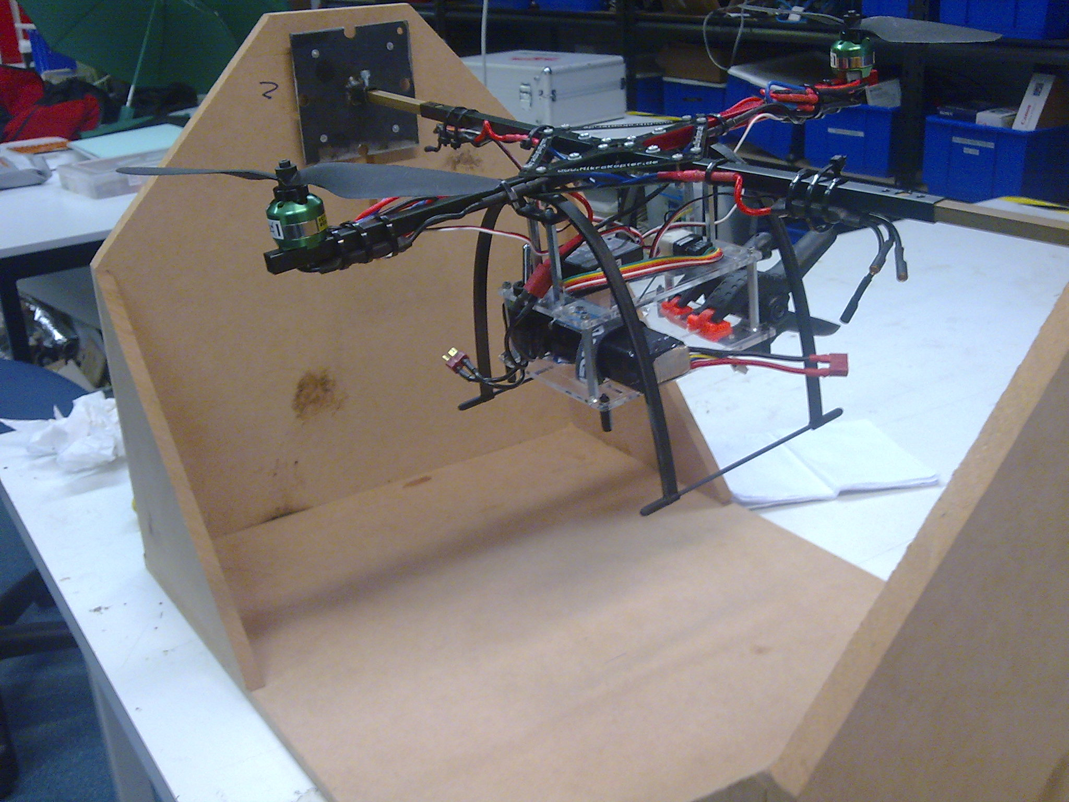

Figure – Axis Restricted Testing Platform

## Bungee Cord Apparatus

The bungee cord used was selected by observing how much a meter long stretched under a 2 kg load. Non-climbing carabineers were used to connect the elastic rope to the platform, with a large swivel to ensure the rope would not splinter under yawing conditions. Figure 4 illustrates the connection rod used to connect the bungee rope to the platform, and that ensures the rope does not come into contact with the spinning helicopter blades. This rod is secured using large washers and four locking nuts. The system is designed for the helicopter to lift to the point were the elastic rope does not support its weight before testing commences.

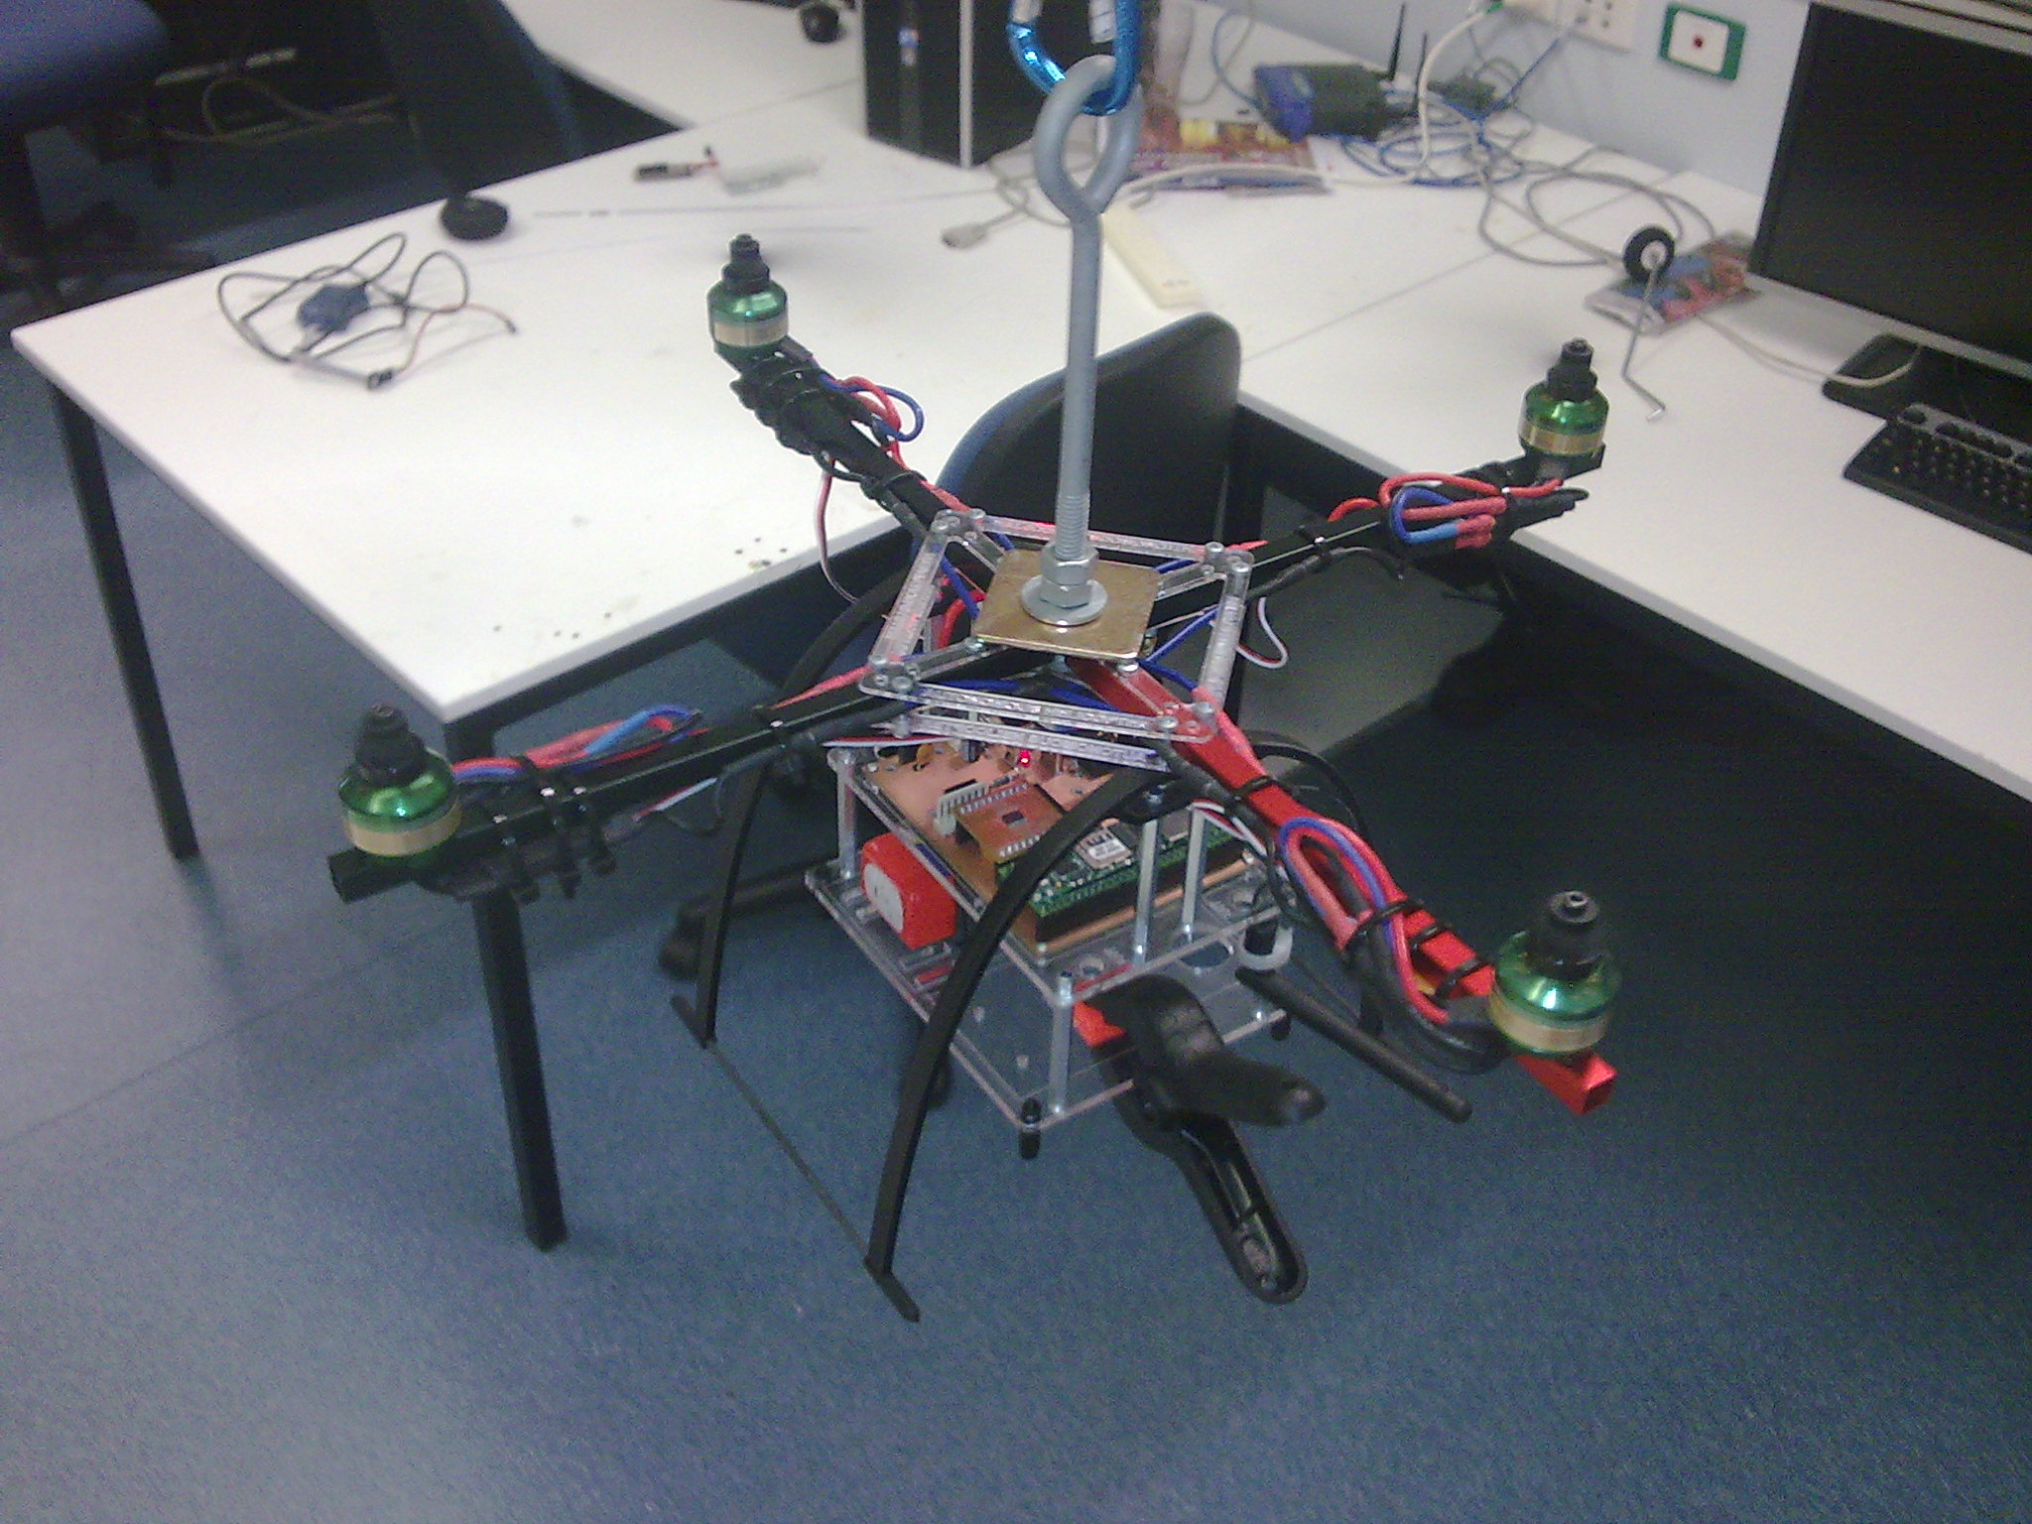

Figure – Bungee Rope Testing Platform

# Conclusions

This document overviews the design choices used in the construction of the testing apparatuses that were used prior to unrestricted testing. This equipment should be used to verify the control and state estimation code prior to the commencement of unrestricted testing.

# Recommendations

It is recommended that the testing apparatuses be used to verify the platforms control prior to unrestricted testing to reduce the likelihood of damage to the airframe, group members and surrounding area.