Title: ,

*“A Project”*

Prepared by Date _______________

, AHNS 2010

Checked by Date _______________

Tim Molloy, AHNS 2010

Approved by Date _______________

Michael Hamilton, Student Manager 2010

Authorised for use by Date _______________

Dr Luis Mejias, Project Coordinator

**QUT Avionics**

Queensland University of Technology

CRCSS-EESE, GPO Box 2434

Gardens Point Campus

Brisbane, Australia, 4001.

Telephone (+61 7) 3864 1772

Facsimile (+61 7) 3864 1517

e-mail luis.mejias@qut.edu.au

web <http://code.google.com/p/ahns10/>

This document is Copyright 2010 by the QUT. The content of this document, except that information which is in the public domain, is the proprietary property of the QUT and shall not be disclosed or reproduced in part or in whole other than for the purpose for which it has been prepared without the express permission of the QUT

**Revision Record**

|  |  |  |  |
| --- | --- | --- | --- |
| Document Issue/Revision Status | **Description of Change** | **Date** | **Approved** |
|  | Initial Issue |  |  |

**Distribution List**

|  |  |  |  |
| --- | --- | --- | --- |
| **Name** | **Affiliation** | **Distribution Date** | **Approved** |
| Avionics Lab File Archive | QUT Avionics |  |  |

**Foreword**

The airframe on the 2010 AHNS project is an essential component as it is the only way to practically test the hardware and software developed during the life of the project. The following trade study clearly identifies a variety of rotary winged airframes. They are subsequently explored, evaluated and compared so as to find the most suitable for the project. The airframes considered herein can be split into two categories, single and quad rotor.

**Table of Contents**

Paragraph Page No.

1 Introduction 8

1.1 Scope 8

1.2 Background 8

2 Reference Documents 9

2.1 QUT Avionics Documents 9

2.2 Non-QUT Documents 9

3 Airframe Requirements 10

3.1 Airframe Specifications 10

4 Trade Study 12

4.1 Solution 1: E-Flight Blade 400 13

4.1.1 Specifications 13

4.2 Solution 2: Align Trex 450 14

4.2.1 Specifications 14

4.3 Solution 3: Darganflyer V 15

4.3.1 Specifications 15

4.4 Solution 4: MicroKopter MK40 16

4.4.1 Specifications 16

5 Evaluation 17

5.1 Approach 1: E-Flight Blade 400 17

5.2 Approach 2: Align Trex 450 18

5.3 Approach 2: Draganflyer V 19

5.4 Approach 4: MikroKopter MK40 20

6 Conclusions 21

7 Recommendations 22

8 Appendices 23

**List of Figures**

Figure Page No.

Figure 1 - E-Flight Blade 400 13

Figure 2 - Align Trex 450 14

Figure 3 - Draganflyer V 15

Figure 4 - MikroKopter MK40 16

**List of Tables**

Table Page No.

Table 1 - Airframe Point Validation System 11

Table 2 – E-Flight Blade 400 Specifications 13

Table 3 – Align Trex 450 Specifications 14

Table 4 – Draganflyer V Specifications 15

Table 5 – MikroKopter MK40 Specifications 16

Table 6 - Approach 1 Validation 17

Table 7 - Approach 2 Validation 18

Table 8 - Approach 3 Validation 19

Table 9 - Approach 4 Validation 20

**Definitions**

|  |  |
| --- | --- |
| AHNS | Autonomous Helicopter Navigation System |
| MTOW | Maximum Take Off Weight |
| PEF | Payload Efficiency Factor: *ratio between max payload and empty weight* |
| eCCPM | Electronic Cyclic Collective Pitch Mixing |
| MEMS | Micro Electro-Mechanical Systems |
| IMU | Inertial Measurement Unit |
|  |  |
|  |  |
|  |  |
|  |  |
|  |  |
|  |  |
|  |  |
|  |  |
|  |  |
|  |  |
|  |  |

# Introduction

The 2010 AHNS project requires the development of an autopilot to facilitate stability augmentation and controlled autonomous flight of a rotary winged aircraft in a GPS denied environment. To practically demonstrate the system’s ability to do this, a suitable airframe must be procured and maintained. Given that the flight tests with the airframe will be performed indoors, the subsequent airframe must have the ability to be operated within a confined space.

## Scope

When identifying an appropriate airframe and its design considerations the scope of this document will be limited to the system requirements of the project.

## Background

In past AHNS projects, conventional single rotor designs were used. These designs are evaluated in this trade study due to their ready availability however quad rotor designs are also evaluated for the first time as they use smaller rotors, making them safer indoors and are less mechanically complex.

# Reference Documents

## QUT Avionics Documents

|  |  |  |
| --- | --- | --- |
| RD/1 | AHNS-2010-SY-SR-001 | AHNS 2010 System Requirements |
| RD/2 | AHNS-2010-SY-HL-001 | AHNS 2010 High Level Objectives |

## Non-QUT Documents

|  |  |  |
| --- | --- | --- |
| RD/3 | http://www.modelflight.com.au/eflite/eflite_blade_400.htm | E-Flight Blade 400 Information and Specifications |
| RD/4 | http://www.zeejayhobbies.com.au/helicopters/t-rex-450/t-rex-450-sport-kit/prod_3744.html | Align Trex 450 Information and Specifications |
| RD/5 | http://www.rctoys.com/rc-toys-and-parts/DF-COMPLETE-AIRFRAME/RC-PARTS-DRAGANFLYER-FRAME.html | Draganflyer V Information and Specifications |
| RD/6 | https://www.mikrocontroller.com/index.php?main_page=product_info&cPath=77&products_id=286 | MikroKopter MK40 Information and Specifications |

In the event of any conflict between this document and any RD referenced herein, such conflict shall be notified to .

In the following text, RD/x identifies referenced documents, where "x" denotes the actual document.

# Airframe Requirements

* [HLO-1 Platform] A platform should be developed and maintained to facilitate flight and on board hardware integration.
* [SR-D-01] The platform shall be capable of maintaining controlled flight with a total payload of 400 grams.

## Airframe Specifications

* The airframe must have a minimum payload capacity of 400g.
* The airframe must be able to fly indoors.
* The Airframe must be less than the allocated budget of $900

|  |  |  |  |  |  |  |
| --- | --- | --- | --- | --- | --- | --- |
|  |  | **Score (/5)** | | | | |
|  | **Weighting** | **5** | **4** | **3** | **2** | **1** |
| **Initial Cost** | 10% | < $700 | $700 – 799 | $800 - 899 | $900 - 999 | > $1000 |
| **Configuration** | 20% | Airframe designed to have components mounted to it. | Components can be mounted to airframe with no modifications. | Components can be mounted to the airframe with minor modifications. | Components can be mounted to the airframe with major modifications | Impossible to mount components to airframe. |
| **Acquisition and Maintenance** | 15% | Can be acquired commercially and rarely requires simple repair. | Can be acquired commercially and repairable. | Can be bought however repair and maintenance expensive. | Not available commercially and difficult to build and repair. | Impractical to acquire; repair limited to rebuilding. |
| **Vibration** | 10% | Airframe generates minor vibrations but is designed with vibration dampeners. | Airframe generates minor vibrations and can have vibration dampeners installed. | Airframe generates major vibrations but is designed with vibration dampeners. | Airframe generates major vibrations but can have vibration dampeners installed. | Airframe generates major vibrations but cannot have vibration dampeners installed. |
| **[SR-D-01] Payload** | 30% | > 500g | 450 – 500g | 400 – 449g | 350 – 399g | < 350g |
| **Safety** | 10% | Airframe has no exposed moving parts. | Airframe has small exposed moving parts with low kinetic energy. | Airframe has small exposed moving parts with high kinetic energy. | Airframe has large exposed moving parts with small kinetic energy. | Airframe has large exposed moving parts with high kinetic energy. |
| **Construction Material** | 5% | Airframe is predominantly constructed out of light weight carbon fibre. | Airframe is predominantly constructed out of lightweight metal. | Airframe is predominantly constructed of heavyweight metal. | Airframe is predominantly constructed out of lightweight plastic. | Airframe is predominantly constructed out of heavyweight plastic |

Table - Airframe Point Validation System

# Trade Study

The four rotary winged airframes that will be evaluated using the Airframe Point Validation System in Table 1 fall into two major categories. The first is a conventional single main rotor, small tail rotor design. The two airframes within this category are the E-Flight Blade 400 and the Align Trex 450. The second category is the quadrotor or quadcopter design. The two airframes within this category are the Draganflyer V and the MikroKopter MK40.

## Solution 1: E-Flight Blade 400

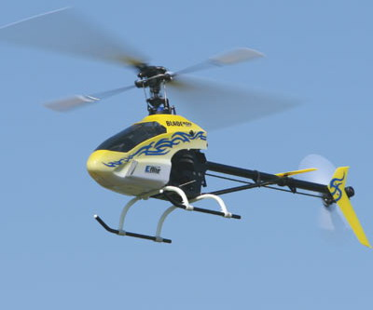

Figure - E-Flight Blade 400

### Specifications

Table – E-Flight Blade 400 Specifications

|  |  |
| --- | --- |
| Rotor diameter | 718mm |
| Number of rotors | 2 |
| Number of servos | 4 |
| Number of motors | 1 |
| Airframe Weight | 665g |
| Payload | 150g |
| MTOW | 815g |
| PEF | 0.23 |
| Attitude control | Three servo eCCPM swash plate |
| Yaw Control | Servo controlled variable pitch tail rotor |
| Mechanical Stability | Flybar |
| Electronic Stability | MEMS Gyro (yaw only) |
| Cost | $0AUD (already owned) |

## Solution 2: Align Trex 450

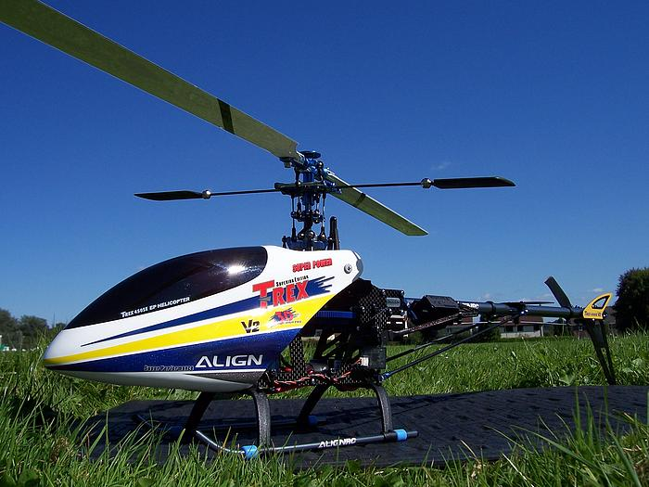

Figure - Align Trex 450

### Specifications

Table – Align Trex 450 Specifications

|  |  |
| --- | --- |
| Rotor diameter | 715mm |
| Number of rotors | 2 |
| Number of servos | 4 |
| Number of motors | 1 |
| Airframe Weight | 770g |
| Payload | 350g |
| MTOW | 1120g |
| PEF | 0.46 |
| Attitude control | Three servo eCCPM swash plate |
| Yaw Control | Servo controlled variable pitch tail rotor |
| Mechanical Stability | Flybar |
| Electronic Stability | MEMS Gyro (yaw only) |
| Cost | $0AUD (already owned) |

## Solution 3: Darganflyer V

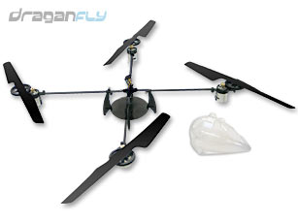

Figure - Draganflyer V

### Specifications

Table – Draganflyer V Specifications

|  |  |
| --- | --- |
| Rotor diameter | 254mm |
| Number of rotors | 4 |
| Number of servos | 0 |
| Number of motors | 4 |
| Airframe Weight | 125g |
| Payload | 400g |
| MTOW | 525g |
| PEF | 3.2 |
| Attitude control | Differential engine speed |
| Yaw Control | Differential engine speed |
| Mechanical Stability | None |
| Electronic Stability | None |
| Cost | $221AUD |

## Solution 4: MicroKopter MK40

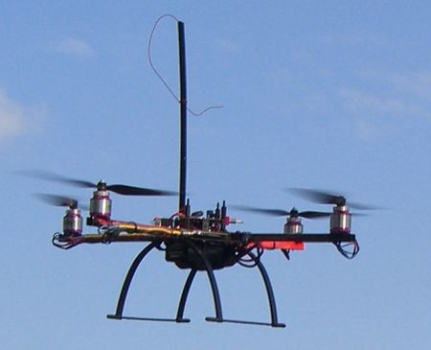

Figure - MikroKopter MK40

### Specifications

Table – MikroKopter MK40 Specifications

|  |  |
| --- | --- |
| Rotor diameter | 254mm |
| Number of rotors | 4 |
| Number of servos | 0 |
| Number of motors | 4 |
| Airframe Weight | 292g |
| Payload | 1000g |
| MTOW | 1292g |
| PEF | 3.42 |
| Attitude control | Differential engine speed |
| Yaw Control | Differential engine speed |
| Mechanical Stability | None |
| Electronic Stability | None |
| Cost | $850AUD |

# Evaluation

## Approach 1: E-Flight Blade 400

Table - Approach 1 Validation

|  |  |
| --- | --- |
|  | **Score**  **(/5)** |
| **Initial Cost** | 5 |
| **Configuration** | 3 |
| **Acquisition and Maintenance** | 3 |
| **Vibration** | 2 |
| **[SR-D-01] Payload** | 1 |
| **Safety** | 1 |
| **Material** | 2 |

* Weighted Total: 45%

This option was considered in this trade study due to its ready availability. As a result of this, approach 1 has a favourable score in the initial cost category. Approach 1 scores poorly in the payload, vibration, and safety categories. These are three very key factors as the system will use an IMU that is sensitive to vibrations and will be tested within a confined space.

## Approach 2: Align Trex 450

Table - Approach 2 Validation

|  |  |
| --- | --- |
|  | **Score**  **(/5)** |
| **Initial Cost** | 5 |
| **Configuration** | 3 |
| **Acquisition and Maintenance** | 3 |
| **Vibration** | 2 |
| **[SR-D-01] Payload** | 2 |
| **Safety** | 1 |
| **Material** | 4 |

* Weighted Total: 53%

This option was considered due to its ready availability, this gives it a favourable score in the initial cost category. It does however offer inadequate payload capabilities and scores very low in the safety category. Given the mechanical complexity of approach 2, it scored marginally in the acquisition and maintenance category.

## Approach 3: Draganflyer V

Table - Approach 3 Validation

|  |  |
| --- | --- |
|  | **Score**  **(/5)** |
| **Initial Cost** | 5 |
| **Configuration** | 4 |
| **Acquisition and Maintenance** | 4 |
| **Vibration** | 4 |
| **[SR-D-01] Payload** | 5 |
| **Safety** | 3 |
| **Material** | 5 |

* Weighted Total: 87%

This option had favourable scores in all categories except for safety. Given that approach 3 has four exposed rotor blades, these can still cause damage to personnel or property. Favourable scores were achieved in payload capacity and vibration without compromising the initial cost score.

## Approach 4: MikroKopter MK40

Table - Approach 4 Validation

|  |  |
| --- | --- |
|  | **Score**  **(/5)** |
| **Initial Cost** | 3 |
| **Configuration** | 5 |
| **Acquisition and Maintenance** | 5 |
| **Vibration** | 5 |
| **[SR-D-01] Payload** | 5 |
| **Safety** | 3 |
| **Material** | 4 |

* Weighted Total: 91%

This option received excellent scores in the configuration, acquisition and maintenance, vibration and payload categories. It received marginal scores in the safety and initial cost categories, however no other option considered in this trade study scored better in the safety category and it does not exceed the allocated budget.

# Conclusions

The selection criteria for selecting a suitable airframe for the project can be broken down into seven evaluation criteria. The trade study evaluated and compared four different airframes from two different categories to yield that the most suitable airframe is a quadrotor type airframe, with the MikroKopter MK40 being most suitable.

# Recommendations

It is recommended that once the MikroKopter MK40 airframe has been procured and assembled, several test flights should be performed before hardware integration is commenced. This should include a bare airframe flown under manual control and a weighted airframe flown under manual control. This is to determine the airframes stability and endurance.

# Appendices

None.