|  |  |  |
| --- | --- | --- |
| Project:  WP Name: State Estimation Design Testing  WP Number: WP-SE-01 | Type of Test:  Verification | Test Procedure:  Change platform attitude and observe the state outputs |
| Test Article:  State estimation of Euler rates and Euler angles | Part Number:  None | Serial Number:  None |
| Test Specification:  State outputs being generated at a minimum rate of 50Hz | Test Equipment:  Quadrotor platform with payload  Laptop (running GCS and MATLAB) | |
| Test Operators:  Liam O’Sullivan | Test Engineer:  Liam O’Sullivan | |
| WP Group Manager:  Michael Hamilton | WP Supervisor:  Dr. Luis Mejias | |

**QUT Avionics**

Queensland University of Technology

CRCSS-EESE, GPO Box 2434

Gardens Point Campus

Brisbane, Australia, 4001.

Telephone (+61 7) 3864 1772

Facsimile (+61 7) 3864 1517

e-mail luis.mejias@qut.edu.au

web <http://code.google.com/p/ahns10/>

This document is Copyright 2010 by the QUT. The content of this document, except that information which is in the public domain, is the proprietary property of the QUT and shall not be disclosed or reproduced in part or in whole other than for the purpose for which it has been prepared without the express permission of the QUT

**Test Summary**

The state estimation design of the Euler rates and Euler angles was tested without the assistance of the Vicon sensor. It was found that in all Euler angle cases, the Euler angle estimate produced by the Kalman filter tracks closely to the Euler angle measurement. The Euler angle measurements were observed to contain high frequency noise components which were removed in the Euler angle estimate. The IMU was also observed to have a mounting error of $ϕ=-1.4°$ and $θ=-1.2°$ which will be removed by adding an axis offset in the state estimation design. Finally the state estimation average update rate was shown to be greater than the required 50 Hz.

**Table of Contents**

Paragraph Page No.

1 Test Objectives 4

2 Test Set-up & Equipment 5

3 Procedure 6

4 Results 7

5 Analysis 14

6 Conclusions 15

7 Recommendations 16

**List of Figures**

Figure Page No.

Figure 1 - Euler rate $ϕ$ output 7

Figure 2 - Euler rate $θ$ output 8

Figure 3 - Euler rate $ψ$ output 8

Figure 4 - Stationary Euler angle $ϕ$ output 9

Figure 5 - Stationary Euler angle $θ$ output 9

Figure 6 - Stationary Euler angle $ψ$ output 10

Figure 7 - Euler angle $ϕ$ output 10

Figure 8 - Euler angle $θ$ output 11

Figure 9 - Euler angle $ψ$ output 11

Figure 10 - Euler angle $ϕ$ comparison with integrated Euler rate $ϕ$ 12

Figure 11 - Euler angle $θ$ comparison with integrated Euler rate $θ$ 12

Figure 12 - Euler angle $ψ$ comparison with integrated Euler rate $ψ$ 13

Figure 13 - State estimation update rate 13

**List of Tables**

No Tables.

# Test Objectives

The test report has the following test objectives:

* Change the quadrotor platform attitude and observe the state estimator outputs generated for the Euler angles and Euler rates
* Verify that the state estimation outputs of the Euler angles and Euler rates are being received by the flight computer at a minimum of 50Hz
* Record all state estimator outputs generated and graph the outputs using MATLAB
* Record what smoothing parameters $α$ and Kalman filter parameters $\left(R,Q,P_{0} \text{and} x_{0}\right)$ worked best for the estimation of the Euler angles and Euler rates

# Test Set-up & Equipment

The following test setup and equipment was used to conduct the test report:

* PC with a Linux based operating system installed
* Quadrotor platform with payload attached (including the IMU, Arduino and compass sensors)
* PC with MATLAB installed
* Log files recorded by the flight computer
* MATLAB test script file (EulerTest.m)

# Procedure

The test report utilised the following procedure:

1. Observe the state estimator outputs for the Euler rates while the quadrotor platform is stationary.
2. Observe the state estimator outputs for the Euler angles while the quadrotor platform is stationary.
3. Change the orientation of the quadrotor platform in the roll axis and observe the changes in the $ϕ$ angle.
4. Change the orientation of the quadrotor platform in the pitch axis and observe the changes in the $θ$ angle.
5. Change the orientation of the quadrotor platform in the yaw axis and observe the changes in the $ψ$ angle.
6. If errors can be seen during steps 1 to 5 then the smoothing factor $α$ and the Kalman filter parameters $\left(R,Q,P_{0} \text{and} x_{0}\right)$ should be modified. Repeat steps 1 to 5 until suitable state estimation performance has been achieved.
7. The log files for all of the above tests should be saved and imported into MATLAB using the script analysis file EulerTest.m.
8. Plots of all data should be generated including the plot which demonstrates the 50 Hz update rate of the state estimation

# Results

The following graphs are included in this section:

* Stationary Euler rates $\dot{ϕ}, \dot{θ}, \dot{ψ}$ with a smoothing factor $α=1.0$ i.e. no filtering is taking place (refer to Figures 1, 2 and 3).
* Stationary Euler angles $ϕ,θ,ψ$ with $R_{k}=σ_{ϕ_{measure}}^{2}=1.7$, $Q_{k}\left(1,1\right)=σ_{ϕ}^{2}=0.057296$, $Q_{k}\left(2,2\right)=σ_{ϕ_{bias}}^{2}=0.171887$, $P_{0}=I_{4×4}$ and $x_{0}=coarse Euler angle$ (refer to Figures 4,5 and 6).
* Euler angles $ϕ,θ,ψ$ when the platform attitude is changing. The Kalman filter parameters are $R_{k}=σ_{ϕ_{measure}}^{2}=1.7$, $Q_{k}\left(1,1\right)=σ_{ϕ}^{2}=0.057296$, $Q_{k}\left(2,2\right)=σ_{ϕ_{bias}}^{2}=0.171887$, $P_{0}=I_{4×4}$ and $x_{0}=coarse Euler angle$ (refer to Figures 7,8 and 9).
* Euler angles $ϕ,θ,ψ$ comparison graphs with only the Euler rates integrated (refer to Figure 10,11 and 12)
* State estimation output rate (refer to Figure 13).

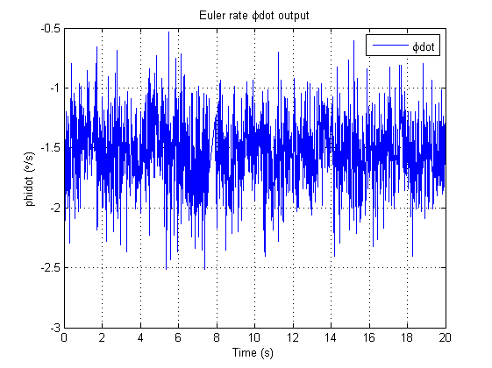

Figure - Euler rate output

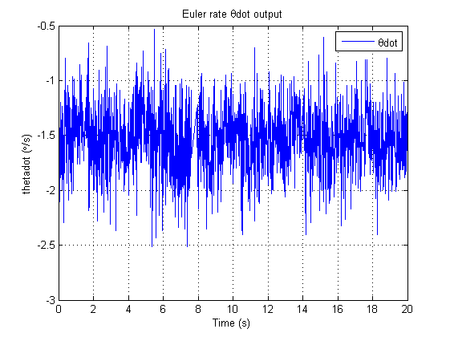

Figure - Euler rate output

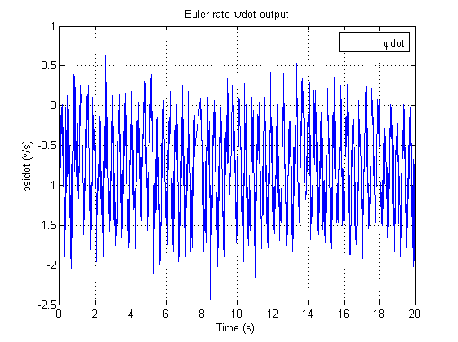

Figure - Euler rate output

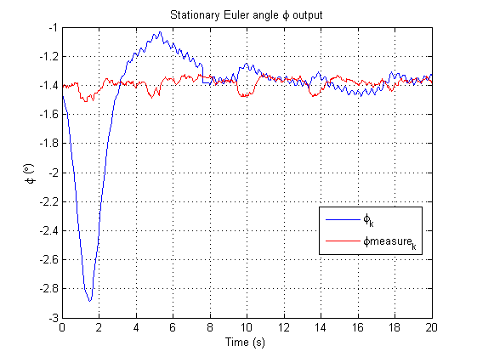

Figure - Stationary Euler angle output

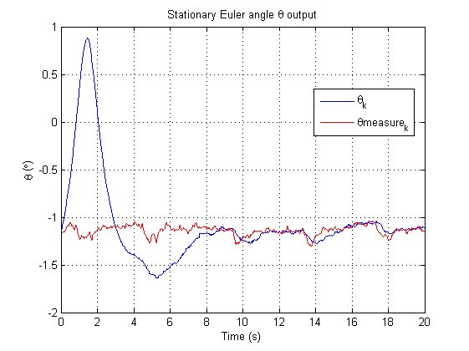

Figure - Stationary Euler angle output

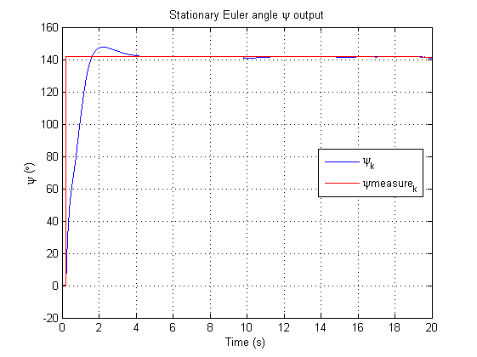

Figure - Stationary Euler angle output

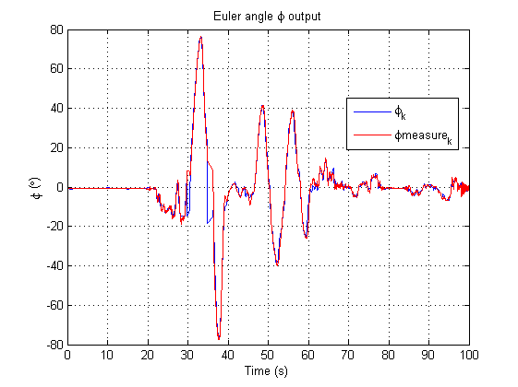

Figure - Euler angle output

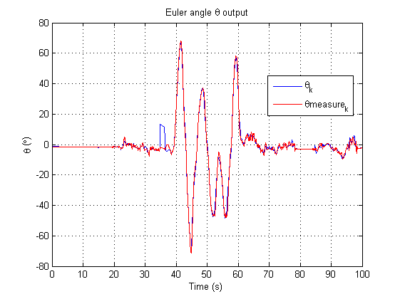

Figure - Euler angle output

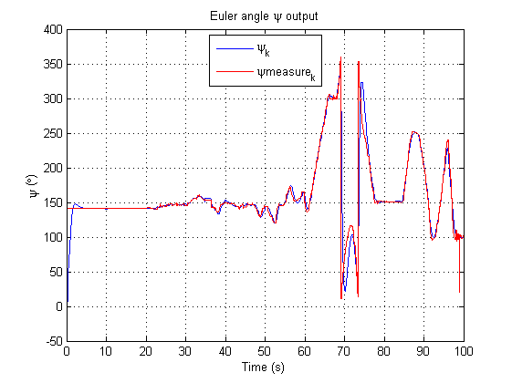

Figure - Euler angle output

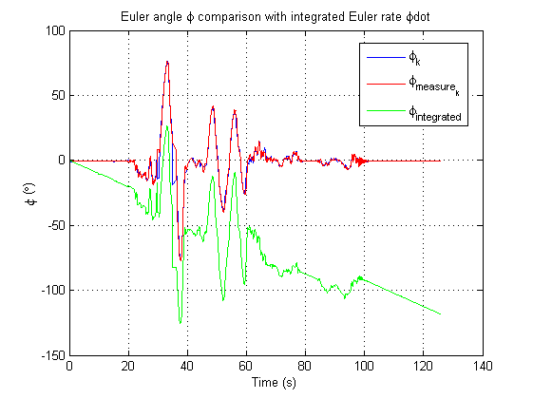

Figure - Euler angle comparison with integrated Euler rate

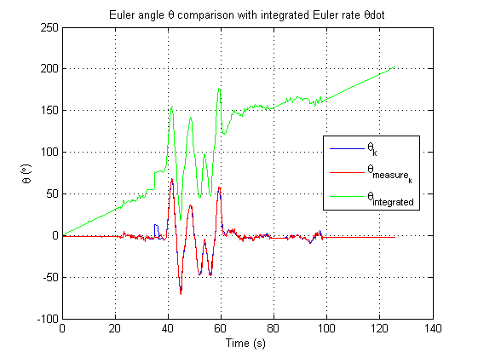

Figure - Euler angle comparison with integrated Euler rate

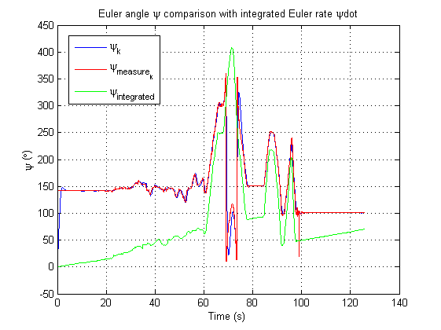

Figure - Euler angle comparison with integrated Euler rate

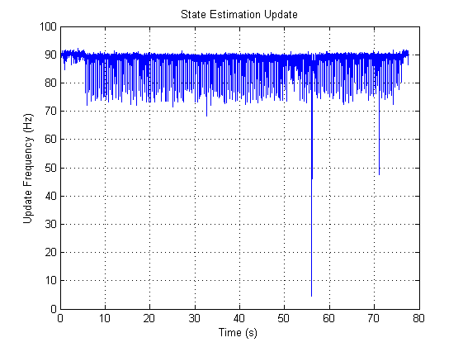

Figure - State estimation update rate

# Analysis

The following analysis can be made from the above figures:

* Figures 1, 2 and 3 show that the Euler rates are being generated and sent to the flight computer.
* Figures 4 and 5 demonstrates that the Kalman Filter Euler angle estimate begins to track the Euler angle measurement closely after 8 seconds (when stationary). Prior to that, the estimator has developed a large uncertainty in the reading thus it takes a few seconds for the estimator and measurement to meet.
* Figures 4 and 5 also shows that the IMU has a mounting error on the platform. This is because while stationary the platform thinks it has been tilted by $ϕ=-1.4°$ and $θ=-1.2°$.
* Figure 6 shows that the Kalman Filter Euler angle estimate $ψ_{k}$ tracks the Euler angle measurement of $ψ$ almost immediately. This is because the $ψ$ measurement from the compass has very little noise when the platform is stationary. Thus the estimator takes very little time to track the measurement closely.
* Figures 7, 8 and 9 contains 100 seconds of Euler angle state data from the Kalman Filter. In each figure it shows that as a change in attitude is performed the measurement and the state estimate change together. The state estimate follows the measurement closely as the attitude change is executed however the state estimate has less noise (in particular the $ϕ$ and $θ$ estimates). This is because the Euler angle measurement for $ϕ$ and $θ$ is corrupted by high frequency noise which the Kalman Filter eliminates in the Euler angle state estimate.
* Figures 10, 11 and 12 show that the integrated Euler rates drift over time. This drift becomes quite sizable after 100 seconds where a difference in $100° \text{and} 200°$ can be seen in Figures 10 and 11. The shape of the integrated Euler rate output is similar to the Euler angle estimate and measurement except that a DC bias has developed at each time step.
* The state estimation update has an average value of 90 Hz (refer to Figure 13). The average range of the state estimation update is between 70 to 90 Hz. The update rate occasionally dips below 50 Hz as can be seen at time points $t=55 \text{s} \text{and} t=71 \text{s}$.

# Conclusions

From the plot outputs it can be concluded that the state estimations for the Euler rates and Euler angles are working as intended. The Kalman filter parameters that were chosen are adequate for the quadrotor platform with the state estimates of the Euler angles tracking the Euler angle measurement closely. An IMU mounting error of $ϕ=-1.4°$ and $θ=-1.2°$ has developed and will need to be corrected. The state estimation update has reached the minimum update rate of 50 Hz when the average update rate has been considered. On some occasions it has been noted that the update rate dips below the minimum 50 Hz requirement. This requirement cannot be met 100% of the time due to the implementation of the state estimator on a soft real time operating system.

# Recommendations

It is recommended that the IMU mounting error be fixed either through hardware or software means. It can be changed from a software approach by adding an angular offset for each axis. This offset will be constant for the duration of the state estimation. The performance of the state estimator should also be re-evaluated when the state estimation data is being used for a flight test. Flight testing will cause vibrations to occur which will affect the Euler angle measurements and degrade the performance of the state estimation. The smoothing factor parameter $α$ will need to be changed on all Euler rate and accelerometer state estimates forcing the vibrations generated through flight testing to be damped. Removing these vibrations will improve the state estimates allowing the quadrotor platform to be more easily controlled.