|  |  |  |
| --- | --- | --- |
| Project:  WP Name: Vicon Testing  WP Number: WP-SE-02 | Type of Test:  Verification | Test Procedure:  Modify platform attitude and position and observe outputs |
| Test Article:  State estimation of quadrotor platform | Part Number:  None | Serial Number:  None |
| Test Specification:  Vicon state updates at a minimum of 50Hz | Test Equipment:  Quadrotor platform with payload  Vicon  Laptop (running GCS and MATLAB) | |
| Test Operators:  Liam O’Sullivan | Test Engineer:  Liam O’Sullivan | |
| WP Group Manager:  Michael Hamilton | WP Supervisor:  Dr. Luis Mejias | |

**QUT Avionics**

Queensland University of Technology

CRCSS-EESE, GPO Box 2434

Gardens Point Campus

Brisbane, Australia, 4001.

Telephone (+61 7) 3864 1772

Facsimile (+61 7) 3864 1517

e-mail luis.mejias@qut.edu.au

web <http://code.google.com/p/ahns10/>

This document is Copyright 2010 by the QUT. The content of this document, except that information which is in the public domain, is the proprietary property of the QUT and shall not be disclosed or reproduced in part or in whole other than for the purpose for which it has been prepared without the express permission of the QUT

**Test Summary**

The Vicon system was tested to see if it could update the platform states at the minimum of 50 Hz. The mean update rate for the Vicon was 151 Hz and produced outputs for the X, Y, Z translation and Euler angle states. The state estimators for all 3 Euler angles were compared against the Vicon system. The ϕ and θ estimators performed quite well but the original implementation for ψ did not. Using MATLAB a new implementation of ψ was developed and compared quite favourably to the Vicon ψ output. This new implementation will be added to the state estimation library.

**Table of Contents**

Paragraph Page No.

1 Test Objectives 4

2 Test Set-up & Equipment 5

3 Procedure 6

4 Results 7

5 Analysis 14

6 Conclusions 15

7 Recommendations 16

**List of Figures**

Figure Page No.

Figure 4.1 - Vicon X translation output 7

Figure 4.2 - Vicon Y translation output 8

Figure 4.3 - Vicon Z translation output 8

Figure 4.4 - Vicon 3D trajectory 9

Figure 4.5 - Vicon Euler angle ϕ output 9

Figure 4.6 - Vicon Euler angle θ output 10

Figure 4.7 – Vicon Euler angle ψ output 10

Figure 4.8 - Euler angle output ϕ comparison 11

Figure 4.9 - Euler angle θ output comparison 11

Figure 4.10 - Euler angle ψ output comparison (incorrect state estimation) 12

Figure 4.11 - Euler angle ψ output comparison (MATLAB state estimation) 12

Figure 4.12 - Vicon update rate 13

**List of Tables**

No Tables.

# Test Objectives

The test report has the following test objectives:

* Change the quadrotor platform X, Y and Z position or translation and observe the Vicon outputs.
* Change the quadrotor platform attitude and observe the Vicon outputs
* Compare the Euler angle outputs of the Vicon system with the State estimation of the Kalman filter.

# Test Set-up & Equipment

The following test setup and equipment was used to conduct the test report:

* PC with a Linux based operating system installed
* Quadrotor platform with payload attached (including the IMU, Arduino and compass sensors)
* Vicon system with the Vicon Tracker program
* PC with MATLAB installed
* Log files recorded by the flight computer
* MATLAB test script file (ViconTest.m)

# Procedure

The test report utilised the following procedure:

1. Observe the Vicon X, Y and Z translation outputs while the quadrotor platform is moving.
2. Observe the Vicon Euler angle outputs when the quadrotor platform attitude is changed.
3. The log files for all of the above tests should be saved and imported into MATLAB using the script analysis file ViconTest.m.
4. Compare the Vicon Euler angle outputs with the state estimation outputs via the script analysis file ViconTest.m.
5. Plots of all data should be generated and presented in this test report

# Results

The following graphs are included in this section:

* Vicon X,Y and Z translation outputs with a 3D plot (refer to Figures 4.1, 4.2 ,4.3 and 4.4).
* Vicon Euler angles $ϕ,θ,ψ$ (refer to Figures 4.5, 4.6 and 4.7)
* Comparison between the Vicon Euler angles and the state estimation outputs from the IMU (refer to Figures 4.8, 4.9 and 4.10)
* From the results of Figure 4.10 a new $ψ$ state estimator was developed in MATLAB leading to the Figure in 4.11
* Vicon update rate (refer to Figure 4.12)

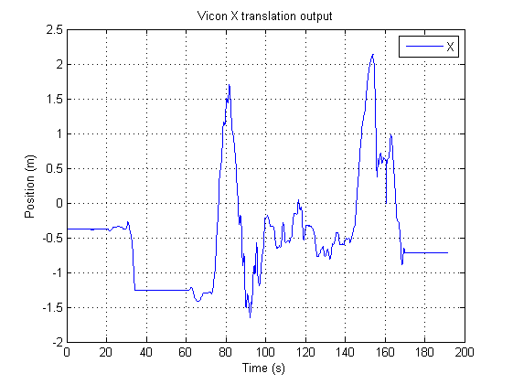

Figure .1 - Vicon X translation output

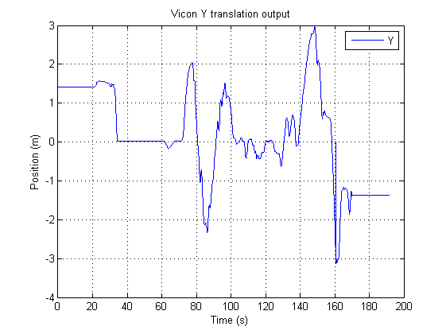

Figure .2 - Vicon Y translation output

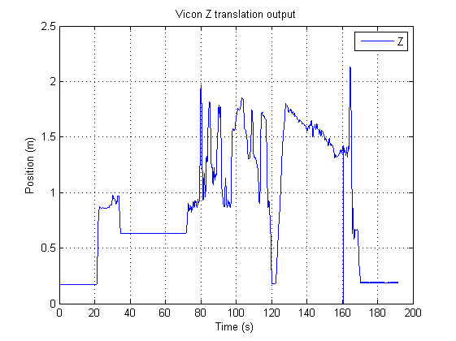

Figure .3 - Vicon Z translation output

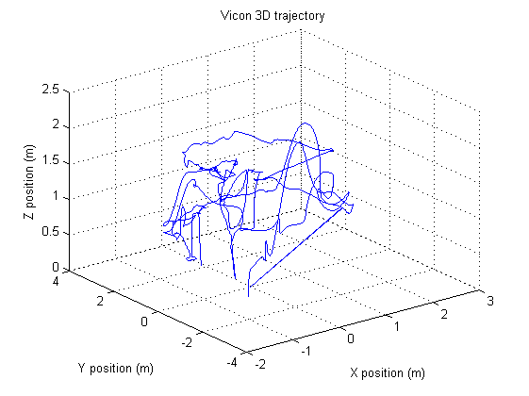

Figure .4 - Vicon 3D trajectory

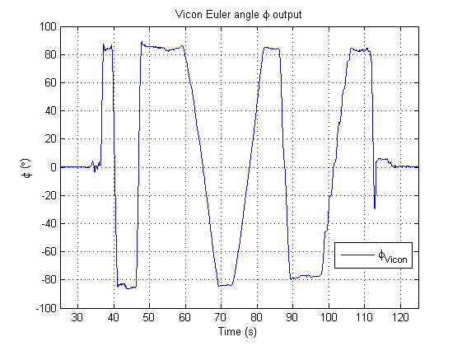

Figure .5 - Vicon Euler angle ϕ output

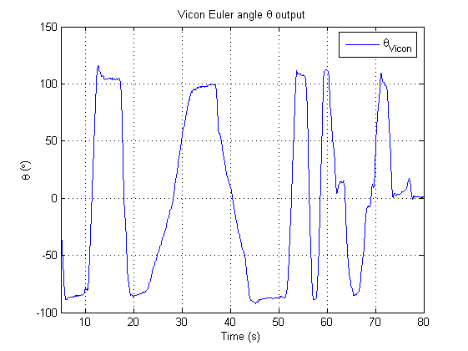

Figure .6 - Vicon Euler angle θ output

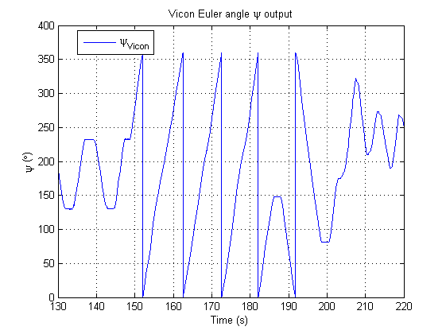

Figure .7 – Vicon Euler angle ψ output

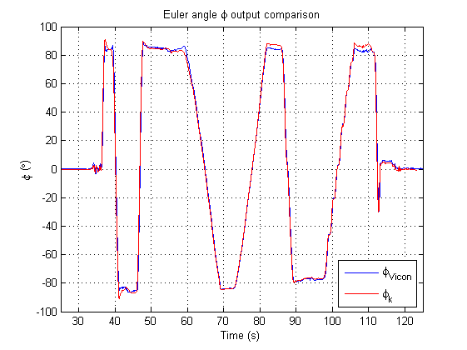

Figure .8 - Euler angle output ϕ comparison

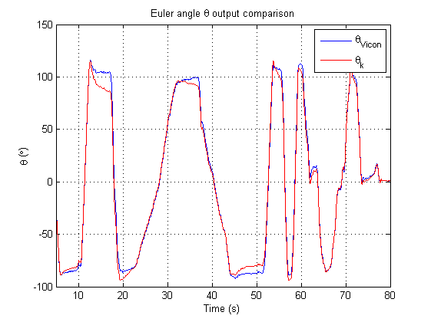

Figure .9 - Euler angle θ output comparison

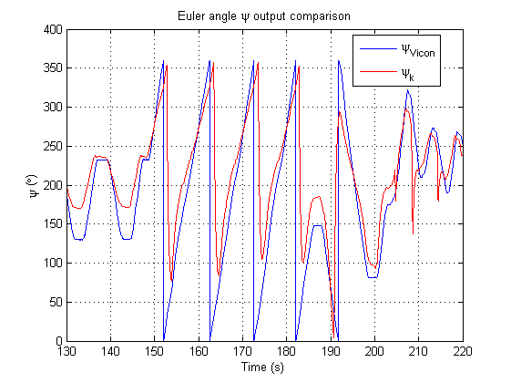

Figure .10 - Euler angle ψ output comparison (incorrect state estimation)

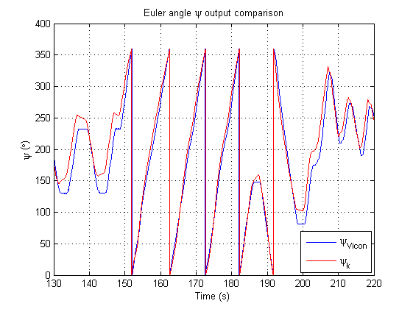

Figure .11 - Euler angle ψ output comparison (MATLAB state estimation)

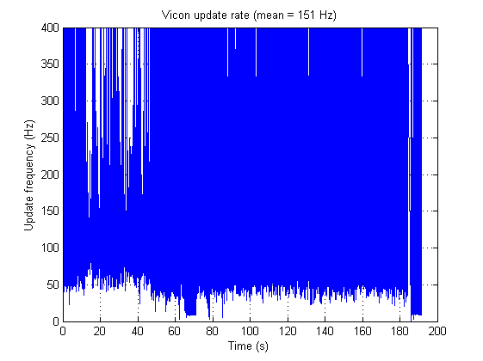

Figure .12 - Vicon update rate

# Analysis

The following analysis can be made from the above figures:

* The Vicon system produces translation and Euler angle outputs for the quadrotor platform at a mean rate of 151 Hz.
* The Euler angle ϕ output comparison reveals that the state estimator for ϕ is predicting the ϕ Euler angle with high accuracy.
* The Euler angle ϕ output comparison reveals that the state estimator for ϕ is predicting the ϕ Euler angle with high accuracy. The state estimator performance degrades when the platform attitude reaches a ϕ output of $±90°$.
* The Euler angle θ output comparison reveals that the state estimator for θ is predicting the θ Euler angle with high accuracy. The state estimator performance degrades once again when the platform attitude reaches a θ output of $±90°$.
* In Figure 4.10, the Euler angle ψ output comparison reveals that the state estimator for ψ is not predicting the ψ Euler angle with any reasonable accuracy. From this figure a new state estimator for ψ was developed leading to Figure 4.11
* In Figure 4.11, the Euler angle ψ output comparison reveals that the new state estimator for ψ is predicting the ψ Euler angle with a reasonable level of accuracy. Differences between $10°-20°$ can clearly be seen in Figure 4.10.

# Conclusions

The Vicon sensor is transmitting the X,Y and Z position and Euler angles to the GCS at extremely high update rates. The comparison between the Vicon Euler angle output and the state estimators of ϕ and θ revealed that both were quite similar. This means that the state estimators for both of these Euler rates are working as designed. The original implementation for the state estimator of ψ compared poorly with the Vicon output for ψ. The state estimator for ψ was redesigned in MATLAB and yielded much better results when compared with the Vicon output.

# Recommendations

It is recommended that the new state estimator for ψ be implemented in the Kalman filtering design. These new design notes should be specified in AHNS-2010-SE-DD-001 and a new revision of this document should be generated.