Title: , Autonomous Helicopter Navigation System, System Level, Progress Report

*“A Project”*

Prepared by Date _______________

,

Checked by Date _______________

,

Approved by Date _______________

, Student Manager 2010

Authorised for use by Date _______________

Dr Luis Mejias, Project Coordinator

**QUT Avionics**

Queensland University of Technology

CRCSS-EESE, GPO Box 2434

Gardens Point Campus

Brisbane, Australia, 4001.

Telephone (+61 7) 3864 1772

Facsimile (+61 7) 3864 1517

e-mail luis.mejias@qut.edu.au

web <http://code.google.com/p/ahns10/>

This document is Copyright 2010 by the QUT. The content of this document, except that information which is in the public domain, is the proprietary property of the QUT and shall not be disclosed or reproduced in part or in whole other than for the purpose for which it has been prepared without the express permission of the QUT

**Revision Record**

|  |  |  |  |
| --- | --- | --- | --- |
| Document Issue/Revision Status | **Description of Change** | **Date** | **Approved** |
|  | Initial Issue |  |  |

**Distribution List**

|  |  |  |  |
| --- | --- | --- | --- |
| **Name** | **Affiliation** | **Distribution Date** | **Approved** |
| Avionics Lab File Archive | QUT Avionics |  |  |

**Foreword**

This document is a formal representation of the progress of the Queensland University of Technology Autonomous Helicopter Navigation System in 2010 project from the perspective of the student named on the cover page. The progress report provides a summary of the project and how the student is contributing to its success. Methodology outlining milestones and how they will be met is also provided along with a statement describing unforseen risks and mitigation mechanisms. Finally a brief summary is provided of all lessons learnt from the project to the current date.

**Table of Contents**

Paragraph Page No.

1 Introduction 7

1.1 Scope 7

1.2 Background 7

2 Reference Documents 8

2.1 QUT Avionics Documents 8

2.2 Non-QUT Documents 8

3 06219322 Project Summary 9

3.1 Methodology for Delivering Against Milestones 10

3.2 Statement of Progress Against Milestones 15

3.3 Risks 16

4 Conclusions 17

5 Lessons learnt and Recommendations 18

6 Appendix A 19

**List of Figures**

Figure Page No.

Figure 1 - MikroKopter MK40 10

Figure 2 - AHNS Hardware Architecture 11

Figure 3 - Development Board Schematic 12

Figure 4 - Development Board Layout 12

Figure 5 - Quadrotor Model Used in Simulator (Source: www.aerosimrc.com) 13

Figure 6 – Practise Airframe in Operation 14

**List of Tables**

Table Page No.

Table 1 - Current Progress 15

**Definitions**

|  |  |
| --- | --- |
| AHNS | Autonomous Helicopter Navigation System |
| QUT | Queensland University of Technology |
| HLO | High Level Objective |
| RC | Remote Control |
| FC | Flight Computer |
| MCU | Mode Control Unit |
|  |  |
|  |  |
|  |  |
|  |  |
|  |  |
|  |  |
|  |  |
|  |  |
|  |  |
|  |  |
|  |  |
|  |  |

# Introduction

The ensure the project is successful, all participating students are required to conform to the drafted timeline. This report is a summary of the current progress of the project and methods employed to ensure that all deliverables are met before the project completion date.

## Scope

The purpose of this document is to ensure that drafted tasks are being completed as per the timeline and ensure that any unforseen risk or problem is denied the ability to compromise the project. This document is primarily bound by the Project Management Plan RD/3 but also references High Level Objectives, System Requirements, and Risk Management Plan, RD/1, RD/2, and RD/4 respectively.

## Background

No Background

# Reference Documents

## QUT Avionics Documents

|  |  |  |
| --- | --- | --- |
| RD/1 | AHNS-2010-SY-SR-001 | AHNS, System Requirements of |
| RD/2 | AHNS-2010-SY-HL-001 | AHNS, High Level Objectives of |
| RD/3 | AHNS-2010-SY-PM-001 | AHNS, Project Management Plan of |
| RD/4 | AHNS-2010-SY-PM-002 | AHNS, Risk Management Plan of |
| RD/5 | AHNS-2010-PL-TS-001 | AHNS, Airframe, Trade Study of |

## Non-QUT Documents

|  |  |  |
| --- | --- | --- |
| None. |  |  |

In the event of any conflict between this document and any RD referenced herein, such conflict shall be notified to Dr Luis Mejias.

In the following text, RD/x identifies referenced documents, where "x" denotes the actual document.

# 06219322 Project Summary

The AHNS project in 2010 aims to create a functional autopilot system for a quadrotor aircraft. The system will have a hardware layer implemented in the actual aircraft with a software layer performing basic flight stability functions and low level command and control of the aircraft. A second software layer will perform localisation calculations, high level command and control and system monitoring.

The role of this student is to design, develop, implement and test the aforementioned hardware layer. The most fundamental of these tasks is the procurement and assembly of the actual platform as this forms and basis of the entire project. Once the platform is assembled, an RC test needs to be carried out to verify the platforms ability to lift the weight of the onboard systems and its ability to exhibit adequate manoeuvrability. Another important task is the integration of the sensor systems onboard the platform. This leads to the hardware systems development and design. Within this, the issue of power supply must be addressed to ensure that the platform can have sufficient air time during missions, while not being over encumbered by the weight of batteries. All sensors need to be mounted to the airframe in a way that will allow them to perform their respective tasks unhindered. Finally the flight computer, which runs the software layer, has special cooling requirements that need to be addressed. If sufficient cooling is not granted to the FC, the risk of it overheating and failing during a mission is not mitigated.

Finally the student is responsible for being the test pilot for the project. This duty includes the ability to commence and maintain a stable hover as well as the ability to perform recovery manoeuvres if necessary. It is an ongoing duty of all team members to ensure that safety during missions is granted top priority, when the aircraft is under manual control it is the responsibility of the test pilot to ensure that the aircraft is flown responsibly and denied the ability to be flown near group members or other equipment.

## Methodology for Delivering Against Milestones

The milestones associated with this student can be divided up into three major areas. The first pertains to the selection, construction and maintenance of a suitable platform from which testing will take place. The second is the development and implementation of the physical layer of the autopilot system being constructed. The third is the student’s role as pilot for the project. This section will address the methodology that will be followed to ensure that these milestones are delivered against.

The first major design decision that had to be made was the selection of a project test platform. To ensure this was done to industry best practise a formal trade-off study, RD/5, was carried out where both convention single rotor designs were considered along with the alternative quad rotor designs. Within this study several factors were considered pertaining to the airframe and its qualities. These include the initial cost of the airframe, the airframes ability to carry payload, the amount of maintenance required and vibration contributions. Other key factors used in the evaluation of the airframe were the amount of payload that the aircraft could carry, the material that the airframe was constructed from and the airframes relative safety based on the number and size of exposed moving parts. Based on the aforementioned evaluation criteria, it was found that the most suitable candidate would be the MikroKopter MK40 airframe, pictured in Figure 1.

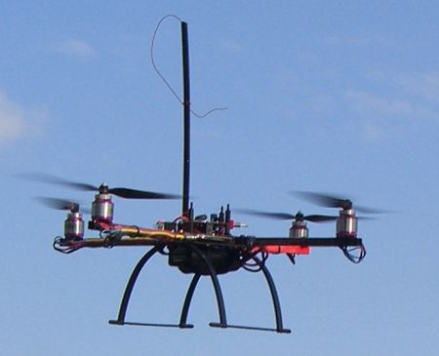

Figure - MikroKopter MK40

The most important aspect of the student’s role on the project is the electronic design and implementation of the onboard electronics. In following industry best practises a full design cycle is being used to ensure the hardware is designed properly, is free from errors, and is designed to specifications. The first step of this is to develop a broad architecture that will clearly and concisely show how all devices onboard the aircraft will connect together. This diagram, shown in Figure 2, will be referred to during the detailed design phase to maintain design integrity. A larger version can be found in Appendix A.

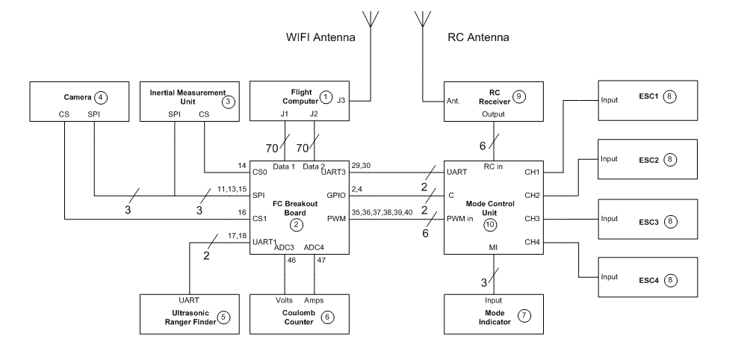

Figure - AHNS Hardware Architecture

In an effort to reduce the weight and chances of a cable failure, it was decided that the entire system would be built on a single PCB. This requires multiple, mostly independent, systems to coexist on the one board. In addition to this, the systems need to be laid out in way that will minimise the space taken up by the board. Although this design methodology is favourable for a final product, it is often very difficult to debug and modify if the prototype circuit underperforms or is found to be erroneous. For this reason a prototype system will be built on a larger scale, this means that each system will be built on a separate board and connected together. Furthermore the boards will be spread out to enable easy modification. Once this development system has been fully bench tested and is found to comply with all specifications the modifications can be noted an the final system can be designed based off the new refined design.

The base board for the development system was the first to be designed. The schematic was made using Eagle PCB. Once this schematic was checked and verified the same software package was used to create the PCB layout. These can be seen in Figure 3 and Figure 4 respectively.

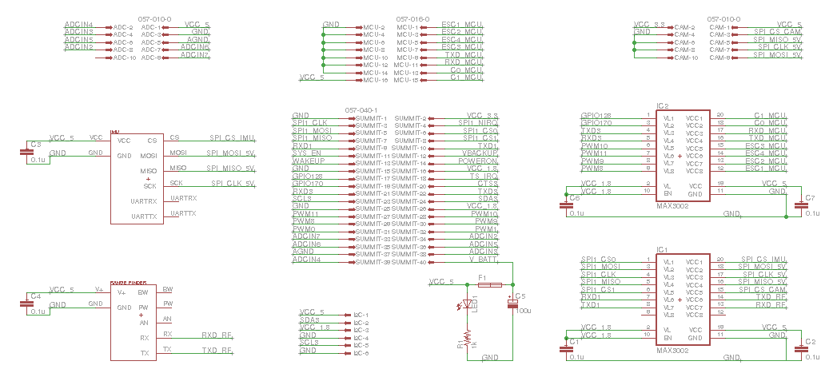

Figure - Development Board Schematic

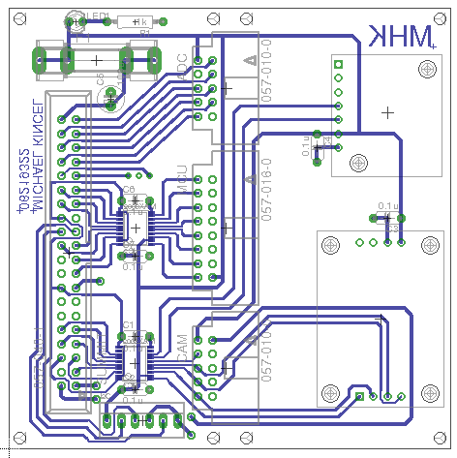

Figure - Development Board Layout

One aspect of the project that is vital to its success is the ability for the pilot to be confident during takeoff and landing as well as while performing recovery manoeuvres. To ensure this is done, it is important for the pilot to practise regularly. This will be done in one of two ways during the course of the project. The first is through the use of an RC simulator. The advantages of the simulator are that indefinite flight times can be sustained, flights are independent of weather, and recovery manoeuvres can be practised without the risk of damaging the airframe. Figure 5 shows the quadrotor model used in the RC simulator.

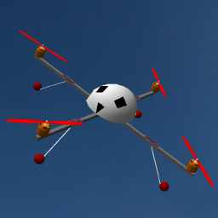

Figure - Quadrotor Model Used in Simulator (Source: www.aerosimrc.com)

In addition to using the simulator, the use of a practise airframe is also exploited. This airframe was given to the project by the supervisor. Pictured in Figure 6, The X-UFO airframe is a lightweight Styrofoam quadrotor with shrouds surrounding the rotors. This means that it is not likely to cause damage to people or objects while recovery manoeuvres are being performed. In addition to this, the low weight of the airframe means that is it a lot less likely to cause damage to its self if a hard landing is ever encountered or simply a crash. The airframe was modified to adapt the indefinite flight time ability of the simulator. This was done by removing the battery and replacing it with a tether. The tether is a wire capable of supplying the appropriate current to the airframe from a ground based power supply. This tether can be seen in Figure 6.

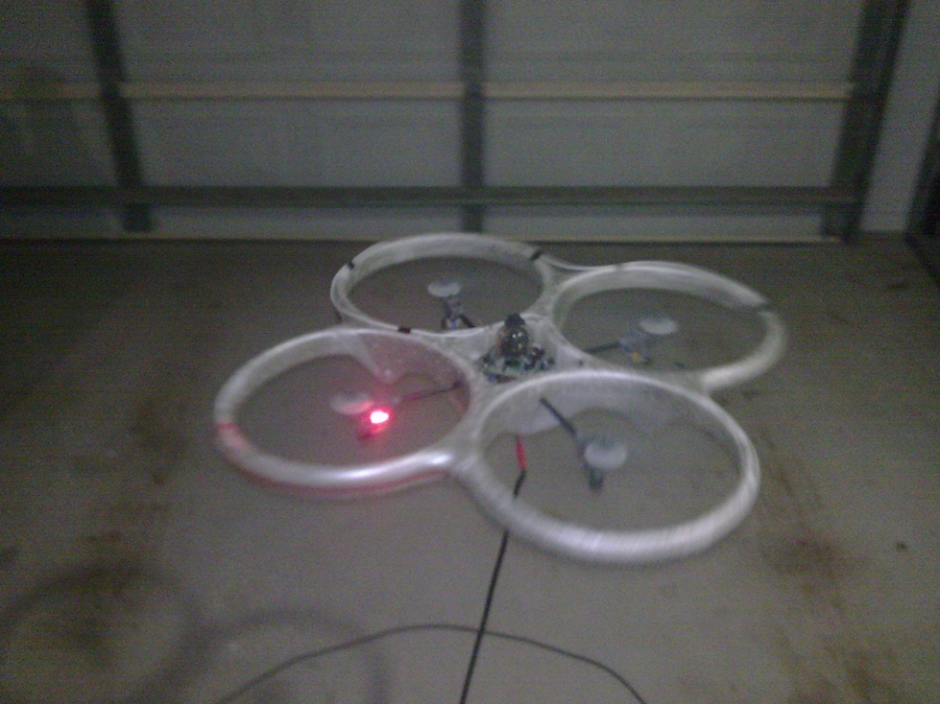

Figure – Practise Airframe in Operation

As a minimum, it has been decided that the pilot must practise for three hours each week. Half of this time can be conducted in the simulator. Under exceptional circumstances, all three of these hours can be conducted in the simulator, however given that the aircraft can be flown indoors, it is unlikely that rain or poor wind conditions will deny this opportunity.

## Statement of Progress Against Milestones

The following table shows a summary of the current progress of the project from a student perspective. It shows the completion statues of tasks that are overdue as well as tasks that are yet to be due.

Table - Current Progress

|  |  |  |  |
| --- | --- | --- | --- |
| **Task** | **Description** | **Due Date** | **Statues** |
| WP-PL-01 | Airframe Trade Study | 14/03/10 | Completed |
| WP-SY-04 | Preliminary Design Document | 14/03/10 | Completed |
| WP-PL-02 | Acquire and Construct Airframe | 01/04/10 | Completed |
| WP-PL-03 | Acquire Platform Electronics | 01/04/10 | Completed |
| WP-PL-04 | Airframe RC Test Report | 30/04/10 | Not Completed |
| WP-PL-05 | Electronics Test Report | 30/04/10 | Not Completed |
| **Present Time** | | | |
| WP-PL-06 | Integrate Onboard Hardware in Enclosure | 31/08/10 | Not Completed |
| WP-PL-07 | Integrate Enclosure into Airframe | 31/08/10 | Not Complete |
| WP-SY-05 | Augmented Flight Test Report | 10/10/10 | Not Competed |
| WP-SY-06 | Station Keeping Test Report | 10/10/10 | Not Completed |
| WP-SY-07 | Complete all Test Reports | 29/10/10 | Not Completed |
| WP-SY-08 | Complete Operation Manuel | 29/10/10 | Not Completed |
| WP-SY-09 | Verification of Success | 29/10/10 | Not Completed |
| WP-SY-10 | Demonstration | 29/10/10 | Not Completed |
| WP-SY-11 | Presentation | 29/10/10 | Not Completed |

It can be seen in that up to the present time, two tasks have not been completed which are now overdue. The remainder of the tasks that have not been completed are not yet due. The reason these tasks are not completed is a combination of these tasks requiring more time than what was originally drafted and student examinations taking up a considerable amount of time. To ensure these overdue tasks do not delay the project, they will be performed over the student holidays.

## Risks

During the design stage of the project’s lifecycle many risks were identified leading to the subsequent imposition of mitigation mechanisms as outlined in RD/4. Despite this, some problems still arose from unforeseen circumstances that had to be overcome before they were able to impose a risk on the problem. An example of an unforseen problem that was identified and overcome was the logic level mismatch between the FC and sensors that had to supply it with data. The Gumstix Overo based FC operates at a logic level of 1.8 volts. This means that all output logic signals are at 1.8 volts, but more importantly all input logic signals need to adhere to this 1.8 volt standard. All the external sensors used onboard the aircraft operate at 5 volt logic levels.

If one of the sensors was connected directly to the FC, data being sent from the FC to the sensor would fall below the threshold and would simply not be picked up, leading to a failure in communication between the devices. More crucially, if data was being sent from a sensor to the FC, it would exceed its maximum logic voltage and permanently damage the Overo. This would lead to a complete loss of the FC and a replacement unit would need to be procured, incurring an additional budgetary and time loss.

To overcome this issue logic level shifters were purchased and integrated into the design of the test bed. These devices connect between the FC and a given sensor and act like a buffer to ensure that 5 volt logic signals are converted to 1.8 volt logic signals and vice-versa.

It is anticipated that other such problems will arise before the final system is constructed. This is why the test bed was first constructed, it is easier to modify if the need arose and once the entire system is deemed functional, a miniature replica can be constructed for implementation in the final design.

# Conclusions

In conclusion is can be seen that milestones are being managed well with only two being overdue. In response to this, alternative arrangements have been made to ensure this delay does not affect the final completion of the project. All designs for the project follow industry best practise where possible and all designs follow a logical design process. It can also be seen that all risks are being managed to with contingencies drafted for all foreseen problems. Finally, unforeseen problems are managed in a way that will allow the project to be completed within time and budgetary constraints.

# Lessons learnt and Recommendations

It is recommended that the two outstanding milestones be met as soon as possible to reduce their follow on affect of future milestones. All designs should continue to be carried out according to industry standards as specified in this document. It is also recommended that as pilot, constant simulation time is required to maintain a high level of skill at all times.

The most important lesson that has been learnt is to double check all specifications for all components, had this not been done, expensive components would have been damaged, potentially compromising the project. This gives rise to the recommendation that all hardware needs to be checked twice before connecting to delicate components.

# Appendix A

Appendix A shows the full hardware architecture with description of all parts. The architecture is composed of four main segments. These are the flight computer, the primary sensors, and secondary sensors and the flight control segment with the MCU at the centre of this. The architecture can be seen on the following page: