|  |  |  |
| --- | --- | --- |
| Project:  WP Name: Augmented Flight Test Report  WP Number: WP-SY-05 | Type of Test:  Verification | Test Procedure:  Flight test platform to verify attitude hold. |
| Test Article:  Attitude Stabilisation | Part Number:  None | Serial Number:  None |
| Test Specification:  Achieve attitude hold with IMU. | Test Equipment:  Quadrotor platform with payload  Laptop (running GCS) | |
| Test Operators:  All AHNS Members | Test Engineer:  All AHNS Members | |
| WP Group Manager:  Michael Hamilton | WP Supervisor:  Dr. Luis Mejias | |

**QUT Avionics**

Queensland University of Technology

CRCSS-EESE, GPO Box 2434

Gardens Point Campus

Brisbane, Australia, 4001.

Telephone (+61 7) 3864 1772

Facsimile (+61 7) 3864 1517

e-mail luis.mejias@qut.edu.au

web <http://code.google.com/p/ahns10/>

This document is Copyright 2010 by the QUT. The content of this document, except that information which is in the public domain, is the proprietary property of the QUT and shall not be disclosed or reproduced in part or in whole other than for the purpose for which it has been prepared without the express permission of the QUT

**Test Summary**

The AHNS 2010 team attempted attitude utilising the on-board IMU, state estimation and PID control developed throughout the year. This test, similar to the gyro test, will test the level of success of the platform maintaining attitude hold while in unrestricted flight. After numerous hours of flight-testing, the PID loop gains were tuned to allow stable flight. The performance compared to the RC gyro was not as stable, but the pilot was still able to maintain a stable position. As with the gyro test, during take-off and landing the vibrations introduced by the landing gear was still present, but were overcome with quick manuviours off the ground.

**Table of Contents**

Paragraph Page No.

1 Test Objectives 3

2 Test Set-up & Equipment 4

3 Procedure 5

4 Results 6

5 Conclusions 8

**List of Figures**

Figure Page No.

Figure 1 – Roll Control from Flight Test 42 7

Figure 2 – Pitch Control from Flight Test 42 7

**List of Tables**

Table Page No.

Table 1 - PID Gains for Roll, Pitch and Yaw 6

# Test Objectives

The test report has the following test objectives:

* Achieve stable attitude during flight using the IMU by changing the three PID gains.
* Observe flight characteristics of platform using ground control station, including IMU, compass and ultrasonic sensor data.
* Record all flight data from ground control station.

# Test Set-up & Equipment

The following test setup and equipment was used to conduct the test report:

* PC with a Linux based operating system installed.
* Ground control station software installed to Linux PC.
* Quadrotor platform with payload attached (including the IMU, Arduino and compass sensors).
* 2.4 Ghz ‘heliconnect’ wireless modem.
* Open area clear of obstructions to flight-test.
* Spare batteries and battery charging station.
* Spare hardware mounting platters to replace in the event of a crash.
* Tools and equipment to make on the spot modifications/repairs to the platform if necessary.
* Safety glasses for all group members.
* Fire extinguisher and first aid equipment.
* Printed copy of risk management plan.
* Working bench for ground control station and tools.

# Procedure

The test report utilised the following procedure:

1. Ensure all connections on the AHNS platform are correct before powering the system.
2. Turn on the main power switch and wait until the wireless on the Overo is initialised.
3. Connect to the platform through ‘heliconnect’ and ensure that all systems are working correctly.
4. Open the ground control station and open the connection to display and record the data transmitted from the on-board sensors.
5. Initialise the Electronic Speed Controllers (ESC) and engines and to observe each engine start.
6. Preform a small input engine test under RC control to observe that all engines are working and rotating the correct way.
7. Place platform in the centre of the testing area and trim the control inputs.
8. After the pilot and project members are satisfied the system is safe to fly, commence the flight-testing.
9. If the attitude stabilisation is not desired, alter the PID gains and repeat from step seven.
10. Record the flights data from the ground control system and observe any anomalies during flight.

# Results

Similar to the RC gyro test, the platform was taken off continuously as the gains for the PID loops on the ground control station were altered to improve stability. After many hours of testing, and many different gains inputted, stable flight was achieved. The final gains for the PID system are outlined in Table 1, whereby stable flight was achieved.

Table - PID Gains for Roll, Pitch and Yaw

|  |  |  |  |
| --- | --- | --- | --- |
|  | **Proportional Gain** | **Integral Gain** | **Derivative Gain** |
| **Roll** | 0.41 | 0 | 1 |
| **Pitch** | -0.69 | 0 | 2.5 |
| **Yaw** | 1 | 0 | 0 |

The figures below outline the roll and pitch response of the system.

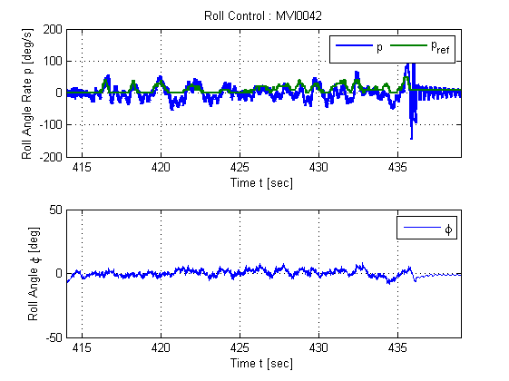

Figure – Roll Control from Flight Test 42

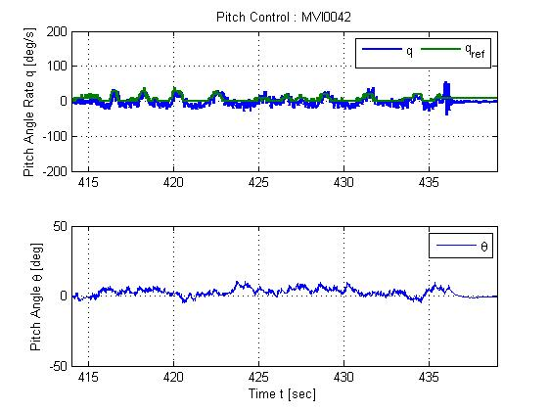

Figure – Pitch Control from Flight Test 42

# Conclusions

The figures outlined on the previous pages illustrate that the pitch and roll angle is constantly following the required angle to maintain stable attitude. The gains for the system are outlined in Table 1. It is recommended that these gains be used for all future flight tests when using the IMU for attitude stabilisation.