|  |  |  |
| --- | --- | --- |
| Project: AHNS10  WP Name: Station Keeping Test Report  WP Number: WP-SY-06 | Type of Test:  Verification | Test Procedure:  Flight test platform to verify altitude hold. |
| Test Article:  Position Stabilisation (altitude) | Part Number:  None | Serial Number:  None |
| Test Specification:  Achieve altitude hold using the VICON localisation system. | Test Equipment:  Quadrotor platform with payload  VICON  Laptop (running GCS) | |
| Test Operators:  All AHNS Members | Test Engineer:  All AHNS Members | |
| WP Group Manager:  Michael Hamilton  **Test Summary**  Altitude position hold tests were undertaken at ARCAA’s helicopter test flight area utilising the VICON positioning system. The helicopter, under RC gyro attitude stabilisation, was taken off manually, and changed into the position hold mode mid-flight. The platform attempted to maintain the desired altitude with success. Through testing it was found that the battery voltage greatly affected the performance of altitude hold. The implementation of an accumulator that changed the natural points with respect to the battery voltage was used to counter this, but through further testing the airframe engaged all engines to maximum. This sent the helicopter to the roof, but the engines were cut before impact. This outlined the danger of testing position hold, and testing was stopped. | WP Supervisor:  Dr. Luis Mejias | |

**QUT Avionics**

Queensland University of Technology

CRCSS-EESE, GPO Box 2434

Gardens Point Campus

Brisbane, Australia, 4001.

Telephone (+61 7) 3864 1772

Facsimile (+61 7) 3864 1517

e-mail luis.mejias@qut.edu.au

web <http://code.google.com/p/ahns10/>

This document is Copyright 2010 by the QUT. The content of this document, except that information which is in the public domain, is the proprietary property of the QUT and shall not be disclosed or reproduced in part or in whole other than for the purpose for which it has been prepared without the express permission of the QUT

**Table of Contents**

Paragraph Page No.

1 Test Objectives 3

2 Test Set-up & Equipment 4

3 Procedure 5

4 Results 6

5 Conclusions 7

**List of Figures**

Figure Page No.

Figure 1 – Altitude Control from Flight Test 35 6

**List of Tables**

Table Page No.

Table 1 - PID Gains for Roll, Pitch and Yaw 6

# Test Objectives

The test report has the following test objectives:

* Achieve altitude hold of the helicopter using VICON tracking system.
* Observe flight characteristics of platform using ground control station, including IMU, compass and ultrasonic sensor data.
* Record all data from the ground control station.

# Test Set-up & Equipment

The following test setup and equipment was used to conduct the test report:

* PC with a Linux based operating system installed.
* Ground control station software installed to Linux PC.
* Quadrotor platform with payload attached (including the RC gyro, IMU, Arduino and compass sensors).
* 2.4 Ghz ‘heliconnect’ wireless modem.
* ARCAA flight-testing hanger, with VICON tracing system.
* Spare batteries and battery charging station.
* Spare hardware mounting platters to replace in the event of a crash.
* Tools and equipment to make on the spot modifications/repairs to the platform if necessary.
* Safety glasses for all group members.
* Fire extinguisher and first aid equipment.
* Printed copy of risk management plan.
* Working bench for ground control station and tools.

# Procedure

The test report utilised the following procedure:

1. Ensure all connections on the AHNS platform are correct before powering the system.
2. Turn on the main power switch and wait until the wireless on the Overo is initialised.
3. Connect to the platform through ‘heliconnect’ and ensure that all systems are working correctly.
4. Open the ground control station and open the connection to display and record the data transmitted from the on-board sensors.
5. Initialise the Electronic Speed Controllers (ESC) and engines and to observe each engine start.
6. Preform a small input engine test under RC control to observe that all engines are working and rotating the correct way.
7. Place platform in the centre of the testing area and trim the control inputs.
8. After the pilot and project members are satisfied the system is safe to fly, commence the flight-testing.
9. Pilot to position the helicopter one meter off the ground, keeping it as still as possible.
10. Pilot to change from RC (red light) to position hold (green light) and observe helicopter. If pilot at any time believes helicopter no longer in a safe position, they must change back to RC (red light) and stabilise the platform.
11. If the altitude position hold is unstable, or does not track the desired position, change the loop gains and re-start from step seven.
12. Record the flights data from the ground control system and observe any anomalies during flight.

# Results

The altitude was tested using the VICON system, and at 1465 seconds into the test the altitude were inputted as one meter, which it oscillates around 40 cm near the desired point. At 1495 seconds the test is concluded. Table 1 outlines the gains used for the z-axis stabilisation loops.

Table 1 - PID Gains for Z-axis

|  |  |  |  |
| --- | --- | --- | --- |
|  | **Proportional Gain** | **Integral Gain** | **Derivative Gain** |
| **Z-axis** | 1.15 | 0 | -1.15 |

The figures below outline the altitude response of the system.

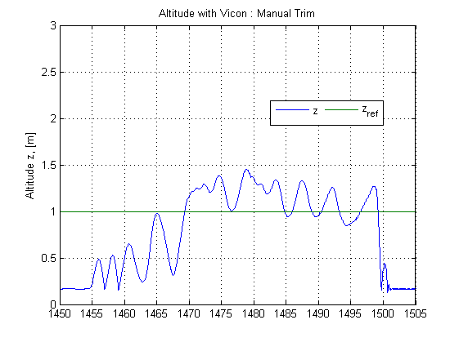

Figure 1 – Altitude Control from Flight Test 35

# Conclusions

In conclusion the z-position using the VICON system was implemented, with the steady state error of approximately 40 cm. It is recommended that this be improved with further testing.